## Introduction

This report describes what has been done to solve exercises in Home Assignment 3 and what were the results. To run code, execute ‘main.m’ file. Code repository: <https://gitlab.cs.ttu.ee/totahv/iti8565>

## Exercise 1. Neural Network [1]

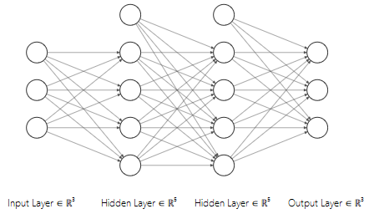Implemented neural network with two hidden layers, each layer supports N neurons. Used Sigmoid function in hidden layers and SoftMax function in the output layer to support multiclass classification. Used cross-entropy function for minimizing error, because partial derivatives were easier to find this way. Figure 1 illustrates structure of the neural network for 3D data and 3 output classes.

Figure 1 Structure of neural network.

Formula (1) describes feedforward step of neural network. Moving from ‘input layer’ to ‘1st hidden layer’, then to ‘2nd hidden layer’ and ‘output layer’.

After that cost function and partial derivatives are needed in backpropagation.

Formula (2) describes cost function and partial derivates for updating weights between output layer and 2nd hidden layer.

Formula (3) describes cost function and partial derivates for updating weights between 2nd hidden layer and 1st hidden layer.

Formula (4) describes cost function and partial derivates for updating weights between 1st hidden layer and input layer.

As a result, this neural network with 2 hidden layers supports arbitrary number of input neurons, arbitrary number of hidden neurons in each layer and any number of output neurons for multiclass classification.

## Exercise 2. Gradient boosting [2]

Implemented gradient boosting algorithm for regression model. Used MATLAB built-in function to create decision stumps. Figure 2 describes boosted decision stump model using gradient boosting after 50 epochs. Figure 3 describes error reduction when growing model. Created animation in gifs folder that animates growing model over 50 epochs.

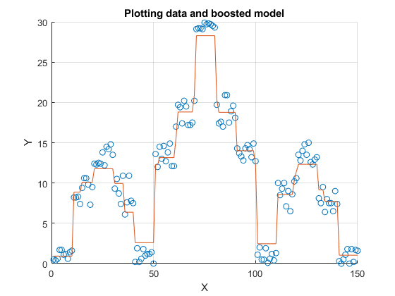

Figure 2 Boosted decision stumps using gradient boosting.

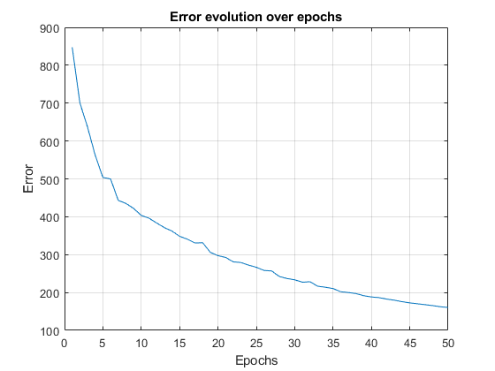

Figure 3 Error evolution over epochs.

## Conclusion

Implemented neural network for multiclass classification and gradient boosting algorithm for regression model.

## Used materials

[1] Creating a Neural Network from Scratch in Python, Usman Malik,

<https://stackabuse.com/creating-a-neural-network-from-scratch-in-python/>

[2] Gradient Boosting from scratch, Prince Grover,

<https://medium.com/mlreview/gradient-boosting-from-scratch-1e317ae4587d>