# Task 1: Preprocessing

Collection of data used in homework was taken from Gitlab repository. Script was written to resize images, however forcing images into 1024x1024 sizes is also distorting slug shape, so images were not resized into specific shape.

# Task 2: Etalons

Initially templates were just rectangle in which slug resides, but it was not effective, because template matching was also matching background which is not relevant. Second template was slugs breathing hole, but this template was also not effective because breathing hole can be like stones or another round object on picture. Final set of etalons were transparent templates in shape of slug body that were finally used for matching. Total of 70 transparent templates in shape of slug were made and 60 were used in training.

# Task3: Baseline

Multiple experiments were made with methods offered by OpenCV library, for example matchTemplate() with multiple standard functions (TM_CCOEFF_NORMED, TM_SQDIFF_NORMED etc), ORB, SIFT, Flann matcher with KNN and RANSAC homography for filtering outliers.

Training for final model was done on 30 lusitania and 30 limax templates created in Task 2. Models were trained using OpenCV methods. First model uses ORB detector, BFMatcher with Hamming distance. Second model uses SIFT detector, FLANN matcher with KNN. Outliers were filtered out using Gaussian with sigma = 1.5.

Testing was done on 10 images that were not included in training. Figure 1 shows Limax training results using ORB and Figure 2 shows Lusitania training results using SIFT.

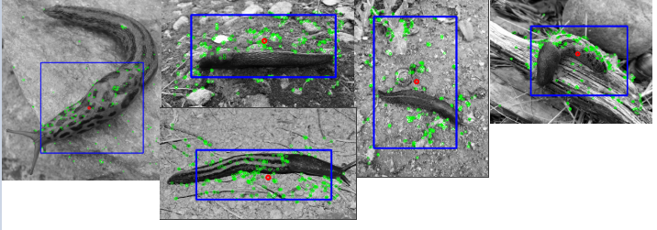

Figure Limax detection using ORB

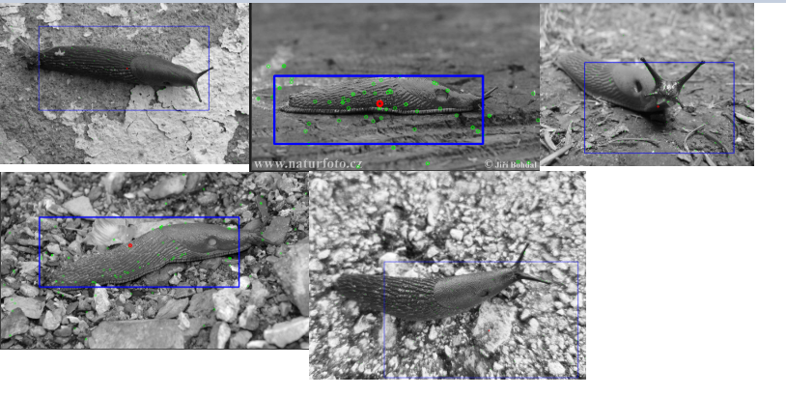

Figure Lusitania using SIFT

# Task4: Neural Network

Neural network was implemented in PyTorch and DenseNet121 was used as pretrained network to avoid designing complicated deep network on our own. Cross-Entropy was used as a loss function. Adam optimization algorithm was used instead of classical stochastic gradient descent to update network weights, so it would train faster and consume less memory. Network was trained for 20 epochs with learning rate of 0.002.

Training set contained 60 original images (labeled 30 as Lusitania and 30 as Limax) and 10 images were excluded from training and used for testing. Images were resized into uniform format before training. Training was done on Nvidia GPU with CUDA support, because training is faster than using CPU.

Figure 3 shows training accuracy and cross-entropy loss function during training. Goal was to predict correctly class of slug. Figure shows prediction results of 10 slugs. 4/5 Limax are correct and 4/5 Lusitania are correct, so accuracy for this training session is 80%.

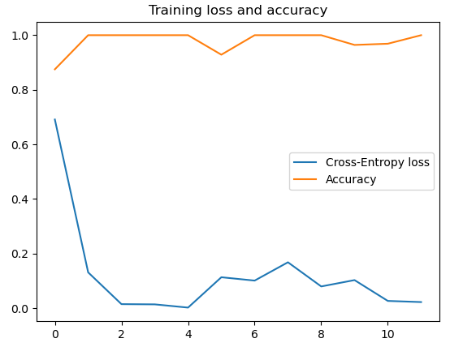

Figure 3 Accuracy and loss

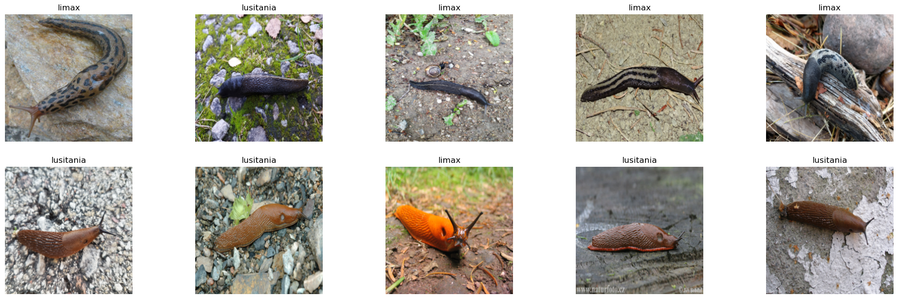

# References

OpenCV documentation - Feature Matching + Homography to find Objects

<https://docs.opencv.org/master/d1/de0/tutorial_py_feature_homography.html>

Kaggle – [pytorch] cat vs dog

<https://www.kaggle.com/jaeboklee/pytorch-cat-vs-dog>

Code for homework

https://gitlab.cs.ttu.ee/totahv/iti8030-hw2