# Assignment 3 report

Assignment was to make experiment using shallow water model. Experiment takes place between isle Isla Isabela and coast of Ecuador.

Figure 1 shows bathymetry map between Isla Isabela and coast of Ecuador. Data is taken from file ETOPO2v2c_f4.nc, which contains bathymetry information of entire planet, so unnecessary data was filtered out.

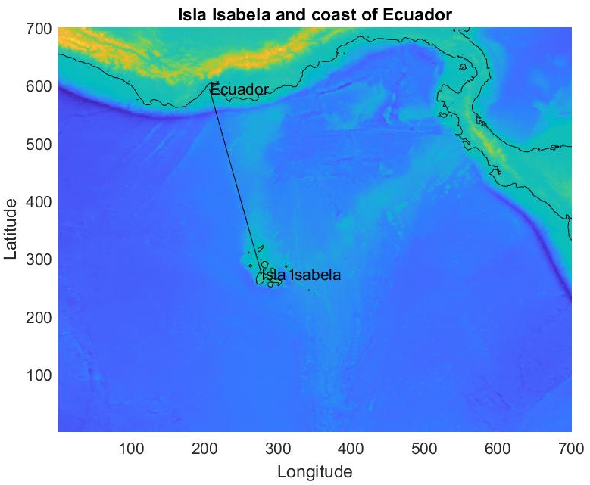

Figure Bathymetry map

Figure 2 shows bathymetry plot between Isla Isabela and coast of Ecuador, x axis has distance between two places and y axis shows depth. Information is calculated on the line between Isla Isabela and coast of Ecuador.

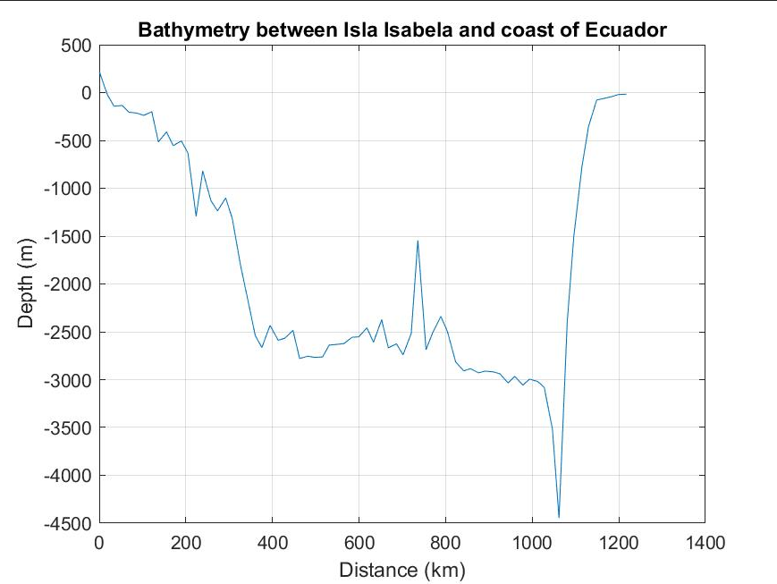

Figure Bathymetry plot

Figure 3 shows results after making experiment. At first sea levels are normal because wave has not yet reached Ecuador, but after some time waves start to increase sea levels and over time, they get dampened. Also animation has been generated which shows wave propagation over time.

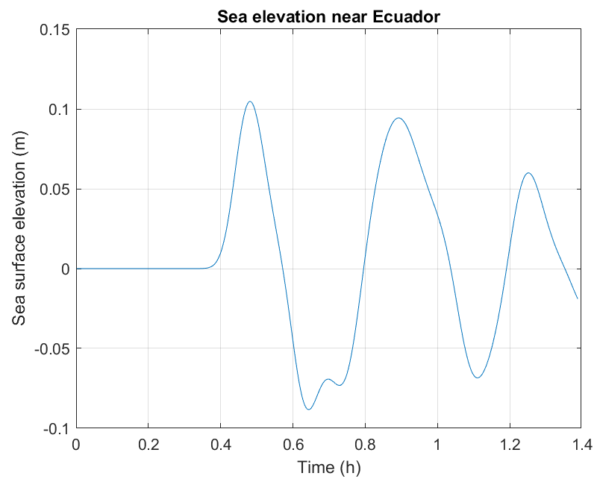

Figure Sea levels near Ecuador