Assignment 6

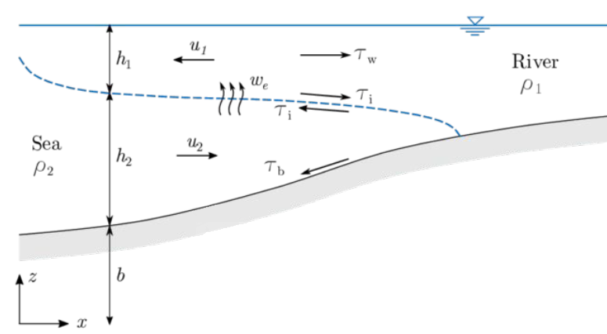

Image Assignment visualization

Initial parameters:

Mixed state:

KE loss:

PE loss:

If KE loss > PE gain, then mixing occurs:

After solving equation, results are:

Answer:

Fresh water flows toward the sea (minus sign) on top of salty water and must be at least = -0.58 m/s.

Salty sea water flows toward the land beneath fresh water at speed = 0.1 m/s.