SYSTEM-TEST

Test Case-01 : The user can view history architecture of the temple.  
Description  
 The users can view history architecture of the temple. The website will display about history of the temple to the users.

Prerequisites or Test input*  
 The test data is available at Appendix A  
Test procedure  
 1. Open “Wat Muen Ngoen Kong website”  
 2. Click on “History” button  
Test Cases :

|  |  |  |  |  |
| --- | --- | --- | --- | --- |
| Test case No. | Description | Input | Expected Output | Status |
| 1 | The users can access to main page. | Open “Wat Muen Ngoen Kong website”. | The website shall display main page of website. | Pass |
| 2 | The users can view history architecture of the temple. | Click on “History” button on main page. | The website shall display the history page that provide the history achitecture of the temple. | Pass |

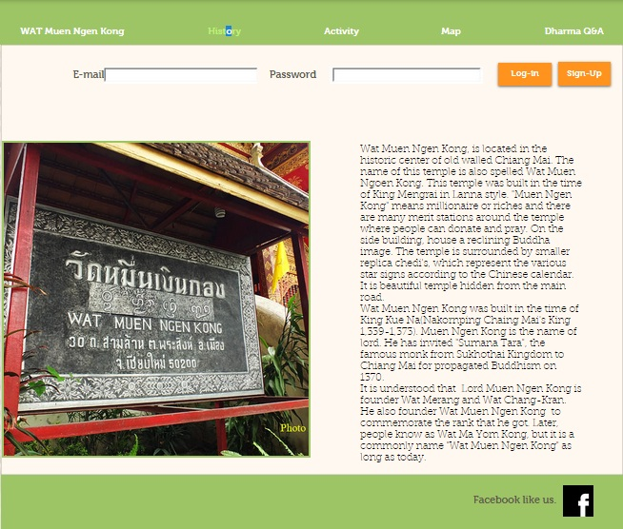

Test Case-02 : The user can view the current activities of the temple.  
Description  
 The users can view the current activities of the temple. The website will display about the current activities of the temple to the users.

Prerequisites or Test input  
 The test data is available at Appendix A*  
Test procedure  
 1. Open “Wat Muen Ngoen Kong website”  
 2. Click on “Activity” button  
Test Cases :

|  |  |  |  |  |
| --- | --- | --- | --- | --- |
| Test case No. | Description | Input | Expected Output | Status |
| 1 | The users can access to main page. | Open “Wat Muen Ngoen Kong website”. | The website shall display main page of website. | Pass |
| 2 | The user can view the current activities of the temple. | Click on “Activity” button on main page. | The website shall display the currently activity that provide the activity of the temple. | Pass |

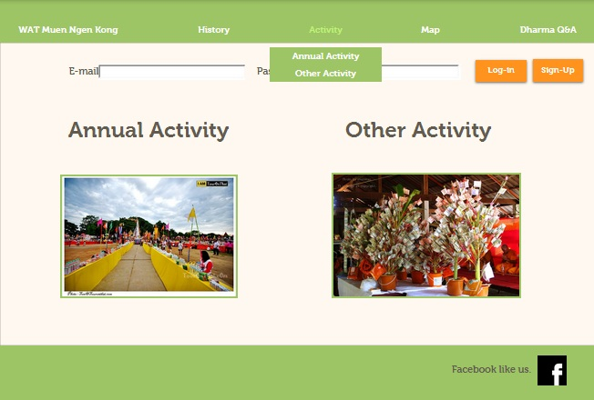

Test Case-03 : The user can registered became to members.  
Description  
 The users can register become to member. The registered method is require to use some function on the website, registered users have to input their account in text box that system provided.

Prerequisites or Test input  
 The test data is available at Appendix A*  
Test procedure  
 1. Open “Wat Muen Ngoen Kong website”   
 2. Click on “Sign-up” button  
 3. Click on “Submit” button to ensure registered  
Test Cases :

|  |  |  |  |  |
| --- | --- | --- | --- | --- |
| Test case No. | Description | Input | Expected Output | Status |
| 1 | The users can access to main page. | Open “Wat Muen Ngoen Kong website”. | The website shall display main page of website. | Pass |
| 2 | The system shall display sign-up page. | Click on “Sign-up” button on log-in page. | The website shall provide the sign-up page that require email and password to sign-up | Pass |
| 3 | The users can registered. | Click on “Submit” button. | The website shall provide pop up (“Registered Successfully”) and display log-in page to users. | Pass |

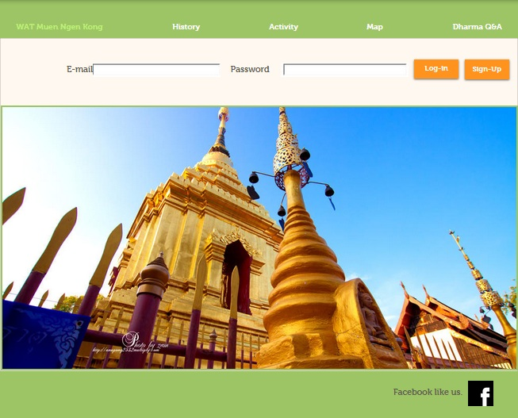

Test Case-04 : The user can view the temple’s map.  
Description  
 The users can view temple’s map by click “Map” button in main-page on menu bar, the system will provide map by google api.

Prerequisites or Test input  
 The test data is available at Appendix A*  
Test procedure  
 1. Open “Wat Muen Ngoen Kong website”  
 2. Click on “Map” button  
Test Cases :

|  |  |  |  |  |
| --- | --- | --- | --- | --- |
| Test case No. | Description | Input | Expected Output | Status |
| 1 | The users can access to main page. | Open “Wat Muen Ngoen Kong website”. | The website shall display main page of website. | Pass |
| 2 | The users can view temple’s map. | Click on “Map” button on main page. | The website shall provide map of temple by google api. | Pass |

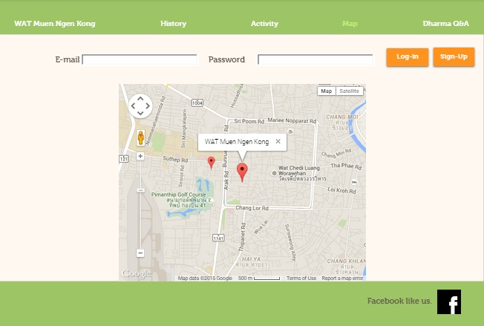

Test Case-05 : The user can click to like the Facebook page.  
Description  
 The users can access temple’s Facebook by click “Facebook” icon on main page, the system will provide Facebook fan page to like that.

Prerequisites or Test input  
 The test data is available at Appendix A  
Test procedure  
 1. Open “Wat Muen Ngoen Kong website”  
 2. Click on “Facebook” icon on main page  
Test Cases :

|  |  |  |  |  |
| --- | --- | --- | --- | --- |
| Test case No. | Description | Input | Expected Output | Status |
| 1 | The users can access to main page. | Open “Wat Muen Ngoen Kong website”. | The website shall display main page of website. | Pass |
| 2 | The users can access temple’s Facebook to like that by link from website. | Click on “Facebook” icon on main page. | The system shall provide Facebook of temple in new window. | Pass |

C:\Users\DDEW\Desktop\footer.jpg

Test Case-06 : The user can change the language of the website.  
Description  
 The users can change the language that switch between Thai-English.

Prerequisites or Test input  
 The test data is available at Appendix A  
Test procedure  
 1. Open “Wat Muen Ngoen Kong website”  
 2. Click on “Eng” or “Thai” button

Test Cases :

|  |  |  |  |  |
| --- | --- | --- | --- | --- |
| Test case No. | Description | Input | Expected Output | Status |
| 1 | The users can access to main page. | Open “Wat Muen Ngoen Kong website”. | The website shall display main page of website. | Pass |
| 2 | Can change language from Engligh to Thai. | Click on “Thai” button on top right of website. | The website shall display Thai language all of web-page. | Pass |
| 3 | Can change language from Thai to English. | Click on “Eng” button on top right of website. | The website shall display English language all of web-page. | Pass |

Test Case-07 : The user can view the annual activity of the temple.  
Description  
 The users can view the annual activities of the temple. The website will display about the annual activities of the temple to the users.

Prerequisites or Test input  
 The test data is available at Appendix A*  
Test procedure  
 1. Open “Wat Muen Ngoen Kong website”  
 2. Click on “Activity” button  
 3. Click on “Annual Activity” button  
Test Cases :

|  |  |  |  |  |
| --- | --- | --- | --- | --- |
| Test case No. | Description | Input | Expected Output | Status |
| 1 | The users can access to main page. | Open “Wat Muen Ngoen Kong website”. | The website shall display main page of website. | Pass |
| 2 | The user can access to the current activities of the temple. | Click on “Activity” button on main page. | The website shall display the currently activity that provide the activity of the temple. | Pass |
| 3 | The user can view the annual activities of the temple. | Click on “Annual Activity” button on activity page. | The website shall display the annual activity that provide the annual activity of the temple. | Pass |

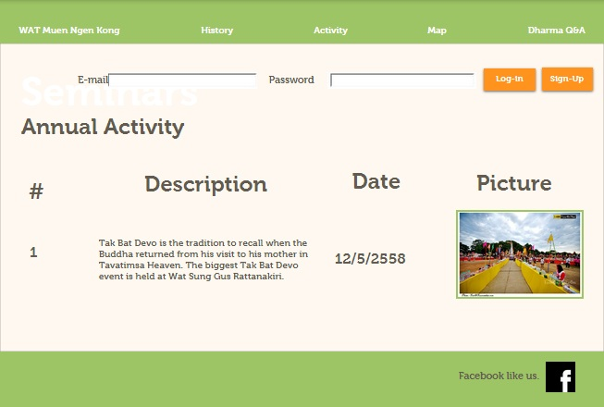

Test Case-08 : The user can view the other activity of the temple.  
Description  
 The users can view the other activities of the temple. The website will display about the other activities of the temple to the users.

Prerequisites or Test input  
 The test data is available at Appendix A*  
Test procedure  
 1. Open “Wat Muen Ngoen Kong website”  
 2. Click on “Activity” button  
 3. Click on “Other Activity” button  
Test Cases :

|  |  |  |  |  |
| --- | --- | --- | --- | --- |
| Test case No. | Description | Input | Expected Output | Status |
| 1 | The users can access to main page. | Open “Wat Muen Ngoen Kong website”. | The website shall display main page of website. | Pass |
| 2 | The user can access to the current activities of the temple. | Click on “Activity” button on main page. | The website shall display the currently activity that provide the activity of the temple. | Pass |
| 3 | The user can view the other activities of the temple. | Click on “Other Activity” button on activity page. | The website shall display the other activity that provide the other activity of the temple. | Pass |

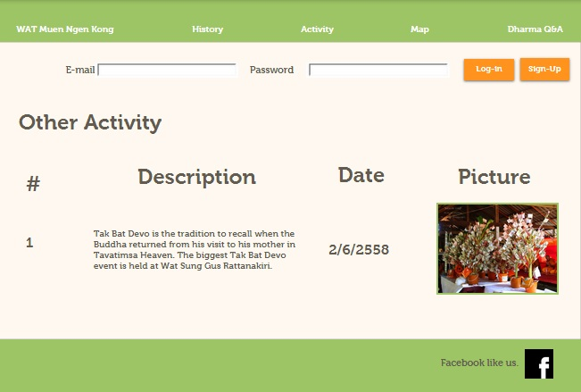

Test Case-09 : The member can log in.  
Description  
 The member can log in to the system. The log in method is require to use some function on the website, the member have to input their account in text box that system provided.

Prerequisites or Test input  
 The test data is available at Appendix A  
Test procedure  
 1. Open “Wat Muen Ngoen Kong website”  
 2. Click on “Dharma Q&A” button  
 3. Click “log-in” button to log-in when member input some required(email and password)  
   
Test Cases :

|  |  |  |  |  |
| --- | --- | --- | --- | --- |
| Test case No. | Description | Input | Expected Output | Status |
| 1 | The member can access to main page. | Open “Wat Muen Ngoen Kong website”. | The website shall display main page of website. | Pass |
| 2 | The system shall display log-in page. | Click on “Dharma Q&A” button on main page. | The website shall provide the log-in page to member for use these features. | Pass |
| 3 | The member can log-in to website. | “Email”, “Password”, and click on “log-in” button. | The website shall provide pop up (“Log in Successfully”) and display the main page to member. | Pass |

C:\Users\DDEW\Desktop\Untitled.jpg

Test Case-10 : The member can log out.  
Description  
 The member can log out the system to back to main page. When the member log out from system, they can’t using some function which has permission for member only.

Prerequisites or Test input  
 The test data is available at Appendix A  
Test procedure  
 1. Open “Wat Muen Ngoen Kong website”  
 2. Click on “Dharma Q&A” button  
 3. Click “log-in” button to log-in when member input some required(email and password)  
 4. Click “log-out” button for exist of using some feature and back to main page  
Test Cases :

|  |  |  |  |  |
| --- | --- | --- | --- | --- |
| Test case No. | Description | Input | Expected Output | Status |
| 1 | The member can access to main page. | Open “Wat Muen Ngoen Kong website”. | The website shall display main page of website. | Pass |
| 2 | The system shall display log-in page. | Click on “Dharma Q&A” button on main page. | The website shall provide the log-in page to member for use these features. | Pass |
| 3 | The member can log-in to website. | “Email”, “Password”, and click on “log-in” button. | The website shall provide pop up (“Log in Successfully”) and display the main page to member. | Pass |
| 4 | The member can log-out the website. | Click on “log-out” button. | The website shall provide pop up(“Logout Successfully”) and back the main page . | Pass |

Test Case-11 : The member can ask the Dharma questions.  
Description  
 The member can ask the Dharma question. The ask Dharma question method is require to use log-in function on the website.

Prerequisites or Test input  
 The test data is available at Appendix A  
Test procedure  
 1. Open “Wat Muen Ngoen Kong website”  
 2. Click on “Dharma Q&A” button  
 3. Click “log-in” button to log-in when member input some required(email and password)  
 4. Input “Question” and click “Submit” button  
Test Cases :

|  |  |  |  |  |
| --- | --- | --- | --- | --- |
| Test case No. | Description | Input | Expected Output | Status |
| 1 | The member can access to main page. | Open “Wat Muen Ngoen Kong website”. | The website shall display main page of website. | Pass |
| 2 | The system shall display log-in page. | Click on “Dharma Q&A” button on main page. | The website shall provide the log-in page to member for use these features. | Pass |
| 3 | The member can log-in to website. | “Email”, “Password”, and click on “log-in” button. | The website shall provide pop up (“Log in Successfully”) and display the main page to member. | Pass |
| 4 | The member can view the webboard. | Click on “Dharma Q&A” button. | The website shall provide the webboard of Dharma Q&A to member. | Pass |
| 5 | The member can ask question to temple. | “Question” and click on “Submit” button. | The website shall provide pop up(Send Successfully) on screen. | Pass |

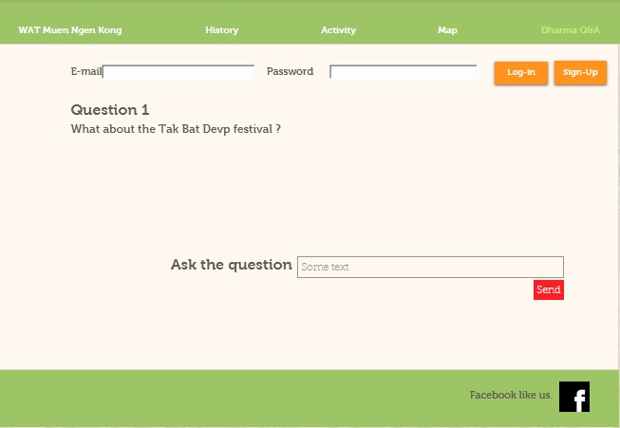

Test Case-12 : The member can view the web-board.  
Description  
 The member can view the web board that provide the lastest question-answer, asked by other member and answer by admin.

Prerequisites or Test input  
 The test data is available at Appendix A  
Test procedure  
 1. Open “Wat Muen Ngoen Kong website”  
 2. Click on “Dharma Q&A” button  
 3. Click “log-in” button to log-in when member input some required(email and password)  
Test Cases :

|  |  |  |  |  |
| --- | --- | --- | --- | --- |
| Test case No. | Description | Input | Expected Output | Status |
| 1 | The member can access to main page. | Open “Wat Muen Ngoen Kong website”. | The website shall display main page of website. | Pass |
| 2 | The system shall display log-in page. | Click on “Dharma Q&A” button on main page. | The website shall provide the log-in page to member for use these features. | Pass |
| 3 | The member can log-in to website. | “Email”, “Password”, and click on “log-in” button. | The website shall provide pop up (“Log in Successfully”) and display the main page to member. | Pass |
| 4 | The member can view the webboard. | Click on “Dharma Q&A” button. | The website shall provide the webboard of Dharma Q&A to member. | Pass |



Test Case-13 : The admin can log in.  
Description  
 The admin can log in to the system. The log in method is require to use some function on the website, the admin have to input their account in text box that system provided.

Prerequisites or Test input  
 The test data is available at Appendix A  
Test procedure  
 1. Open “Wat Muen Ngoen Kong website”  
 2. Click on “Dharma Q&A” button  
 3. Click “log-in” button to log-in when admin input some required(email and password)  
   
Test Cases :

|  |  |  |  |  |
| --- | --- | --- | --- | --- |
| Test case No. | Description | Input | Expected Output | Status |
| 1 | The admin can access to main page. | Open “Wat Muen Ngoen Kong website”. | The website shall display main page of website. | Pass |
| 2 | The system shall display log-in page. | Click on “Dharma Q&A” button on main page. | The website shall provide the log-in page to admin for use these features. | Pass |
| 3 | The admin can log-in to website. | “Email”, “Password”, and click on “log-in” button. | The website shall provide pop up (“Log in Successfully”) and display main page to admin. | Pass |

C:\Users\DDEW\Desktop\Untitled.jpg

Test Case-14 : The admin can log out.  
Description  
 The admin can log out the system to back to main page. When the admin log out from system, they can’t using some function which has permission for admin only.

Prerequisites or Test input  
 The test data is available at Appendix A  
Test procedure  
 1. Open “Wat Muen Ngoen Kong website”  
 2. Click on “Dharma Q&A” button  
 3. Click “log-in” button to log-in when admin input some required(email and password)  
 4. Click “log-out” button for exist of using some feature and back to main page  
Test Cases :

|  |  |  |  |  |
| --- | --- | --- | --- | --- |
| Test case No. | Description | Input | Expected Output | Status |
| 1 | The admin can access to main page. | Open “Wat Muen Ngoen Kong website”. | The website shall display main page of website. | Pass |
| 2 | The system shall display log-in page. | Click on “Dharma Q&A” button on main page. | The website shall provide the log-in page to admin for use these features. | Pass |
| 3 | The admin can log-in to website. | “Email”, “Password”, and click on “log-in” button. | The website shall provide pop up (“Log in Successfully”) and display the main page to admin. | Pass |
| 4 | The admin can log-out the website. | Click on “log-out” button. | The website shall provide pop up(“Logout Successfully”) and back the main page . | Pass |

Test Case-15 : The admin can edit the temple’s history architecture.  
Description  
 The admin can edit history architecture of the temple. The website will provide history of the temple that can edit information to the admin.

Prerequisites or Test input*  
 The admin must loged-in.  
Test procedure  
 1. Open “Wat Muen Ngoen Kong website”  
 2. Click on “History” button  
Test Cases :

|  |  |  |  |  |
| --- | --- | --- | --- | --- |
| Test case No. | Description | Input | Expected Output | Status |
| 1 | The admin can access to main page. | Open “Wat Muen Ngoen Kong website”. | The website shall display main page of website. | Pass |
| 2 | The admin can view history architecture of the temple. | Click on “History” button on main page. | The website shall display the history page that provide a frame of history that can edit information. | Pass |

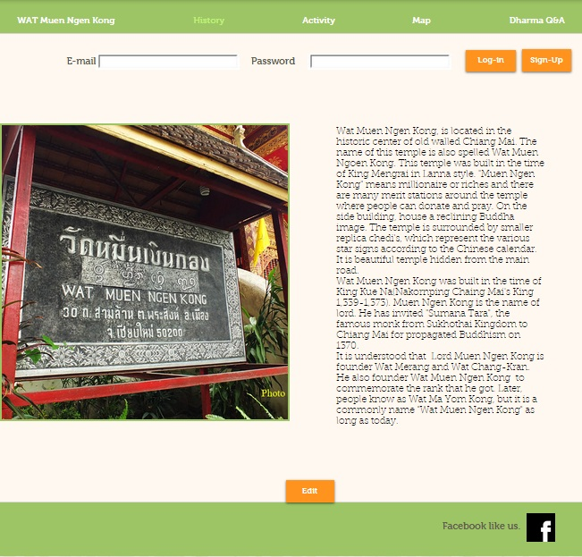

Test Case-16 : The admin can edit the current the temple’s activity.  
Description  
 The admin can edit the activity include annual and other activity to database and display it on activity page with updated.

Prerequisites or Test input  
 The admin must loged-in.  
Test procedure  
 1. Open “Wat Muen Ngoen Kong website”  
 2. Click on “Activity” button  
 3. Click on “Edit” button  
Test Cases :

|  |  |  |  |  |
| --- | --- | --- | --- | --- |
| Test case No. | Description | Input | Expected Output | Status |
| 1 | The admin can access to main page. | Open “Wat Muen Ngoen Kong website”. | The website shall display main page of website. | Pass |
| 2 | The admin can access to activity page. | Click on “Activity” button on main page. | The website shall display the currently activity that provide the annual activity and other activity of the temple. | Pass |
| 3 | The admin can access edit page. | Click on “Edit” button on activity page. | The website shall display the new window to edit selected activity. | Pass |
| 4 | The admin can edit activities of the temple. | Click on “Submit” button on adding page. | The website shall provide activity page with updated activity. | Pass |

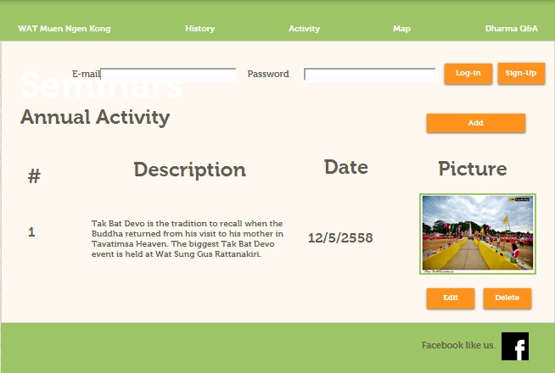

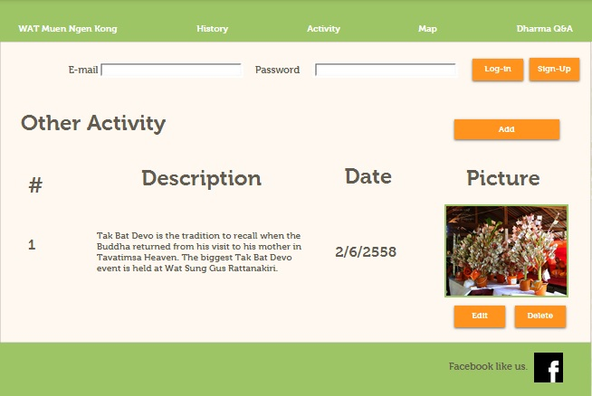

Test Case-17 : The admin can add the current the temple’s activity.  
Description  
 The admin can add the activity include annual and other activity to database and display it on activity page with new activity.

Prerequisites or Test input  
 The admin must loged-in.  
Test procedure  
 1. Open “Wat Muen Ngoen Kong website”  
 2. Click on “Activity” button  
 3. Click on “Add” button  
Test Cases :

|  |  |  |  |  |
| --- | --- | --- | --- | --- |
| Test case No. | Description | Input | Expected Output | Status |
| 1 | The admin can access to main page. | Open “Wat Muen Ngoen Kong website”. | The website shall display main page of website. | Pass |
| 2 | The admin can access to activity page. | Click on “Activity” button on main page. | The website shall display the currently activity that provide the annual activity and other activity of the temple. | Pass |
| 3 | The admin can access adding page. | Click on “Add” button on activity page. | The website shall display the new window to add new activity. | Pass |
| 4 | The admin can add activities of the temple. | Click on “Submit” button on adding page. | The website shall provide activity page with new activity. | Pass |



Test Case-18 : The admin can delete the current the temple’s activity.  
Description  
 The admin can delete the activity include annual and other activity to database and display it on activity page with updated activity.

Prerequisites or Test input  
 The admin must loged-in.  
Test procedure  
 1. Open “Wat Muen Ngoen Kong website”  
 2. Click on “Activity” button  
 3. Click on “Delete” button  
Test Cases :

|  |  |  |  |  |
| --- | --- | --- | --- | --- |
| Test case No. | Description | Input | Expected Output | Status |
| 1 | The admin can access to main page. | Open “Wat Muen Ngoen Kong website”. | The website shall display main page of website. | Pass |
| 2 | The admin can access to activity page. | Click on “Activity” button on main page. | The website shall display the currently activity that provide the annual activity and other activity of the temple. | Pass |
| 3 | The admin can delete activities of the temple. | Click on “Delete” button on activity page. | The website shall delete selected activity and provide activity page with updated. | Pass |

 

Test Case-19 : The admin can post Dharma Q&A on the web-board.  
Description  
 The admin can post dharma question and answer on the web board that provide the lastest question-answer.

Prerequisites or Test input  
 The admin must loged-in.  
Test procedure  
 1. Open “Wat Muen Ngoen Kong website”  
 2. Click on “Dharma Q&A” button  
 3. Click on “Answer” button  
 4. Click on question list  
 5. Click on “Post” button  
Test Cases :

|  |  |  |  |  |
| --- | --- | --- | --- | --- |
| Test case No. | Description | Input | Expected Output | Status |
| 1 | The admin can access to main page. | Open “Wat Muen Ngoen Kong website”. | The website shall display main page of website. | Pass |
| 2 | The admin can view the webboard. | Click on “Dharma Q&A” button. | The website shall provide the webboard of Dharma Q&A to admin. | Pass |
| 3 | The admin can view question list. | Click on “Answer” button on webboard. | The website shall provide list of question that stored in database. | Pass |
| 4 | The admin can access to answer the question. | Selected one question to answer. | The website shall provide an answer box to admin. | Pass |
| 5 | The admin can answer the question and post it to webboard. | Click on “Answer” button on answer page. | The website shall post the question and answer to webboard and back to display the remaining of question. | Pass |

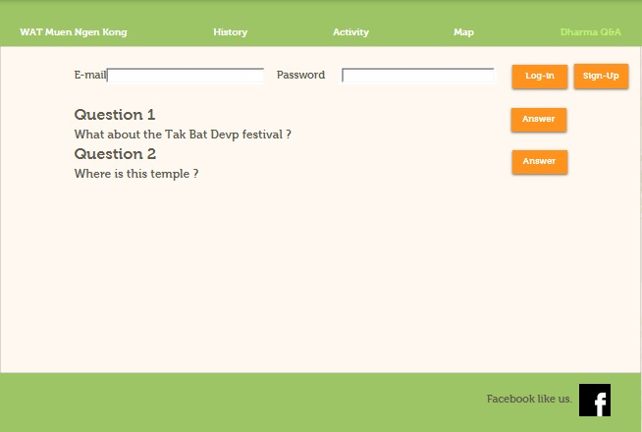

Test Case-20 : The admin can answer Dharma Q&A.  
Description  
 The admin can view the list of dharma question, asked by member.

Prerequisites or Test input  
 The admin must loged-in.  
Test procedure  
 1. Open “Wat Muen Ngoen Kong website”  
 2. Click on “Dharma Q&A” button  
 3. Click on “Answer” button  
 4. Click on question list   
Test Cases :

|  |  |  |  |  |
| --- | --- | --- | --- | --- |
| Test case No. | Description | Input | Expected Output | Status |
| 1 | The admin can access to main page. | Open “Wat Muen Ngoen Kong website”. | The website shall display main page of website. | Pass |
| 2 | The admin can view the webboard. | Click on “Dharma Q&A” button. | The website shall provide the webboard of Dharma Q&A to admin. | Pass |
| 3 | The admin can view question list. | Click on “Answer” button on webboard. | The website shall provide list of question that stored in database. | Pass |
| 4 | The admin can access to answer the question. | Selected one question to answer. | The website shall provide an answer box to admin. | Pass |

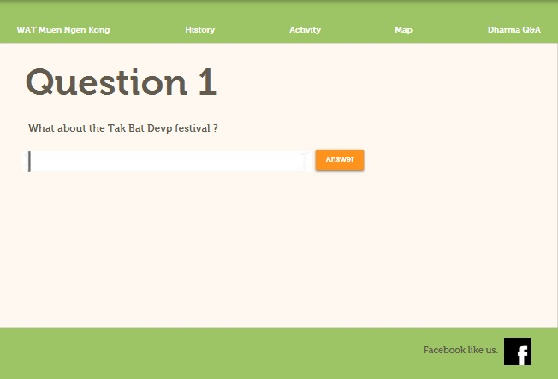

Test Case-21 : The admin can view the web-board.  
Description  
 The admin can view the web board, dharma question and answer, that provide the lastest question-answer.

Prerequisites or Test input  
 The admin must loged-in.  
Test procedure  
 1. Open “Wat Muen Ngoen Kong website”  
 2. Click on “Dharma Q&A” button   
Test Cases :

|  |  |  |  |  |
| --- | --- | --- | --- | --- |
| Test case No. | Description | Input | Expected Output | Status |
| 1 | The admin can access to main page. | Open “Wat Muen Ngoen Kong website”. | The website shall display main page of website. | Pass |
| 2 | The admin can view the webboard. | Click on “Dharma Q&A” button. | The website shall provide the webboard of Dharma Q&A to admin. | Pass |

Test Case-22 : The admin defines the news.  
Description  
 The admin can create the news and defined.

Prerequisites or Test input  
 The admin must loged-in.  
Test procedure  
 1. Open “Wat Muen Ngoen Kong website”  
 2. Click on “Send E-Mail” button  
Test Cases :

|  |  |  |  |  |
| --- | --- | --- | --- | --- |
| Test case No. | Description | Input | Expected Output | Status |
| 1 | The admin can access to main page. | Open “Wat Muen Ngoen Kong website”. | The website shall display main page of website. | Pass |
| 2 | The admin can define the news. | Click on “Send E-Mail” button. | The website shall provide the new page to define the information of news. | Pass |

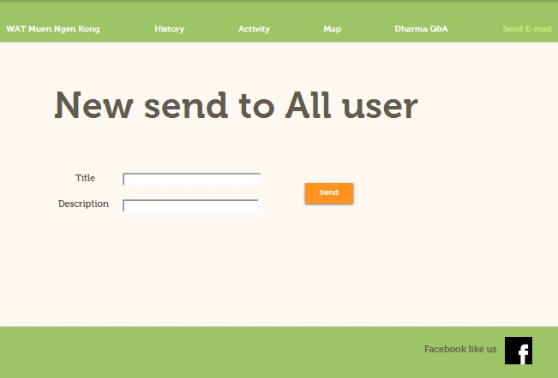

Test Case-23 : The admin can edit the Facebook page.  
Description  
 The admin can edit about temple’s facebook page.

Prerequisites or Test input  
 The test data is available at Appendix A  
Test procedure  
 1. Open “Wat Muen Ngoen Kong Facebook”  
 2. Click on “Setting” button  
 Test Cases :

|  |  |  |  |  |
| --- | --- | --- | --- | --- |
| Test case No. | Description | Input | Expected Output | Status |
| 1 | The admin can access to temple’s facebook page. | Open “Wat Muen Ngoen Kong Facebook”. | The facebook shall display facebook page. | Pass |
| 2 | The admin can set the facebook page. | Click on “Setting” button and “Save” button to edited. | The website shall provide new information to the facebook page. | Pass |

C:\Users\DDEW\Desktop\footer.jpg

Test Case-24 : The admin can send the email to members.  
Description  
 The admin can send the defined news to all member.

Prerequisites or Test input  
 The admin must loged-in.  
Test procedure  
 1. Open “Wat Muen Ngoen Kong website”  
 2. Click on “Send E-Mail” button  
 3. Click on “Send” button  
Test Cases :

|  |  |  |  |  |
| --- | --- | --- | --- | --- |
| Test case No. | Description | Input | Expected Output | Status |
| 1 | The admin can access to main page. | Open “Wat Muen Ngoen Kong website”. | The website shall display main page of website. | Pass |
| 2 | The admin can access to define the news. | Click on “Send E-Mail” button. | The website shall provide the new page to define the information of news. | Pass |
| 3 | The admin can send email to member. | Click on “Send” button. | The website display pop up(Send Successfully) and back to define news page. | Pass |

