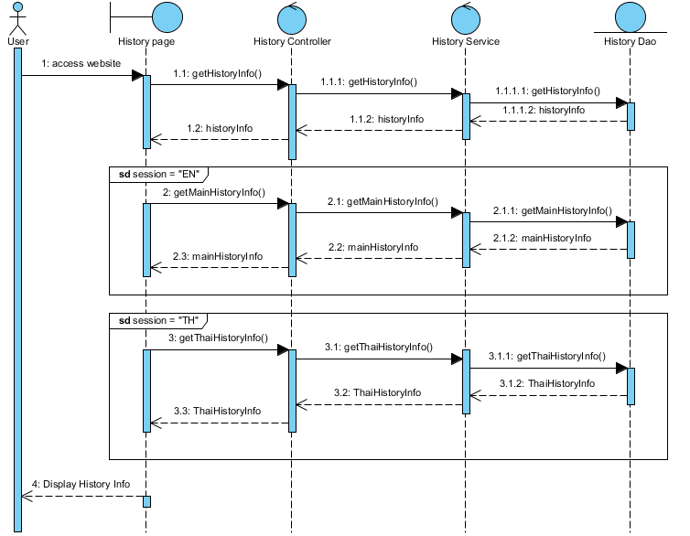  
Sequence Diagram : The user can view history architecture of the temple.

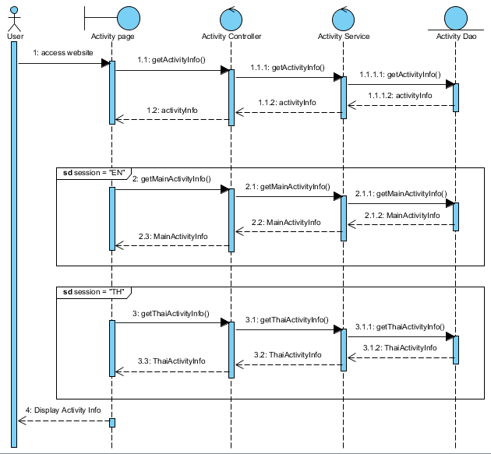

The user can view the activities of the temple.

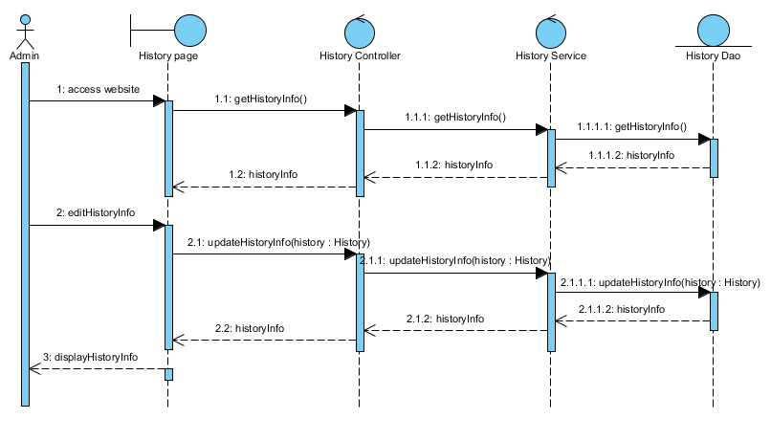  
The admin can edit the temple’s history architecture.  
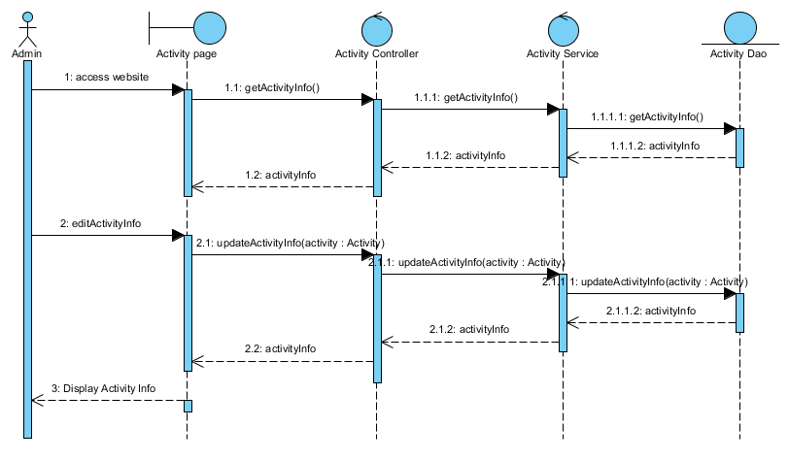  
The admin can edit the temple’s activity.

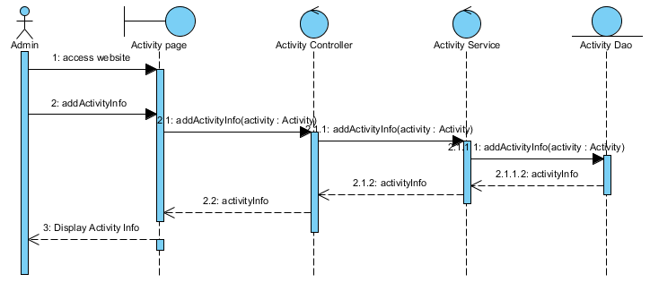  
The admin can add the current the temple’s activity.

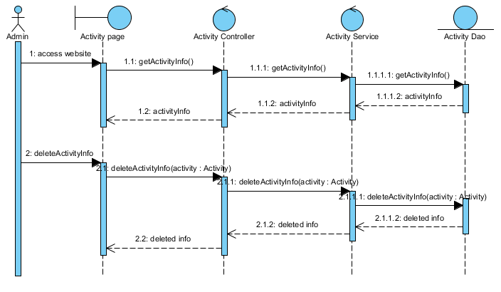  
The admin can delete the temple’s activity.

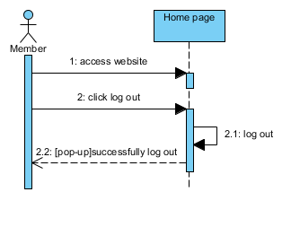  
The member can log out.  
  
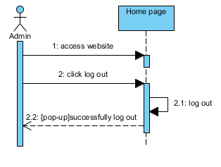  
The admin can log out.  
  
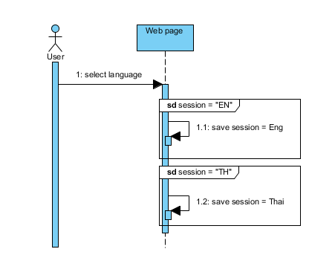  
The user can change the language of the website.