CLIENT_LOGIN

Command id :1

Description: The login command is used for local authentication inside the game database. It is only used today for developers and testers that need to get a client connected to the game servers without the overhead of generating a token for LOGIN2.

Response: The Server will do one of two things. It will either return a CLIENT_LOGIN_RESP message with the results indicated or it will just close the connection if it feels this is an attempt to hack the servers. In the event of it just closing the connection the client agent log file should be checked for the reason why.

Command | 1 | Uint16
Username |  | String8 | Used as the Primary Key for The account Information.
IP Address |  | UInt32 | little endian ( Obsolete)
Port |  | UInt16 | little endian ( Obsolete)
Version |  | String8 | This is the site release version. Must match the one provided at startup of the client agent.
DC Version |  | UInt32 | Dc file hash. Must match the hash of the server version of the dc file.
Pass Word |  | String8 | For creation of the account this password will be set as the login password. For reuse of an account it will be verified that it matches the old version. This is case sensitive.
Allow Create |  | Uint8 | True/False. If this flag is set and this exact account string is not found in the database. The account will be created.
Check Hash |  | String8 | If and only if the validate Download Hash is provided to the client agent and it does not match this string the login will be refused and client notified.
Privilege String |  | String8 | If this string matches the string provided to the client agent for an admin connection the client agent will flag the connection as privileged and allowed to issue admin commands and access restricted fields.

Details: This or the client_login2 must be the first message sent to the servers after successful session establishment.

----------------------------------------------------------------------------------------------------------

CLIENT_LOGIN_RESP

Message ID: 2

Description: This message is sent as a response to a client login message.

Response: N/A

Command | 2 | Uint16
Return code |  | Uint8 | 0 = All is Ok any other value is an error.
Account ID |  | Uint32 | The DOID for this account.
Error Text |  | String8 | Human Readable Text Indicating the error Condition. Should be ignored if return code is 0.
Epoch Sec |  | Uint32 | Obsolete
Epoch Usec |  | Uint32 | Obsolete

Details:
----------------------------------------------------------------------------------------------------------

CLIENT_GO_GET_LOST_RESP

Message ID: 4

Description: This string is sent prior to a close of a game connection unless the connection is closed to transmission errors or the client agent fills like the connection is behaving like a hacker.

Response: N/A

Command | 4 | Uint16
Index |  | UInt16 | A Code indicating why the connection was closed.
Text |  | String8 | A human readable text string indication the reason for the close. These strings are compiled into the client agent and today have means to alter them except at compile time.

Details:
1 | No message. This is actually an error in the code that requested a disconnect.
2 | Response to a client logout message.
99 | The CLIENT_SET_AVATAR failed to pass a DOID or is malformed.
100 | I different communication channel was just established with the same identity as this one.
101 | A CLIENT_SET_SECURITY was sent with a NULL token on the message.
102 | The server had a problem decrypting the token provided with a CLIENT_SET_SECURITY. (OpenSSL token)
103 | There was an error parsing the OpenSSL token for the required fields.
104 | The name length is in error. The unique account identifier is shorter than 2 bytes or longer than 45 bytes.
105 | The expiration time on this play token has passed.
106 | The field indicating what type of token we are processing is invalid.
108 | Error decoding CLIENT_SET_WISHNAME. Malformed request.
109 | Error decoding CLIENT_SET_WISHNAME_CLEAR or CLIENT_CREATE_AVATAR. Malformed request.
110 | The DNA provided has failed the basic range tests. See Client Agent log for details.
111 | The DNA name converter had a problem creating a default a name for this DNA string.
113 | Error decoding the CLIENT_DELETE_AVATAR message. Malformed request.
115 | The client request CLIENT_SET_SHARD seems to be malformed.
116 | The CLIENT_SET_ZONE message seems to be malformed.
117 | The CLIENT_OBJECT_UPDATE_FIELD seems to be malformed.
118 | Got a CLIENT_OBJECT_UPDATE_FIELD for a field that this client is not allowed to update.
119 | Got a CLIENT_OBJECT_UPDATE_FIELD for a field that this client is not allowed to update.
120 | This client tried to send a chat message but does not have chat permissions set.
122 | Error decrypting OpenSSL token in CLIENT_LOGIN_2.
123 | CLIENT_LOGIN. The client agent is in a mode that disallows this type of login.
124 | CLIENT_LOGIN failed to parse this message. Malformed.
125 | Error validating download hash or invalid download hash.
126 | Got admin command from non admin. Admin bit not set at login or we had an error decoding a CLIENT_GET_AVATAR_DETAILS.
151 | A CLIENT_AGENT_CLOSE_CONECTION message was just received by the client agent. Today the only server that uses this comment is the client agent web page.
153 | Your avatar has been removed by an AI request. This is usually issued when a district goes threw a hard shutdown. But technically could be caused by any trusted server issuing a state server delete for an active avatar.
200 | Internal error in the client state machine. Contact the developers for correction.
201 | A fatal error has happened on the database part of the LOGIN2 client transaction.
204 | The token type provided to the CLIENT_LOGIN_2 message is invalid.
205 | The DC hash provided does not match the servers.
207 | The green token is invalid. Fails basic tests.
208 | The green indicates you are not allowed to play.
210 | The SWID in the green does not pass basic validation.
211 | Invalid Version code in the CLIENT_LOGIN message.
212 | Invalid DC hash in the CLIENT_LOGIN message.
220 | Internal error in the client state machine. Contact the developers for correction.
221 | Error decoding CLIENT_LOGIN_2 malformed message.
222 | Error dispatching the message. Usually caused by a client request for a function that he is not in the right state to execute.
223 | Error dispatching the message. Usually caused by a client request for a function that he is not in the right state to execute.
224 | Login failed for version string mismatch OR an account name size problem in the Login Command.
225 | Error parsing the play token.
288 | A limited time account has tried to connect and the allocated time has expired. This is only issued at login see 349 for runtime error.
345 | Inactivity Timeout. This connection has failed to send a message in the configured amount of time.
347 | Socket Write Error. The TCP stack has issued a fatal write error for this communication channel. See the client agent log for detailed error codes.
348 | Socket Read Error. The TCP communication channel has issued a fatal error on this connection. See the Client agent log for more details.
349 | Limited Time Expired. This account is limited to the amount of time it can play in a period and has exceeded this time plus a padding factor.
350 | The client tried to overwrite an avatar in CLIENT_CREATE_AVATAR.
351 | The client tried to load an invalid avatar position in CLIENT_CREATE_AVATAR.
601 | The CLIENT_SET_AVATAR has passed a DOID that is not in the account list of valid avatars.
602 | The CLIENT_SET_WISHNAME has passed a DOID that is not in the account list of valid avatars.
603 | The CLIENT_SET_WISHNAME_CLEAR or CLIENT_SET_NAME_PATTERN has passed a DOID that is not in the account list of valid avatars.
620 | Client sent a with whisper. He flags indicate he can not whisper.
621 | Client is whispering to none secret friend.
622 | The client just tried to whisper to another client with an avatar ID that is not the one he is using.
625 | Killing a client for FIELD_ID_BATTLESOS with wrong avatar. This must be his active avatar id.
626 | Got a FIELD_ID_TELEPORT_QUERRY message with wrong source AVID.
911 | Got a client request that has an invalid ID or is not appropriate for the state he is in.
2226 | The token is expired in the Login2 message.

CLIENT_GET_AVATARS

Message ID: 3

Description: This message requests that the client agent fetch the avatar list from the database for the client and return a CLIENT_GET_AVATAR_RESP message as a response.

Response: CLIENT_GET_AVATAR_RESP

Command | 3 | Uint16

Details:
----------------------------------------------------------------------------------------------------------

CLIENT_GET_AVATAR_RESP

Message ID: 5

Description: This message is generated as a response to the CLIENT_GET_AVATARS message. IF the return code field is not 0 the reader should not try and read any data past that point on the message.

Response: N/a

Command | 5 | Uint16
Return Code |  | Uint8 | This value indication if there was an error in the fetch and format of the avatar list. If there was the value would be none zero and no other values will be returned on this message.
Value Counts |  | UInt16 | This field indicates the count of values to fallow. The Next Fields are repeated The number of time indicated by this count. .. This should always be in the range of 0 to 5. Any other value would indicate a domain error.
Avatar ID |  | UInt32 | This is the DOID of the avatar.
Name |  | String8 | This is the name of the avatar.
Request |  | String8 | If the avatar has a name request in the request state it will appear here.
Approved |  | String8 | If the avatar has a name that has been approved. It is indicated here.
Denied |  | String8 | If the avatar has a name that has been denied it appears here.
DNA |  | String8 | The DNA String for the avatar.
Slot |  | Uint8 | The Slot the avatar is stored in on the account record. ( 0-5)
Wish State |  | Uint8 | A bool indicating weather this avatar is allowed to request a custom name.

Details: See also CLIENT_GET_AVATARS
----------------------------------------------------------------------------------------------------------
CLIENT_CREATE_AVATAR

Message ID: 6

Description: This message is sent from a client to a client agent indicating that he would like the client agent to create a new avatar for him. The DNA and slot ID are indicated on this message and are scrutinized for validity.

Response: CLIENT_CREATE_AVATAR_RESP

Command | 6 | Uint16
Echo Context |  | Uint16 | This is just included in the return function. CLIENT_CREATE_AVATAR_RESP to help the sender manage its state.
DNA |  | String8 | This field is the proposed DNA to be used by the avatar. The client Agent Also uses it to extract a default name for this avatar.
Slot Index |  | Uint8 | This is the index into the accounts avatar slots. IT must be vacant and in the rang of 0-5 for this to be accepted.

Details: An echo context is added to this command to help the server manage the return values.

----------------------------------------------------------------------------------------------------------
CLIENT_CREATE_AVATAR_RESP

Message ID: 7

Description: This is the response for the client_create_avatar message. Ti is brief and not many details are returned in the response. To get the details of the avatar state after this message has finished the cleitn should issue the CLIENT_GET_AVATARS message.

Response: N/A

Command | 7 | Uint16
Echo context |  | Uint16 | The exact value provided by the CLIENT_CREATE_AVATAR request.
Result Code |  | UInt8 | The return code. If any value other than 0 ( All Ok) is returned no attempt to read or use the rest of the information on this message should be made.
Avatar DOID |  | Uint32 | This is the KEY or id provided to the new avatar.

Details:
CLIENT_GET_SHARD_LIST

Message ID: 8

Description: This function is a request to get all districts currently active in the system

Response: CLIENT_GET_SHARD_LIST_RESP

Command | 8 | Uint16

Details:
----------------------------------------------------------------------------------------------------------
CLIENT_GET_SHARD_LIST_RESP

Message ID: 9

Description: This is the response for the get shard list message. Caution should be used with the information provided in this list. It is out of date even before it is sent to a client. All code using the district ID and names provided should be treated as request that may never succeed.

Response:

Command | 9 | Uint16
Detail Count |  | Uint16 | The count of detail records to fallow.
District ID |  | Uint32 | The Unique ID/Channel Code for this District
Name |  | String8 | The Human Readable Name for This District. This is not guaranteed to be Unique.
Avatar Count |  | UInt32 | The Number of active Avatars on this District.
Prime Zone Count |  | UInt32 | The Number of avatars In the “Startup” Zones on this District
Active |  | Uint8 | A Binary Flag Indicating if this District is active or inactive.

Details:
----------------------------------------------------------------------------------------------------------
CLIENT_GET_FRIEND_LIST

Message ID: 10

Description: This message is sent by the client requesting a list of friend for the currently selected avatar.

Response: CLIENT_GET_FRIEND_LIST_RESP

Command | 10 | Uint16

Details:
----------------------------------------------------------------------------------------------------------
CLIENT_GET_FRIEND_LIST_RESP

Message ID: 11

Description: This message is sent as a response to the CLIENT_GET_FRIEND_LIST message.

Response: n/a

Command | 11 | Uint16
Response Code |  | UInt8 | A code indicating if there was an error retrieving the friends list. 0 = All ok
Friend Count |  | Uint16 | A value indication how many detail friend records are to fallow.
Avatar ID |  | Uint32 | The DOID of the avatar we are friends with.
Name |  | String8 | The string name of this avatar.
dna |  | String8 | The DNA string for this avatar.

Details: Care must be taken when using this command set or others like it. The core system does not allow for fragmentation and reassemble of application packets except at the transmission layer. This means that all other game related traffic to a client must block until this message is successfully transmitted. IT can grow very large if we do not watch it.
----------------------------------------------------------------------------------------------------------
CLIENT_GET_FRIEND_DEATILS

Message ID: 12

Description: This request is sent by the client to get some state information for a active avatar or friend. Most important is what district and zone this avatar is on.

Response: CLEINT_GET_FRIEND_DETAILS_RESP

Command | 12 | Uint16
Avatar ID |  | UInt32 | The ID of the Avatar we are querying.

Details: If the avatar is not currently logged in you will not get a response to this request.
----------------------------------------------------------------------------------------------------------
CLEINT_GET_FRIEND_DETAILS_RESP

Message ID: 13

Description: This message

Response:

Command |  | Uint16
Friend ID |  | Uint32 | The DOID that was requested in the get friend details message.
Name |  | String8 | The name of the avatar.
District |  | Uint32 | The District the avatar is in.
Zone |  | Uint32 | The zone the Avatar is in.

Details: Again diligence must be taken by the user of this provided information. You must be prepared for it to change even before you receive it.
----------------------------------------------------------------------------------------------------------
CLIENT_GET_AVATAR_DETAILS

Message ID: 14

Description: A request to have the client agent fetch and return your detail avatar information.

Response: CLIENT_GET_AVATAR_DETAILS_RESP

Command | 14 | Uint16
Avatar ID |  | Uint32 | The DOID of the avatar the information applies too.
Return Code |  | Uint8 | A code indicating the state of the request. Any value other than zero indicates and error an no information after this on the message should be refrenced.
A Value List |  | DC Driven

Details: The value list is governed by the Avatar definition in the DC file. All fields flagged as required are appended to this message in the order and format they are defined in the DC file.
----------------------------------------------------------------------------------------------------------
CLIENT_LOGIN_2

Message ID: 16

Description: This is the new and improved login function for clients. The major difference is that this function relies on external usability validation that must be provided by an OpenSSL, Blue or green Token.

Response: CLIENT_LOGIN_2_RESP

Command | 16 | Uint16
Token |  | String8 | The Token authenticating what account the client can play and what privileges are available to this session.
Version |  | String8 | This is the site release version. Must match the one provided at startup of the client agent.
DC Version |  | UInt32 | Dc file hash. Must match the hash of the server version of the dc file.
Token Type |  | Uint32 | Green=1  OpenSSL=2  Blue=3
Check Hash |  | String8 | If and only if the validate Download Hash is provided to the client agent and it does not match this string the login will be refused and client notified.
Privilege String |  | String8 | If this string matches the string provided to the client agent for an admin connection the client agent will flag the connection as privileged and allowed to issue admin commands and access restricted fields.

Details: This or the client_login must be the first message sent to the servers after successful session establishment. It is very possible for malformed login commands or tokens to force a CLIENT_GO_GET_LOST_RESP not the client login 2 response messages.

----------------------------------------------------------------------------------------------------------
CLIENT_LOGIN_2_RESP

Message ID: 17

Description: This is the response to the CLIENT_LOGIN_2 message.

Response:

Command |  | Uint16
Return Code |  | Uint1 | A value indication if you are allowed to continue. ) is all ok any other value is considered an error.
Response String |  | String8 | A String describing the outcome of the login request.
Account Name |  | String8 | The name that was derived from this login token.
Chat Code |  | Uint8 | A Bool indicating if this connection will be allowed to issued restricted chat commands.
Current Time ( SEC) |  | Uint32 | Depreciated.
Current Time (Usecs) |  | Uint32 | Depreciated
Paid Flag |  | Uint8 | A Flag indicating if this client is Paid.
Remaining Minutes |  | Uint32 | The Number of minutes Remaining in the current Period for this client to play. This only applies to time limited accounts.
Family Account |  | String8 | The String representing the family accounted that time is accruing for this play session.

Details: It is very possible for malformed login commands or tokens to force a CLIENT_GO_GET_LOST_RESP not the client login 2 response message.

----------------------------------------------------------------------------------------------------------
CLIENT_OBJECT_UPDATE_FIELD

Message ID: 24

Description: This is the core message used by the client to indicate a request to update a field. The exact encoding of the field is governed by the DC definition of that field. The CLIENT_OBJECT_UPDATE_FIELD_RESP is just an asias to this exact encoding.

Response: No response is received even on a failure.

Command | 24 | Uint16
DOID |  | Uint32 | The DOID of the object.
Field index |  | Uing16 | The index of the field to be updated. This is the integer value of the field in the DC file. It also Governs the Encoding of the field.
Value |  | DC Driven | The value to set the field.

Details: This operation is allowed to quietly fail. No assumptions should be made about the successes of this operation with out some higher layer ac/nack type process.
CLIENT_OBJECT_DISABLE_RESP

Message ID: 25

Description: This is a message that a client can receive but not send. It indicates that an object has gone out of network visibility.

Response:

Command | 25 | Uint16
DOID |  | Uint32 | The ID of the object that has left your network visibility regions.

Details: You will receive a create object if this object comes back into network visibility.
----------------------------------------------------------------------------------------------------------
CLIENT_OBJECT_DELETE_RESP

Message ID: 27

Description: This message is never sent in the current implementation of toontown.

Response: N/A

Command |  | Uint16
DOID |  | Uint32 | The ID of the object that has been deleted.

Details: No cache should be kept on a deleted object. IF this ID is seen again it will be a different object totally.
----------------------------------------------------------------------------------------------------------
CLIENT_SET_ZONE

Message ID: 29

Description: Indicates the client would like to switch or enter a zone. Both the session and the Avatar are marked as being in this zone. The avatar will inform all session in the zone or visible zone of his arrival. The session will be informed of all new visible items in the visibility list of this zone.

Response: CLIENT_GET_STATE_RESP

Command | 29 | Uint16
Zone ID |  | Uing32 | The zone to attach this session to and to place this avatar in for network culling.

Details: You must have selected a District Before you select a Zone. CLIENT_SET_SHARD
----------------------------------------------------------------------------------------------------------
CLIENT_SET_SHARD

Message ID: 31

Description: This message indicate to the client agent you would like to switch or pick an initial District to manifest your selected avatar in. You must have previously selected an avatar to complete this transaction and you must fallow the successful set shard with a set zone message.

Response: CLIENT_GET_STATE_RESP

Command | 31 | Uint16
District ID |  | Uing32

Details: Upon the completion of this message successful or not. Your avatar will be removed from any zone you where currently listening to or manifested in.

----------------------------------------------------------------------------------------------------------

CLIENT_SET_AVATAR

Message ID: 32

Description: This message indicates to the client agent that the client would like to be associated with the indicated avatar. If the client was associated with a different avatar this association is broken and all shard and zone information is purged.

Response: CLIENT_GET_STATE_RESP

Command | 32 | Uint16
Avatar ID |  | Uint32 | The ID of the Avatar to play. Must be a member of this accounts avatar list.

Details:
----------------------------------------------------------------------------------------------------------
CLIENT_CREATE_OBJECT_REQUIRED_RESP

Message ID: 34

Description: This is one of the messages a client will receive when an object comes into network visibility of a session.

Response: N/A

Command | 34 | Uint16
Class ID |  | Uint16 | The object Type as Indicated in the Dc file index field.
DOID |  | Uint32 | A unique ID for this object instance.
….. DC Driven Value Sets… |  | DC Defined | All fields marked as required in the DC file. They will be in the order provided by the DC fiel and in the format Specified by the DC file.

Details: The
----------------------------------------------------------------------------------------------------------
CLIENT_CREATE_OBJECT_REQUIRED_OTHER_RESP

Message ID: 35

Description: This is one of the messages a client will receive when an object comes into network visibility of a session. Again the decoding and encoding of this field are driven by the DC file definition.

Response:

Command | 34 | Uint16
Class ID |  | Uint16 | The object Type as Indicated in the Dc file index field.
DOID |  | Uint32 | A unique ID for this object instance.
….. DC Driven Value Sets… |  | DC Defined | All fields marked as required in the DC file. They will be in the order provided by the DC file and in the format Specified by the DC file.
Count Of Others |  | Uint16 | The count of additional Fields that fallow
Field Id |  | Uint16 | The field ID of the value to fallow It is encoded with the definition of the DC file.
Value |  | DC Driven

Details:
----------------------------------------------------------------------------------------------------------
CLIENT_LOGOUT

Message ID: 37

Description: A graceful way for a client to indicate he is done with this communication channel.

Response: CLIENT_GO_GET_LOST_RESP

Command | 37 | Uint16

Details:
----------------------------------------------------------------------------------------------------------
CLIENT_CHANGE_IP_ADDRESS_RESP

Message ID: 45

Description: The client No longer Supports This function.

Response:

Command | 45 | Uint16
Address |  | Uing32
Port |  | Uint16

Details: Obsolete.
----------------------------------------------------------------------------------------------------------

CLIENT_GET_STATE

Message ID: 46

Description: This message allow the client to query the state values of it’s connection.

Response: CLIENT_GET_STATE_RESP

Command | 46 | Uint16

Details:
----------------------------------------------------------------------------------------------------------
CLIENT_GET_STATE_RESP

Message ID: 47

Description: This is the message used to answer queries or just inform the client when the internal state machine on the client agent has changed.

Response: n/a

Command | 47 | Uint16
Account |  | Uint32 | The account we are using else 0
Avatar |  | Uint32 | The avatar we are using else 0
District |  | Uint32 | The District We are using else 0
Zone |  | Uint32 | The zone we are using else 0

Details: This message is sent as a response to client get state. It is also sent every time one of the values in the list changes weather it is caused by the client or other condition in the server farm. The client must be prepared to receive this message at any time.
----------------------------------------------------------------------------------------------------------

CLIENT_DONE_SET_ZONE_RESP

Message ID: 48

Description: This message is obsolete and should not be depended on.

Response: n/a

Command |  | Uint16
Zone id |  | Uint32 | The zone we completed the transition into.

Details:
----------------------------------------------------------------------------------------------------------
CLIENT_DELETE_AVATAR

Message ID: 49

Description: This message is used for a client to indicate that he is done with the current avatar and it can be removed from the account avatar list. The only possible recovery from this action is a human based restore.

Response: N/A

Command | 49 | Uint16
Avatar ID |  | UINT32 | The DOID of the avatar

Details: Today the servers are responsible for cascading the delete to his house and removing him from the friend list of other avatars.
----------------------------------------------------------------------------------------------------------
CLIENT_FAST_CONNECT_ACCOUNT

Message ID: 51

Description: Obsolete.. No Longer Supported.

Response:

Command | 51 | Uint16

Details:
----------------------------------------------------------------------------------------------------------
CLIENT_HEART_BEAT

Message ID: 52

Description: This message is effectively a keep alive from the client to the servers. It should be sent on a periodic basis during times of inactivity to assure the client agent that the client is still alive.

Response: N/A

Command | 52 | Uint16

Details:
----------------------------------------------------------------------------------------------------------
CLIENT_FRIEND_ONLINE

Message ID: 53

Description: This message is sent when the servers detect that an avatar in your friend list has just started to play. The client will also receive a spam of these messages when he first connects his avatar to the active session.

Response: n/a

Command | 52 | Uint16
Friend ID |  | Uint32 | The DOID of the friend.

Details:
----------------------------------------------------------------------------------------------------------
CLIENT_FRIEND_OFFLINE

Message ID: 54

Description: This message is sent to the client when a avatar in his friend list is going off line.

Response: N/A

Command |  | Uint16

Details:
----------------------------------------------------------------------------------------------------------
CLIENT_REMOVE_FRIEND

Message ID: 56

Description: This is a request from the client to the server to remove this avatar from his friend list and inform all concerned of the changes.

Response:

Command |  | Uint16
Friend ID |  | Uint32 | The DOID of the friend to remove from list

Details: The removed avatar does not receive a special message about this. He will receive A DC update from the state server indicating the results of the transaction if it was successful.
----------------------------------------------------------------------------------------------------------
CLIENT_SERVER_UP

Message ID: 57

Description: This message is sent to the client when a new district becomes available.

Response: N/A

Command | 57 | Uint16
Server ID |  | Uint32 | The DOID of the District Coming up.
Name |  | String8 | The Text Name of the server.

Details:
----------------------------------------------------------------------------------------------------------
CLIENT_SERVER_DOWN

Message ID: 58

Description: This message is sent to the client when a district is not longer available for use.

Response: N/A

Command | 58 | Uint16
Server ID |  | Uint32 | The DOID of the District Coming up.
Name |  | String8 | The Text Name of the server.

Details:
----------------------------------------------------------------------------------------------------------
CLIENT_CHANGE_PASSWD

Message ID: 65

Description: This command is used to change the password for a type 1 account. It is only relevant to account that use the long_1 function.

Response: N/A

Command |  | Uint16
New Password |  | String8 | The new value of the password.

Details: This should never be used today except possibly be developers.
----------------------------------------------------------------------------------------------------------
CLIENT_SET_NAME_PATTERN

Message ID: 67

Description: This account is used to set the name of an avatar from a pick a name list. The values are sent as indexes and the list on the client agent must agree with the list that the client is using. The transaction takes 4 indexes and 4 flags. The indexes are offsets in the name lists and the Flags are indicator as to weather to uppercase this value or not.

Response: CLIENT_SET_NAME_PATTERN_ANSWER

Command | 67 | Uint16
Avatar ID |  | Uint32 | The ID of the avatar to apply this too.
Index1 |  | Uint16 | Index To list 1.
Flag1 |  | Uint16 | Uppercase Flag . Value 1.
Index2 |  | Uint16 | Index To list 2.
Flag2 |  | Uint16 | Uppercase Flag . Value 2.
Index3 |  | Uint16 | Index To list 3.
Flag3 |  | Uint16 | Uppercase Flag . Value 3.
Index4 |  | Uint16 | Index To list 4.
Flag4 |  | Uint16 | Uppercase Flag . Value 4.

Details:
----------------------------------------------------------------------------------------------------------
CLIENT_SET_NAME_PATTERN_ANSWER

Message ID: 68

Description: This is the response to the set_name_pattern message.

Response: N/A

Command | 68 | Uint16
Avatar ID |  | Uint32 | The DOID of the requested avatar.
Response Code |  | Uint16 | Any Value other than ) indicates an error and you should disregard the rest of the message.
Name |  | String8 | The assigned name if the transaction was successful.

Details:
----------------------------------------------------------------------------------------------------------
CLIENT_SET_WISHNAME

Message ID: 70

Description: This message is sent when a client wishes to start the custom name approval process.

Response: CLIENT_SET_WISHNAME_RESP

Command | 70 | Uint16
Avatar ID |  | Uint32 | The DOID of the Avatar to start this process on.
Wish Name |  | Strign8 | The name to submit for approval.

Details:
----------------------------------------------------------------------------------------------------------
CLIENT_SET_WISHNAME_RESP

Message ID: 71

Description: This is the response for a set wish name message.

Response: N/A

Command | 71 | Uint16
Avatar ID |  | Uint32 | The DOID provided on the request.
Response Code |  | Uint16 | A flag Indicating the outcome of the Wish name Function.
Wish Name |  | String8 | If the Name was submitted for later approval.. This will be set
Approved Name |  | String8 | If the Name Was Approved this will be set.
Rejected Name |  | String8 | If the Name was Auto Rejected this will be set.

Details: Auto Rejections are common . We run a size and Obsenity filter on the name patterns.
----------------------------------------------------------------------------------------------------------

CLIENT_SET_WISHNAME_CLEAR

Message ID: 72

Description: This function finishes the set wish name process for a client. One of 2 things can happen. The name will be applied to his setname field or the set wish name process will be flagged to allow for re submission of a name.

Response: N/A

Command | 72 | Uint16
Avatar ID |  | Uint32 | The DOId of the effected avatar.
Action Flag |  | Uint8 | True = move to setname, False = Restart The Process.

Details:
----------------------------------------------------------------------------------------------------------
CLIENT_SET_SECURITY

Message ID: 73

Description: This function allow for a Login type2 client to switch his functional permission during the played session. It will not allow the switching of account identifiers. You must submit a login type2 to do this.

Response:

Command | 73 | Uint16
Token |  | String8 | The token to process. Today the servers only support this for OpenSSl tokens.
Token Type |  | Uint32 | The Index of the token type to process.

Details:
----------------------------------------------------------------------------------------------------------

XXXX

Message ID:

Description:

Response:

Command |  | Uint16

Details:
----------------------------------------------------------------------------------------------------------
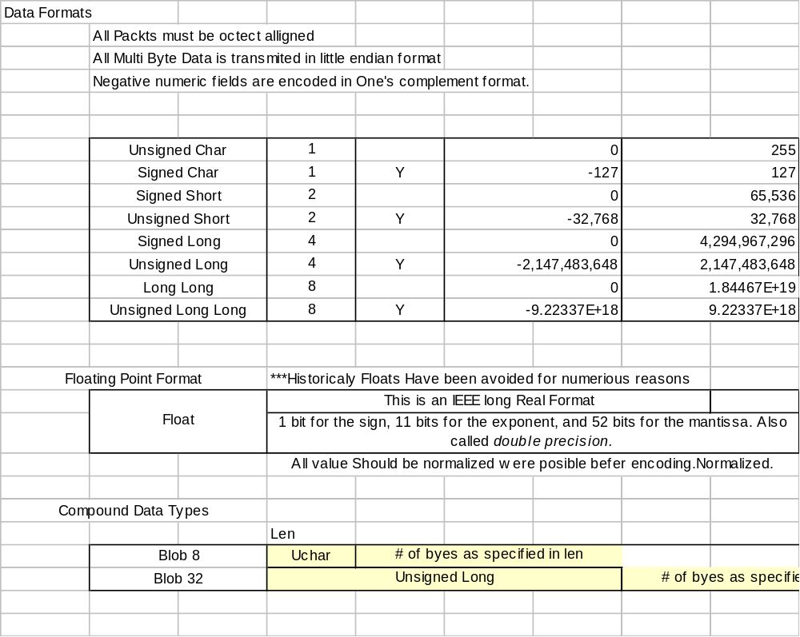

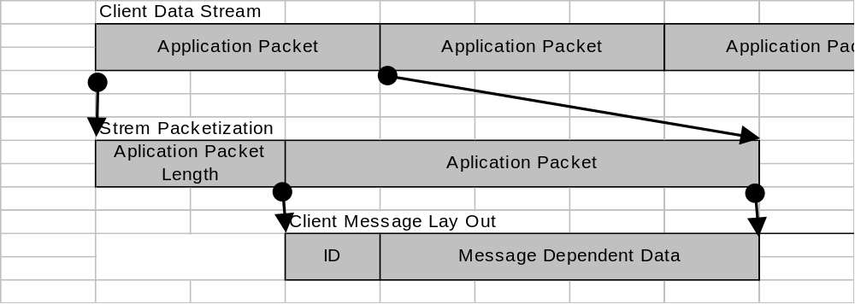

 | Client Messages
1 | CLIENT_LOGIN
2 | CLIENT_LOGIN_RESP
4 | CLIENT_GO_GET_LOST_RESP
3 | CLIENT_GET_AVATARS
5 | CLIENT_GET_AVATAR_RESP
6 | CLIENT_CREATE_AVATAR
7 | CLIENT_CREATE_AVATAR_RESP
8 | CLIENT_GET_SHARD_LIST
9 | CLIENT_GET_SHARD_LIST_RESP
10 | CLIENT_GET_FRIEND_LIST
11 | CLIENT_GET_FRIEND_LIST_RESP
12 | CLIENT_GET_FRIEND_DEATILS
13 | CLEINT_GET_FRIEND_DETAILS_RESP
14 | CLIENT_GET_AVATAR_DETAILS
15 | CLIENT_GET_AVATAR_DETAILS_RESP
16 | CLIENT_LOGIN_2
17 | CLIENT_LOGIN_2_RESP
24 | CLIENT_OBJECT_UPDATE_FIELD
24 | CLIENT_OBJECT_UPDATE_FIELD_RESP
25 | CLIENT_OBJECT_DISABLE_RESP
27 | CLIENT_OBJECT_DELETE_RESP
29 | CLIENT_SET_ZONE
31 | CLIENT_SET_SHARD
32 | CLIENT_SET_AVATAR
34 | CLIENT_CREATE_OBJECT_REQUIRED_RESP
35 | CLIENT_CREATE_OBJECT_REQUIRED_OTHER_RESP
37 | CLIENT_LOGOUT
45 | CLIENT_CHANGE_IP_ADDRESS_RESP
46 | CLIENT_GET_STATE
47 | CLIENT_GET_STATE_RESP
48 | CLIENT_DONE_SET_ZONE_RESP
49 | CLIENT_DELETE_AVATAR
51 | CLIENT_FAST_CONNECT_ACCOUNT
52 | CLIENT_HEART_BEAT
53 | CLIENT_FRIEND_ONLINE
54 | CLIENT_FRIEND_OFFLINE
56 | CLIENT_REMOVE_FRIEND
57 | CLIENT_SERVER_UP
58 | CLIENT_SERVER_DOWN
62 | CLIENT_PROCESS_FRIEND_TOKEN
63 | CLIENT_PROCESS_FRIEND_TOKEN_RESP
65 | CLIENT_CHANGE_PASSWD
67 | CLIENT_SET_NAME_PATTERN
68 | CLIENT_SET_NAME_PATTERN_ANSWER
70 | CLIENT_SET_WISHNAME
71 | CLIENT_SET_WISHNAME_RESP
72 | CLIENT_SET_WISHNAME_CLEAR
73 | CLIENT_SET_SECURITY

