Firefly Flightplan
Name | Email | Phone | Date
Tomás Opazo  Gregor Müller | tzo4@psu.edu  gregor.mueller94@gmail.com | +1 814 777 1882  + 49 174 2986445

Remote Control and Flight Modes mapping
channel | Mode | Active when
6 | Offboard | switch F is towards pilot
7 | Kill switch | switch B is towards pilot
8 | Default ctrlalloc | switch D is towards pilot
5 | Stabilized | switch C is away from pilot
5 | Position control | switch C is centered
5 | Mission | switch C is towards pilot

Checklist of the day before the flight
- Charge ESC batteries and annotate its capacity
- Charge Pixhawk batteries and annotate its capacity
- Charge RC battery and annotate its capacity
- Charge router battery and annotate its capacity
- Charge grass cutter battery
- Charge powerbank for Raspberry Pi
- Check that we physically have the full list of materials
- Check general condition of the Drone (cables, landing gear, etc)
- Check if router has power and network is working
- Check power supply of Raspberry Pi
- Check if Raspberry Pi has connection to Pixhawk and network
- Calibrate all sensors -> preflight?
- Check that we can arm the vehicle
- Check spin direction of motors
- Check that log files are being saved

Spin direction of motors
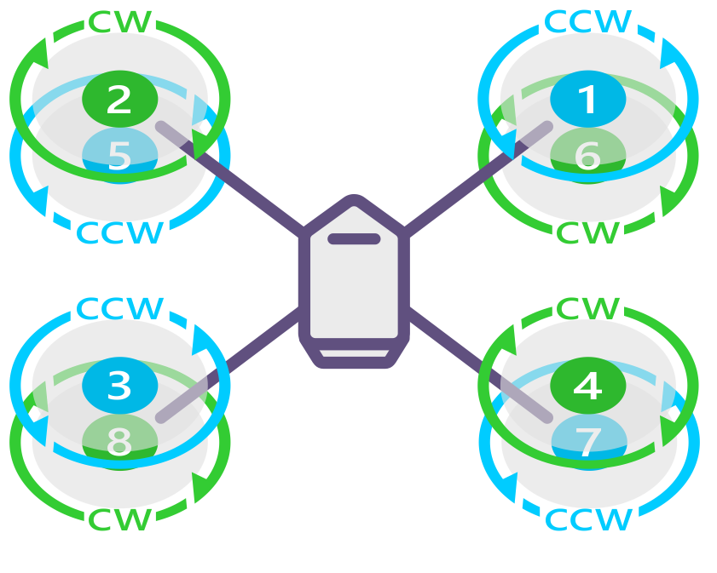

Taken from https://dev.px4.io/v1.9.0/en/middleware/modules_command.html
mc_att_control stop # if you don't do this, only rotor 1 will spin
fw_att_control stop # if you don't do this, only rotor 1 will spin
motor_ramp sine 1100 0.5 # Needed first on Pixhawk 4 (Nov 2019)
pwm arm # arming the system
pwm test -c 1 -p 1200 # -c channel (1 to 8) -p throttle
c # to stop the test

List of materials to bring to the flight site
- Firefly drone
  - Airframe
  - Actuators = ESC + Motors + Blades
  - OBC = Pixhawk + GPS + RC radio + Telemetry radio
  - Connectors and voltage regulators to power up OBC
  - Ribbons to hold ESC batteries and blades in place (4 units)
- Batteries
  - ESC batteries (4 units)
  - Pixhawk Batteries (2 units)
  - RC batteries (2 units)
  - Router batteries (2 units)
  - Powerbank for Raspberry Pi (not available in the lab, but you can use any powerbank)
- Notebook with the following software and files
  - qGroundControl
  - File “flight_xxx.params“
  - File “flight_xxx.plan”
  - File “flight_xxx.fence “
- Ground Station
  - Micro USB cable + Telemetry Radio
- Remote Control
  - Futaba SN 13230504 (fully charged and configured to communicate with the Drone)
- Router
- Toolbox
  - Bubble level
  - Voltmeter
  - Battery checker
  - Compatible Torque Wrench = KDE-TW5030
  - Hexagonal key = 2.5 x 60 for blades (2 pieces if available) + 3.0 x 60 for motors
  - Screwdriver for GPS screws
  - Tapes = Blue Tape + Insulating Tape + Double contact + Aluminum tape
  - Marking pen
  - Wire stripper
  - Screwdrivers (Phillips and flathead)
  - Scissors
  - Pliers
- Spare parts
  - Propellers KDE-CF245-DP
  - Zip ties
- Grass cutter
- Fire extinguisher

Checklist before the actual flight
- Connect Router to battery
- Open notebook and qGroundControl
- Check if WiFi network “linksys” is available
- Connect the 3DR radio to the Notebook using the USB cable
- Connect RaspberryPi to Powerbank
- Plug Pixhawk batteries
- Wait for qGroundControl to connect to the Pixhawk and load info
- Connect to RapsberryPi via SSH:
  - Username: avia1
  - Password: ros4avia
  - In PC terminal use: ssh avia1@10.42.0.104 and type in password
- Mount and fix ESC batteries (DO NOT PLUG THEM BEFORE ALL PRE-FLIGHT CHECKS ARE DONE)
- Because the Firefly is heavy and big, two people should help to calibrate all sensors with a ROTATION_NONE configuration
  - Gyroscope
  - Accelerometer
  - Compass
  - Level Horizon
  - Reboot after calibration

- (If firmware has changed) Load to the pixhawk the “Flight_xxx.params” file and check
  - Multicopter Attitude Control
    - MC_ROLL_P, MC_PITCH_P, MC_YAW_P
    - MC_ ROLLRATE_P, MC_ PITCHRATE_P, MC_ YAWRATE_P
    - MC_ROLLRATE_I, MC_PITCHRATE_I, MC_YAWRATE_I
    - MC_ROLLRATE_D, MC_PITCHRATE_D, MC_YAWRATE_D
  - Multicopter Position Control
    - MPC_LAND_SPEED
    - MPC_TKO_SPEED
    - MPC_XY_CRUISE
    - MPC_XY_VEL_MAX
    - MPC_Z_VEL_MAX
    - MPC_XY_ P
    - MPC_XY_VEL_P, MPC_XY_VEL_I, MPC_XY_VEL_D
    - MPC_Z_ P
    - MPC_Z_VEL_P, MPC_Z_VEL_I, MPC_Z_VEL_D
- (If using “mission mode”) Load “Flight_xxx.mission” file and check
- (If using “mission mode”) Load “Flight_xxx.fence” file and check
- Check RC connection to the Pixhawk and make sure that switches are detected
- Engage Kill-switch
- Select “Manual” mode and arm Pixhawk (troubleshoot any problem)
- Disarm Pixhawk
- Double check that ESC batteries are disconnected
- Move vehicle to starting position
- (If not already done) Mount blades
- Perform a radio-range check for the RC radio and the Telemetry radio
- Connect all ESC batteries and check that motors are armed (4 beeps plus 1 long beep)
- Make sure custom control allocation is activated (Channel 8, Switch D)
- Double check blade numbers and spinning direction of motors
- Start data logger on RaspberryPi. (run command: python3 ./data_logger/run_logger.py)
- Check that all connections are working (SUCCESS has to be printed in the terminal 3x)
- Check for air traffic, humans, animals, birds, snakes, bears, etc.
- Disengage Kill-switch -> check order of these items
- Fly

Telemetry Setup

- Connect router to battery

