Requirements list for the Web-Application
“Contact-Book-New”

Initial requirements from the 22nd of October 2018:

What we need: the Contact book application must have a form for inserting contacts as well as a list of the numbers from the contact book and the option to change the contact details. Filter for the contacts also must be included as well as login authentication.

Requirements: Website must be fully responsive (you are allowed to use 100% free theme elements if they are without any copyrighted restrictions and of course you must implement them in combination with your styles - only using a prepared theme without your styles is not allowed).

Only authenticated users are able to work in the Contact application, for non authenticated users access is restricted. Authenticated user is able to add, edit and delete contacts. Every contact must have fields: First name, Last name, Phone number, Email, Type (Student, Lunch-speaker, Company). Authenticated user must be able to filter contacts by name and type.

Inspiration for the design:
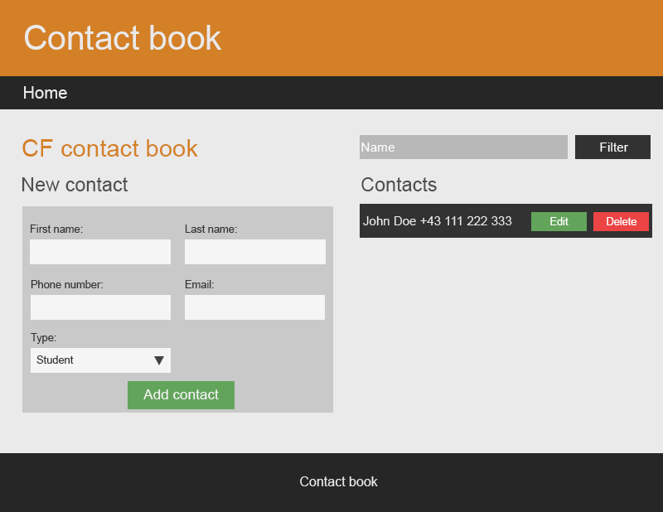
Update from the 22nd of October 2018

The initial requirements were soon to be updated after the first project proposal. Subsequently are following the changes from the 22nd of October 2018 made from the original design. The project team will ONLY guarantee that the requirements with priority equal high will be solved till the end of the project. The other priorities are optional and can be done by the project team but won’t be obligatory.

Login interface [id=1, priority = high]:
- This describes a function where the user can open the app but before anything will work in there a login screen has to be mastered (mastering → enter valid credentials). When this is done, the user will see the “contact” page of the application

Contact referer [id=2, priority = low]:
- The client will have an option to click on the contact details (email and phone) so an app opens which will take the associated action with it (email→ send email with Outlook; phone→make a call with Skype).

Contact fields and design changes [id=3, priority = high]:
- The programming team will implement
  - First name
  - Last name
  - Phone number
  - Email
  - Type
  - Comment
for the form. The design though will look more or less the same as in the picture above except that the “create new contact” form will be only shown if you click on a button. So the final design will only show one table with the saved contacts (if needed the user can show or hide the new contacts form)

Filtering abilities for the “contact-list” [id=4, priority = high]:
- The filter will be able to filter through all the fields mentioned in [id=3], though it wont have the “AND” functionality as described in [id=9]. This means that the user can make a search for every field alone but not combine the search with another field (you can search for First Name OR Last Name but not both together.

Upload pictures function [id=5, priority = medium]:
- The user can choose to upload a picture for each and one contact. If done so the picture will appear somewhere in the contact-list (either when you click on the contact or as extremely small thumbnail in the contact-list)

Subtype for type = Student [id=6, priority = low]:
- In the “add contact” form we will have the option to choose, if “Student” is selected, from a sub category which will show the courses the student visited. This sub category is somehow configurable by the admin user. He/she can add but NOT remove options (this means that you can insert a new option, which will be saved and also presented next time you load the page as an option, but you cannot delete from the frontend an option you once put)
- The customer offered a way of an easy solution to solve this issue. It would be fine if we use the “Comment” field for this sub-category. This way you would of course have the problem with wrong written categories and that filtering will be harder the more data is in the database! But editing or deleting a wrong sub-category would be possible

User management [id=7, priority = medium]:
- If this is implemented the admin-user can easily add new users and assign them roles (admin role and user role). These roles decide then what the user can do in the database.
- Role admin allows to read and write the database
- Role user allows to only read the database

Responsive Design [id=8, priority = high]:
- The project team will make two designs. One is for mobile devices like the Samsung Galaxy S5. The other one will be responsive for large Screens up to 1200px

Filtering abilities for the “contact-list” advanced [id=9, priority = medium]:
- This filter adds up with the filter from [id=4], which means that you now are able to search with the “Type” filter option activated AND the filter for the fields from [id=4]. For example you could choose that you are filtering all the students and in there you are searching for a name.

How to use the requirements:
You will find on Trello a project which will be used be the project team (https://trello.com/b/lopEMEfj/fswd50-project02-contactbook). The tickets there carry the ids which are mentioned in this document. The description of the tickets is the same as you see in this document.

The project team will also show the initial mockups to the customer. These will be used as working base and the design will be more or less follow the mockup.

Vienna 23rd of October 2018 Project Team represented by Marco Häfner

Customer: CodeFactory represented by Goran Stević

