User Manual Contact Book New

Table of Contents
User Manual Contact Book New 1
Introduction 2
Phone Book New 2
Login 2
Logout 2
Insert a new contact 3
Editing existing contacts 4
Delete 6
Firebase 7
Project interface 7
Firebase Storage 9
User Authentication 10

Introduction

The Contact Book application allows users a simple interface to store all the contacts information on a Firebase Database from a mobile or desktop device. This document will provide instructions for using the application.

Phone Book New

Login


Tap the URL in your browser and the login screen will be brought up. Enter your e-Mail and Password, press the Login button and the contacts will be displayed.

Logout

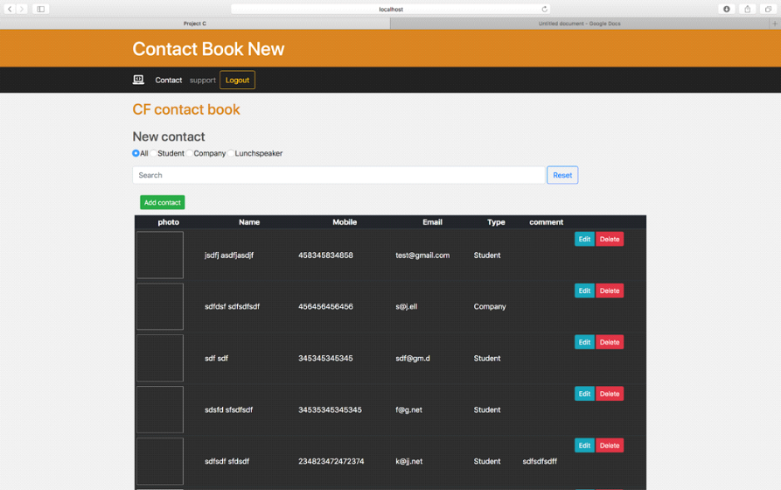
Press the logout button in order to leave the application so the contact book will not be displayed anymore.

Insert a new contact

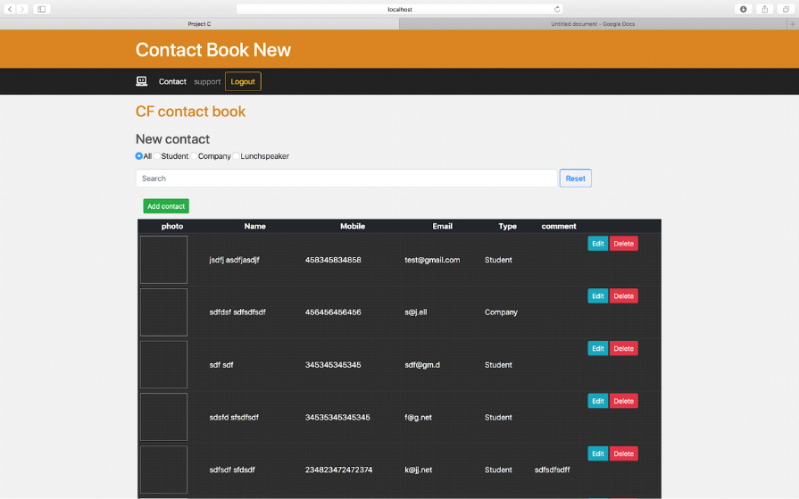

In order to create a new contact please press the Add Contact button which will automatically open a form window.

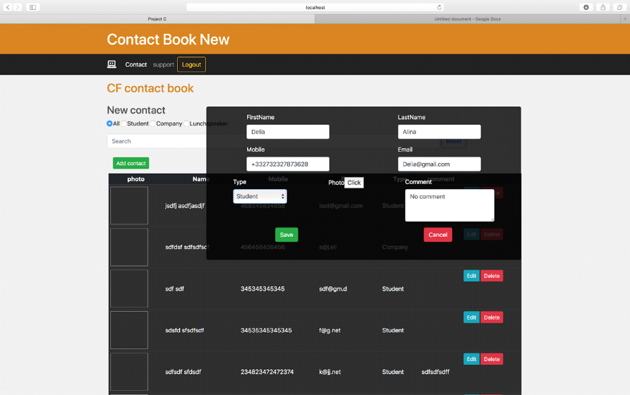

Fill in all the fields before save it so you will not any errors. In case you have an error the contact will not be saved.

In order to avoid any errors please take the following into consideration:
- Mobile tab accept as an input only numbers.
- Email should have the following format name@domain.com .
- Type input includes 3 categories and you should choose only one.
- The Comment and Photo field are not mandatory in order to save so if you consider it unnecessary you can skip it.

After you successfully save the contact all the information will be stored in the database and also printed on the screen.

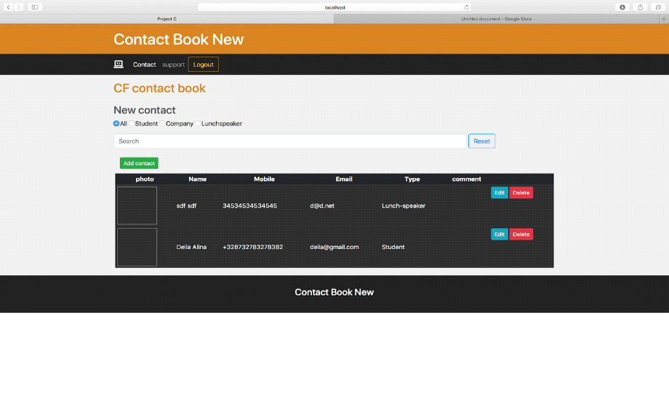
Now your contact is save so we can go to the next step.

Editing existing contacts

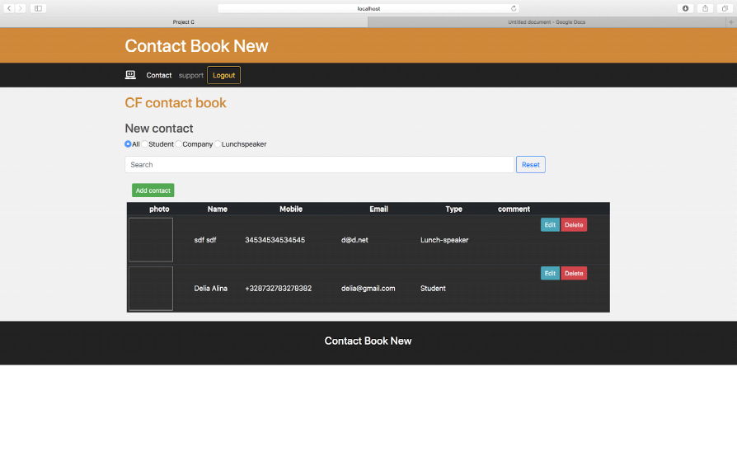
In order to edit an old contact press the Edit button and the form will show up again.
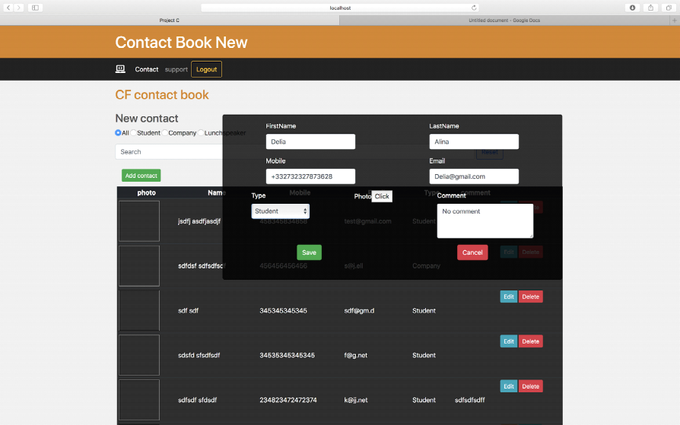

Now you can edit any field and click save. After the saving process only the updated contact will be displayed.

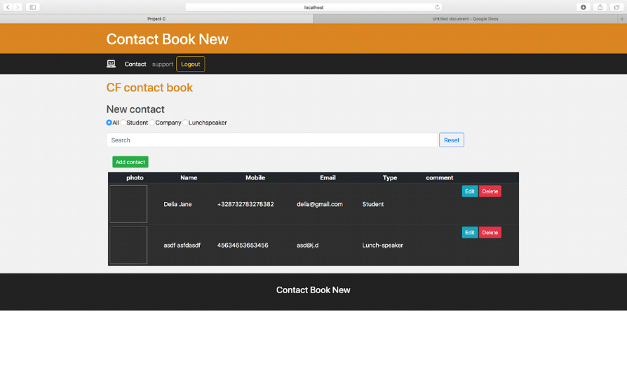

You can see on image from above that the name was changed from Delia Alina to Delia Jane. Be very careful with that you really want to save the change because you will overwrite the old contact.

Delete

In order to delete a contact from the list and also from the database just press the Delete button.

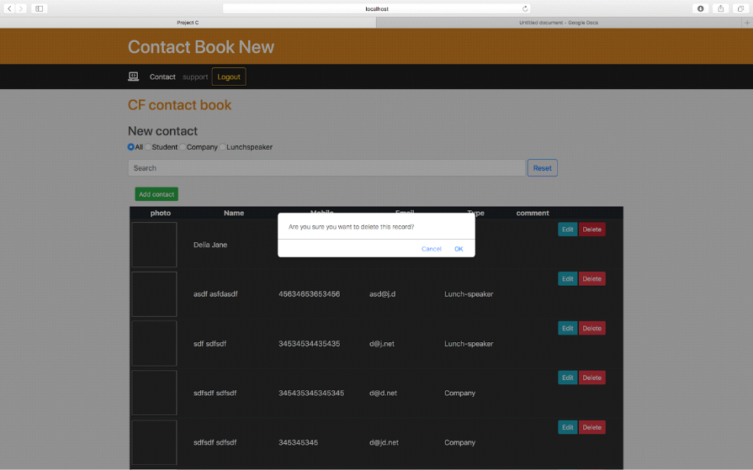

For security reasons after you press the delete the application will check with you again if you are sure you want to remove the contact. In this way you can be sure that

Please take into consideration that everything you delete you will not be able to restore it. Use the delete function only when you are sure that you do not need the information anymore.

In case you want to clear the database use the Delete all button. This will remove all your entries.

Firebase

Project interface
Firebase is a backend platform for building Web, Android and IOS applications. It offers real time database, different APIs, multiple authentication types and hosting platform. This is an introductory tutorial, which covers the basics of the Firebase platform and explains how to deal with its various components and sub-components.
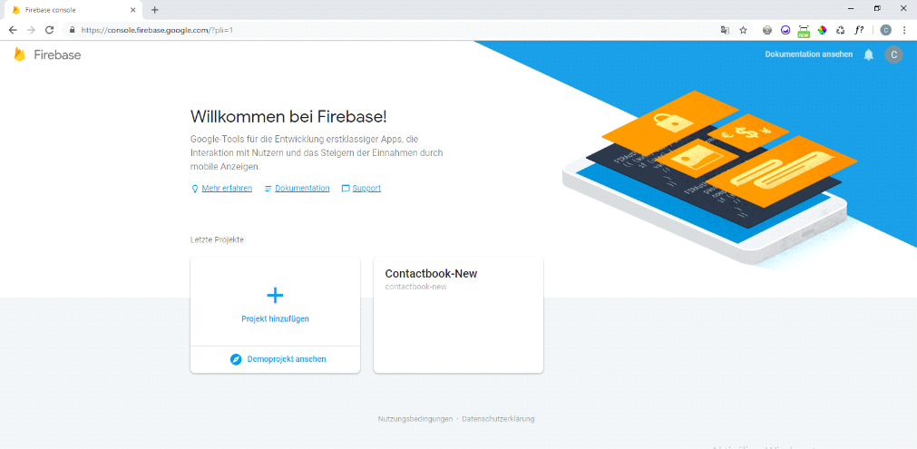

Real-time Database − Firebase supports JSON data and all users connected to it receive live updates after every change.Authentication − We can use anonymous, password or different social authentications.Hosting − The applications can be deployed over secured connection to Firebase servers
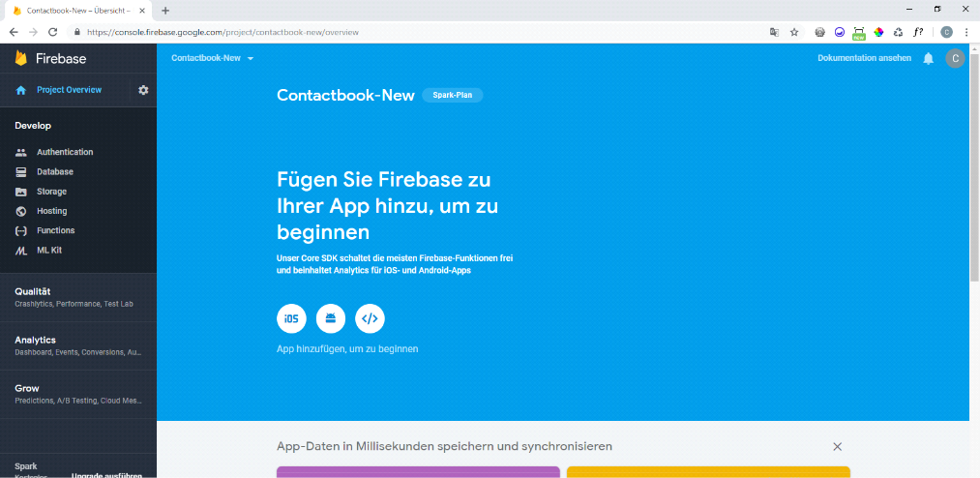
You can have multiple projects hosted within one Firebase, here you can choose from them.
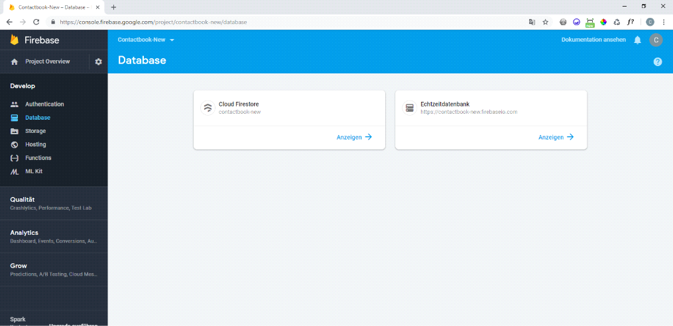

The Firebase data is representing JSON objects. If you open your app from Firebase dashboard, you can add data manually by clicking on the + sign.But since it's connected to our webpage, not recommended to add data here.
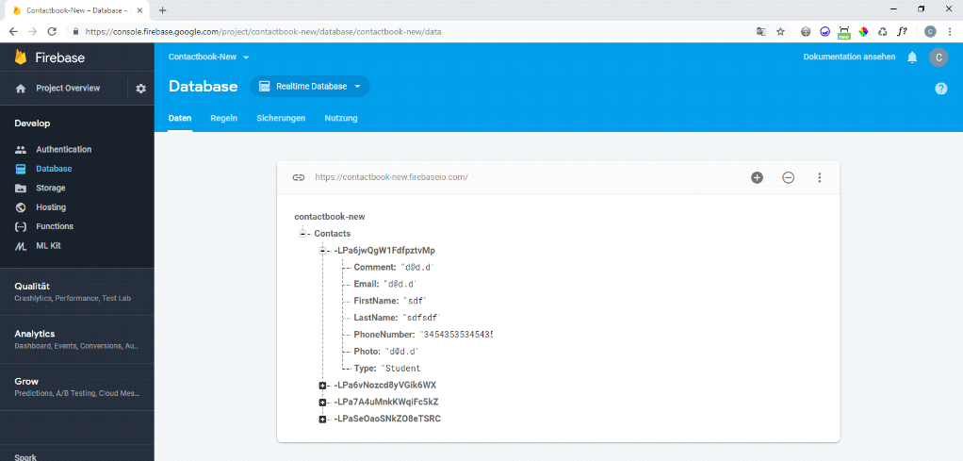
Following Cloud Firestore's NoSQL data model, you store data in documents that contain fields mapping to values. These documents are stored in collections, which are containers for your documents that you can use to organize your data and build queries.

Firebase Storage
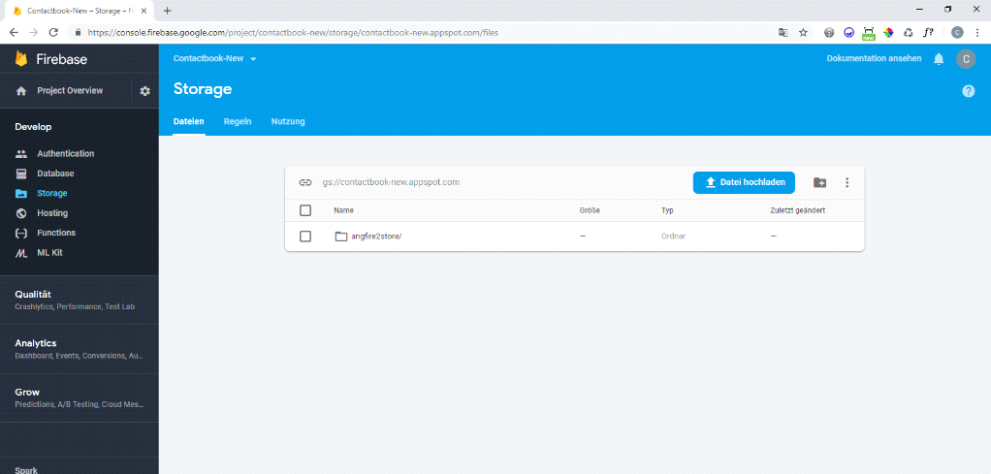
Inside the sotorage you can see your stored files, in our case the images.
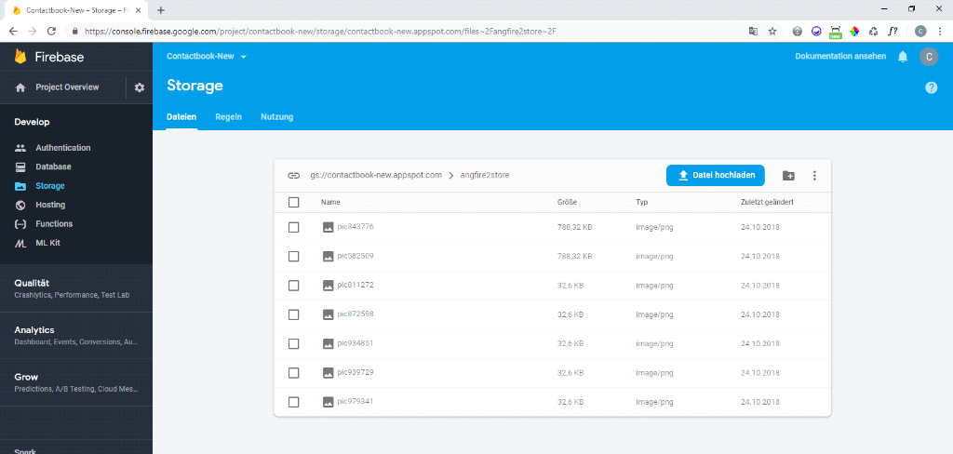
The details of the images.(size, title, url...)
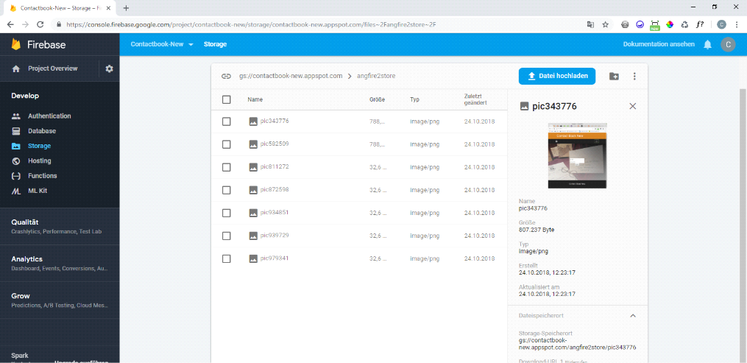

User Authentication
Firebase Authentication provides backend services, easy-to-use SDKs, and ready-made UI libraries to authenticate users to your app. It supports authentication using passwords, phone numbers, popular federated identity providers like Google, Facebook and Twitter, and more.
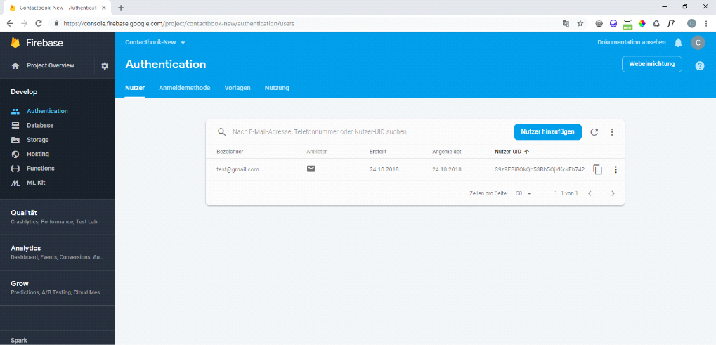
Authenticate users with their email addresses and passwords. The Firebase Authentication SDK provides methods to create and manage users that use their email addresses and passwords to sign in. Firebase Authentication also handles sending password reset emails.


