Reliability and Safety Analysis

Year: 2018 Semester: Spring Team: 16 Project: Track-on-Track

Creation Date: March 28, 2018 Last Modified: March 28, 2015

Member 1: Nick Geirland Email: ngeirlan@purdue.edu

Member 2: Nathan McNally Email: nmcnall@purdue.edu

Member 3: Yunsheng Li Email: li1436@purdue.edu

Member 4: Aaron Kaiser Email: kaiser20@purdue.edu

Assignment Evaluation:

|  |  |  |  |  |
| --- | --- | --- | --- | --- |
| **Item** | **Score (0-5)** | **Weight** | **Points** | **Notes** |
| **Assignment-Specific Items** | | | | |
| **Reliability Analysis** |  | x2 |  |  |
| **MTTF Tables** |  | x3 |  |  |
| **FMECA Analysis** |  | x2 |  |  |
| **Schematic of Functional Blocks (Appendix A)** |  | x2 |  |  |
| **FMECA Worksheet (Appendix B)** |  | x3 |  |  |
| **Writing-Specific Items** | | | | |
| **Spelling and Grammar** |  | x2 |  |  |
| **Formatting and Citations** |  | x1 |  |  |
| **Figures and Graphs** |  | x2 |  |  |
| **Technical Writing Style** |  | x3 |  |  |
| **Total Score** |  | | |  |

5: Excellent 4: Good 3: Acceptable 2: Poor 1: Very Poor 0: Not attempted

Comments:

1. Reliability Analysis

Our projects microcontroller, voltage regulator, and bluetooth module were chosen for the reliability analysis. The micro controls the entire system and has a high complexity so it’s failure will have a great impact on the device. The voltage regulator was chosen because of its function to deliver the proper voltage to the entire system. If it were to fail, other components may receive incorrect voltage levels, resulting in digital logic miscalculations or component failures. The bluetooth module was also chosen because of its complexity and critical role of being the communicator between the device and the mobile application.

The model to estimate the failure rate per million hours for was taken from the MIL-HDBK-217F handbook[4]:

λP= (C1𝜋T + C2𝜋E)𝜋Q𝜋L

The mean time to failure for one component is calculated by:

MTTF = 106 / (24 * 365 * λP) years

Some of the values, such as C1 for the bluetooth module, were estimated because the number of gates for the module were not listed on the datasheet.

Table 1. MSP430FR6989 - Microcontroller[2]

|  |  |  |  |
| --- | --- | --- | --- |
| **Parameter Name** | **Description** | **Value** | **Comments** |
| C1 | Die Complexity Failure Rate | .28 | Failure rate for 16-bit microcontroller given by MIL-HDBK-217F |
| 𝜋T | Temperature Factor | .98 | From MIL-HDBK-217F, with a temperature of 85°C, the maximum recommended operating temperature. |
| C2 | Package Failure Rate | .052 | 100 pin microcontroller that is non-hermetic |
| 𝜋E | Environment Factor | .5 | GB |
| 𝜋Q | Quality Factor | 10 | Commercial Component |
| 𝜋L | Learning Factor | 1 | Product is designed for more than 2 years in production |
| λP | Failure Rate Per Million Hours | 3.004 |  |
| MTTF | Mean Time To Failure | 332889.4807 | Approx. 38 years to failure |

Table 2. REG710NA - 2.5 Voltage Regulator [1]

|  |  |  |  |
| --- | --- | --- | --- |
| **Parameter Name** | **Description** | **Value** | **Comments** |
| C1 | Die Complexity Failure Rate | .010 | Estimated 1 to 100 transistors used, value obtained from MIL-HDBK-217F page 5-3 |
| 𝜋T | Temperature Factor | 5.6 | TJ = 150C |
| C2 | Package Failure Rate | .0019 | 6 pins |
| 𝜋E | Environment Factor | 4.0 | GM for mobile devices |
| 𝜋Q | Quality Factor | 10 | Commercial Component |
| 𝜋L | Learning Factor | 1.0 | > 2 years in production |
| λP | Failure Rate Per Million Hours | 0.636 |  |
| MTTF | Mean Time To Failure | 1,572,327.044 | Approximately 179 years to failure |

Table 3. RN4020 - Bluetooth Module[3]

|  |  |  |  |
| --- | --- | --- | --- |
| **Parameter Name** | **Description** | **Value** | **Comments** |
| C1 | Die Complexity Failure Rate | .08 | Estimated number of gates to be 30,000 to 60,000 to safely estimate the highest failure rate per million hours |
| 𝜋T | Temperature Factor | .98 | From MIL-HDBK-217F, with a temperature of 85°C, the maximum recommended operating temperature. |
| C2 | Package Failure Rate | .0079 | 22 functional pins |
| 𝜋E | Environment Factor | 4.0 | GM for mobile devices |
| 𝜋Q | Quality Factor | 10 | Commercial Component |
| 𝜋L | Learning Factor | 1 | Product is designed for more than 2 years in production |
| λP | Failure Rate Per Million Hours | 0.8235 |  |
| MTTF | Mean Time To Failure | 1,214,329.083 | Approximately 138 years to failure |

With these estimates, the reliability of our product is proven to be acceptable. With the exception of the microcontroller, these estimates point to well over one hundred years before a failure. One way to increase the reliability of the micro would be to find a slightly more simplistic design that still meets the needs of our product.

1. Failure Mode, Effects, and Criticality Analysis (FMECA)

There are three criticality levels for this project, which are low, medium and high. High refers to failures that can cause injuries to users such as burning or battery exploding. Medium refers to failures that makes the device inoperable such as battery not being charged and being unable to communicate with users’ cell phone. Low means that some inconvenience for users is introduced such as the LCD screen fails, the pushbutton fails and bluetooth or cell modem modules fail. The failure rate required for high criticality level is at most 10e-9 per unit*hour and the failure rate required for medium and low criticality is at most 10e-6 per unit*hour. We assume the device is not opened or modified by user.

3.0 Sources Cited:

1. Ti.com. (2018). [online] Available at: http://www.ti.com/lit/ds/symlink/reg71050.pdf [Accessed 28 Mar. 2018].
2. Ti.com. (2018). MSP430FR6989 16 MHz ULP Microcontroller. [online] Available at: http://www.ti.com/lit/ds/symlink/msp430fr6989.pdf [Accessed 30 Mar. 2018].
3. ww1.microchip.com. (2018). RN4020 Bluetooth Low Energy Module. [online] Available at: http://ww1.microchip.com/downloads/en/DeviceDoc/50002279B.pdf [Accessed 30 Mar. 2018].
4. Engineering.purdue.edu. (1990). Military Handbook Reliability Prediction of Electronic Equipment. [online] Available at: https://engineering.purdue.edu/ece477/Course/Assignments/Reference/Mil_Hdbk_217F.pdf [Accessed 30 Mar. 2018].

Appendix A: Schematic Functional Blocks

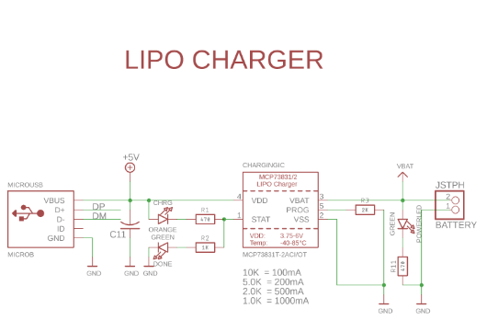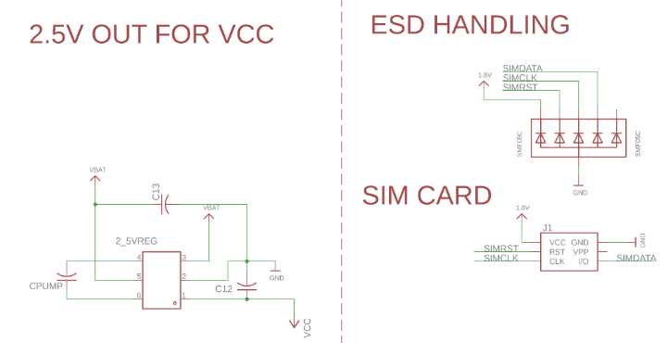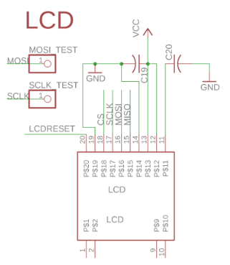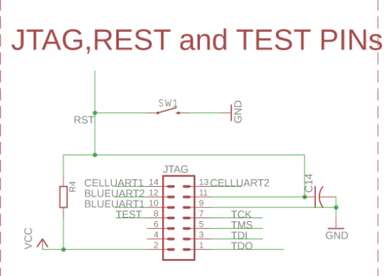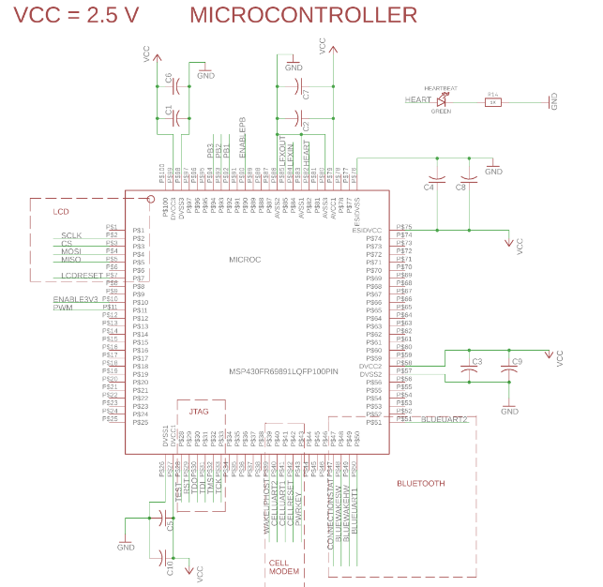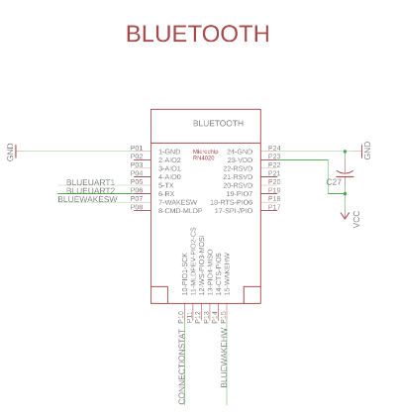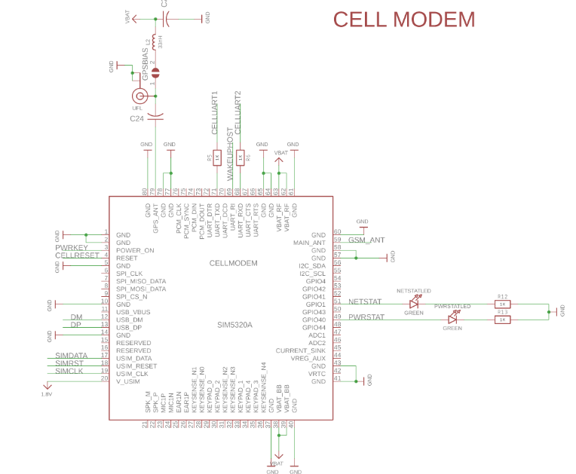

Appendix B: FMECA Worksheet

**Table 3. lithium-ion polymer Battery Charging Circuit FMECA**

|  |  |  |  |  |  |  |
| --- | --- | --- | --- | --- | --- | --- |
| **Failure No.** | **Failure Mode** | **Possible Causes** | **Failure Effects** | **Method of Detection** | **Criticality** | **Remarks** |
| 1 | Vdd connected to both 5V and ground | C11 fails short | Power trace can be burned | Add a PTC fuse in series | Medium | The device cannot be charged |
| 2 | Battery is not charged | Vdd = 0, charging IC damaged | Battery cannot be charged | Observation, device stops to run | Medium |  |
| 3 | Battery catch on fire or explode | Charging IC fails and gives too much current, battery punctured | User might be hurt | Observation | High | Make the device package sturdy |

**Table 4. 3.7V to 2.5V Buck Regulator FMECA**

|  |  |  |  |  |  |  |
| --- | --- | --- | --- | --- | --- | --- |
| **Failure No.** | **Failure Mode** | **Possible Causes** | **Failure Effects** | **Method of Detection** | **Criticality** | **Remarks** |
| 4 | Vcc = 0 | Vbat = 0, C12 fails short | System loses power | Observation, device doesn’t work at all | Medium |  |
| 5 | Vcc = 3.7 V | Regulator fails | Microcontroller is fed with more voltage than designed which might overheat other modules | Observation | Low | The microcontroller can run with 3.7 V |

**Table 5. LCD Subsystem FMECA**

|  |  |  |  |  |  |  |
| --- | --- | --- | --- | --- | --- | --- |
| **Failure No.** | **Failure Mode** | **Possible Causes** | **Failure Effects** | **Method of Detection** | **Criticality** | **Remarks** |
| 6 | LCD doesn’t work | C19 fails short, LCD fails, LCD reset pin stuck low(active low) | User cannot interact with the device or read information from the device | Observation, LCD shows nothing or doesn’t make sense | Low | Can still help find device and maintain most of functions |

**Table 6. Microcontroller FMECA**

|  |  |  |  |  |  |  |
| --- | --- | --- | --- | --- | --- | --- |
| **Failure No.** | **Failure Mode** | **Possible Causes** | **Failure Effects** | **Method of Detection** | **Criticality** | **Remarks** |
| 7 | Vcc = 0 | Regulator circuit fails, any of the decoupling capacitor fails short | Microcontroller is off and system is inoperable | Observation, system doesn’t work | Medium |  |

**Table 7. Bluetooth module FMECA**

|  |  |  |  |  |  |  |
| --- | --- | --- | --- | --- | --- | --- |
| **Failure No.** | **Failure Mode** | **Possible Causes** | **Failure Effects** | **Method of Detection** | **Criticality** | **Remarks** |
| 8 | Vcc = 0 | Regulator circuit fails, C27 fails short | Bluetooth module inoperable | Observation or from software, the connection status signal is fed into a microcontroller GPI/O pin | Low |  |
| 9 | Wakeup signal is stuck low | Microcontroller GPI/O pin fails | Bluetooth module doesn’t turn on | Observation, no bluetooth connection | Low |  |

**Table 8. Cell Modem module FMECA**

|  |  |  |  |  |  |  |
| --- | --- | --- | --- | --- | --- | --- |
| **Failure No.** | **Failure Mode** | **Possible Causes** | **Failure Effects** | **Method of Detection** | **Criticality** | **Remarks** |
| 10 | Vbat = 0 | Battery has no charge, decoupling capacitors fail short | Cell modem module inoperable | Observation, status LEDs off | Low |  |
| 11 | No GPS signal | Antenna fails,uFL connector fails | Cell modem cannot get GPS location | Observation,cannot get GPS location | Low |  |
| 12 | Cannot send GSM message | Antenna fails, SMA connector fails | Cell modem cannot communicate with user’s cell phone | Observation, cannot receive text message on cell phone | Low |  |

**Table 9. JTAG and Reset Circuit for microcontroller FMECA**

|  |  |  |  |  |  |  |
| --- | --- | --- | --- | --- | --- | --- |
| **Failure No.** | **Failure Mode** | **Possible Causes** | **Failure Effects** | **Method of Detection** | **Criticality** | **Remarks** |
| 13 | Reset is stuck low | Reset pushbutton damaged | Microcontroller is inoperable | Observation | Medium | Renders system inoperable |
| 14 | No input from JTAG pins | Any of the JTAG pin connection is damaged | Cannot program microcontroller | Observation | Low | User doesn’t need to reprogram the device |