User Manual

Year: 2018 Semester: Spring Team: 16 Project: Track-on-track

Creation Date: 4/11/2018 Last Modified: April 12, 2015

Member 1: Nick Geirland Email: ngeirlan@purdue.edu

Member 2: Nathan McNally Email: nmcnall@purdue.edu

Member 3: Yunsheng Li Email: li1436@purdue.edu

Member 4: Aaron Kaiser Email: kaiser20@purdue.edu

Assignment Evaluation:

|  |  |  |  |  |
| --- | --- | --- | --- | --- |
| **Item** | **Score (0-5)** | **Weight** | **Points** | **Notes** |
| **Assignment-Specific Items** | | | | |
| **Product Description** |  | x1 |  |  |
| **Product Illustration** |  | x2 |  |  |
| **Setup Instructions** |  | x3 |  |  |
| **Usage Instructions** |  | x3 |  |  |
| **Troubleshooting Instructions** |  | x3 |  |  |
| **Writing-Specific Items** | | | | |
| **Spelling and Grammar** |  | x2 |  |  |
| **Formatting and Citations** |  | x1 |  |  |
| **Figures and Graphs** |  | x2 |  |  |
| **Technical Writing Style** |  | x3 |  |  |
| **Total Score** |  | | |  |

5: Excellent 4: Good 3: Acceptable 2: Poor 1: Very Poor 0: Not attempted

Comments:

1. Product Description

Losing a bag or having it stolen can be a troublesome experience for anyone who carries personal belongings or valuables with them. Tracing back your steps to find something is an arduous task, and often times can come up empty. The Track-on-track device was designed to help anyone with a bag or luggage find their item if it was lost or stolen. The device is designed as a box, which can be placed in the bag that the customer wants to know the location of, where it will stay for up to 2 months without charge. It includes buttons which can be used to configure settings, and an LCD screen which can relay information. The device can be contacted at long range via a text message, where it will send back a message with its GPS coordinates, as long as it is receiving signal. It can also use bluetooth at close range to approximate distance to the user. This product also includes an app which makes communicating with the device simple, and even includes a display which shows where the device is on Google Maps.

1. Product Illustrations

**Complete System and Features:**

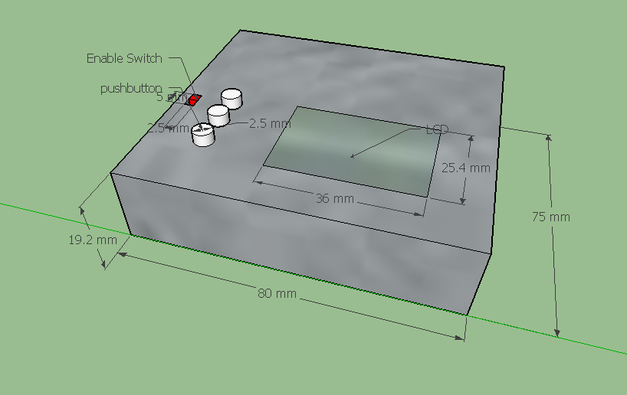

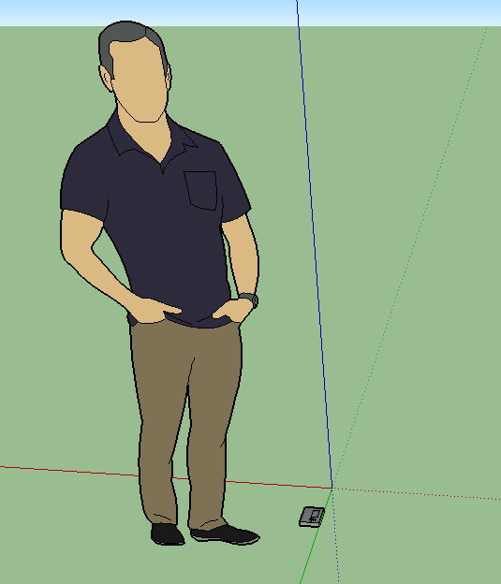

1. Setup Instructions
2. Charge the battery by plugging the MicroUSB cable into the charging port on the side of device.
3. Download the phone app for the device from our apk if you have android.
4. Set the phone number and name for the device in the app’s settings.
5. The app will ask for you to setup a password with the device or if you’re using SMS then text “SetPass:<password>”. If the device hasn’t already been setup then commands shouldn’t require a password yet.
6. Either open the app to test bluetooth connection, location functionality, and the buzzer or text the device to test just the location functionality.
7. Once it is charged, put the device into the item to be tracked.
8. Usage Instructions

For long-range tracking:

1. On android:
   1. Open the app and tap on the middle *track button* () which will requests the device’s location.
   2. Wait for the device to respond with a set of coordinates.
   3. The map will automatically update the device’s marker with the new set of coordinates.
2. On SMS:
   1. Text the device “<password>: LocReq”.
   2. Wait for the device to respond with a set of coordinates.

**For short-range tracking (only available through app):**

1. Open the app and tap on the left *Bluetooth button* () which will take you to the Bluetooth screen.
2. If the device has not yet been paired, tap the pair button to sync a new device.
3. If the device has been paired and is within range, the app and device will automatically pair when the app is open.
4. The signal strength indicator will display the connection strength between the device and the app.
5. As you move further or closer to the device, the signal strength indicator will update.
6. A higher strength signal indicates the device is closer in proximity, while a lower strength signal indicates the device is farther in proximity.
7. The device’s buzzer can also be activated through Bluetooth.
   1. Tapping on the *buzzer button* () will activate the device’s buzzer until the button is released.

**For navigation in the device menu:**

1. Switch the **Enable Switch** to **On** position.
2. Use the **top push button** to go up in the menu
3. Use the **bottom push button** to go down in the menu
4. Use the **middle push button** to make a selection
5. Troubleshooting Instructions

|  |  |
| --- | --- |
| **Problem** | **Potential Solutions** |
| The device’s LCD doesn’t show anything | * The device may need to be charged. See setup instructions * If charging doesn’t solve the problem, please contact Track-on-Track support team at the number below |
| App cannot connect with device via bluetooth | * The device may be out of range for bluetooth connection. Check map in the phone app to confirm the GPS location of device. * If the device is in close range but the problem persists, close the app and try again. * Unpair the Bluetooth connection between the phone app and device, and then attempt to pair them again. * If above steps don’t solve the problem, please contact Track-on-Track support team at the number below |
| The device’s location doesn’t show up in the app | * It could be the battery has died in which case you’ll have to get to the device and recharge * The device may have no or low cell reception. Move the device to a new location and try again. * Wait a few minutes and try again. It could be taking a while for the communications to go through. |
| The device’s location doesn’t update in the app when a new set of coordinates is received | * Verify and update (if necessary) the device’s phone number in the app’s settings to correctly match the device’s phone number |
| The device doesn’t respond with a new set of coordinates when tracking is initiated | * Verify and update (if necessary) the device’s password in the app’s settings to correctly match the device’s password |

We are sorry you are experiencing trouble with your Track-on-Track!

24/7 Customer support: 1-999-999-9876