Electrical Overview

Year: 2018 Semester: Spring Team: 16 Project: Track-on-track

Creation Date: 1/31/2018 Last Modified: November 24, 2015

Member 1: Nick Geirland Email: ngeirlan@purdue.edu

Member 2: Nathan McNally Email: nmcnall@purdue.edu

Member 3: Yunsheng Li Email: li1436@purdue.edu

Member 4: Aaron Kaiser Email: kaiser20@purdue.edu

Assignment Evaluation:

|  |  |  |  |  |
| --- | --- | --- | --- | --- |
| **Item** | **Score (0-5)** | **Weight** | **Points** | **Notes** |
| **Assignment-Specific Items** | | | | |
| **Electrical Overview** |  | x3 |  |  |
| **Electrical Considerations** |  | x3 |  |  |
| **Interface Considerations** |  | x3 |  |  |
| **System Block Diagram** |  | x3 |  |  |
| **Writing-Specific Items** | | | | |
| **Spelling and Grammar** |  | x2 |  |  |
| **Formatting and Citations** |  | x1 |  |  |
| **Figures and Graphs** |  | x2 |  |  |
| **Technical Writing Style** |  | x3 |  |  |
| **Total Score** |  | | |  |

5: Excellent 4: Good 3: Acceptable 2: Poor 1: Very Poor 0: Not attempted

General Comments:

1.0 Electrical Overview

The electrical aspect of the design for Track-on-track will revolve around the transmission of data through a usb transceiver and a cell modem. Transmission between these devices will be controlled by a 16-bit microcontroller. The microcontroller will be responsible for receiving the messages, processing them, and then sending them onward or responding to them directly. The data received from bluetooth will contain commands which must be responded to by the microcontroller. The SMS messages coming in will contain commands to the microcontroller, and in addition, can also contain requests for GPS location. If a request for location is received, the microcontroller will send a request for location to the cell modem, which will return the device’s current location. After decoding this information, the device will send the location to the user’s smartphone via SMS formulated as a set of coordinates, and it will also include battery life information. The microcontroller will also be responsible for displaying information on the LCD while the LCD is active, and for responding to requests given via the physical buttons located on the device..

Because the device is battery powered, all components will have to be powered by a battery, and thus power consumption becomes an important factor of this project. The SMS will have to check for texts at least semi-regularly, but the bluetooth transceiver will spend most of its time sitting asleep until the user sends an SMS message to wake it up, so the power draw from bluetooth will be minimal. The LCD will also have to spend most of its time off to avoid drawing power. The audio speaker connected to the device will also stay deactivated the majority of the time.

2.0 Electrical Considerations

1: Operating Frequencies

115200 baud will be used as the transmission rate for UART communications between the microcontroller and both the bluetooth transceiver and the cell modem. This is done because 115200 baud is the default rate for UART communications, and the design will not require faster transmission speeds.

The microprocessor will be running at a rate of 1 MHz. This speed was chosen because the benchmark for power for the chosen microcontroller, and ensuring that power use is not excessive is critical to the Track-on-track project. In addition, speeds higher than 1 MHz will not be necessary for the microcontroller, as it will be spending the majority of its time waiting for transmissions that will communicate with the microcontroller at the baud rate of 115200 baud, which is much slower than 1 MHz.

2: Power Budget

The microcontroller can run between a recommended voltage of 1.8 and 3.6 V, for the moment 2.5 V will be selected as the operating voltage because it sits well within the recommended range for safe operation. Eventually, the final voltage of the microcontroller may be lowered slightly to 2.2 V or even 2 V, as the lower the voltage is the less power is consumed. It is currently unclear if this will be feasible, however, as lowering the voltage does lower the maximum clock frequency, and it must be ensured that the microcontroller will be able to run at 1 MHz without difficulty. The current draw by the microcontroller will depend on its current operation, but with the current parameters will be between 375 µA and 110 µA.

|  |  |  |
| --- | --- | --- |
|  | Voltage | Current |
| Microcontroller | 2.5 V | 375 µA |
| Bluetooth Transceiver | 3.3 V | 5 µA / 16 mA |
| Cell Modem | 3.3 V | 4.5 mA / 300 mA |
| LCD | 3.3 V | 0 A / 440 µA |
| Buzzer | 3.3 V | 0A / 10 mA |
| **Total** |  | 4.88 mA / 326.8 mA |

3: Tolerances

The microcontroller requires at least 1.8 V to operate, and it should not exceed 3.6 V. The absolute maximum voltage that can be applied to the microcontroller is 4.1 V, but the design should be well within that allotment as the voltage that will be supplied to the microcontroller will be 2.5 V.

For the LCD, no maximum voltage was given by the data sheet, it was simply stated that the recommended voltage was 3.3 V, however a maximum current of 45 mA was stated. This will not be difficult to achieve using a voltage regulated in combination with a resistor to supply power the LCD.

The cell modem requires a minimum voltage of 3.3 V, and has a recommended limit of 3.8 V. The absolute maximum is 4.2 V, but we will be well below this with an operating voltage of 3.3 V.

For the bluetooth transceiver, the supply voltage must be between 1.8 V and 3.6 V. The design will fit comfortably within that range at 3.3 V.

4: Electrical Loading Considerations

Power will be supplied to the device by a 3 cell lithium ion battery. This type of battery was chosen because it is rechargeable and has a high enough charge to power all of the components that have been selected. The battery has a charge limited voltage of 4.20 V, a nominal voltage of 3.70 V, and a discharge cutoff voltage of 2.80 V. Because of the nature of batteries varying in the level of voltage supplied, this design will also require two regulators, one for 2.5 V and another for 3.3 V. These will ensure that all components receive the correct voltage level for operation.

3.0 Interface Considerations

Our two main interfaces are SPI and UART. SPI will be used to control the LCD display since the LCD display only supports SPI and I2C and the microcontroller doesn’t have I2C interface available. UART will be used for both the Bluetooth module and the GSM Cell Modem because UART is easy to use and is sufficient for our needs.

For the SPI, 4 wires are used and 0.5 MHz clock will be provided, although the LCD display’s maximum clock frequency is 1 MHz, because the microcontroller is operating in 1 MHz and 0.5 MHz for LCD display is enough to provide smooth user interaction. It will have a synchronizing bit string leading the data to be transferred according to the datasheet [1] of LCD display.

For the UART, both of the UART interfaces used for cell modem and the Bluetooth will be of 115200 baud rate because this baud rate is the standard UART baud rate and it is fast enough for them to communicate.

4.0 Sources Cited:

[1] Mouser.com. (2017). EA DOGS104-A. [online] Available at: <https://www.mouser.com/ds/2/127/dogs104e-553061.pdf> [Accessed 26 Jan. 2018].

Appendix 1: System Block Diagram

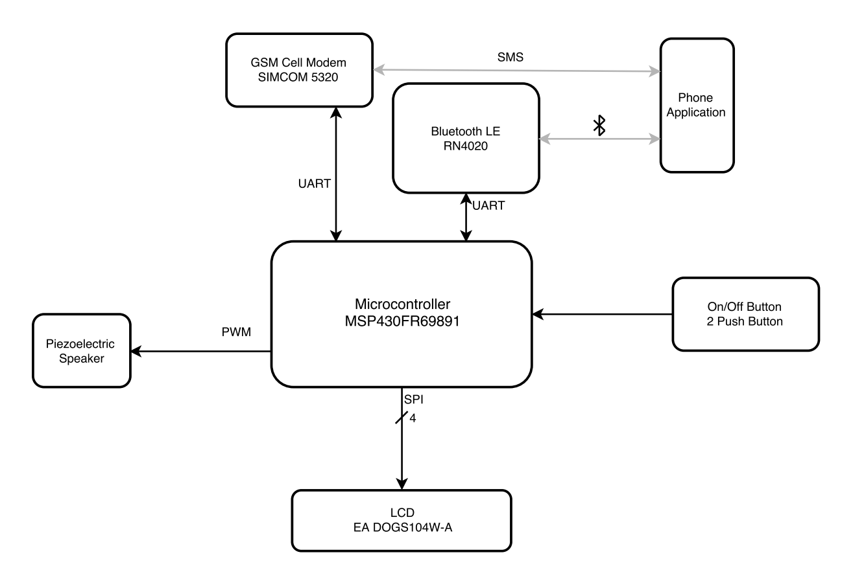

*Figure 1: System Block Diagram*