Mechanical Overview

Year: 2018 Semester: Spring Team: 16 Project: Track-on-track

Creation Date: 2/7/2018 Last Modified: March 3, 2015

Member 1: Nick Geirland Email: ngeirlan@purdue.edu

Member 2: Nathan McNally Email: nmcnall@purdue.edu

Member 3: Yunsheng Li Email: li1436@purdue.edu

Member 4: Aaron Kaiser Email: kaiser20@purdue.edu

Assignment Evaluation:

|  |  |  |  |  |
| --- | --- | --- | --- | --- |
| **Item** | **Score (0-5)** | **Weight** | **Points** | **Notes** |
| **Assignment-Specific Items** | | | | |
| **Commercial Packaging Analysis 1** |  | x2 |  |  |
| **Commercial Packaging Analysis 2** |  | x2 |  |  |
| **CAD Model Illustrations** |  | x4 |  |  |
| **Project Packaging Specifications** |  | x2 |  |  |
| **PCB Footprint Layout** |  | x2 |  |  |
| **Writing-Specific Items** | | | | |
| **Spelling and Grammar** |  | x2 |  |  |
| **Formatting and Citations** |  | x1 |  |  |
| **Figures and Graphs** |  | x2 |  |  |
| **Technical Writing Style** |  | x3 |  |  |
| **Total Score** |  | | |  |

5: Excellent 4: Good 3: Acceptable 2: Poor 1: Very Poor 0: Not attempted

Comments:

*Comments from the grader will be inserted here.*

1. Commercial Product Packaging
   1. Product #1

A commercial product similar to our device is TrackR [1]. It provides the bluetooth function similar to our device and helps find location of device by making sound. The package of TrackR is a small round plastic piece with an LED on it.

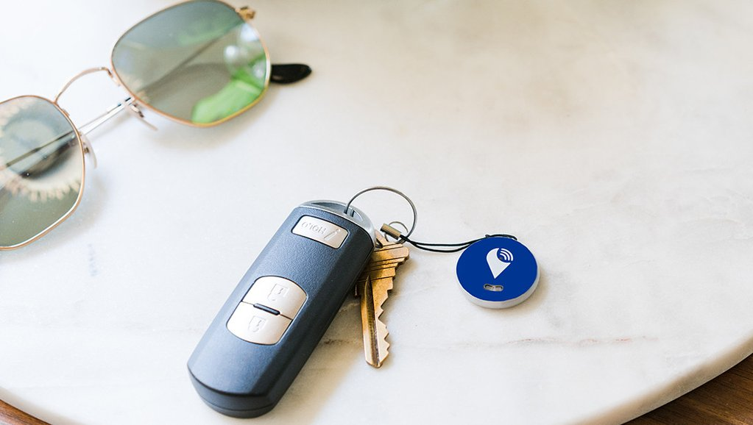

Fig1. Packaging of TrackR Pixel

The advantage of this package is that it is small and can be attached to everything. One of the disadvantages of this packaging is that the size limits the device to only being able to run off of very small batteries. The average battery life is only around 71 days. The small size also makes it so a physical interface would be difficult to implement, and only the smallest LCDs would be able to fit on it.

* 1. Product #2

Another commercial device similar to the long range tracking portion of our device is the TrakDot [2] luggage tracking device. It’s packaging is a small somewhat oblong and almost rectangular shape with rounded edges on two sides.

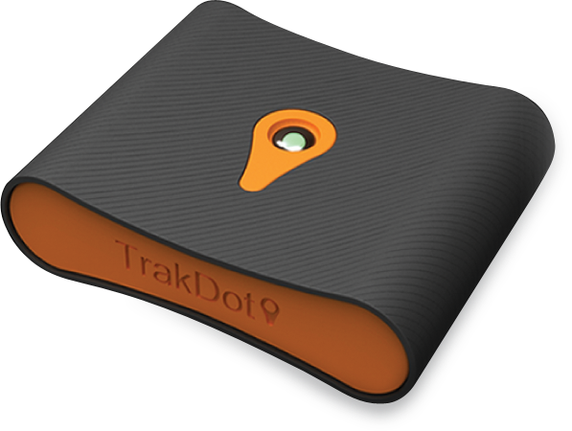

Figure 2: Image of exterior of TrakDot

In comparison to our design, this tracker has a much nicer and elaborate design and even has this odd shape. Our design is more focused on improving the electrical hardware and the software as it’s an ECE course so we’re only having a basic rectangular box. The TrakDot’s design is more appealing to the consumer which is useful for a commercial product. Our design does benefit from being easier to stack alongside other rectangular devices.

The only similarity in packaging between our design and the TrakDot is its general size. Not only are we differing in the general shape, we’re also providing the user a method of interfacing directly on the device with an LCD, buttons, and a switch.

3.0 Sources Cited

[1] “TrackR” TrackR Pixel. [Online]. Available: <https://secure.thetrackr.com/products/online-pixel-5-pack?discount=V0T73FUGUKEB&gclid=CjwKCAiA5OrTBRBlEiwAXXhT6FCdpvCqcSHKGFjmLBNhxNelvw6_d3u4TEA20Z8XtRbbfKiWpqsm3xoCPUYQAvD_BwE> [Accessed: 07-Feb-2018].

**[2]** “Trakdot Luggage Tracker, Flight Baggage Tracer, Anti-lost Palm-size Locator, Airline Trip Worldwide Travel Tracking Monitor Detector Finder, GSM Chip (Cell Towers), SMS Alert, iOS & Android Compatible: Electronics,” *Amazon.com: Trakdot Luggage Tracker, Flight Baggage Tracer, Anti-lost Palm-size Locator, Airline Trip Worldwide Travel Tracking Monitor Detector Finder, GSM Chip (Cell Towers), SMS Alert, iOS & Android Compatible: Electronics*. [Online]. Available: <https://www.amazon.com/dp/B015ZASEG6>. [Accessed: 17-Jan-2018].

Appendix 1: CAD Model Illustrations

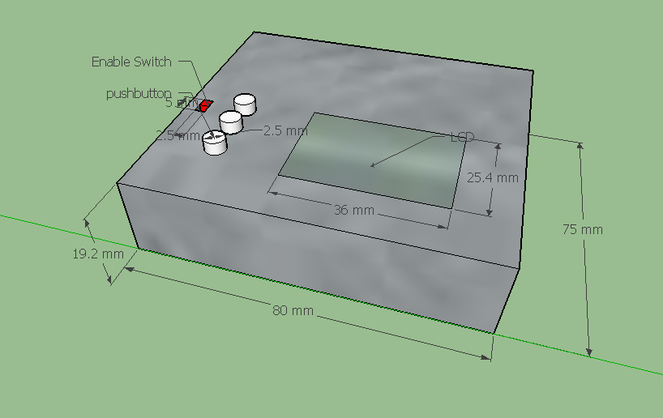

Fig.1. Dimensions of Package

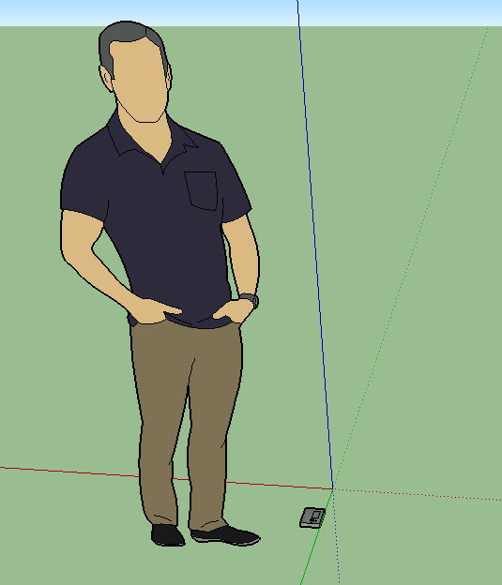

Fig.2. Relative size of device (man for scale)

Appendix 2: Project Packaging Specifications

*Include a table of project packaging specifications here. Include a materials list, tooling requirements, estimated weight, estimated unit cost, and other relevant specifications.*

|  |  |  |  |
| --- | --- | --- | --- |
| Material | Tools Required | Weight | Cost |
| polylactic acid plastic | Drill, Saw, Glue | 20 grams | $5 |
| Screws (quantity of 4) | Screwdriver | 3 grams | $5 |
|  |  |  |  |

Appendix 3: PCB Footprint Layout

*Provide a “rough sketch” of your PCB layout, including board dimensions, component footprint choices, and relative location of major components chosen; include relevant dimensions and area estimates for your PCB.*

