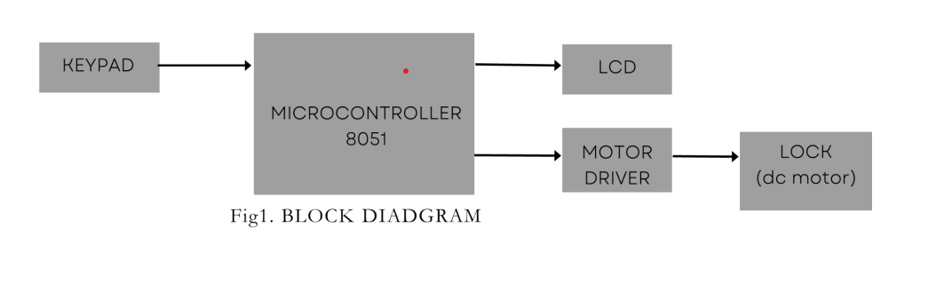

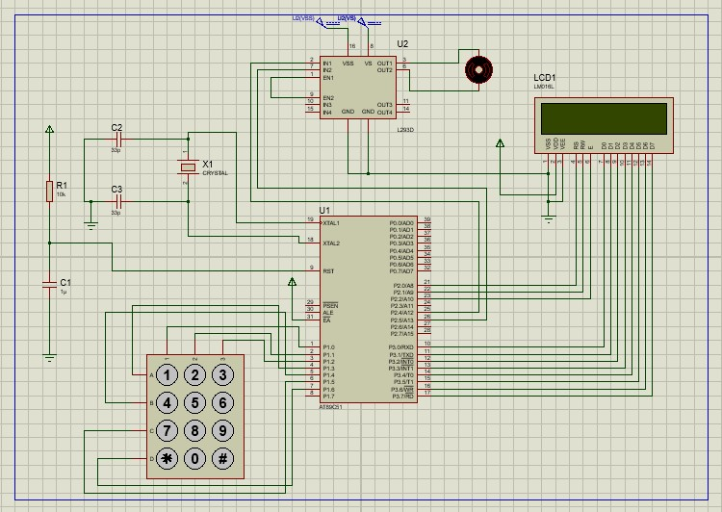

Fig2. Draft Proteus circuit design