Installation

Fair point — let me boil it down.

What you change as a customer (the short version)
1. Network
- Add a subnet for DAM components (capture pods, audit pullers, scanners)
- Add routes so DAM subnet can reach your database subnets
- Add NAT/route for outbound to the DAM SaaS
2. Firewall
- Allowlist outbound to DAM SaaS endpoints (a handful of FQDNs on port 443)
- If you do TLS inspection, either exempt DAM domains or give DAM your CA bundle
3. IAM
- Create a service role/managed identity for DAM with scoped read permissions (RDS describe, audit log read, secrets read)
4. Secrets
- Create scoped DB credentials (audit_reader, va_scanner) in your secrets manager
- Grant DAM's role access to those specific secret IDs
5. Database engines
- Enable native auditing on each database (UNIFIED_AUDIT for Oracle, SQL Server Audit, pgaudit, MySQL Audit Plugin, MongoDB audit)
- This is usually the longest task because it goes through your DBA team
6. DNS
- Resolve DAM SaaS hostnames (usually automatic, sometimes needs a conditional forwarder)
7. Optional but common for regulated workloads
- PrivateLink/Private Endpoint to DAM SaaS instead of public internet
That's it. Everything else (WAF, DDoS, Akamai) is usually unaffected because they protect inbound traffic, not your outbound to DAM.

Realistic effort
- Cloud platform team: ~1-2 weeks of work spread across changes
- DBA team: 4-12 weeks to enable auditing across all databases (biggest line item)
- Security/compliance review: 4-6 weeks in parallel
Total: 3-6 months end-to-end for a regulated customer, mostly waiting on internal approvals rather than technical work.
Want me to turn this into a one-page checklist you can hand to your cloud platform team?

Short version:
- You log into the DAM web UI and click "Add database" or "Deploy agent"
The UI generates an install command with a one-time enrollment token, like:
curl https://install.dam.vendor.com/agent | sh -s -- --token=abc123

- You run that command on the target (VM, K8s cluster, or cloud shell) — it pulls the agent binary/container, registers with your tenant, and starts capturing
- For agentless (RDS, Azure SQL, etc.), the UI walks you through granting an IAM role and pointing audit logs at a queue — no install, just config
- The agent appears in the UI within a minute, status goes green, events start flowing
That's the whole flow from the customer's perspective. Behind the scenes the token does the mTLS cert exchange, fetches config, and connects to the right tenant.

Short version of how these get installed on the customer side:
Discovery Scanner, VA Scanner, Audit Log Puller, Audit Push Consumer — all run in the customer's cloud, not on database hosts. So installation means deploying small services into a customer-managed compute environment.
Options the customer picks from:
- Kubernetes (most common) — DAM UI generates a Helm install command; customer runs it against their cluster. Pods deploy as Deployments (always-on pullers) or CronJobs (scheduled VA/Discovery scans).
- Serverless (cloud-native) — DAM UI generates a Terraform/CloudFormation/Bicep template; customer applies it. Creates Lambda/Azure Functions/Cloud Run jobs on a schedule.
- VM-based (for environments without K8s or serverless) — customer provisions a small VM, runs a curl-piped installer with an enrollment token; systemd service starts.
In all three cases the flow is the same:
- DAM UI: "Add VA Scanner" → pick deployment target → generates install artifact with one-time token
- Customer: applies the artifact (helm/terraform/bash)
- Service registers with DAM tenant via mTLS, fetches config, starts running
- Appears as "active" in DAM UI within a minute
For agentless audit consumption specifically (RDS, Azure SQL), there's no service to install — the customer just grants an IAM role and points audit logs at a queue/log group the DAM Audit Push Consumer (running in your SaaS) reads from.
So: same install pattern as agents, but the workload runs in customer compute rather than on database hosts.

How install artifacts are generated
Short flow:
- Customer clicks "Deploy [scanner/puller/agent]" in DAM UI, picks target (K8s / serverless / VM)
- Control Plane API:
  - Creates an agent row in Postgres with status enrolling
  - Generates a one-time enrollment token (random 32 bytes, bcrypt-hashed in DB, plaintext shown once)
  - Selects the right template from a versioned template store (S3/Blob)
  - Renders it with tenant-specific values (tenant ID, ingest endpoint URL, token, tenant CA cert, agent version)
- UI shows the rendered artifact to download or copy:
  - Helm: helm install dam-agent oci://registry.vendor.com/charts/dam-agent --set token=xyz --set tenant=abc
  - Terraform: a .tf file or module reference with variables pre-filled
  - Bash: curl https://install.vendor.com/v1/agent.sh | sh -s -- --token=xyz
- Customer applies it in their environment
- Agent boots, presents the token to the enrollment endpoint, swaps it for a long-lived mTLS cert, token is invalidated, status flips to active
The templates themselves are just Go text/template or Helm charts stored in the vendor's artifact repo, versioned per release. Rendering is a 50-line function in the Agent Service.

Agent vs Agentless capability matrix
Capability | Host Agent (eBPF/ETW) | Network Agent (libpcap) | Audit Pull (agentless) | Audit Push (agentless)
Remote network connections | ✓ | ✓ | ✓ | ✓
Local connections (Unix socket, shared mem, BEQUEATH) | ✓ | ✗ | Partial | Partial
TLS-encrypted query content | ✓ | ✗ (without keys) | ✓ | ✓
Full SQL + bind variables | ✓ | ✓ | Engine-dependent | Engine-dependent
Result row counts | ✓ | ✓ | ✓ | ✓
Result content (specific rows) | ✓ | ✓ | ✗ | ✗
Failed login attempts | ✓ | ✓ | ✓ | ✓
OS-level context (process, OS user, container) | ✓ | ✗ | ✗ | ✗
Real-time blocking | ✓ | ✓ (inline mode) | ✗ | ✗
Real-time alerting | ✓ (ms) | ✓ (ms) | Near-real-time (60-300s poll) | ✓ (push, seconds)
Database CPU overhead | ~1-3% | 0% | 3-15% (audit enabled) | 3-15% (audit enabled)
Works on managed DBs (RDS, Azure SQL) | ✗ | ✗ | ✓ | ✓ (native)
Works on PaaS without DB host access | ✗ | ✗ | ✓ | ✓
Install footprint on DB host | Agent binary | Agent binary | None | None
Politically easy to deploy | ✗ | Medium | ✓ | ✓
Rule of thumb: Host agent = max visibility, hardest to deploy. Network agent = good visibility, blind to local + TLS. Agentless pull/push = easiest to deploy, blind to local connections and OS context.

Brief architecture diagram
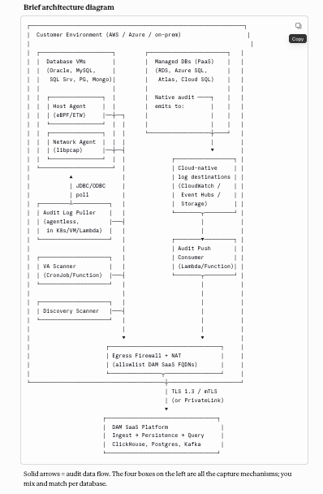

Solid arrows = audit data flow. The four boxes on the left are all the capture mechanisms; you mix and match per database.

