SOP — Agentless Monitoring of a GCP Cloud SQL (PaaS) Database via Pub/Sub Push
Purpose: Onboard a managed GCP Cloud SQL (MySQL) database into TooVix DAM agentlessly — no agent on the DB, no inbound path into the customer network. The DB emits audit records to Cloud Logging; a Log Sink pushes them to a Pub/Sub topic; the DAM pulls the subscription outbound.
Audience: Cloud/DB admin (customer side) + DAM operator (platform side). Scope: GCP Cloud SQL for MySQL 8.0. (Postgres/SQL Server, AWS RDS, Azure SQL are analogous — different audit source + stream service; see Appendix C.)

1. Architecture (detailed) + security touchpoints
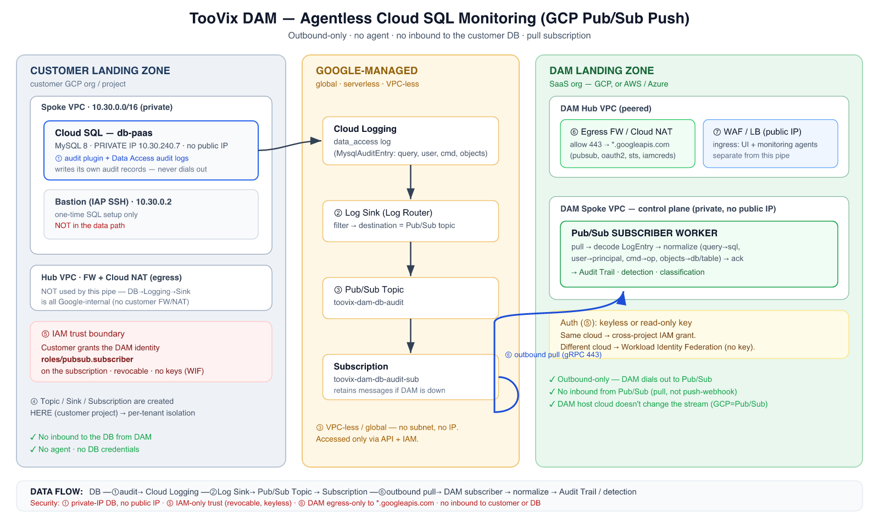

Security touchpoints (keyed to the diagram)
# | Touchpoint | Configuration | Direction / exposure
1 | Cloud SQL audit | cloudsql_mysql_audit=ON  flag + audit rule;  Data Access audit logs enabled  . DB has  private IP, no public IP  . | Internal to Google — DB never opens outbound to DAM.
2 | Log Sink (Log Router) | Filter selects Cloud SQL audit records → destination = Pub/Sub topic. Auto-created  writer identity  . | Google-internal; no network path.
3 | Pub/Sub topic + subscription | Managed,  VPC-less, global  . Lives in the  customer's project  (next to the logs). | No IP/subnet; accessed only via the API + IAM.
4 | Resource ownership | Topic/sink/subscription created in the  customer project  — per-tenant isolation; a tenant's audit never shares a pipe. | —
5 | IAM grant (the trust boundary) | Customer grants  the DAM's identity  roles/pubsub.subscriber  on  their  subscription. Sink writer granted  pubsub.publisher  on the topic.  No keys shared if using WIF. | Identity-based, not network. Revocable anytime.
6 | DAM egress (the only network path) | DAM subscriber  dials out  443 (gRPC) to  pubsub.googleapis.com  . DAM  hub egress FW / Cloud NAT  allowlists  *.googleapis.com  (+  oauth2  ,  sts  ,  iamcredentials  for keyless).  No inbound from Pub/Sub  (pull model). | Outbound-only.
7 | DAM ingress (separate from this pipe) | UI + monitoring agents reach the control plane via the  DAM hub WAF/LB (public)  → private DAM. Not used by the Pub/Sub pull. | Inbound, but unrelated to agentless ingest.

Key security properties
- No inbound to the customer DB or network from the DAM — ever. (Pull, not push-webhook.)
- No agent, no DB credentials for monitoring — the DB writes its own audit; the DAM only reads a stream.
- No customer NAT/FW change for the data path — DB→Logging→Sink→Pub/Sub is all Google-internal.
- Only the DAM landing zone needs egress to *.googleapis.com.
- Least privilege: the DAM identity holds only pubsub.subscriber on one subscription (+ read-only discovery roles). Delete the subscription/IAM binding to offboard a tenant — nothing else affected.

2. Prerequisites
- Customer: roles/cloudsql.admin (flags + audit), roles/logging.configWriter (sink), roles/pubsub.admin (topic/sub), and project IAM admin (Data Access audit config + granting the DAM identity).
- A reachable admin path to the DB for the one-time SQL step (private IP → a bastion via IAP, or Cloud SQL Auth Proxy).
- The DAM's identity to grant: either
  - a read-only service account the customer creates, or
  - the DAM's Workload Identity Federation principal (keyless, recommended cross-cloud), or
  - (same-project lab only) the DAM VM's attached service account.
- Pub/Sub API enabled in the customer project (gcloud services enable pubsub.googleapis.com).
Set once:
PROJECT=YOUR_PROJECT_ID INSTANCE=db-paas TOPIC=toovix-dam-db-audit SUB=toovix-dam-db-audit-sub DAM_IDENTITY="serviceAccount:dam-collector@DAM_PROJECT.iam.gserviceaccount.com" # or the WIF principal

PART A — Customer side: turn on audit → Pub/Sub

A1. Enable the Cloud SQL audit plugin (⚠ restarts the instance)
gcloud sql instances patch $INSTANCE \ --database-flags=cloudsql_mysql_audit=ON,cloudsql_mysql_audit_log_write_period=1
- Value is uppercase ON. --database-flagsreplaces the whole set — list all flags together.
- cloudsql_mysql_audit_log_write_period=1 flushes buffered audit records ~every second (lower latency).

A2. Create the audit rule (inside MySQL)
Connect via the bastion (private IP) as the Cloud SQL admin user:
mysql -h <PRIVATE_IP> -u admin -p
CALL mysql.cloudsql_create_audit_rule('`%`@`%`', '`%`', '`%`', 'connect,dql,dml,ddl,dcl', 'B', 1, @rc, @msg); SELECT @rc, @msg; -- 0 / NULL = success
Gotchas: 8 arguments; wildcards backtick-quoted (`%`@`%`, `%`); op_result='B' (both success+fail); ops are categories (connect,dql,dml,ddl,dcl), not all. Verify: SELECT * FROM mysql.audit_log_rules;

A3. Enable Data Access audit logs (⚠ REQUIRED for user-data queries)
Without this, only admin/system queries are logged; reads/writes on user tables won't appear.
gcloud projects get-iam-policy $PROJECT --format=json > policy.json python3 - <<'PY' import json f='policy.json'; p=json.load(open(f)) acs=[c for c in p.get('auditConfigs',[]) if c.get('service')!='cloudsql.googleapis.com'] acs.append({'service':'cloudsql.googleapis.com', 'auditLogConfigs':[{'logType':'DATA_READ'},{'logType':'DATA_WRITE'}]}) p['auditConfigs']=acs; json.dump(p,open(f,'w')) PY gcloud projects set-iam-policy $PROJECT policy.json
Data Access audit config changes can take several minutes (up to ~10) to propagate.

A4. Create the Pub/Sub topic
gcloud pubsub topics create $TOPIC --project=$PROJECT

A5. Create the Log Sink → topic
gcloud logging sinks create toovix-dam-db-audit-sink \ pubsub.googleapis.com/projects/$PROJECT/topics/$TOPIC --project=$PROJECT \ --log-filter='resource.type="cloudsql_database" AND protoPayload.methodName="cloudsql.instances.query"'
(One sink per project covers all Cloud SQL instances there; the DAM tells them apart from each message.)

A6. Let the sink publish to the topic
SINK_SA=$(gcloud logging sinks describe toovix-dam-db-audit-sink --project=$PROJECT --format='value(writerIdentity)') gcloud pubsub topics add-iam-policy-binding $TOPIC --project=$PROJECT --member="$SINK_SA" --role="roles/pubsub.publisher"

A7. Create the subscription
gcloud pubsub subscriptions create $SUB --topic=$TOPIC --project=$PROJECT \ --ack-deadline=30 --message-retention-duration=7d # (optional) dead-letter: # gcloud pubsub topics create ${TOPIC}-dlq --project=$PROJECT # gcloud pubsub subscriptions update $SUB --project=$PROJECT --dead-letter-topic=${TOPIC}-dlq --max-delivery-attempts=5

A8. Grant the DAM identity subscriber (the trust boundary)
gcloud pubsub subscriptions add-iam-policy-binding $SUB --project=$PROJECT \ --member="$DAM_IDENTITY" --role="roles/pubsub.subscriber"
That single cross-org IAM binding is the entire connection — no VPC, no peering, no inbound.

PART B — DAM side: register the connector + subscription
In the DAM UI: Discovery → Cloud connectors → Connect a cloud:
- Provider GCP, project = $PROJECT.
- Credential: Keyless (recommended — WIF/attached identity) or paste a read-only SA key.
- Pub/Sub subscription:toovix-dam-db-audit-sub (or the full projects/$PROJECT/subscriptions/...).
- Save. The DAM's subscriber loop begins pulling; the connector row shows Agentless ingest = streaming.
(API equivalent: POST /api/discovery/connectors { provider:"gcp", keyless:true, project, subscription }.)

PART C — Network / landing-zone configuration
Customer landing zone
- Cloud SQL: private IP, no public IP. No FW rule and no NAT are needed for this pipe — the DB→Logging→Sink→Pub/Sub path is entirely Google-internal.
- The bastion is only for the one-time A2 SQL step (IAP SSH); it is not in the data path.
DAM landing zone
- DAM control plane sits private behind the hub.
- Egress (touchpoint 6): the hub Egress FW / Cloud NAT must allow outbound 443 from the DAM subnet to: pubsub.googleapis.com, oauth2.googleapis.com, and (keyless) sts.googleapis.com, iamcredentials.googleapis.com. DNS resolution for *.googleapis.com via the hub.
- No inbound rule for Pub/Sub (pull model). Ingress (touchpoint 7) — the public WAF/LB → private DAM — exists for the UI + monitoring agents and is unrelated to this agentless pipe.
- DAM on AWS/Azure: identical, plus the subscriber authenticates to GCP via Workload Identity Federation (its AWS/Azure identity → short-lived GCP token); that token exchange is also outbound 443 through the landing-zone egress FW. Still no inbound.

PART D — Validation
- Fire an audited user query on the DB (via bastion): SELECT * FROM <db>.<table> LIMIT 5;
- Confirm it reached Cloud Logging:gcloud logging read 'resource.type="cloudsql_database" AND protoPayload.methodName="cloudsql.instances.query"' \ --project=$PROJECT --limit=5 --freshness=10m --format='value(timestamp, protoPayload.request.user, protoPayload.request.query)'
- Confirm it reached the subscription (optional): gcloud pubsub subscriptions pull $SUB --project=$PROJECT --limit=3
- Confirm it landed in the DAM: Audit Trail → Database Activity shows the query with source_host = the instance and (Instance/Host) the registered instance. Connector shows ingest_status = ok.

PART E — Troubleshooting (issues we actually hit)
Symptom | Cause | Fix
on was not an expected string  (flag) | Flag value must be  uppercase | Use  cloudsql_mysql_audit=ON
zsh: unknown file attribute: * | Ran the  CALL  in the  shell | Run it  inside mysql>
expected 8, got 6  /  op_result should be 'S'/'U'/'B'/'E'  /  Special characters only between backticks  /  operation "all" not supported | Wrong  create_audit_rule  args | 8 args;  op_result='B'  ; backtick wildcards; ops =  connect,dql,dml,ddl,dcl
Pull error:  Pub/Sub API not enabled | API just enabled | gcloud services enable pubsub.googleapis.com  ; wait a few min (loop retries)
System queries flow, but user-table queries don't | Data Access audit logs OFF  (  auditConfigs  null) | Do  A3  ; wait for propagation (~10 min)
Records lag / appear in bursts | Audit buffer flush period | Set  cloudsql_mysql_audit_log_write_period=1  (A1)
Access denied connecting as admin | Cloud SQL admin user is  admin  (not  root  ); secret mismatch | gcloud sql users set-password admin --host=% --instance=$INSTANCE --password=…

Appendix A — Least-privilege IAM summary (what the DAM holds)
Purpose | Role | On
Cloud discovery (list instances) | roles/cloudsql.viewer | project
(Pull path) consume audit stream | roles/pubsub.subscriber | the subscription
(If reading logs directly instead of Pub/Sub) | roles/logging.viewer  +  roles/logging.privateLogViewer | project

No write roles, no DB credentials, no network access into the customer VPC.

Appendix B — Offboarding a tenant
Delete the subscription (stops the DAM pulling) and/or revoke the pubsub.subscriber binding. Optionally remove the sink, topic, audit rule, and turn off the flag/Data-Access-audit. Nothing else is affected.

Appendix C — Other clouds (same pattern, different source + stream)
DB cloud | Audit source | Stream | DAM consumer
GCP Cloud SQL | Cloud Logging (data_access) | Pub/Sub | pull subscriber
Azure SQL / MySQL / PG | Diagnostic Settings | Event Hub | Event Hub consumer
AWS RDS / Aurora | CloudWatch Logs | Kinesis | Kinesis consumer
OCI | OCI Audit / Logging | OCI Streaming | Streaming consumer
The DB cloud dictates the stream service; the DAM is a multi-cloud consumer (one adapter per stream). Its
own hosting cloud doesn't change any of the above — only its
egress
target +
auth
(WIF cross-cloud).

