Support tickets: Drop down menu:

Building Issue - Inside

Building Issue - Outside

Security

Bylaw

Account Question

General Question

Other

Building Information - Link is dead – no information here - This can be a simple page with the building email address

/user/legal_docs Suggest to add the following:

/user/legal_docs_Bylaws

/user/legal_docs_AGM

AGM needs it’s own category for files to be uploaded (same concept as Bylaws)

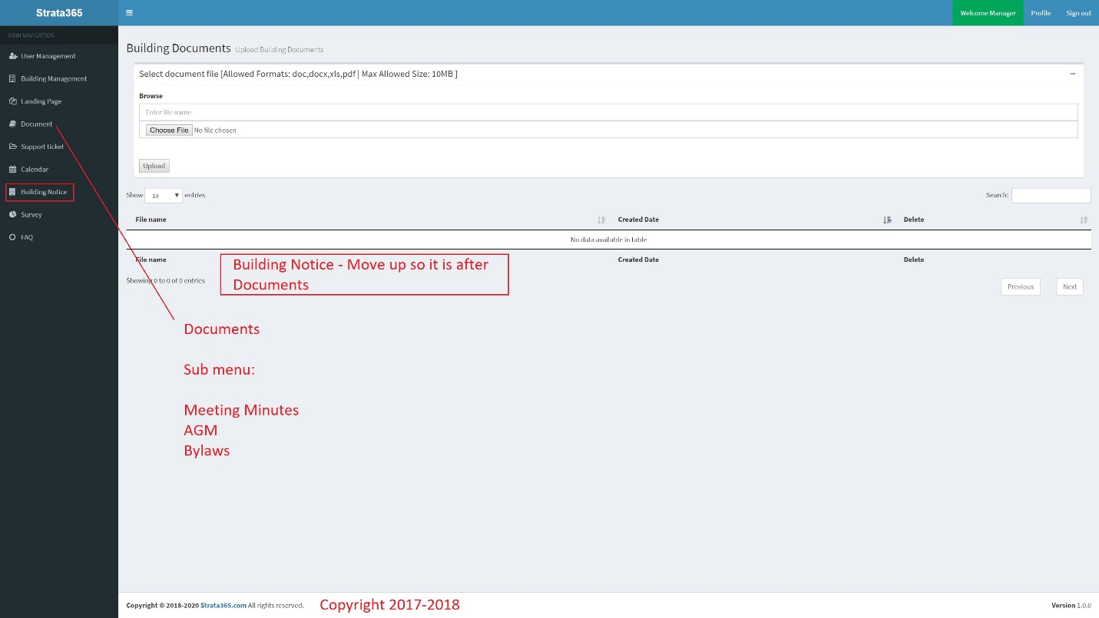

ADD: Home Icon at the top of the navigation panel – This brings the home page with the calendar and notices - Please use the frame suggestion here and on the calendar page too.

Request booking – Larger box perhaps

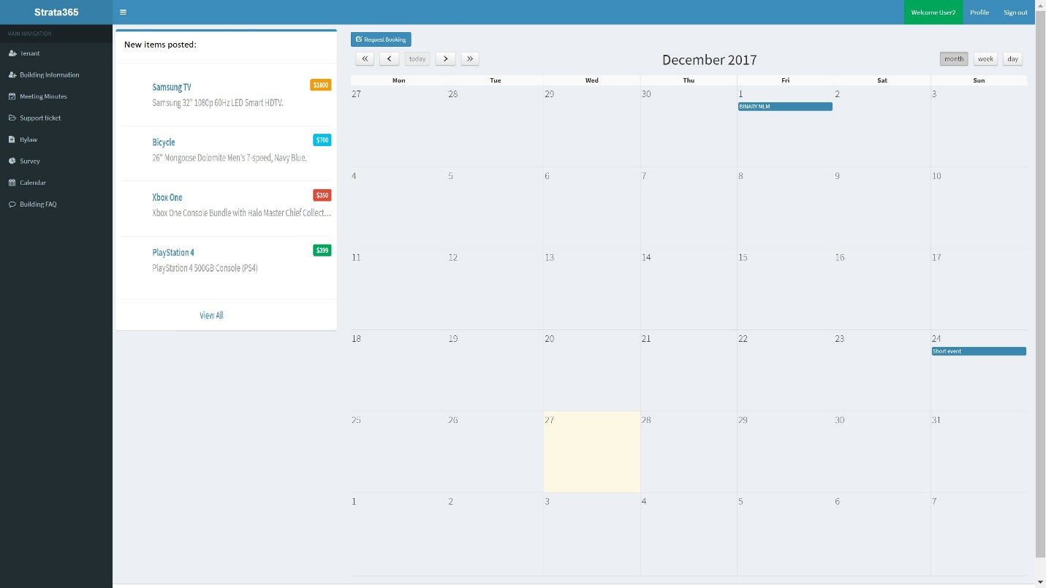

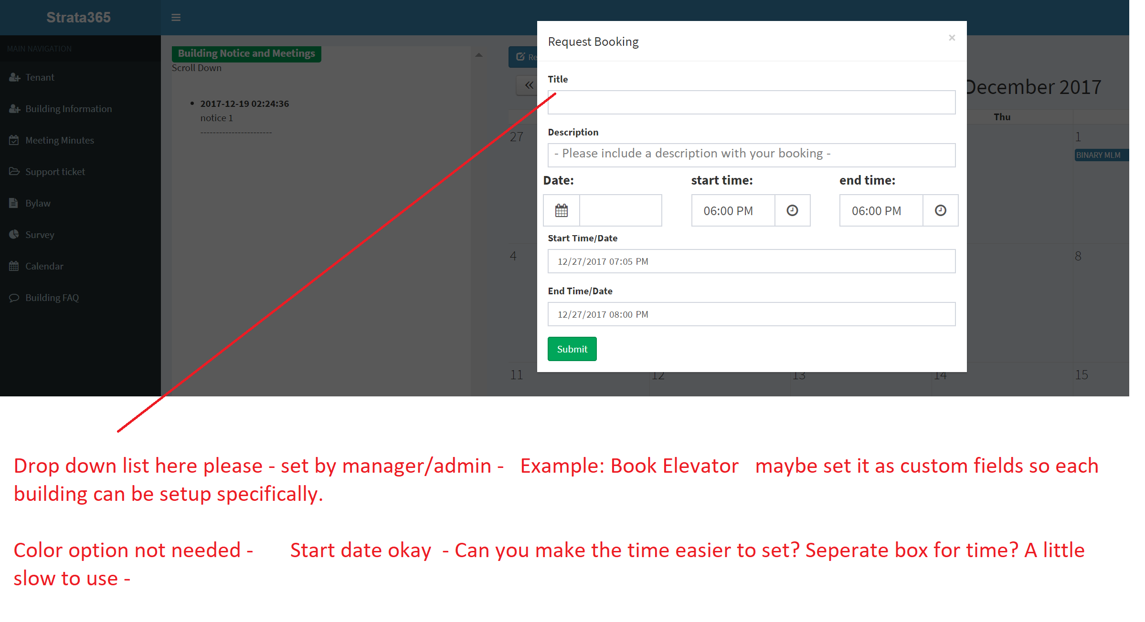

Drop down menu in booking – Manager/Admin to set – Suggest custom fields that each building can set

Can you edit the time/date to this format so it is easier?

Meeting Minutes – Need to be able to select a single meeting to view/print etc…

* Saves as a .pdf file by default

Survey – View result - Not working – Error message

**Survey Subject** – Same line top says Subject bottom some Name - Error?

**Survey Name**

Refer Building Units as Unit # or Unit Number

Building Unit: change to > Unit Number:

Tenant – Add tenant – Will the tenant get an email upon setup? Can a password be auto generated or be changed by the tenant or just set by the user?