**Experiment#2 ENEE2103**

**Circuit Laws and Theorems**

**Pre-lab: Second2021-2022**

1. **Simulate the circuits in the procedure section using Pspice and determine the required values.**
2. **You will need to perform bias point analysis only**
3. **For all simulations copy the simulated circuit into your prelab report and extract the required values of currents and voltages to be filled into the tables or to answer the questions**

**Procedure:**

# KVL,KCL

# In Fig (2.1). Consider Rx=R1=R4=1kΩ , R5=3.3kΩ,R6=4.7kΩ and Vs= 15V

# Perform bias point analysis and display the node voltages and currents

# Provide a screen shot for the simulated circuit showing voltages and currents

# Fill in the first row of table 2.1

# From your measurements verify the validity of KCL (at node C ) and KVL for the mesh containing Vs, R4 and R6.

|  |  |  |  |  |  |  |  |  |  |  |  |
| --- | --- | --- | --- | --- | --- | --- | --- | --- | --- | --- | --- |
| Rx | | R6 | | R5 | | R4 | | R1 | |  | Vs |
| Ix | Vx | I6 | V6 | I5 | V5 | I4 | V4 | I1 | V1 |
|  |  |  |  |  |  |  |  |  |  | Rx=1k | 15V |

Table (2.1)



Fig (2.1)

# Voltage & Current Division:

1. ***Current division***

# In the circuit of Fig (2.1) replace R1 by a short circuit and set Rx to 1k.

# Measure the curents in all the resistive branches of the circuit and fill the values in table2.3.

# In each case apply the resistors values into the current division formula

# Do the measured values satisfy the theoretical values of the current division rule?

|  |  |  |  |  |  |
| --- | --- | --- | --- | --- | --- |
| **Vs (volt)** | **Pot.** | **I4** | **I5** | **I6** | **Ix** |
| **10** | **Rx** |  |  |  |  |

Table (2.3)

# Superposition:

# Connect the circuit of Fig (2.2).

1. Set the source Vs1 to 5 volts and Vs2 to 10 volts.
2. Set the variable resistor Rx to the value of 1K.
3. Measure the current and the voltage on R6
4. Set vs1 to zero and Vs2 to 10 volts measure the current and the voltage on R6
5. Set Vs1 to 5 volts and Vs2 to zero and measure the current and the voltage on R6
6. Define the relation between the three current values measured in (4,5,6)
7. Define the relation between the three voltage values measured in (4,5,6)

|  |  |  |  |
| --- | --- | --- | --- |
| **Vs1(volt)** | **Vs2 (volt)** | **V6 (volt)** | **I6 (mA)** |
| **5** | **10** |  |  |
| **0** | **10** |  |  |
| **5** | **0** |  |  |

Table (2.4)

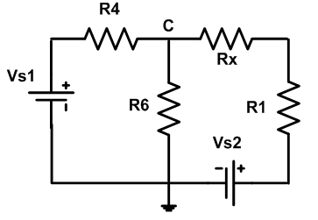

Fig (2.2)

# Thevinin and Norton equivalent circuits:

# Connect the circuit of Fig (2.2).

# Set the Vs1 to 5volts and Vs2 to 10 volts and measue voltage across R1.

# Disconnect R1 and measure the voltage on the terminals (a,b) where R1 was connected as in Fig (2.3).[ Voc- open circuit voltage]

1. Short circuit the terminals (a, b) and measure the current in the short circuit (Isc).
2. Disconnect the voltage sources and short circuit the terminals where each source was connected.

# Measure the resistance from the terminals (a,b) (Rab=Rth).

1. Connect the voltage source in series with the variable resistance from the potentiometer (VR1) as in Fig (2.4) , do not connect R1.
2. Set the voltage source to Voc measured in step (3) and the variable resistance to Rth measured inn step (4).
3. Connect the resistance R1 across terminal a-b of Fig. 2.4 and measure the voltage across it?
4. Compare voltage across R1 from step (9) to its value measured in step (2)
5. What is the relation between the circuit of Fig.2.2 and the circuit of Fig.2.4 constructed in steps (7,8)? Refer to the electric variables on the port (a, b).

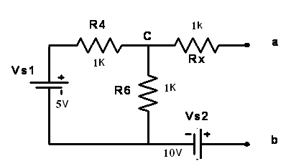  
Fig (2.3)



Fig (2.4)