**Prelab Instructions for Experiment#3 ENEE2103**

**First and Second Order Circuit**

**Pre-lab:**

1. Simulate the circuits in the procedure section and determine the required values)

# RC Circuit:

# Connect the circuit of Fig (3.1 in Pspice )

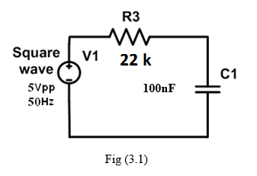

1. Use Vpulse to replace the square wave with the following setting:

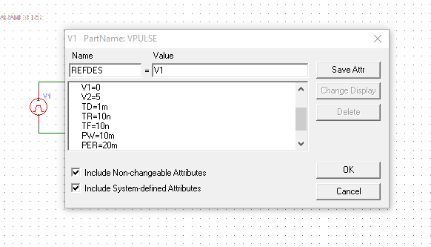

PER=period=1/f=1/50=20m

PW= pulse width=0.5T=10m

1. Run transient analysis, make sure to adjust Final Time( at least one period of the signal) and Step ceiling to 1% of the period or less

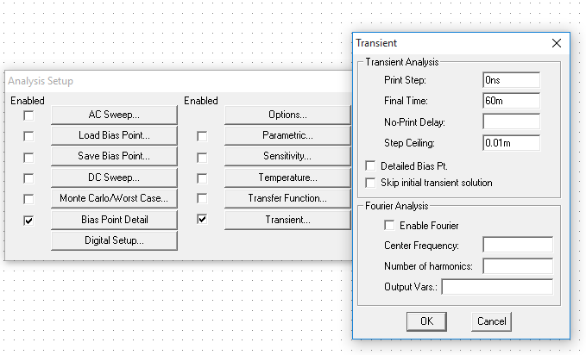

1. Plot the voltage across the capacitor and measure value of time constant on the plot using cursors

# RL Circuit:

# Connect the circuit of Fig (3.2) in Pspice.



Fig (3.2)

# Set the signal generator to generate a periodic square waveform from 0 to10V and f=500Hz

# Run transient analysis and display voltage and current responses of the inductor.

# Measure the time constant of the circuit and the steady state values of the voltage and current responses.

1. Change the period of the periodic square wave to T=2τL and repeat steps above.

# RLC Circuit:

1. **Response type:**

# Connect the circuit of Fig (3.3) in Pspice



Fig (3.3)

1. Display the voltage across the capacitor.
2. Calculate R3 to give critically damped response ( Note that Rcritical will result in two equal roots S1=S2=-)
3. Run parametric + transient analysis with varying R3 with 3 values corresponding to critical damping , underdamped (use R3=600 ohm) and overdamped (R3=22 kohm) responses
4. **Response parameters:**
5. For the under damped response case (for this prelab use R3=750 ohm)
6. Make sure to use the cursor to measure the decay-envelope time constant (), the damping coefficient () and the damped frequency (d)

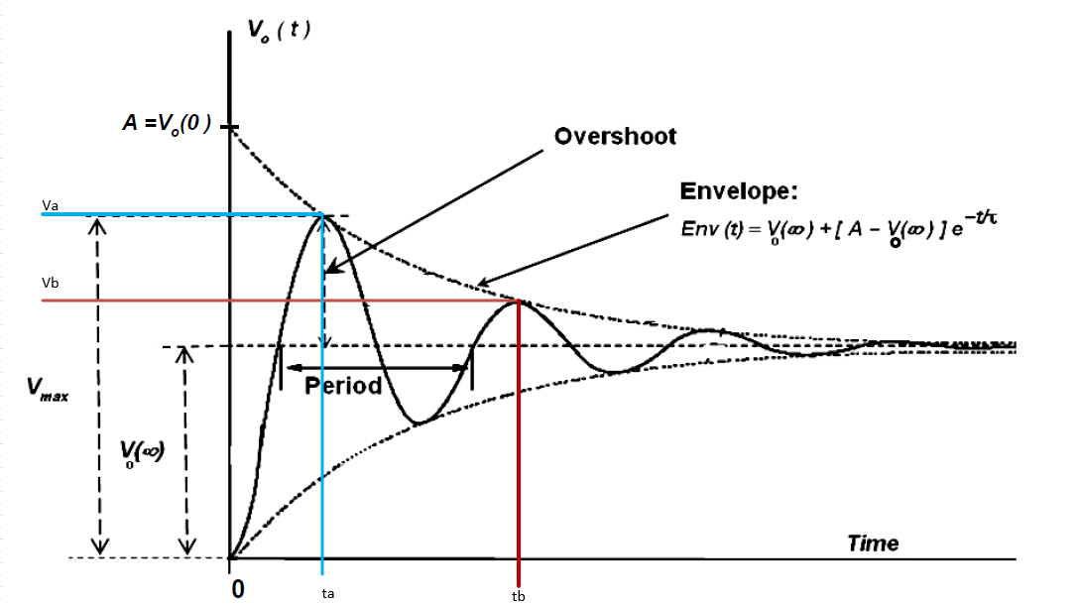

Decay time constant $τ=\frac{t_{b}-t_{a}}{ln\left(\frac{V_{a}-V_{o(∞)}}{V_{b}-V_{o(∞)}}\right)}$

Damping Coefficient $α=\frac{1}{τ}$

Damped radian frequency $ω_{d}=\frac{2π}{t_{b}-t_{a}}$

**Additional Info**

**For series RLC**

$$ω_{o}=\frac{1}{\sqrt{LC}}$$

$α<ω_{o}$ $→$ We have under damped case:

$$α>ω_{o} → over-damped case$$

$α=ω_{o} → Critically-damped case$

$α=\frac{R}{2L }$