**Experiment # 6 Prelab ENEE2103**

***Diode Characteristic and Applications.***

**Pre-lab Work:**

You have to use PSPICE to simulate to all practical circuits shown in the procedure below, and you have to do all necessary calculation you will need.

**Procedure:**

***I. DIODE CHARACTERISTICS.***

1. Connect the Circuit of Fig. (6.1) vary the source from 0 to 3 V and measure VR, VD and ID



1. Fill in the results in the table 6.1

|  |  |  |  |
| --- | --- | --- | --- |
| VS | VR | VD | ID |
| 0 |  |  |  |
| 0.2 |  |  |  |
| 0.4 |  |  |  |
| 0.6 |  |  |  |
| 0.8 |  |  |  |
| 1 |  |  |  |
| 1.5 |  |  |  |
| 2 |  |  |  |
| 2.5 |  |  |  |
| 3 |  |  |  |

Table 6.1

1. Reverse the diode and repeat the simulations, what do you notice?

***II. RECTIFICATION .***

1. ***HALF - WAVE RECTIFICATION.***
2. Connect the circuit as shown in Fig.( 6-3), use diode 1N5806

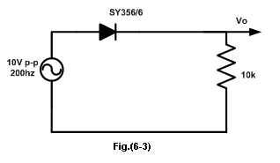

1. Simulate the circuit for 5 cycles, display only the last cycle using no print delay in the transient analysis setup.
2. Measure the period **T** and the peak voltage **Vpk**  for the Vo
3. Estimate the dc value of the output voltage
4. Reverse the Diode and observe the output voltage
5. Now add a capacitor of 2.2µF to your circuit, the circuit becomes as shown in Fig.(6-4).

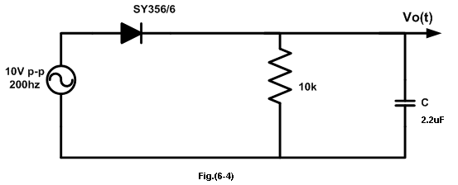

1. Simulate the circuit for 5 cycles, display only the last cycle..
2. Measure peak to peak ripple and estimate dc value

* Repeat the simulation with C=47 µF

1. ***FULL-WAVE RECTIFICATION***

***Diode bridge circuit as a full wave rectifier:***

1. Simulate the circuit of Fig.(6-5 ) in Pspice, but do not use the transformer, instead use a source with 10 V p-p directly on bridge input.



1. Simulate the circuit for 5 cycles, display only the last cycle.
2. Measure peak value and period then estimate dc value
3. Repeat the simulation with C=2.2 µF and measure ripple and estimate dc value

.***III. other applications:***

***A. clipping:***

* 1. Connect the circuit as shown in Fig.(6-6)



* 1. Simulate the circuit with three values of the dc source using parametric + transient analysis: 0V, 1.5V and 3.5 V

***B. Clamping:***

1. Connect the circuit shown in Fig.( 6-7).



1. Follow the same steps you had followed in the previous part A (clipping).
2. ***VOLTAGE MULTIPLIER CIRCUITS***
3. Set up the circuit as shown in Fig.(6-8). Use D1N914 for D1,D2 and D3
4. Measure the voltage across each capacitor.
5. Measure voltage across C1+C3