**Experiment #7 -Prelab ENEE2103**

**BJT Transistor As An Amplifier, CE, CC, CB Connection**

**Pre-lab**

You have to apply PSPICE simulation to all practical circuits shown in the procedure below

**Procedure:**

1. Connect the following circuit in Pspice, make sure to add resistor of very high value (for example 10 Meg) from Vo(t) to Ground. Use a Q2N2222 Transistor

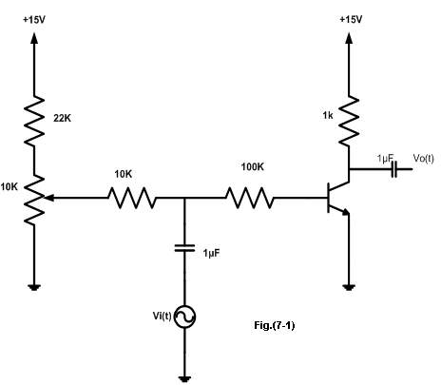

1. Initially set Vi(t) amplitude to 0, set the potentiometer value to 10 k and its set value to 0.
2. Set sinusoidal source to 1 kHz and amplitude to zero.
3. Measure Vc, VBE, VCE, Ic, IB
4. Adjust amplitude of Vi(t) to 1 V and measure Vo(t) ? Change peak of Vi(t) such that Vo(t) =4V peak and perform Transient analysis
5. Calculate the voltage gain of the transistor Av = Vo (t) / Vi (t) and Av1 = Vo (t) / VB (t)
6. Remove the 100k resistor and see what happens to voltage gain?
7. ***COMMON COLLECTER TRANSISTOR AMPLIFIER.***
8. Connect the circuit of Fig. (7.2) in Pspice, use same transistor in previous part



1. Set the sine wave generator to a frequency of 1 kHz , and its output amplitude to zero,
2. Perform bias point analysis and measure VB, VC, IB,IC
3. Adjust the amplitude of the sine wave generator until an output amplitude from the amplifier is about 2volts peak-to-peak. (make sure the waveform is undistorted).
4. Perform transient analysis and measure the ac input voltage needed to achieve this output.
5. Calculate the voltage gain Av.
6. Measure the input and output currents and calculate Ai.
7. Calculate the current gain Ai.
8. Estimate Zi from Ii and Vi values
9. To find the output impedance of the amplifier, you should take off the input sine wave generator and replace it with a short circuit, then you have to connect the generator to the output (emitter) via a capacitor, and measure its output voltage and current.

Table 7.1

|  |  |
| --- | --- |
| **Quantity** | **Measured values** |
| **Vin** |  |
| **Vout** |  |
| **v100k_RMS** |  |
| **iout** |  |
|  | **Calculated values** |
| **AV=Vout/Vin** |  |
| **iin = v100k_RMS /100k** |  |
| **Ai=iout/iin** |  |
| **Zin=Vin/iin** |  |
| **Zout=VT/iT** |  |