About Me

Sofia Marques Hill

Table of Contents

# Who I am and where I came from

I am from Uruguay, a little country of South America located between Brazil and Argentina. I grew up in a farm and when I started high school I moved to Uruguay’s capital, Montevideo. My parents showed me how great is to work as an Agronomist and that’s why in 2010, with 17 years old, I started this career at the [University of the Republic of Uruguay](http://www.fagro.edu.uy/). One fun fact is that the career starts with a 2 week visit to a farmer establishment and I had to go to a family farm of vegetable growers that where so hardworking and humble that gave me a new perspective of what farmers challenges may be.

I end the career thinking of specializing in cattle production, but I found a good job as a seed certified technician in the [National Institution of Seeds](https://www.inase.uy/). This job required me to visit crop fields and check variety purity and presence of forbidden weeds. I also had to check every machinery used by farmers to be clean from seeds before its use. In harvest season I ended up driving 6200 miles per month. I loved working there for three years, I learned tons of things but I wanted more challenges in my life and I couldn’t see myself growing there.

In 2019 I started my master in Plant Sciences at the same University, but in association with the [National Institution of Agricultural Research](http://www.inia.uy/). There I performed the first herbicide resistance survey of weeds in the country and was when I realized I liked researcher work a lot. My former adivsor knows my actual advisor, Dr.Todd Gaines, and it was because of that contact that I applied for my actual scholarship. Dr. Gaines lab is in charge of the [International Weeds Genomic Consortium](https://www.weedgenomics.org/) that aims to improve genomic resources of weeds to enhance their use in research and control technologies development. My PhD projects are framed in this big objectives. I am still in my first year of the PhD program and I am already learning a lot. One of my main project is to build a reference genome of *Cirsium arvense* and use it to identify the genomic region that determines sex in this species.

The activities that I enjoy the most are:

1. Explore nature. I am enjoying the hikes that are available near by. Uruguay is quite flat.
2. Singing, I was part of a choir back in Uruguay and I loved it.
3. Hanging out with friends and family. This usually involves drinking mate. Yes, all together from the same straw. What can I say, traditions are traditions.

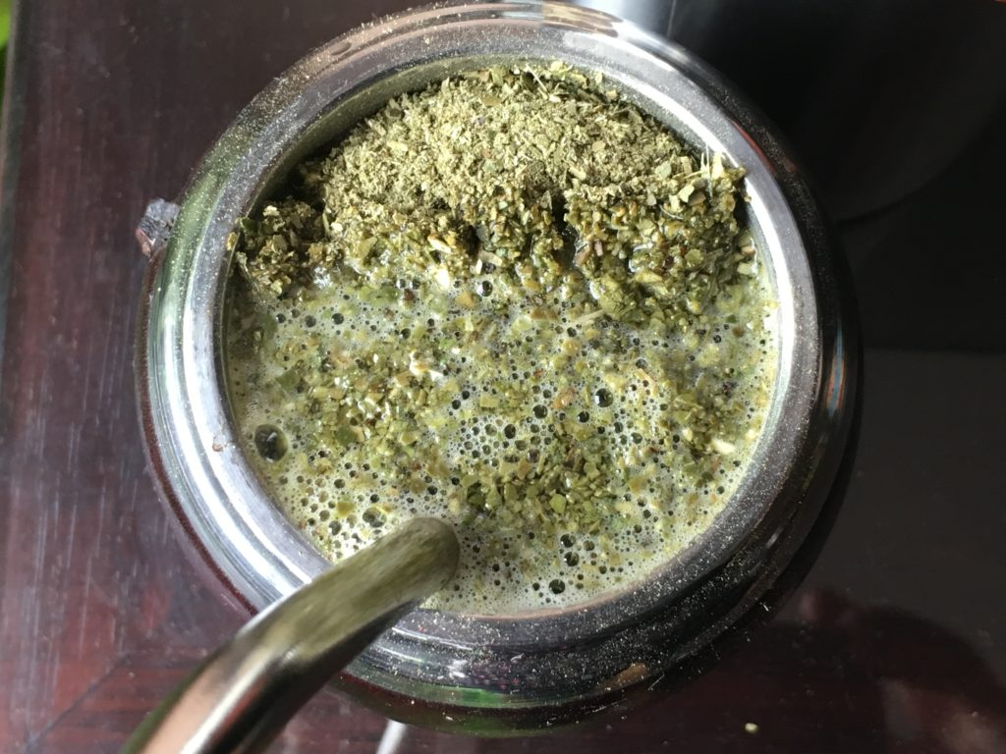

1. Playing cards or boarding games.

# Research Interests

I am interested in weed control management and plant evolution and biology. I think that basic science is crucial for understanding weeds better, and developing more sustainable technologies or techniques for weed control. My objective in these coming years is to learn as much as I can of molecular biology, mainly genomics. This would give me the skills for research about weed evolution and spreading, and herbicide resistance.

## Influential papers

I really don’t have any influential papers in my head. But if I have to choose two papers I’d say that Kreiner, Stinchcombe, and Wright (2018) is a great review that led me to think about genomics as a tool for understunding and managing weeds.

Another paper that I really liked was Brusa et al. (2021) that shows the applicability of genomics and molecular tools for detecting herbicide resistance in seed lots.

## The mathematics behind my research

In herbicide resistance research dose response curves are frequently used to determine resistance of a certain biotype or population. The response usually follows log-logistic function of 3 parameters represented as:

$$f(x)=0+\frac{d−0}{1+\text{exp}(b(\text{log}(x)−\text{log}(e)))}$$

## My computing experience

I almost have no experience with coding. I used the terminal of mac computer to use bowtie2 and manage bam files and create vcf files. I think the language is bash. The following is a part of the script I used for creating vcf file from sorted.

#generate variant likelihoods, where "-g" is for generating genotype likelihoods in BCF output and "-f" is indicating fasta reference line.   
  
samtools mpileup -g -f my_file.fasta my_file.sorted.bam > my_file.raw.bcf  
  
#SNP Calling with bcftools, where "-O b" is output type BCF, "-v" is variant only and "-c" is for using the original consensus calling method.   
  
bcftools call -O b -vc my_file.raw.bcf > my_file.var.bcf   
   
#SNP filtering with vcfutils.pl  
  
bcftools view my_file.var.bcf | vcfutils.pl varFilter -> my_file.var-final.vcf

I also used R for statystical analysis in previous research.

library(drc)  
DRData<-read.csv("Glifosato_DR.csv", sep = ",")  
summary(DRData)  
head(DRData)  
DRLL3<- drm(Biomasa~Dosis,Poblacion,data=DRData,fct=LL.3(), na.action=na.omit, type="continuous")  
plot(DRLL3, type = c("average"), col = c(1, 5, 3, 4, 2), xlab="Glyphosate (g ae ha-1)", ylab="Biomasa (g)")  
summary(DRLL3)  
modelFit(DRLL3)

## What I hope to get out of this class

* Learn how to organize and keep track of bioinformatic work progress.
* Understand more of languages and coding.
* Learn where to find guidance and basic tools for working with genomes.

# Evaluating some R code

data("mtcars")  
library(tidyverse)

## ── Attaching packages ─────────────────────────────────────── tidyverse 1.3.1 ──

## ✓ ggplot2 3.3.5 ✓ purrr 0.3.4  
## ✓ tibble 3.1.6 ✓ dplyr 1.0.7  
## ✓ tidyr 1.1.4 ✓ stringr 1.4.0  
## ✓ readr 2.1.1 ✓ forcats 0.5.1

## ── Conflicts ────────────────────────────────────────── tidyverse_conflicts() ──  
## x dplyr::filter() masks stats::filter()  
## x dplyr::lag() masks stats::lag()

ggplot(data = mtcars, mapping = aes(x = mpg, y = wt)) +  
 geom_point()

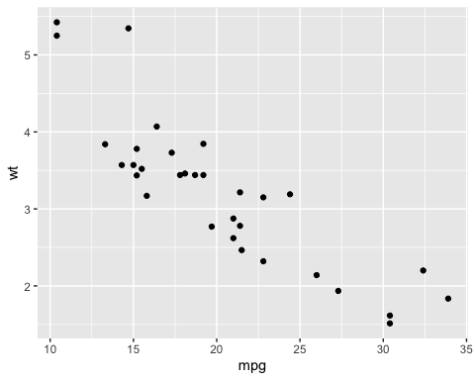

# Citations

Brusa, Anthony, Eric L Patterson, Todd A Gaines, Kevin Dorn, Philip Westra, Crystal D Sparks, and Don Wyse. 2021. “A Needle in a Seedstack: An Improved Method for Detection of Rare Alleles in Bulk Seed Testing Through KASP.” *Pest Management Science* 77 (5): 2477–84.

Kreiner, Julia M, John R Stinchcombe, and Stephen I Wright. 2018. “Population Genomics of Herbicide Resistance: Adaptation via Evolutionary Rescue.” *Annual Review of Plant Biology* 69: 611–35.