Topaze Publishing

A Python / Pandoc based publishing system

Version v1.0 (28 Oct 2022)

Topaze Publishing (“TP”) is a collection of Python libraries destined to create beautiful and modular papers, mostly from augmented markdown sources, ie markdown files with a yaml header for metadata. The python libraries mostly deal with the creation of the aggregated and augmented markdown file, and possibly its conversion to html. They then invoke pandoc for conversion into other formats, including Word, LaTeX and ultimately pdf.

* Stefan Loesch [stefan@topaze.blue](mailto:stefan@topaze.blue)
* Oscar D Torson [oscar@topaze.blue](mailto:oscar@topaze.blue)

# Section: Overview

## Introduction

This document is mostly a destined to show the different options of how documents can be created. Before we have a look at the document so far we briefly want to mention how documents are created: key to this is Convert.py in the code directory, or Convert.ipynb. Those two files are equivalent and kept in synch by JupyText. Note that whilst Convert.py can be run in a Python interpreter it will fail if not run in a proper Jupyter environment as we are using the bang-execution framework, eg !pandoc to execute pandoc.

Up to here we have already seen the following features

* documents are assembled according to their tags; eg tags: DocPaper unites all the documents that are part of DocPaper; the files are assembled in lexical order, hence the prefix 000 or t000; a file with tags: DocPaper, OtherPaper would be part of both papers
* the document-wide metadata (in 000) that in particular sets key frontmatter items like title, subtitle, abstract, author(s), date and version; it also contains key LaTeX items under the latex key (see below)
* a custom title page (in 010), to be used for non-tex documents only (notex: true); it is a template (istemplate: true) which means that eg {title} will be replaced with the document title; tex documents
* two structure pages (in 100, 101), here specifically a section break (type: section) and a chapter break (type: chapter); a page break is included before (breakbefore: 1; this may or may not work in LaTeX)

The aforementioned items under the latex key are as follows:

* template: which template to use (the templates are in code/templates)
* fontsizea: eg 11pt
* geometry: eg a4paper
* stretch: eg 1.5 for line spacing

The first feature we see in this paper the WordTag feature where we include raw XML into the markdown that pandoc in term preserves in the generated Word documents (it ignores it when producing LaTeX). Wordtags are included with the following syntax

<!--WT=[ITEM]-->

where ITEM can be any of

* PAGEBREAK
* SECTIONBREAK

Other tags are planned, but have not been introduced yet. The code for this is in wordtags.py.

We can also include equations into the markdown, that pandoc then properly converts to Word (or to LaTeX, but this is trivial). Equations can be included literally, eg like here

$$E=mc^{2}$$

We are also providing a module (in formulalib.py) that allows to include formulas generated in Python via Sympy, typically in a Jupyter notebook (or in multiple Jupyter notebooks) that can be reused across multiple documents. Below is an example for an included equation

$$a^{2}+b^{2}=c^{2}$$

We can also include images using the markdown ![]() construct. In Word, those images will appear exactly where they have been placed. In LaTeX, they will float and the text in [.] will be the figure caption that can be used to refer to them in the text.

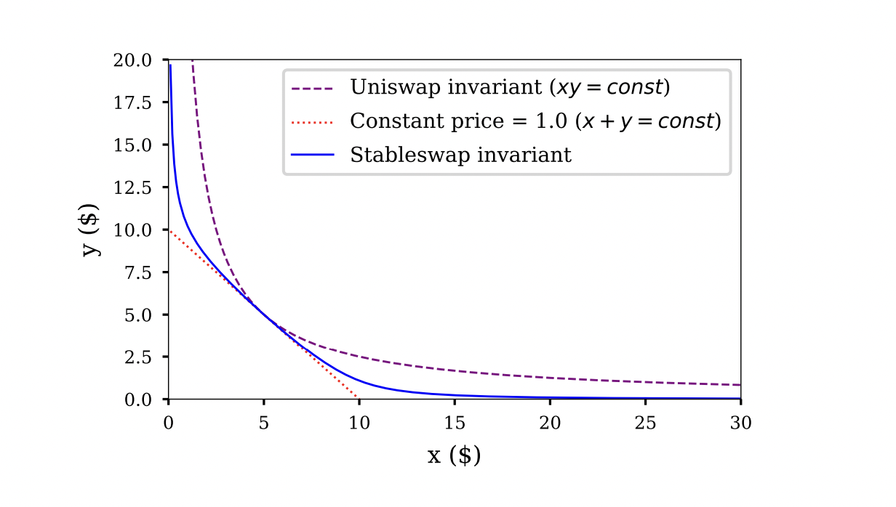

Example Image

In Word this text is after the image. In LaTeX, it will have the caption “Example Image”, but to where it will float is rather uncertain. Note that images will have to be in the src/_img (which means they’ll show up in VSCode linked preview) and Convert will copy them to out/_img. ATTENTION: out/_img will be cleaned up before every run. Do not store images there.

## After a section break

The above heading is preceded by a <!--wt=SECTIONBREAK-->. Now let’s do some lorem ipsum dolor sit amet, consectetur adipiscing elit. Nulla eu congue nulla. Nulla congue vel quam vitae convallis. Proin finibus congue orci eu ultricies. Curabitur tristique et justo eu fringilla.

Praesent tincidunt tellus sit amet leo euismod efficitur. Pellentesque habitant morbi tristique senectus et netus et malesuada fames ac turpis egestas. Vestibulum in turpis sed leo tincidunt dictum quis eu mi. Sed molestie ligula eget dignissim viverra.

Ut pulvinar lorem sit amet metus condimentum bibendum. Vestibulum egestas ut erat sed scelerisque. Aliquam eget lectus sit amet eros dignissim dapibus. Phasellus quis orci diam. Pellentesque et tempus tortor. Duis mollis efficitur nisi nec commodo. Vestibulum bibendum risus id diam ultricies congue. Vivamus et mollis lectus.

* Suspendisse fringilla erat enim, id iaculis eros ultricies et. Fusce consectetur nisi vel venenatis tincidunt. Aenean cursus ante ut accumsan fringilla.
* Nam posuere quam a feugiat varius. Curabitur ullamcorper vehicula justo sit amet convallis.
* Proin a nisl ut elit fringilla maximus sollicitudin ac libero. Maecenas molestie diam sem, vitae ultricies magna efficitur sed.

Aliquam erat volutpat. Maecenas vehicula augue purus, a dapibus justo accumsan non. Phasellus faucibus finibus tristique. Duis cursus porttitor nibh. Aliquam nec est metus. Ut eu lacus in ante luctus volutpat. Nulla eget tincidunt quam, nec semper arcu. Nulla arcu massa, posuere non leo eu, mollis egestas ligula.

### After a page break

The above heading is preceded by a <!--wt=PAGEBREAK-->. More of the lorem ipsum pellentesque consequat malesuada erat sit amet aliquam. Ut mattis arcu nec ipsum luctus, et auctor eros cursus. Curabitur varius vulputate purus, non eleifend dui dapibus vel. Quisque eleifend massa vel nulla convallis luctus. Etiam dignissim vel diam quis commodo.

Nulla tristique nulla ut arcu iaculis, ac tempus sapien laoreet. Quisque et dui sit amet mi dapibus aliquet. Nam sit amet lectus quis urna venenatis mattis. Morbi mattis, diam vehicula gravida iaculis, ante eros maximus neque, a tristique nunc sapien sit amet leo.

In hac habitasse platea dictumst.  
Vestibulum eu ligula at sapien tincidunt.  
Interdum et malesuada fames ac ante.  
Ipsum primis in faucibus fusce.

Nam ut interdum risus, nec feugiat nisl. Sed vestibulum dui eget aliquam dictum. Phasellus imperdiet sem massa. Integer tincidunt nisi elit, eget consequat mauris tristique id.

### After another page break

The above heading is preceded by a <!--wt=BREAK:page-->. More lorem ipsum dolor sit amet, consectetur adipiscing elit. Proin at lobortis orci, quis rhoncus ipsum. Nam vitae diam vel nisl euismod bibendum. Mauris a odio nisi. Mauris vestibulum eu arcu sodales efficitur. Vivamus sagittis varius turpis sed accumsan. Nunc interdum nunc vel tellus mattis, ut suscipit elit varius. Etiam sed diam sem.

1. Vestibulum in diam eget metus tristique vestibulum. Integer semper purus in ultricies cursus. Duis malesuada sagittis arcu, at consequat tortor iaculis ut. Nam id est nunc.
2. In odio magna, cursus ac tempus et, mollis ac metus. Nulla bibendum est mollis, auctor tellus eget, hendrerit felis. Cras malesuada blandit ante, id rhoncus nunc efficitur non.
3. Quisque condimentum efficitur ligula, a molestie tortor mollis in. Nunc vulputate malesuada felis. Pellentesque pellentesque, orci vitae bibendum malesuada, ipsum neque facilisis eros, non dignissim felis lectus id elit. Nullam tincidunt elit commodo luctus suscipit.
4. Integer accumsan fringilla mi, a tempus diam. Nullam erat sapien, posuere et orci in, convallis tincidunt velit. Fusce tincidunt dictum libero, vitae tincidunt sapien bibendum eget.

Nunc ac egestas neque. Donec consequat viverra nunc a mattis. Phasellus finibus lorem id pulvinar tincidunt. Nulla vestibulum placerat eros ut interdum. Aliquam accumsan hendrerit augue, eget fermentum sem volutpat vitae. Aliquam volutpat scelerisque lorem. Sed ultricies, felis vitae pharetra tempus, nunc erat ornare metus, sed placerat nibh mi vel mauris.

## Equation testing

This sections is testing equation tags of the form $$!=ERROR[...]=$$

Lorem ipsum dolor sit amet, consectetur adipiscing elit. Integer sit amet enim vitae nibh commodo tincidunt. Nam et felis enim. Etiam blandit et neque et faucibus. Pellentesque habitant morbi tristique senectus et netus et malesuada fames ac turpis egestas. Sed sed vestibulum mauris, vitae ultrices odio. Maecenas sodales porta ex, et dapibus ante eleifend vel.

$$a^{2}+b^{2}=c^{2}$$

The above equation has no namespace, hence the ID is PythagorasE.

Sed tempus mi viverra suscipit ultrices. Ut finibus tortor risus, quis dictum nisi gravida quis. Donec malesuada velit vitae aliquet dignissim. Vestibulum ante ipsum primis in faucibus orci luctus et ultrices posuere cubilia curae; Sed ut mauris ante. Mauris et maximus ante, blandit elementum lacus. Donec sagittis nibh tortor, at commodo nibh commodo ac.

$$b=−\sqrt{−a^{2}+c^{2}}$$

This equation is imported from the second notebook, and as there were overlapping names we prefaced the import in Context.py with the f2 namespace, so the ID of this equation is f2.PythagorasBE.

The code in Context.py reads as follows

# import formulas without namespace  
from src.TestFormulas1 import FORMULAS   
  
# import formulas into temp location...   
from src.TestFormulas2 import FORMULAS as _FORMULAS2   
  
# ...and add them with namespace f2   
FORMULAS.addfrom(_FORMULAS2, ns="f2")

Aenean feugiat vulputate odio id gravida. Praesent ac tellus sed tellus varius sodales non eu lacus. Donec venenatis metus eget turpis accumsan varius. Vestibulum bibendum leo non malesuada porta. Donec condimentum tempus dolor vel rutrum. Ut et quam rutrum, volutpat orci at, pharetra diam.

Here we show the same equation ID (and incidentally the same equation, but that does not necessarily have to be the case) using two different namespaces.

$$E=c^{2}m$$

Nulla vitae mauris nisi. Morbi nec neque sodales ipsum malesuada fringilla. Quisque rhoncus at nisi eget commodo. Donec rutrum at ipsum a pellentesque. Nullam porta pulvinar elementum. Integer et magna lectus. Quisque vulputate ligula in sapien venenatis auctor.

$$E=c^{2}m$$

Aenean a volutpat quam, ac ultrices nisl. Nam laoreet ex nec orci elementum, ut mattis justo venenatis. Cras mi velit, aliquet eu quam imperdiet, tincidunt sodales ipsum.

# Working with templates

In this file we are working with templates. For this to work we need istemplate: true. The metadata section of this file reads as follows

localmeta1: my local meta data item 1 localmeta2: my local meta data item 2

data: localdata1: my local data item 1 localdata2: my local data item 2

## Example template evaluations

* **localmeta1** from local meta data “my local meta data item 1” (it does **not** appear in the global data!)
* **localdata2** from the local data “my local data item 2” and from the global data “my local data item 2” (because it only appears in this file) and from the global data using kwargs “my local data item 2”
* **title** from global data (it is not defined in this file) “Topaze Publishing” and using kwargs “Topaze Publishing”
* **authors** as a list “[{‘name’: ‘Stefan Loesch’, ‘email’: ‘stefan@topaze.blue’}, {‘name’: ‘Oscar D Torson’, ‘email’: ‘oscar@topaze.blue’}]”
* the first author as dict “{‘name’: ‘Stefan Loesch’, ‘email’: ‘stefan@topaze.blue’}”
* the second author nicely formatted “Oscar D Torson [oscar@topaze.blue](mailto:oscar@topaze.blue)”

## Explaining datas and templates

### Data

Before we can understand templates, we need to understand what data is, and how it is handled. There are two types of data in this system, meta data (“metadata”) and data proper (“data”). The differences are as follow

1. **metadata**: metadata is local to a specific file, and whilst it can in principle be arbitrary data, it is mostly used to convey information about the file in question; for example, important metadata items are tags and istemplate, both of which being critical to how a specific file is treated
2. **data**: data is aggregated across all files into a single global dataset; the system does not make any further use of the data, other than providing it via the templating system as demonstrated above, and as explained below

For *regular files* (markdown etc), metadata is all data in the preamble yaml section, *except* the items that hang under the data entry itself: all those are considered data. For example the preamble of this file is as follows

tags: DocPaper  
  
istemplate: true  
  
localmeta1: my local meta data item 1  
localmeta2: my local meta data item 2  
  
data:  
 localdata1: my local data item 1  
 localdata2: my local data item 2

The items tags, istemplate and localmeta1/2 are metadata, with the first two being actively considered by the system. The items localdata1 and localdata2 are data, and they will be aggregated across the entire system

In *data file* (yaml extension), all data is considered data and aggregated globally. For example below are the data items of this document that, as we can see, contain information like the title and subtitle as well as version and date

tags: DocPaper  
  
version: "0.0"  
date: "13 Oct 2022"  
  
title: Topaze Blue Advisory  
subtitle: Advising on anything Defi

Note that technically the data for data files is also considered its meta data as we see above with the data item tags. This is somewhat inelegant as this means that the metadata of data files is also subject to aggregation, but in the grand scheme of things we do not care enough to change it.

### Data aggregation

A final word on **data aggregation**: the way it works is that data is collected in a single dict, starting from the front of the document and working one’s way through to the back. To the extent that there are no duplicate keys this does not matter, but if there are the later data replaces the earlier one. For structured data the result is undefined. What we mean with this is the following. Consider the following data in file 1

lorem:  
ipsum: 1  
dolor: 2

and the following data in the later file 2

lorem:  
 dolor: 20  
 sit: 30

In this case you can rely on the fact that the data from file 2 is present, ie dolor is 20 and sit is 30. However – you should not rely in ipsum being present in the final data (but also not on it *not* being there; it is undefined).

### Using templates

Templates are simple Python templates that are evaluated with .format. More specfically, if we assume that the local metadata and data are in lm and ld respectively, and the global data is in gd, then the call to format is exectuted as follows

template.format(_m=lm, _ld=ld, _d=gd, **gd)

This means that local meta data can be accesed in the template as {_m[item]} and local data as {_ld[item]}. Global data can be accessed either as {_d[item]} or simply as {item}. Note that unless it is overwritten at a later stage, local data will be included in the global dataset as well, so in most cases {item}, {_d[item]} and {_ld[item]} will be equivalent.

Here also a short reminder that templates allow for accessing structured data as well. For example, if lst is a list and dct is a dict in the global data, then {lst[0]} gets the first list item, and {dct[key]} accesses an element in the dict. Hierarchical access works as expected, eg {item[k1][1][k2]} would access and element that is part of a dict that is part of a list that in turn is part of a dict.

# References

## Sympy References

* The general SymPy documentation is [here](https://docs.sympy.org/latest/index.html)
* A very interesting article about upgrading SymPy to allow for more elegant evaluation is [here](https://awstip.com/customizing-pythons-sympy-for-easy-equation-manipulation-ca30b9d0dabf); the code is also on [github](https://github.com/mathcube7/customize-sympy/blob/main/customizer.py)