Topcoder - TCO Scoreboard

Verification Guide

# Setup

Follow /community-app/README.md . Note there are additional notes in the “Configuration for Scoreboard” section.

# Postman Verification

Import postman collection/environment from \community-app\docs\scoreboard

Setup the postman environment token. This can be taken by logging in to <http://local.topcoder-dev.com:3000/> and looking at the console. You can use amy_admin/topcoder1 as credentials.

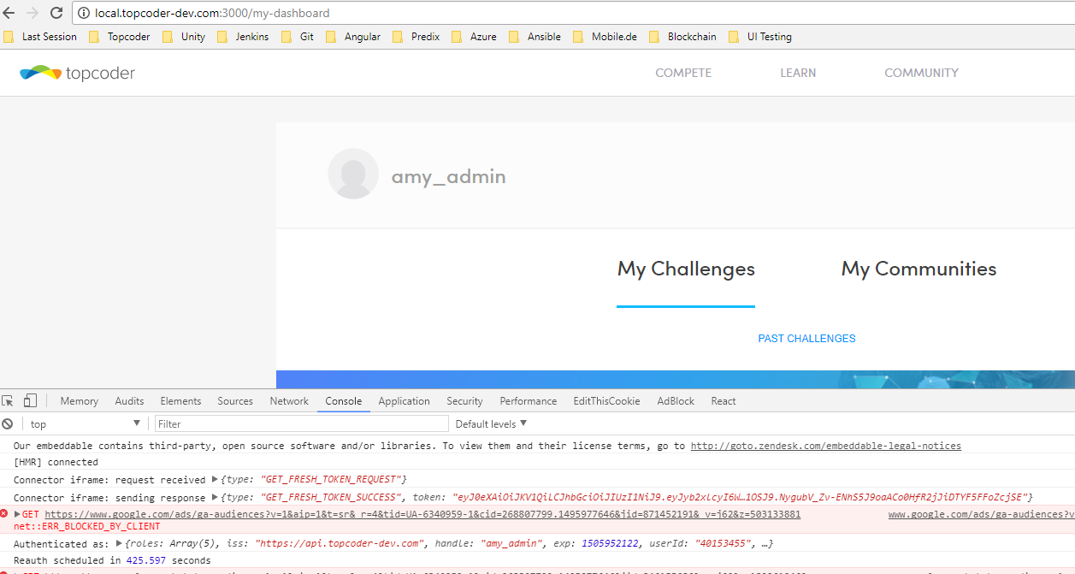

## Challenge

### 2.1.2 Get

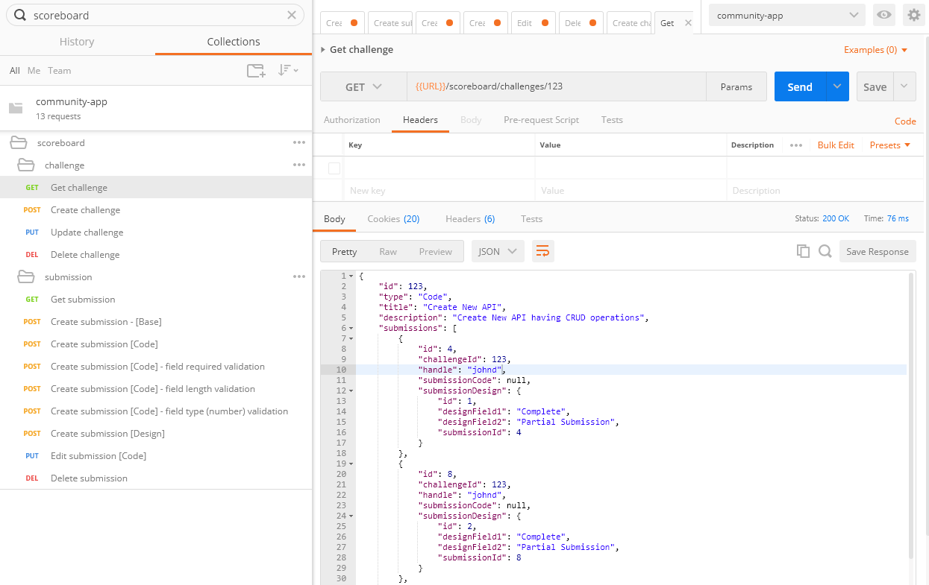

### 2.1.2 Create

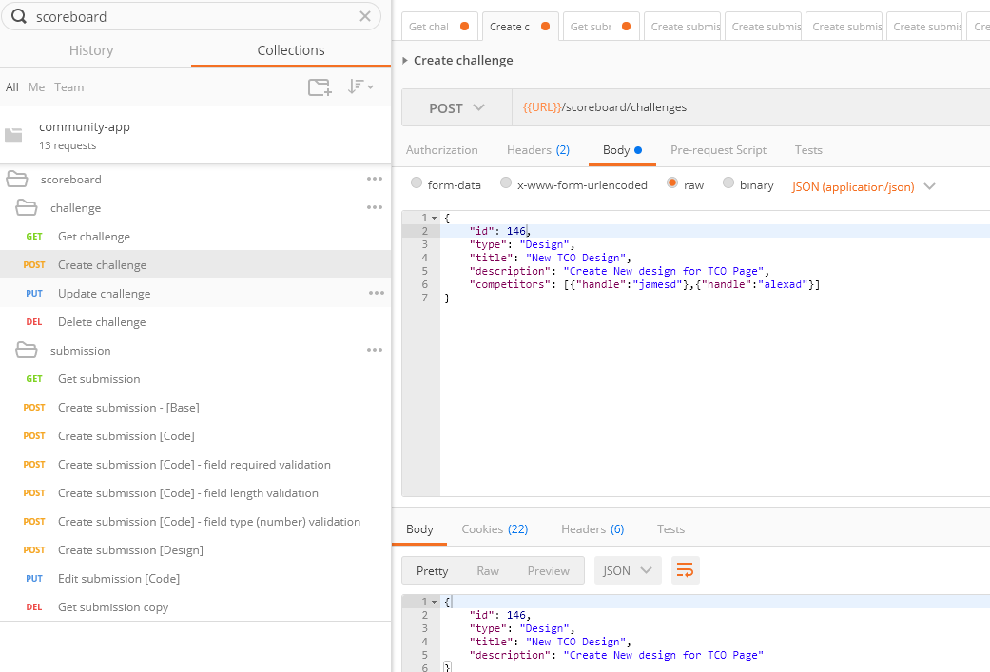

Token expiration sample

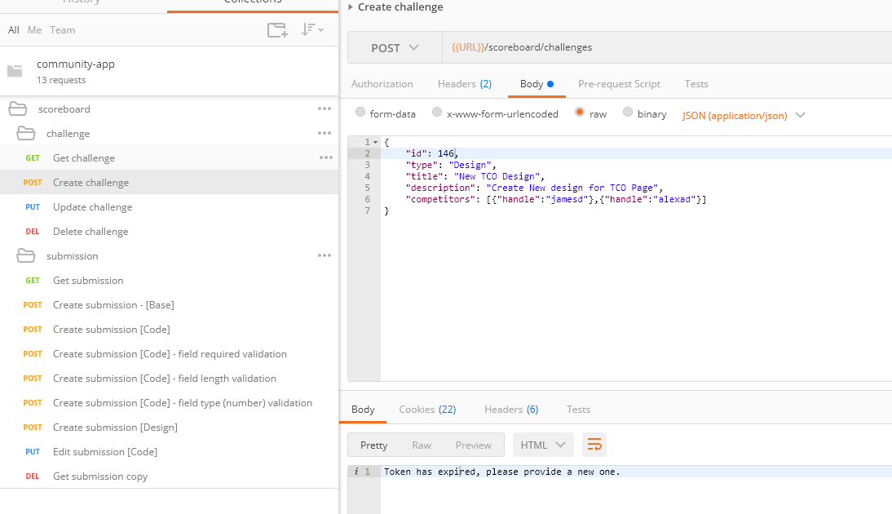

### 2.1.3 Update

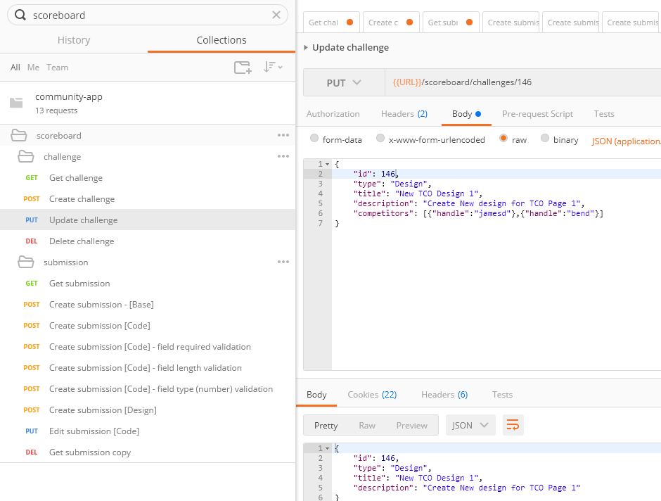

Checking saving was done correctly:

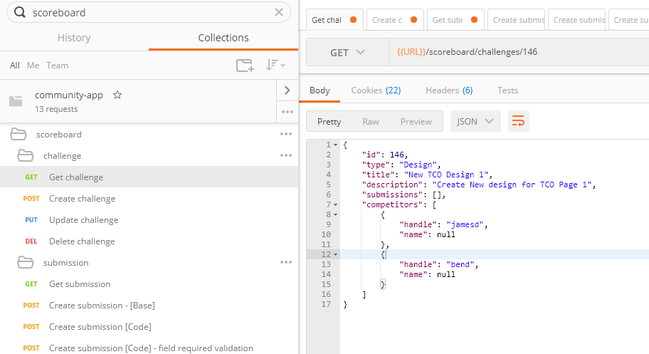

### 2.1.4 Delete

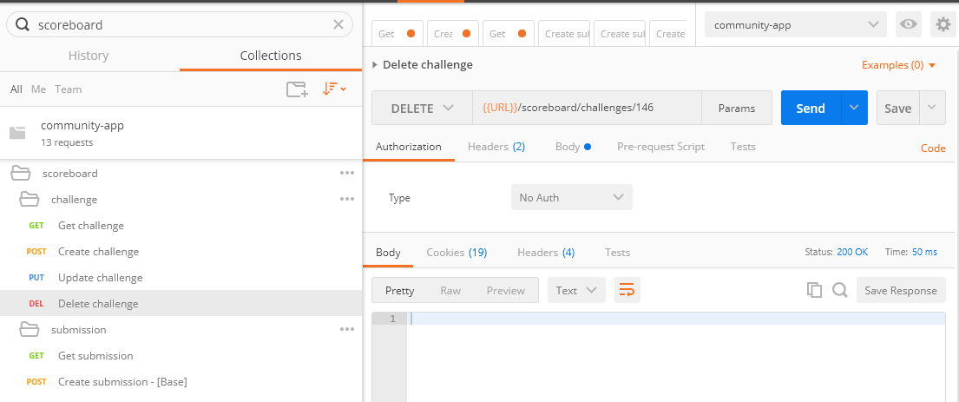

Verification with get:

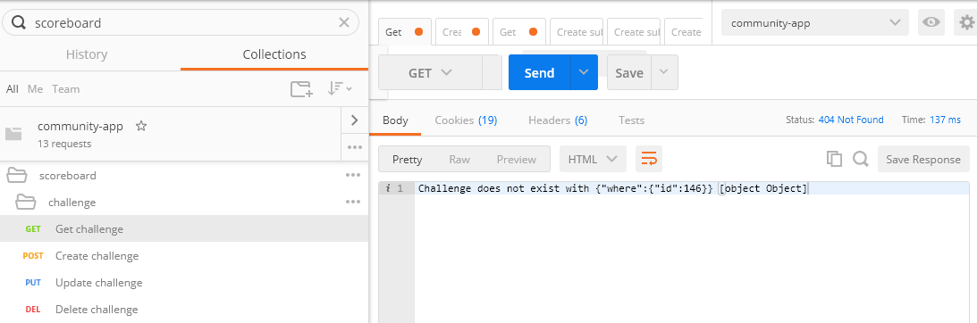

## Submission

### Get

Retrieve a simple/base submission:

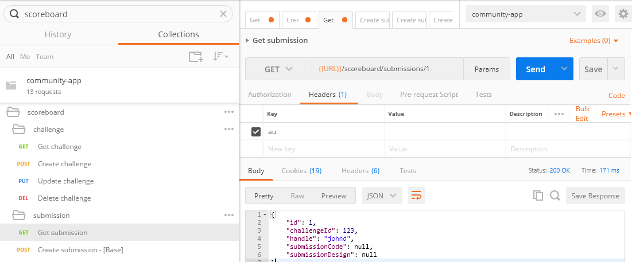

### Create

#### Create simple/base submission:

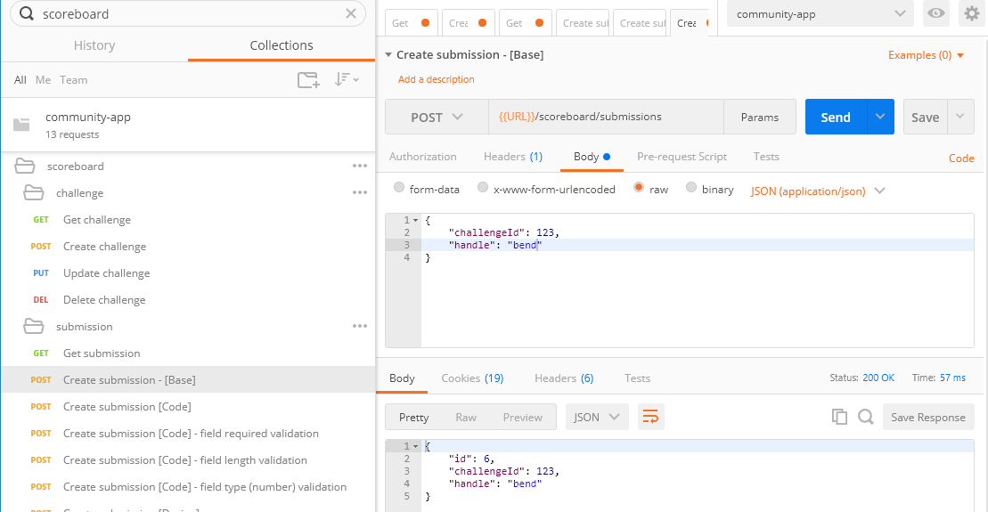

#### Create submission with code type/template

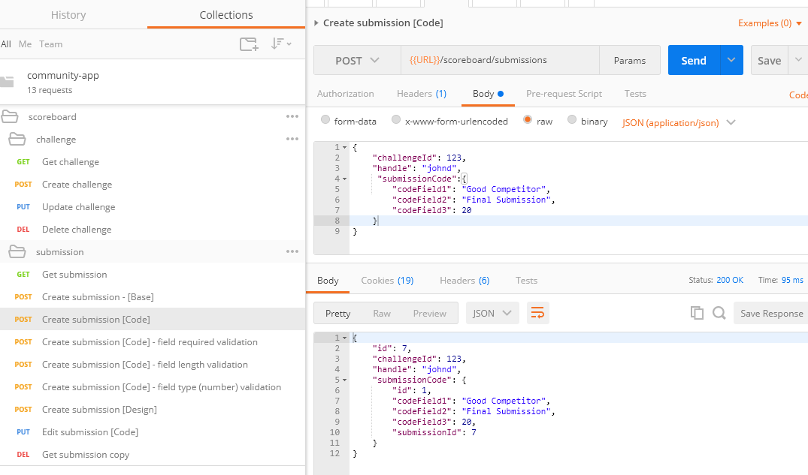

#### Create submission Field validation (taken from /server/tco/scoreboard/config/submissionCodeFields.json)

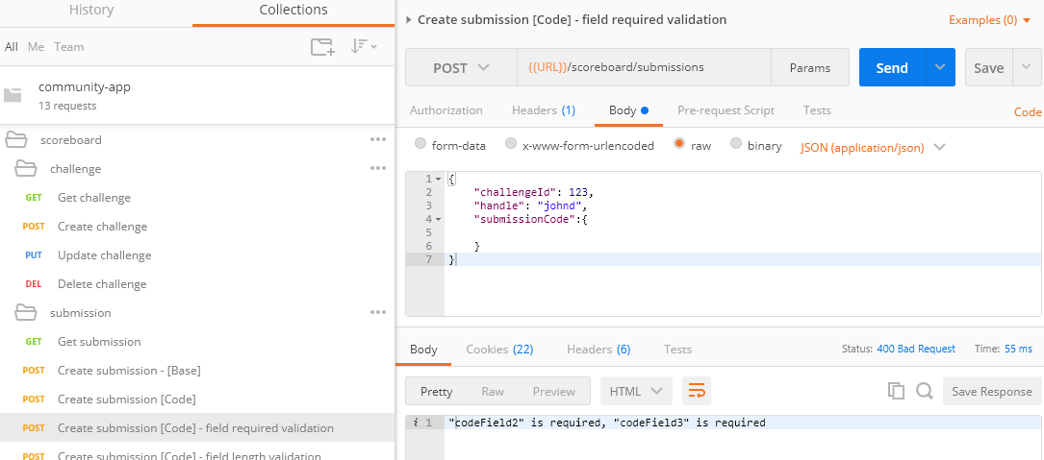

#### Create submission Field length validation

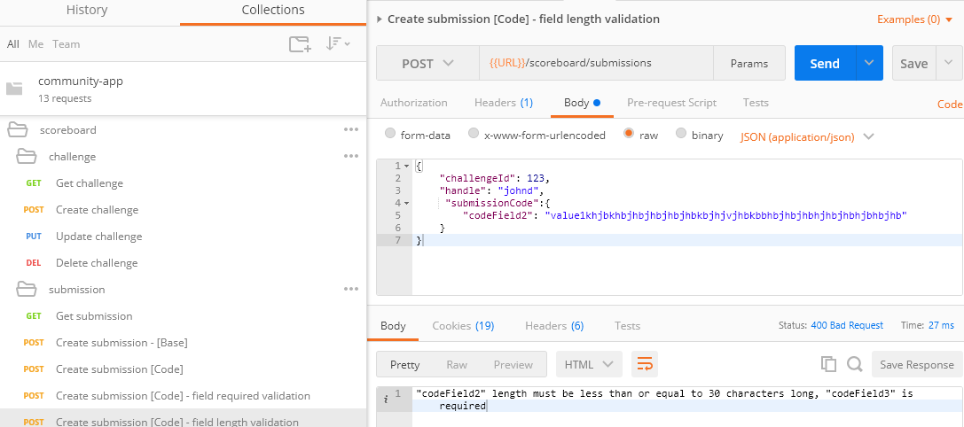

#### Create submission Field type (number) validation

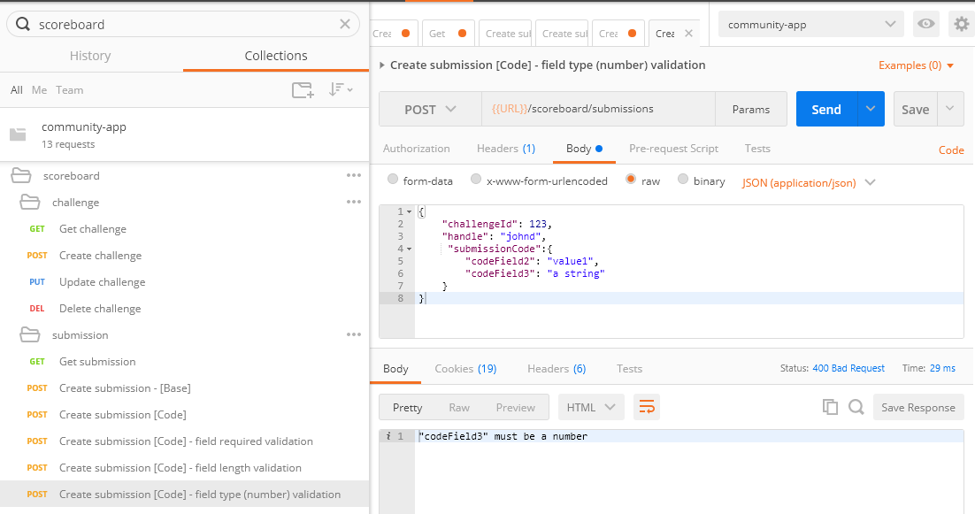

#### Create submission with design type/template

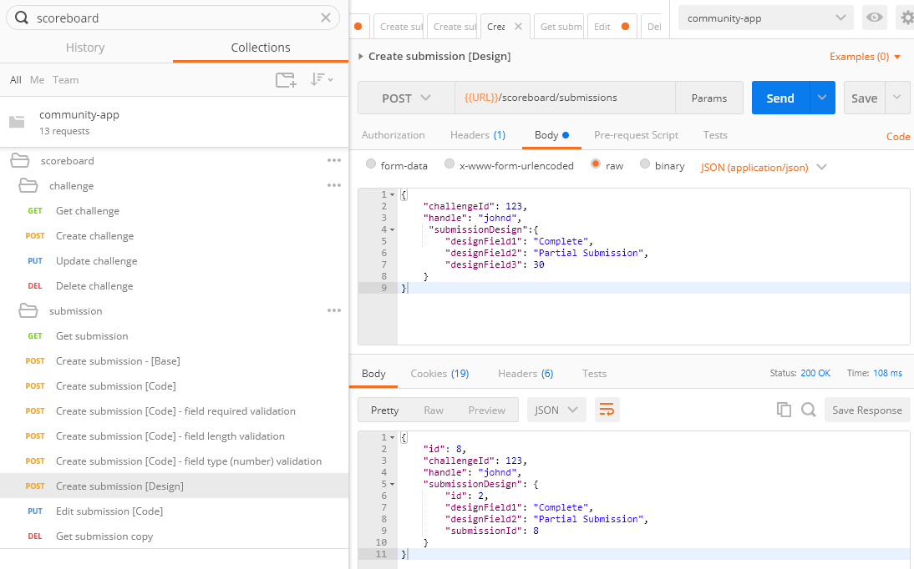

### Update

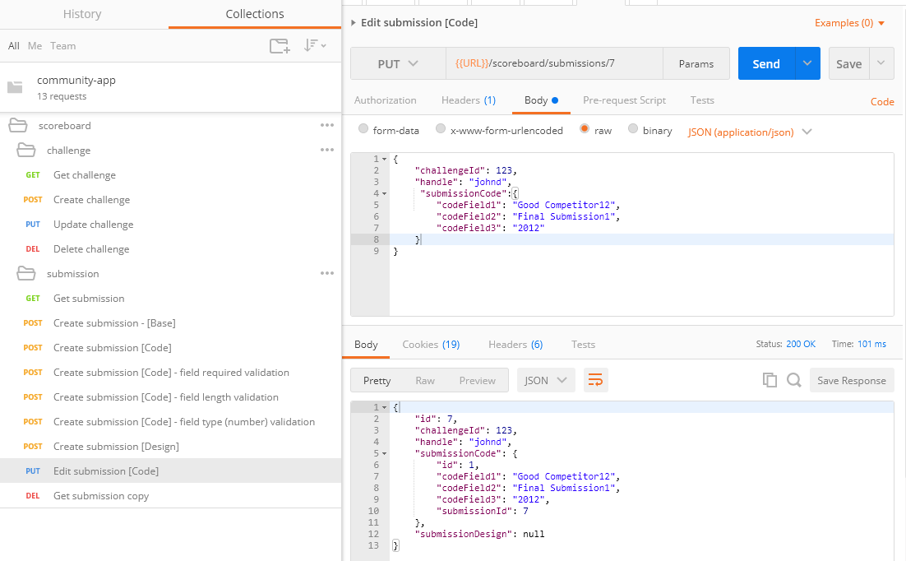

### 2.2.4 Delete

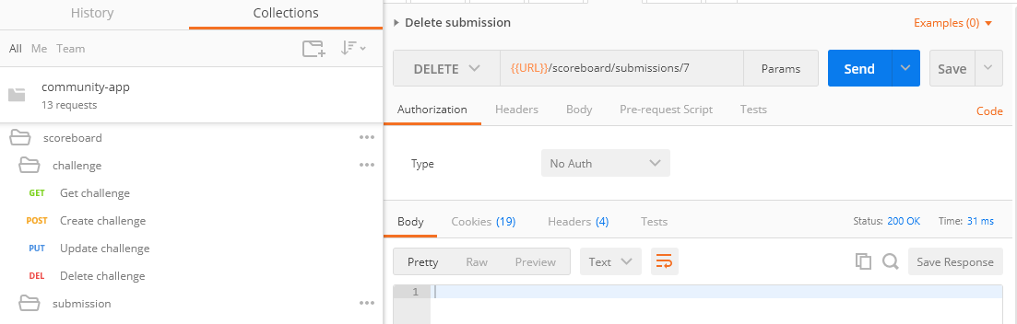

# Public Page Verification

Add a Code Challenge and a few submissions to it and you will see the below table.

The fields are loaded dynamically based on configuration (/server/tco/scoreboard/config/submissionCodeFields.json and /server/tco/scoreboard/config/submissionDesignFields.json.)

By default challenge ID 123 is setup for Code and 1234 for Design.

Note that when creating data, you can add submissions only for the handles associated with the challenge.

Code:

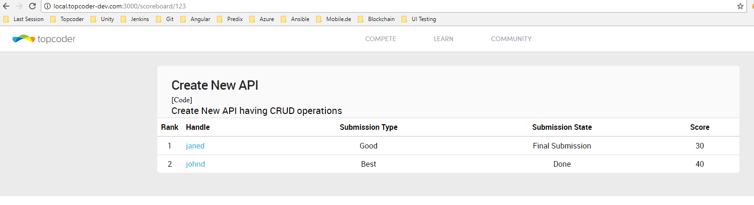

Design:

