**Topcoder Alexa Chatbot PoC**

***Setup Guide***

Revision History

|  |  |  |
| --- | --- | --- |
| **Author** | **Revision Number** | **Date** |
| TCSCODER | 1.0 | 2019-01-17 |
|  |  |  |

1. Introduction 3

2. Details 3

2.1 Skill setup 3

2.2 Lambda function setup 6

2.3 Connect Lambda Function to Skill 10

# Introduction

The main goal of this guide is to provide a step by step setup guide, to activate the Alexa Bot contained inside this submission.

# Details

There are two prerequisites for a correct setup of the provided Alexa Bot:

1. Valid Amazon account on [https://developer.amazon.com](https://developer.amazon.com/) used to setup the skill
2. Valid AWS account on [https://aws.amazon.com](https://aws.amazon.com/) used to setup the lambda function

## 2.1 Skill setup

A new skill needs to be created according to the following steps:

1. Go to <https://developer.amazon.com/alexa-skills-kit> , sign in with your Amazon account and click on the “**Start a Skill**” button.

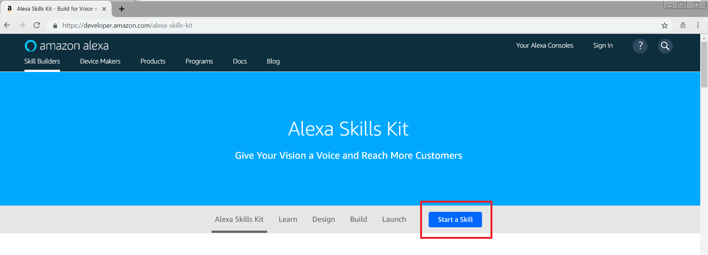

1. Click on “**Create skill**” button

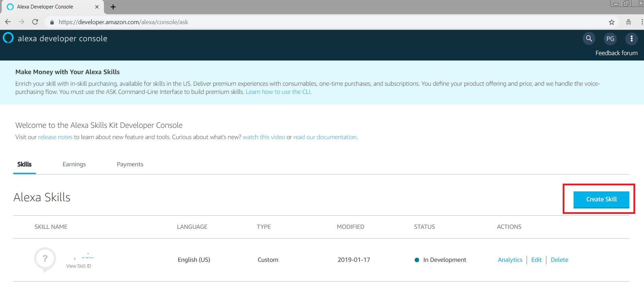

1. Enter the skill name of your choice, ensure that Custom model is selected and click on “**Create skill**” button

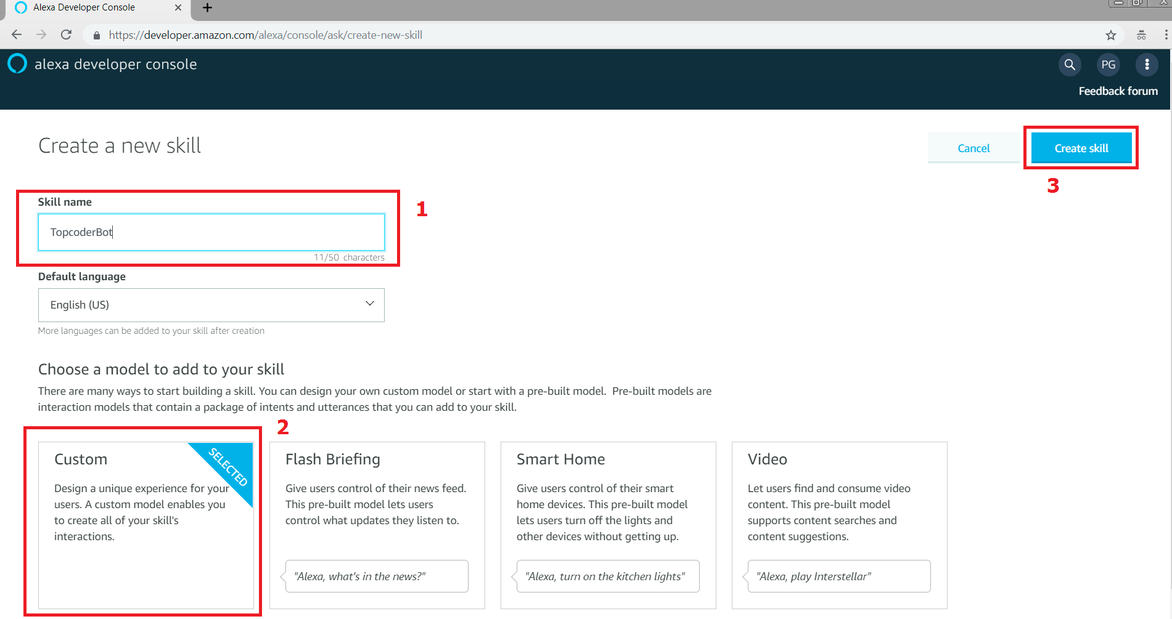

1. Choose “**Start from scratch**” template and click on “**Choose**” button

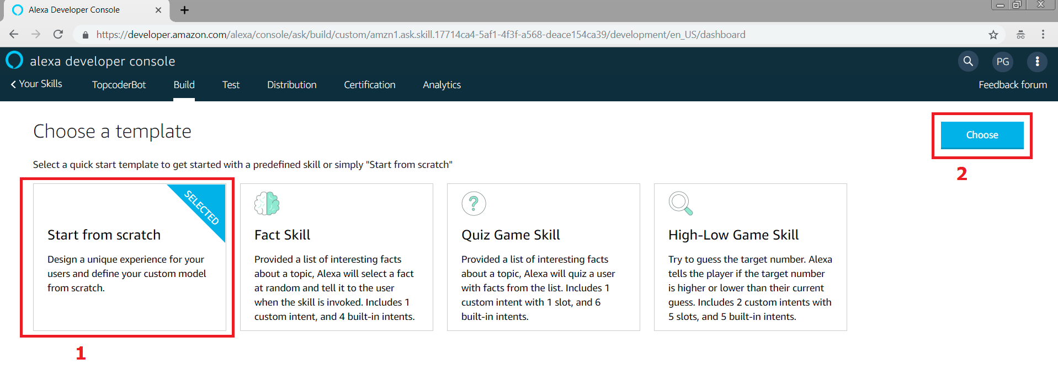

1. Click on “**Json Editor**”

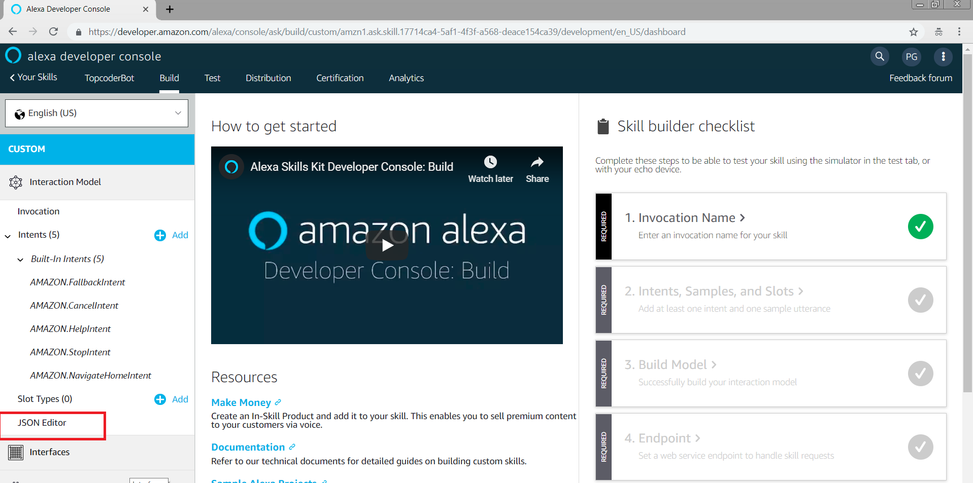

1. Click on “**Drag and drop a json file**” and load the file **skill.json** located in the *src/alexa* folder, then click on “**Save Model**” button

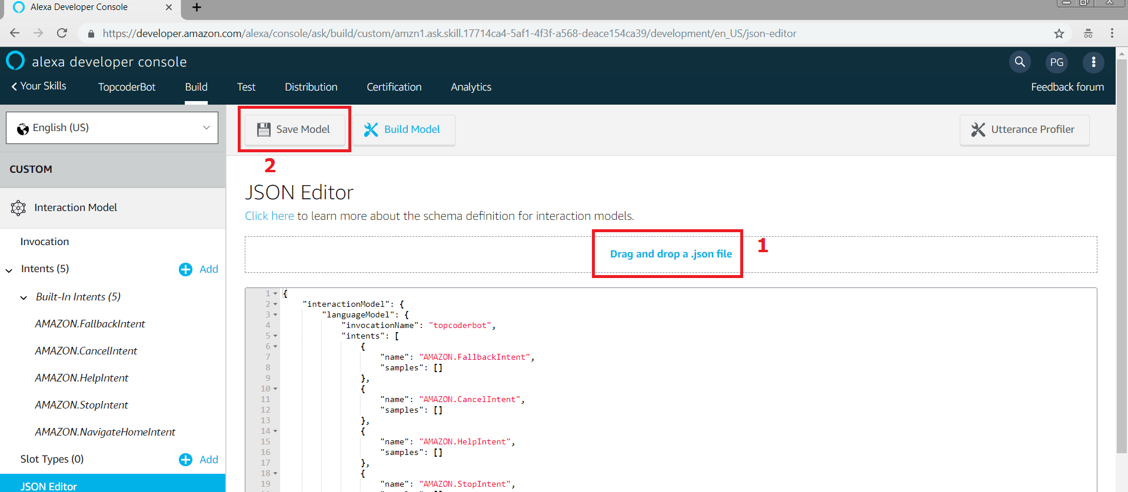

1. Click on “**Endpoint**”, select **AWS Lambda ARN** and copy “Your Skill ID” value. It will be used to connect the lambda function to this skill

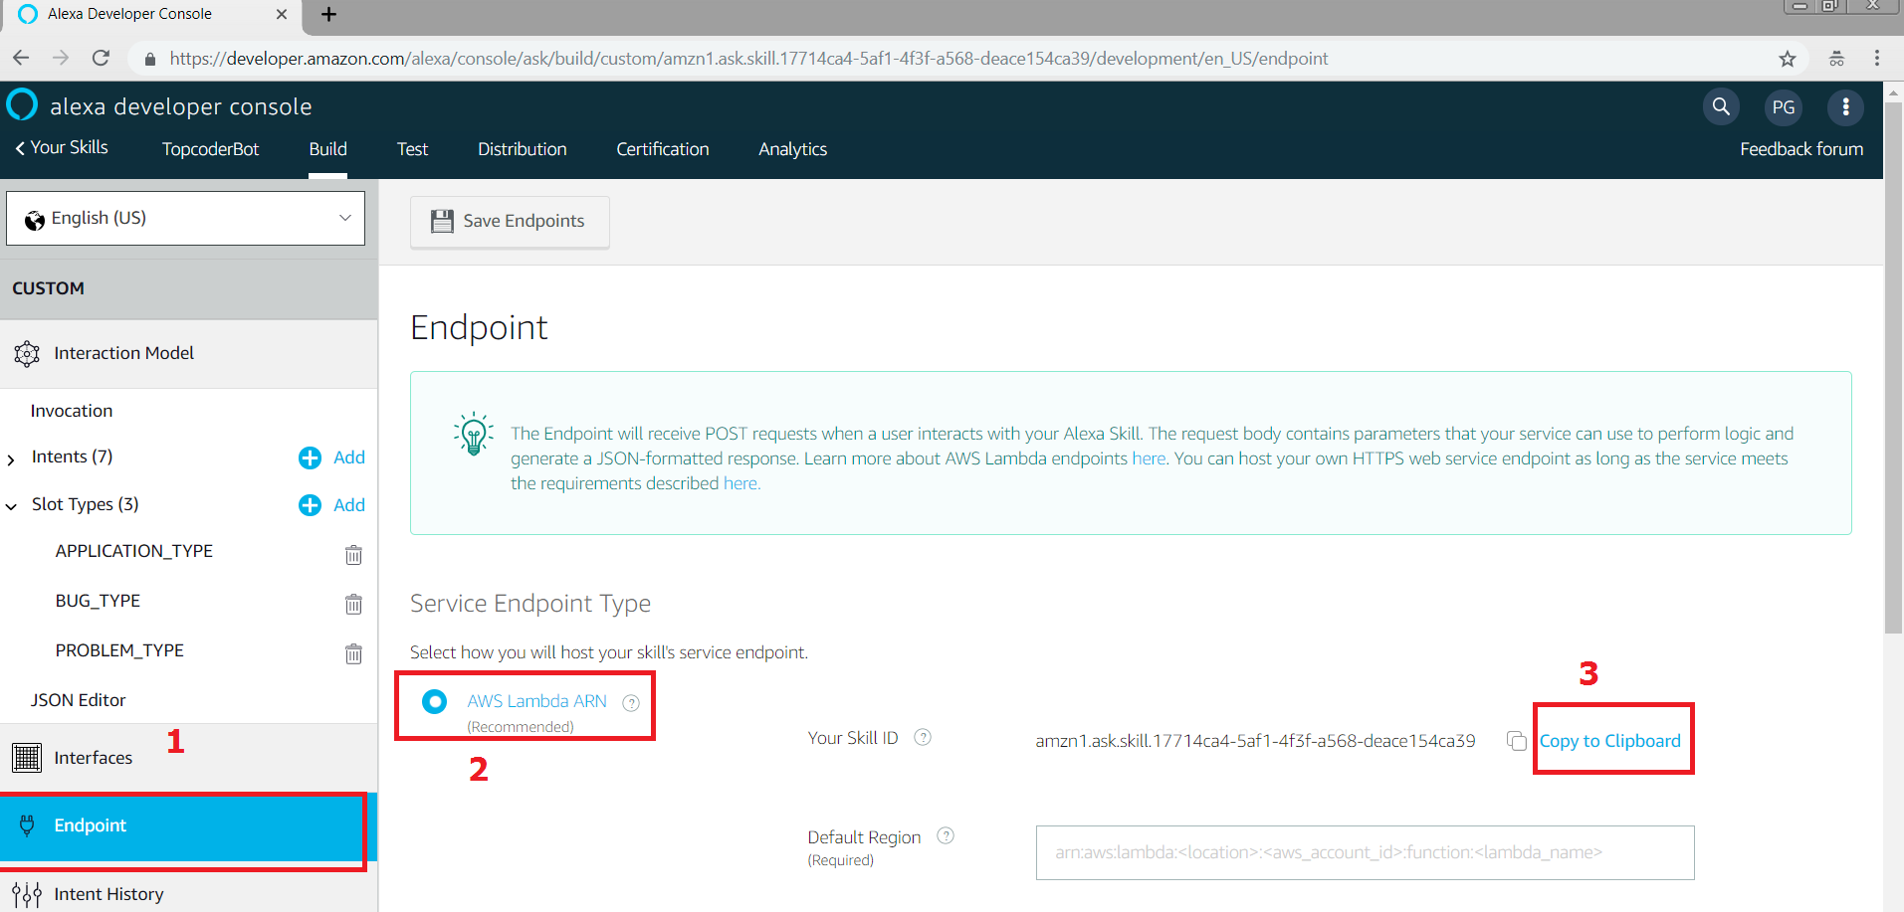

## 2.2 Lambda function setup

A lambda function needs to be created, according to the following steps:

1. Go [https://console.aws.amazon.com](https://console.aws.amazon.com/) , sign in with your AWS account, input the keyword “**lambda**” in the search bar and press **ENTER** button of the keyboard

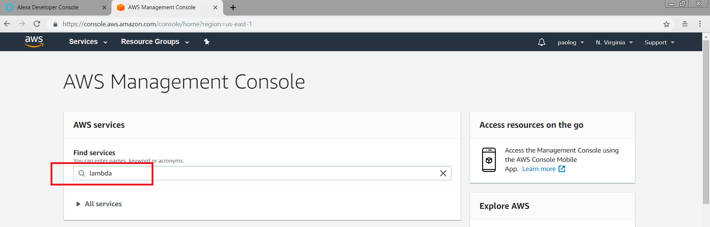

1. Click “**Create function**” button

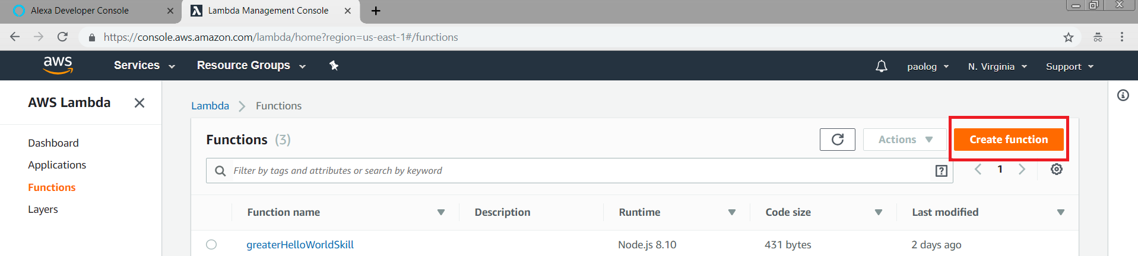

1. Input a **function name** of your choice, select **Node.js 8.10** runtime, select “**Choose an existing role**” role, choose “**lambda_basic_execution**” role and press “**Create function**” button (please note that if this is the first use of the AWS console, we need to create role “lambda_basic_execution”. For details, please refer to AWS documentation).

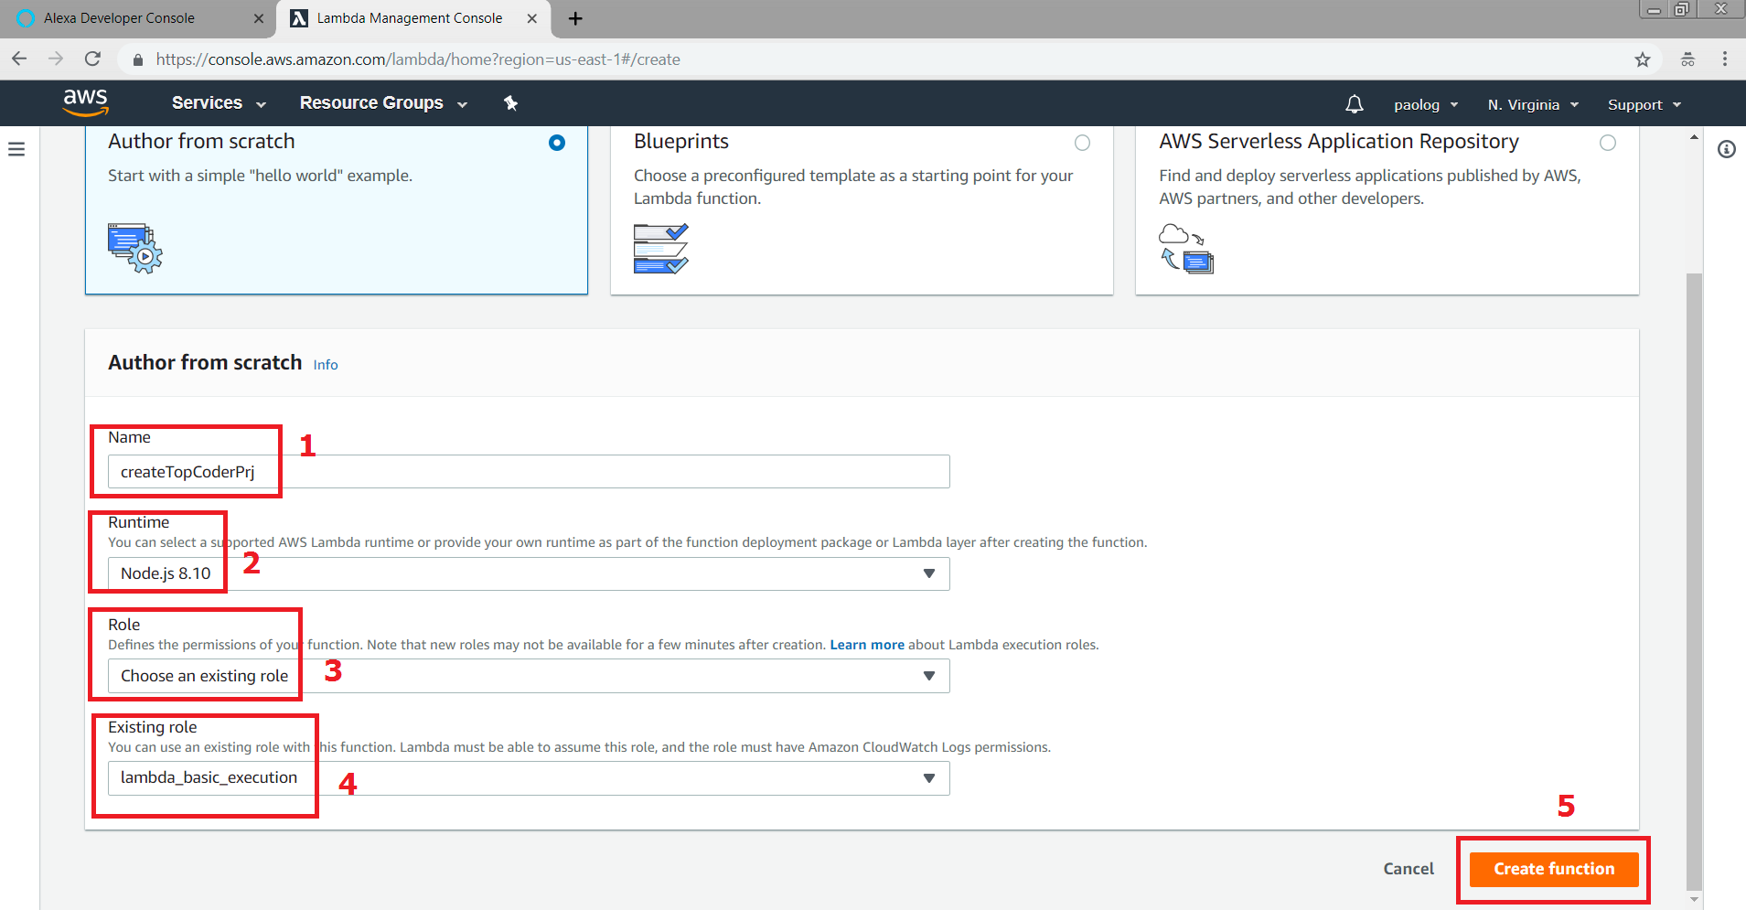

1. Click on “**Alexa Skills Kit**”

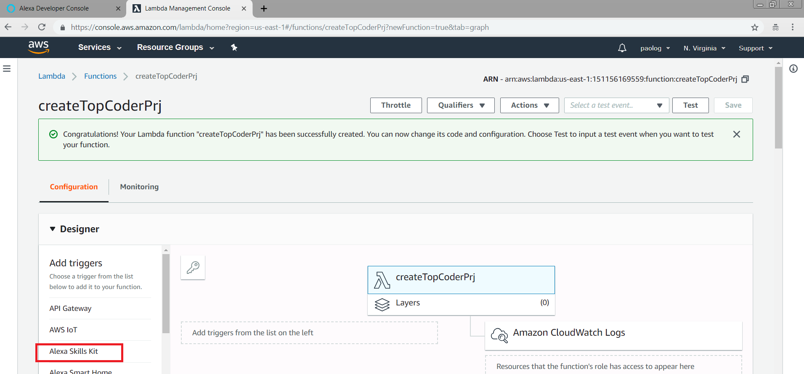

1. Click on “**Configuration required**”

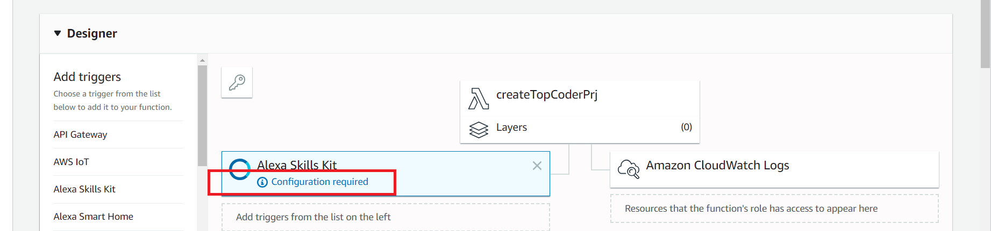

1. Input the **Skill ID** copied in the last step of section 2.1, then click on “**Add**” button

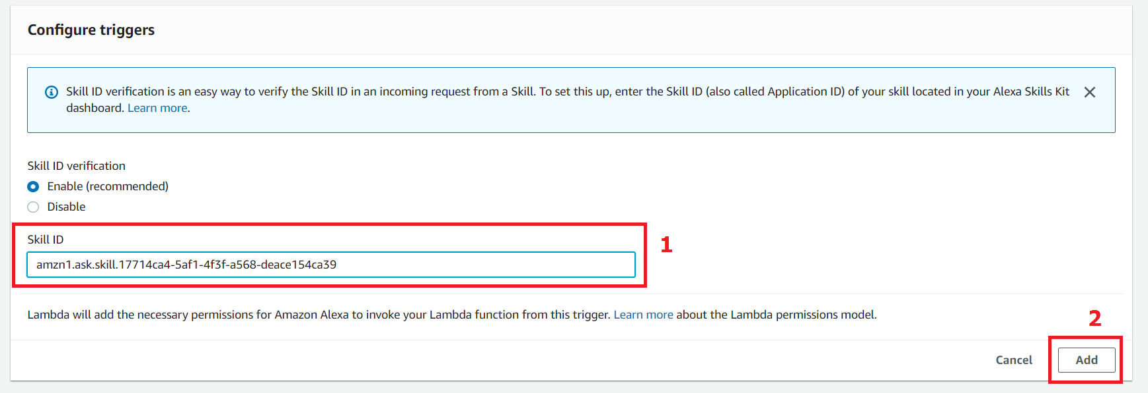

1. Click on your lambda function name and go to the inline editor in the bottom part of the page, copy the source code from the file **index.js** located in the *src/lambda* folder and replace the existing code, then click “**Save**” button

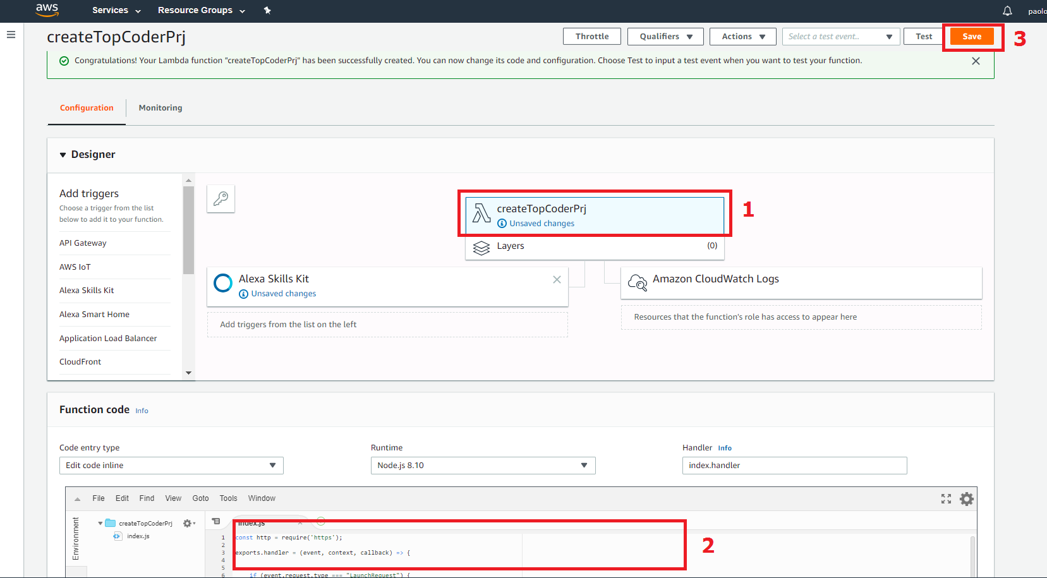

1. Go to the “**Environment variables**” section and insert the following variables and values, then click “**Save**” button:

* TOPCODER_BEARER_TOKEN=<bearer token> // The token needed to make the API call to Topcoder connect
* TOPCODER_HOSTNAME= api.topcoder-dev.com // Endpoint to create the project in Topcoder connect
* TOPCODER_METHOD= POST
* TOPCODER_PATH= /v4/projects
* TOPCODER_PORT=443

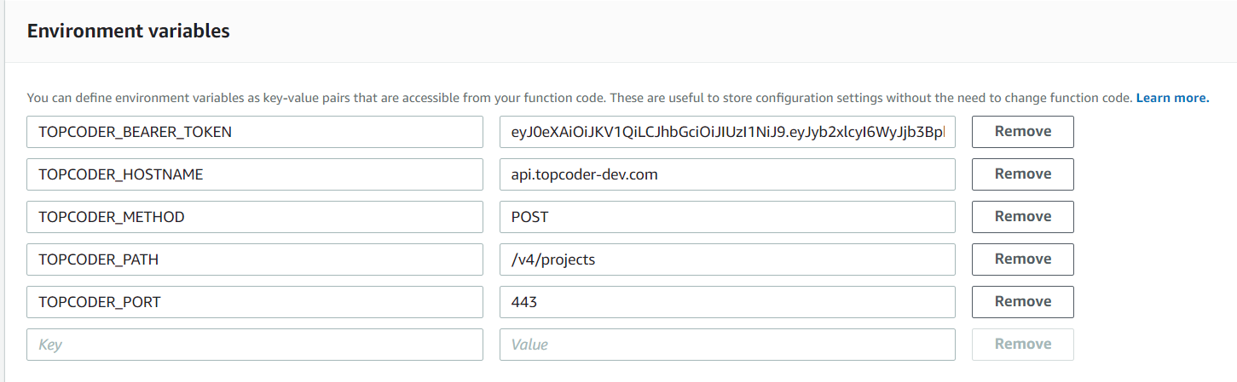

1. Note for reviewers: the bearer token expires after 15 minutes, please consider this info while testing. For details regarding how to get the bearer token, please check this thread <https://apps.topcoder.com/forums/?module=Thread&threadID=929947&start=0>
2. Copy the ARN value. This value will be used in section 2.3

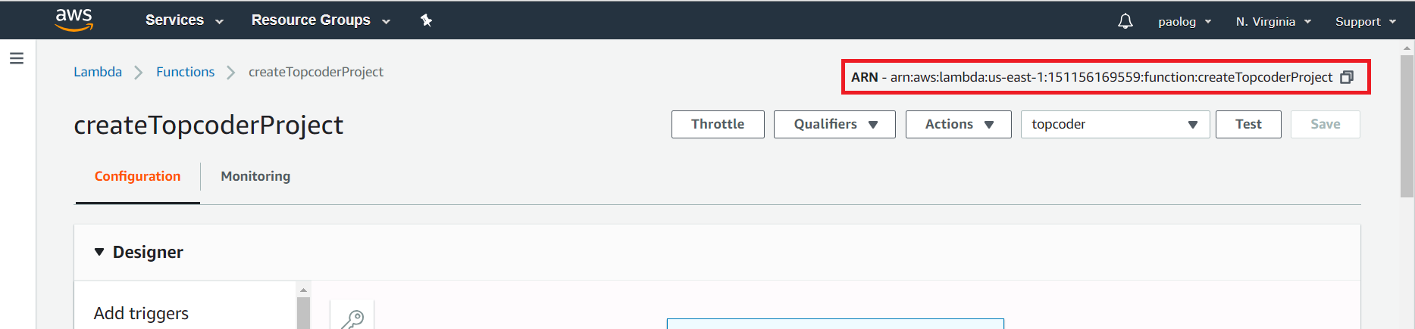

## 2.3 Connect Lambda Function to Skill

Follow the following steps:

1. Return to <https://developer.amazon.com/alexa-skills-kit> , sign in with your Amazon account and click on the “**Start a Skill**” button as shown in section 2.1
2. Select “TopcoderBot” from the list (the Skill name may be different depending on your choices in section 2.1

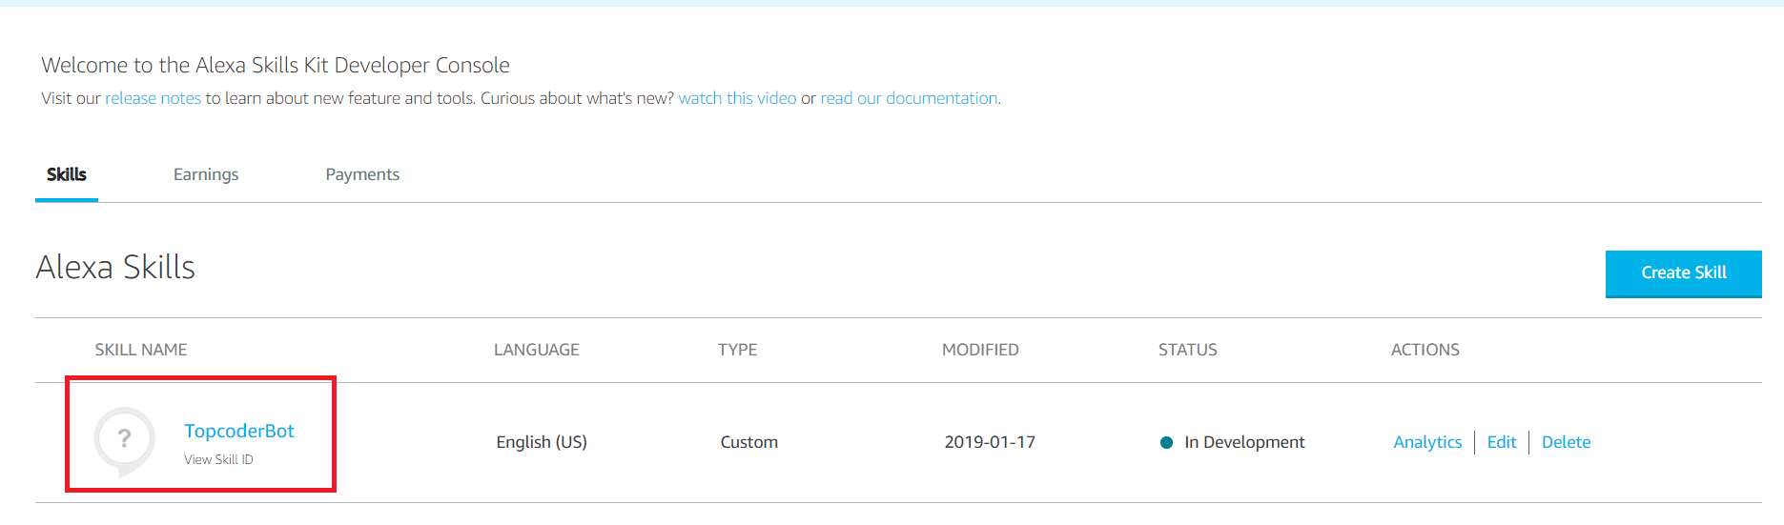

1. Click on “Endpoint”

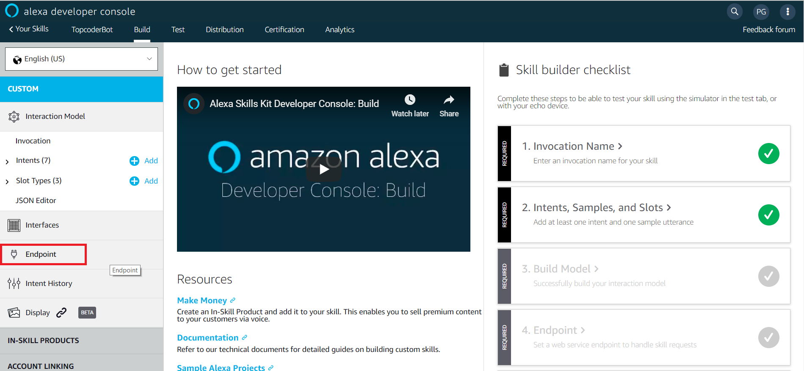

1. Select **AWS Lambda ARN** and paste the Lambda function ARN value copied at section 2.2 into “**Default Regio**n” field, then click on “**Save Endpoints**” button. After saving the endpoint, click on “**CUSTOM**” in the sidebar

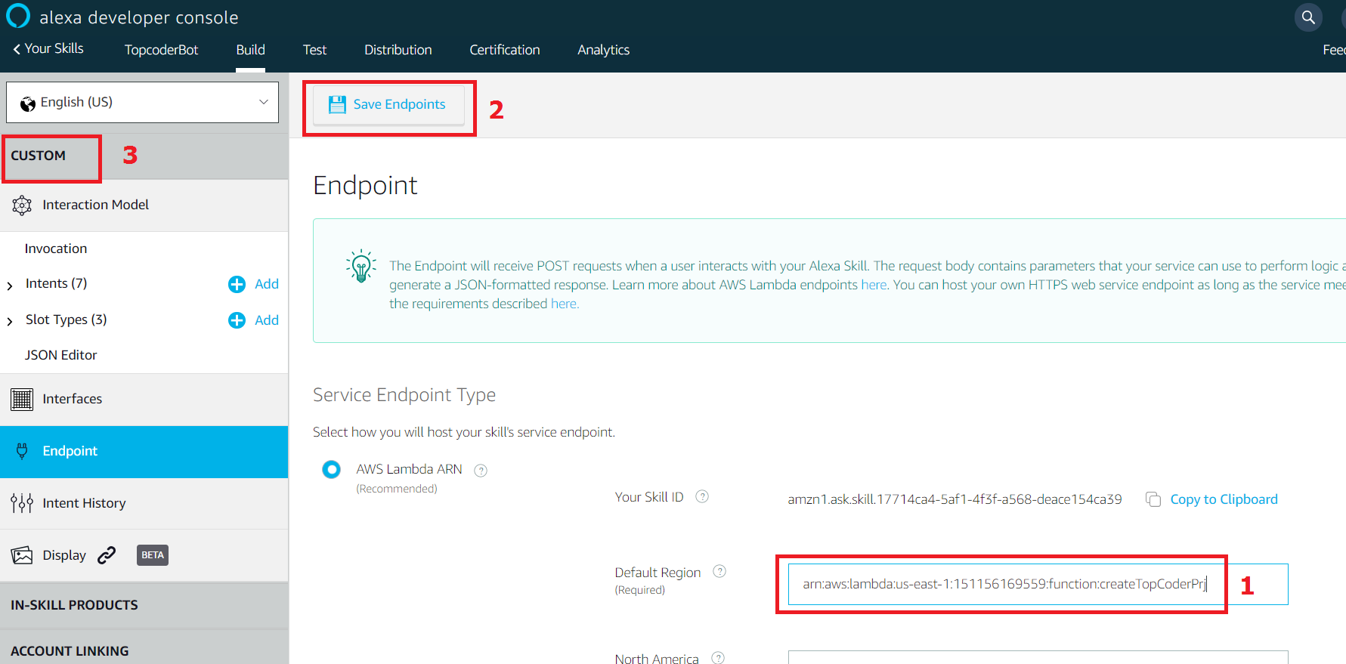

1. Click on “**Build model**”

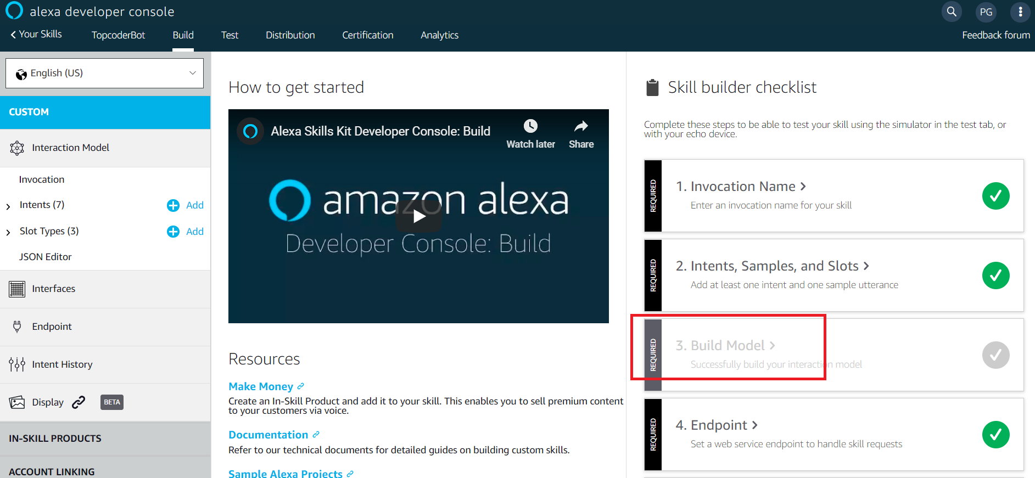

1. Wait until the end of the build

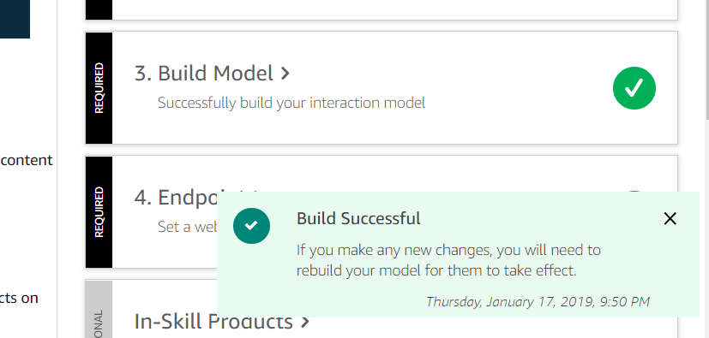

The setup is now complete. Please check the Verification Guide (**Verification.docx** in folder docs of this submission) for details on testing this bot.