**Topcoder Alexa Chatbot PoC**

***Verification Guide***

Revision History

|  |  |  |
| --- | --- | --- |
| **Author** | **Revision Number** | **Date** |
| TCSCODER | 1.0 | 2019-01-17 |
|  |  |  |

1. Introduction 3

2. Verification 3

2.1 Set bearer token 3

2.2 Test the bot 3

# Introduction

The main goal of this guide is to provide a step by step testing path, for verification purposes.

# Verification

Please follow the following steps:

## 2.1 Set bearer token

1. Go [https://console.aws.amazon.com](https://console.aws.amazon.com/) , sign in with your AWS account, input the keyword “**lambda**” in the search bar and press **ENTER** button of the keyboard
2. Select “**createTopCoderPrj**” from the list (the name of the function may be different depending of user choices made during setup)
3. Go to “**Environment variables**” section and set the token on TOPCODER_BEARER_TOKEN environment variable. For details on getting the token, please check <https://apps.topcoder.com/forums/?module=Thread&threadID=929947&start=0>
4. Save the lambda function

## 2.2 Test the bot

1. Go to <https://developer.amazon.com/alexa-skills-kit> , sign in with your Amazon account and select “**TopcoderBot**”
2. Click on “**Test**”

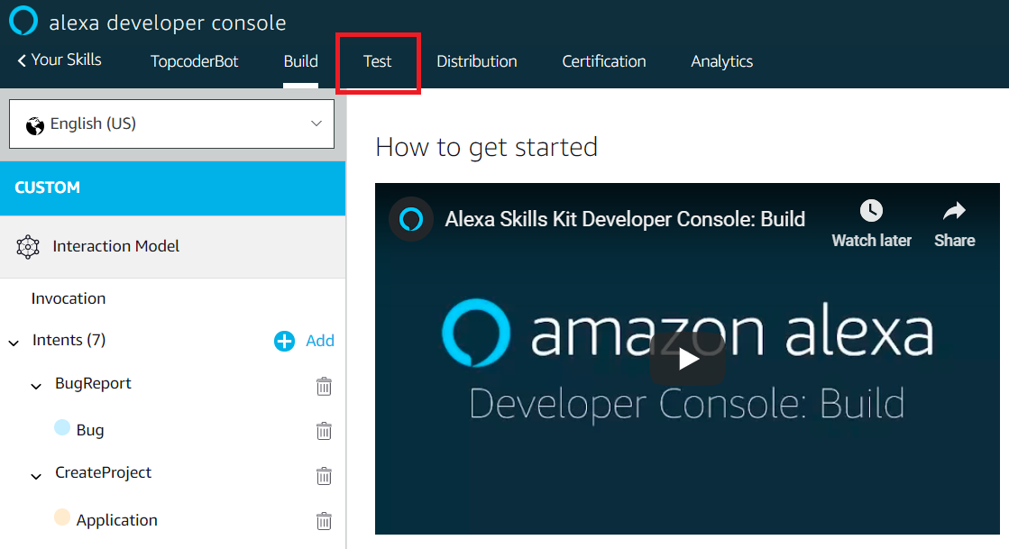

1. Use the following flow:

* **User**: Alexa, start topcoder bot
* **Bot**: Hi, you’ve got Topcoder here, are you looking to report and fix a bug OR get a task done?
* **User**: yes, we want to fix a bug
* **Bot**: Great, we’re good at that. Please tell us about the bug now and we’ll create a Topcoder project automatically for you. Please go ahead…
* **User**: our web application runs out of memory everyday
* **Bot**: OK, your Topcoder project is created on our platform, as requested. A Topcoder copilot will pick up your work and contact you shortly. Goodbye

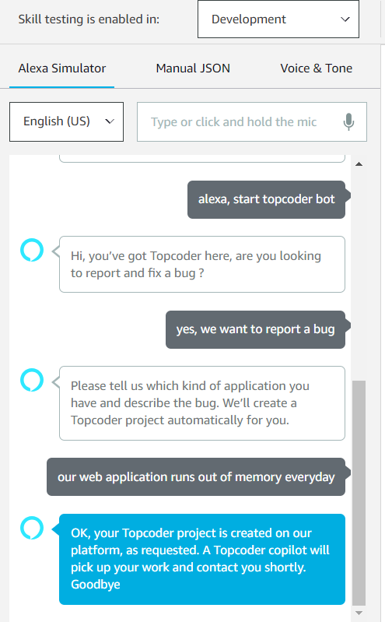

1. A new project is created in <https://connect.topcoder-dev.com/>
2. Log to <https://connect.topcoder-dev.com/projects> to check the project

