Topcoder Online Review GitHub Import Script

Verification Guide

1. Follow the steps described in the Readme.md file for environment configuration values.
2. For SVN user/pass you can use the ones already filled in the .env file so that you don’t have to setup new SVN repos and configure them in components.xml.
3. The Git API token can be setup from <https://github.com/settings/tokens> and below are the rights I’ve gave the token (repo and user access).

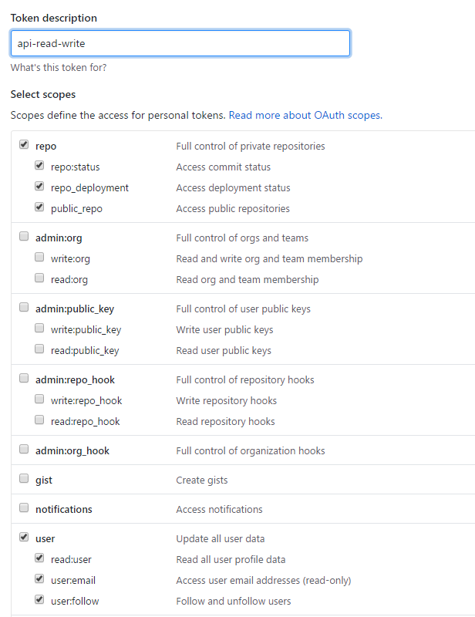

1. After the script is run (e.g. using *npm start*), it will fill details in the debug.log (solution contains a sample debug.log with several runs that show both error and success scenarios). Below is a sample log from a successful run.

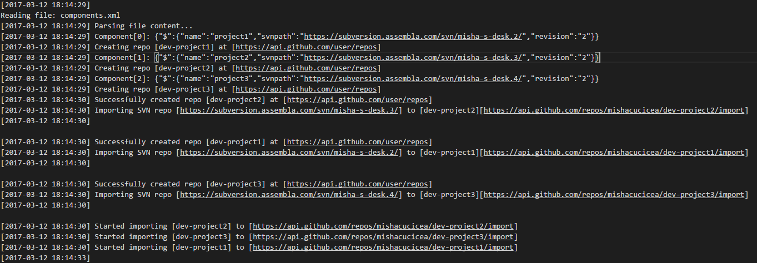

1. After the imports were started, the script can be run with *npm start showStatus* and this will show the import status of the current repositories:

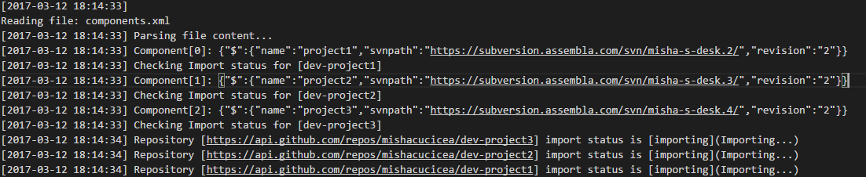

And a subsequent run is showing that the import is done:

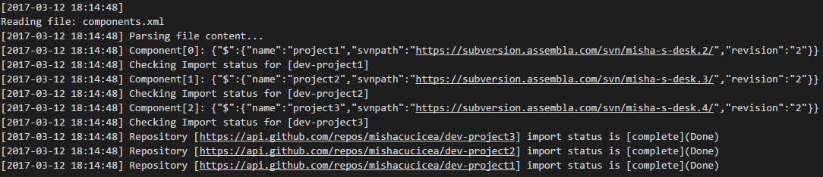

1. The following are the projects imported into GitHub (note that the repo prefix is *dev-*):

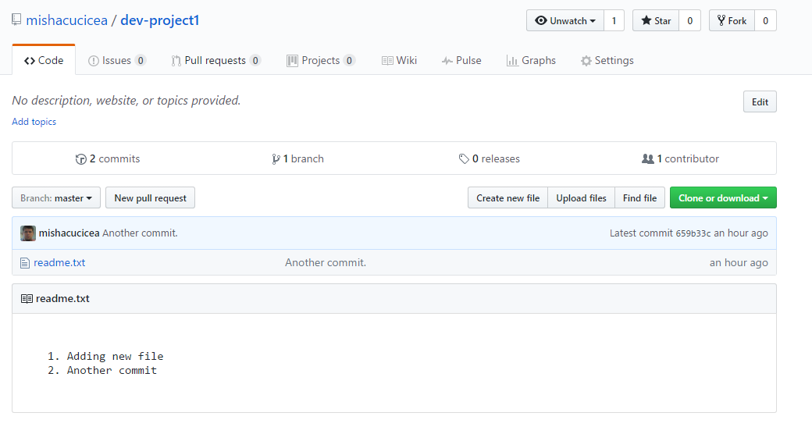

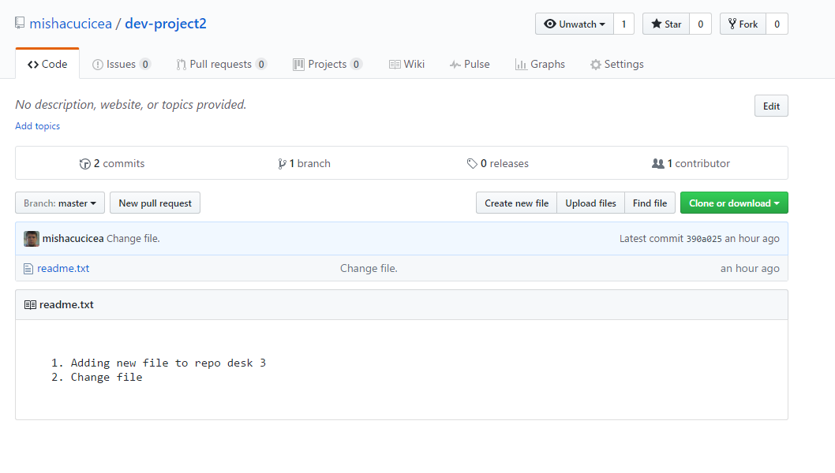

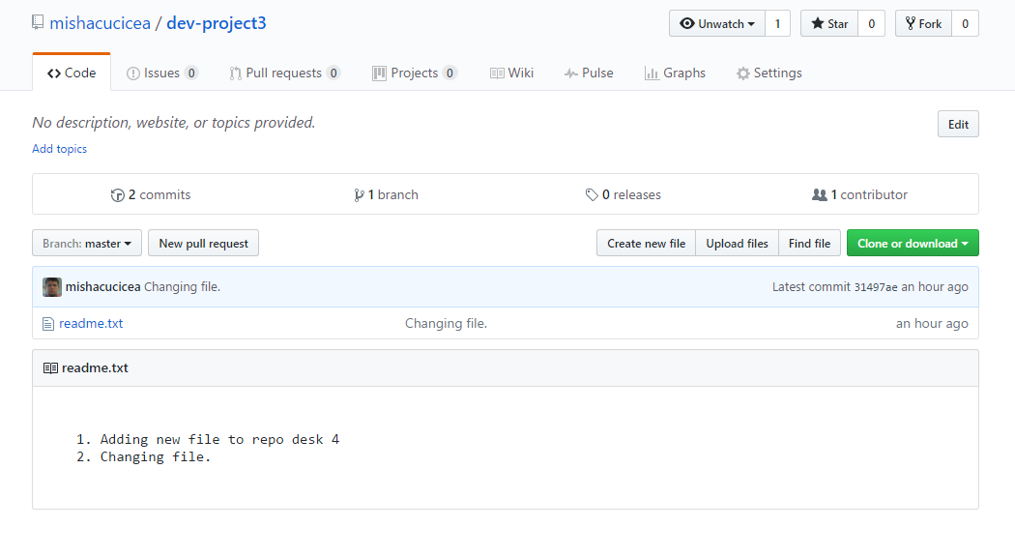

1. Mail notifications are sent by GitHub (to the github owner) upon completion of import:

