Scheduled Email Broadcast Engine

Basic Architecture

Overview
The scheduled email broadcast engine consists of three major components: the EmailJobScheduler, the EmailEngine, and the EmailServices.

The EmailJobScheduler and the EmailEngine are part of the com.topcoder.server.email package. The EmailServices are data access objects in the com.topcoder.server.ejb.EmailServices package.

Some features also require the Statistics package (com.topcoder.web.stat.ejb.*).

EmailJobScheduler
The EmailJobScheduler does the work of translating email jobs into email messages and sending reports. In a steady state, it will periodically query the EmailServices to determine if any jobs are ready to be run. When one is found, the scheduler will determine the task type and create a task object to process it. If the task is a email broadcast, the task will first convert the source data into job detail records, then iterates through the detail records, combining them with the job data to create email message that are sent by the EmailEngine. If the task is a report, it checks the source job to see if it is in a completed state. If not, it reschedules itself. If the source job is complete, the report task creates an XML report and merges the report with the report template. The resulting file is saved as a new template and the job is converted into a email broadcast job of the new report results template.

The scheduler implements a passive fault tolerance (faults are detected by a lack of activity). When a scheduler is working on an active task, it is required to periodically check that it continues to have ownership of the task and update the ownership token to indicate that it is still working on the task. If control of an active task is not updated for a sufficient amount of time, another scheduler may take control of the task.

Example: Two schedulers schedA and schedB are running when task1 becomes ready to run. Let us assume schedA obtains control of task1. schedB sees that task1 has recently been updated, so it ignores task1 for the time being. As long as schedA continues to process task1, it also updates the control token, and schedB continues to ignore task1. However, if schedA should stop working for some reason, the control token will no longer get updated. After enough time passes (configurable, defaults to 10 minutes), schedB takes control of task1 and starts working on it. If schedA should return to life at this point, it will check the control token and see that it no longer has control of task1 and stops processing it.

The ownership of tasks is currently implemented using a database table sched_control. The sched_control table has two columns, sched_control_id and sched_job_id. Each scheduler periodically obtains a new control_id from the database. control_ids are numbers that have ever increasing values. The schedulers also keep track of their old control_ids and how old they are. If any sched_job_id in the database that has a sched_control_id that is smaller than an old control_id that is too old, then the job defined by the sched_job_id must have been abandoned and the scheduler may take control of it. Tasks that are started by a scheduler check the sched_control table to see that their control_id still matches. If it does match, and the scheduler has a new control_id, the task updates the sched_control table with the scheduler's new control_id and begins using the new control_id for future checks. If the task's control_id doesn't match the sched_control_id, then the task has been taken over by another scheduler and the task should stop work immediately.

EmailEngine
The EmailEngine takes a prepared email message, connects to a known SMTP server, and transmits the message.

EmailServices (EJB data access objects)
The EmailServices provide access to the long-term storage of the broadcast data. There are three categories of information stored: job data, list data, and template data. The EmailServices allow the creation, modification, and in some cases deletion of the data.
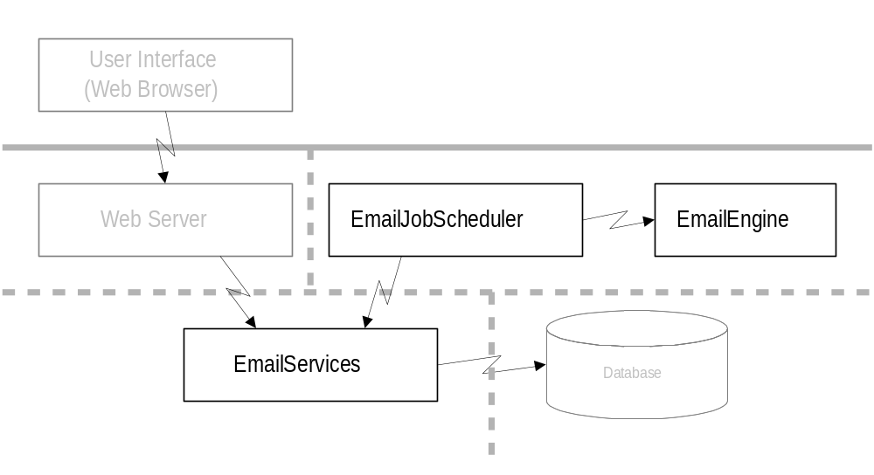

Installation tasks, property files and external class dependencies.
To install:
- Make sure the EmailJobScheduler, EmailEngine, and EmailServices are in your class path. (com.topcoder.server.email.*, com.topcoder.server.ejb.EmailServices.*)
- To use the dynamic list creation, also include the Statistics package in your class path. (com.topcoder.web.stat.ejb.*)
- Setup a database for use by the EmailServices. There are script files that may help with the creation and initialization of the database (sched_email_init.sql, build.sql).
- Setup a EJB server with the EmailServices EJBs installed on it.
- Create or edit the Email.properties and EmailEngineConfig.properties files and place them in your class path.
- Start the EmailJobScheduler ('java com.topcoder.server.email.EmailJobScheduler')
- To stop the scheduler, simply kill the process.
- There is also a tool to monitor the jobs (com.topcoder.server.email.JobMonitor).

The EmailJobScheduler's configuration file, Email.properties, must be in the class path. The file is re-read each polling interval, so changes made to it will be detected before any ready jobs are started. Jobs that are already running will continue to use the resources they were started with, with the exception that max_emails_per_second_per_job is checked repeatedly by the active jobs (so the active jobs will use the changed value *after* the next polling interval).

Property | Description | Default
polling_interval_msec | Milliseconds to wait between database checks. A job that is ready to start might wait as long as this setting before processing even starts, and on average will wait 1/2 this time.  1000 milliseconds = 1 second.  60000 milliseconds = 1 minute.  3600000 milliseconds = 1 hour. | 60000 (equals 60 seconds)
context_factory | The context factory name that the scheduler should use for creating the EmailServices EJBs. | weblogic.jndi.WLInitialContextFactory
context_provider | The context provider address. | t3://172.16.20.140:8020
max_worker_threads | Maximum number of email jobs that will be run in parrallel. If more jobs are ready, then some jobs will wait for a running job to complete before they begin.  Some items to keep in mind when setting this value are that the job speed will largely be constrained by the database and SMTP servers. | 10
max_emails_per_second_per_job | Maximum number of emails a single job will send during one second. If multiple jobs are running, then each job may send up to this many emails.  This parameter may be used to assure that multiple jobs are fairly distributing resources, or it may be used to prevent overloading of the database or SMTP servers. | 100
job_timeout_msec | Minimum amount of time that an active job must appear to be have been abandoned for before a scheduler will attempt to take control of it.  This should be set to a value greater than the maximum polling_interval_msec for ALL schedulers to prevent race conditions. The recommended value is 10 times the polling_interval_msec setting.

The EmailEngine's configuration file, EmailEngineConfig.properties, must be in the class path. The file is read for each email sent.

Property | Description | Default
smtp_host_addr | The IP address or name where the SMTP server should be contacted. | 172.16.20.41
smtp_host_port | The port to use when contacting the SMTP server. | 25

User Instructions
Every email job requires two resources: a template and a list of email addresses.

Templates
A template contains the content for the email. The template's data is in XSL format and will be passed through a Transformer to be combined with each list member's data. The following is a very simple template.

<?xml version="1.0"?>
<xsl:stylesheet xmlns:xsl="http://www.w3.org/1999/XSL/Transform" version="1.0">
<xsl:output method="text" media-type="text/rtf"/>
<xsl:template match="/">
This is a test to <xsl:value-of select="/member/email_address"/>!
</xsl:template>
</xsl:stylesheet>

Templates are created and modified using the EmailTemplate EJB. To help with the organization of templates, each template is assigned a template group. Under normal circumstances, templates will not be deleted as they were probably used by a past job that still has a reference to the template. When a template is no longer wanted, it should be moved to a group made for that purpose (for example the 'deleted templates' group).

Email Address Lists
There are two possible ways to specify a list of email address. One way is to create a static list. In this case the list is stored in the database and may edited when desired using the EmailList EJB. Like templates, static lists are also placed into groups for organizational purposes. The following is some sample data for one member of an email list. The only required parts are that it must have a <member> tag that contains an <email_address> tag that has a valid email address.

<member>
<name>Support</name>
<email_address>emailsupport@topcoder.com</email_address>
</member>

The second way to specify a list is by using a dynamic query. In this case the final list of addresses will not be known until the job is ready to run. At that point the database is queried to create a list of email addresses that will be merged with the template. The dynamic queries use the Statistics EJB to provide a flexible interface for querying the database.

In either case, once the job is run the actual addresses that were used remain available for review.

Email Broadcast Jobs
Assuming you have a template and either a static or dynamic email list, creating an email broadcast job is just a matter of putting the two items together along with when to send them. The EmailJob EJB has a createEmailJob method that takes a templateId, a listId and a commandId (one of the two should be set to 0 to indicate it is not used), the startAfter date, the stopBefore date, and the from address and message subject to use.

Once a job is created, the EmailJobScheduler will automatically find it on the next poll that occurs after the job's startAfter date. Under normal circumstances the EmailJobScheduler will be started up and left running. If for some reason it isn't, it must be started for the job to run.

Email Broadcast Jobs have two job states that are designated as two job types: a pre-list-build state type and post-list-build state type. New jobs are created with the pre-list-build type. At this point the source address list has not been merged and any changes to the source data will be included in the job when it is sent. When the EmailJobScheduler runs the pre-list-build job, it will convert the static or dynamic list source into email job detail records. Any system failures during this step will cause the job to restart from scratch (by re-copying the static list or re-querying the dynamic list). Once this step completes, the job type is changed to post-list-build and the address targets are fixed.

Post-list-build jobs already have all their detail records and each detail record contains a result code for the email destination. Initially all the codes will indicate that no attempt has been made to send an email. When the EmailJobScheduler runs the post-list-build job, it finds each detail record that has not been attempted, builds an email message, and sends it. If the message is accepted by the SMTP server, the detail record is marked as sent, if the message is rejected, the detail record is marked as failed. A system failure during the post-list-build step will be resumed right at the point of failure, with a worst case of a single email being sent twice.

Email Report Jobs
Email Report Jobs are similar to the Email Broadcast Jobs, and in fact will eventually become an email broadcast job. However, the report job has two main differences. One is that it needs a job id to base the report on. The second difference is that the template for the email report job will be merged with two sets of data. The first being a XML report, the second being the address list to send the report to. To deal with the dual merge, the initial report template should output a valid XSL document when merged with the XML report data.

The XML report data is contained in a <report> root tag. The report has the following sub-tags.

Property | Description
id | The job id of the email broadcast job for which the report is generated.
status | A text description of the final status of the email broadcast job.
date | The start date for the email broadcast job (may not match the actual time the job was started if resources were not available).
template | The text name of the template that was used for the email broadcast job.
template_group | The text name of the group the template was assigned to.
sender_email | The email address that the broadcast was sent by.
sender_name | The name that the broadcast was sent by.
subject | The subject line of the email broadcast.
count_sent | The number of emails that were successfully sent.
count_failed | The number of emails that did not get sent.
count_other | The number of emails that have a status other than sent or failed. Primarily intended to cover the case of new result statuses being added in the future.
list_sent | The email addresses that were successfully sent the message, 1 per line.
list_failed | The email addresses that did not get sent the message and the reason that they did not get the sent the message. 1 address plus reason per line.
list_other | The email addresses that have an unexpected status and the reason for the status, if any. 1 address plus reason per line.

The following would be an example of a simple report template.

<?xml version="1.0"?>
<xsl:stylesheet xmlns:xsl="http://www.w3.org/1999/XSL/Transform" version="1.0">
<xsl:output method="text" media-type="text/rtf"/>
<xsl:template match="/"><![CDATA[<?xml version="1.0"?>
<xsl:stylesheet xmlns:xsl="http://www.w3.org/1999/XSL/Transform" version="1.0">
<xsl:output method="text" media-type="text/rtf"/>
<xsl:template match="/">]]>
This is a report for broadcast about: <xsl:value-of select="/report/subject"/>

The broadcast is <xsl:value-of select="/report/status"/>. There were <xsl:value-of select="/report/count_failed"/> failed messages.

<xsl:value-of select="/report/list_failed"/>
<![CDATA[</xsl:template>
</xsl:stylesheet>]]>
</xsl:template>
</xsl:stylesheet>

Email Job Status
Most email jobs will be created in the READY state (meaning the job is ready to run). Then move into the ACTIVE state while the job is being run (or has been queued up to run). And finish up in the COMPLETE state when all job details have been attempted. However, there are a few more states that are possible. Report jobs follow the same cycle, but will return to the ready state after the report template has been generated and the report is ready to send.

Any job that is ready or active may be CANCELED. The EmailJobScheduler will not run canceled jobs, and if they are already running, they will stop running at the next status check (the status is checked about once a second). Canceled jobs may be resumed. Once resumed, the job returns to the ready state and will be processed by the EmailJobScheduler on the next polling cycle.

Another state is the INCOMPLETE state. The incomplete state occurs if a job has not completed before the stopBefore date. The incomplete status means that not all detail records were processed (possibly none were processed). The incomplete state should not occur normally, but may happen because of either human intervention or a configuration error. Some reasons why a job might end up with an incomplete status are:
- The job was scheduled to stop before the current time.
- The job was canceled and then later resumed after the stopBefore date.
- The stopBefore date is before the startAfter date.
- The EmailJobScheduler was not running between the email job's start and stop dates.

External Classes
com.topcoder.server.ejb.EmailServices.*
EmailJob | Interface for job creation. Allows manipulation of email jobs, querying of job status, and querying of job detail data and status.
EmailList | Interface for list creation, modification, and information.
EmailTemplate | Interface for template creation, modification, and information.
EmailListGroup | Interface for list group creation, modification, information, and deletion.
EmailTemplateGroup | Interface for template group creation, modification, information, and deletion.
EmailJobHome | Allows creation of a EmailJob interface object.
EmailListHome | Allows creation of a EmailList interface object.
EmailTemplateHome | Allows creation of a EmailTemplate interface object.
EmailListGroupHome | Allows creation of a EmailListGroup interface object.
EmailTemplateGroupHome | Allows creation of a EmailTemplateGroup interface object.

com.topcoder.server.email.*
EmailJobScheduler | Contains a main() function. Can be run to schedule email jobs.

Internal Classes
com.topcoder.server.email.*
SendEmailTask | A runnable object. Contains the logic to convert lists into detail records and then detail records into TCSEmailMessages.
EmailReportTask | A runnable object. Contains the logic to scan the detail records from an email broadcast job and create a XML report. The report is merged with a report template to create a new template that will be broadcast to the admin list assigned to the report. The broadcast part of the report job is scheduled as an email broadcast job.
JobMonitor | Contains a main() function. Repeatedly queries the database and displays the status of the ready, active, and recently completed jobs.

com.topcoder.server.ejb.EmailServices.*
EmailJobBean | Job creation. Allows manipulation of email jobs, querying of job status, and querying of job detail data and status.
EmailListBean | List creation, modification, and information.
EmailListGroupBean | List group creation, modification, information, and deletion.
EmailTemplateBean | Template creation, modification, and information.
EmailTemplateGroupBean | Template group creation, modification, information, and deletion.
EmailServer | Interface for low level access to the email job structure. Contains functions that could be destructive if used improperly.
EmailServerHome | Allows creation of an EmailServer interface object.
EmailServerBean | Low level access to the email job structure. Contains functions that could be destructive if used improperly.

com.topcoder.server.util.*
EmailEngine | Sends TCSEmailMessages
TCSEmailMessage | Container class for an email message.
TCSMessage | Base class for messages.

