Replatforming Data Migration Release 2 Deployment Guide

Revision History
Author | Revision Number | Date
TCSDEVELOPER | 1.0 | 04/23/2011

Deployment Instructions 3
1. Organization of Submission 3
2. Application Setup 3
2.1 Ant .Properties File 4
2.2 Build Scripts Setup 4
3. Database Setup 4
4. Deployment Instructions 5
5. Starting 5
6. Verification 5
7. Resource Contact List 7

Deployment Instructions

Organization of Submission

The submission follows directory structure provided below:

docs

Contains this document which is the Deployment Guide for the Replatforming Data Migration Release 2 assembly.

scripts

Contains the scripts for database updating.

test_files

Contains the helper files to be used for testing/review purposes only.

web_module

Contains the configuration, libraries, sources for TopCoder Website application developed/updated in the course of this assembly. This directory replicates the application development distribution structure and includes only updated and new files.

Application Setup

The application is expected to be deployed to the following environment:

JRE 1.5
JBoss 4.0.4.GA
Informix DS 11.0

The following configuration parameters may be set in order to configure the behavior of the Studio Contests Migration Tool

Configuration file scripts/studio/contest_migration.xml

sourcedb - a JDBC-compliant connection string for source database to migrate Studio contests from

targetdb - a JDBC-compliant connection string for source database to migrate Studio contests fto

start_date - a lower boundary of contest start times range for selecting the contests for migration (may be empty). Must be formatted as MM/dd/yyyy

end_date - an upper boundary of contest start times range for selecting the contests for migration (may be empty). Must be formatted as MM/dd/yyyy

contest_ids - a comma separated list of IDs of contests for migration (may be empty)

screening_scorecard_id - an ID for screening scorecard (must not be empty)

review_scorecard_id - an ID for review scorecard (must not be empty)

milestone_screening_scorecard_id - an ID for milestone screening scorecard (must not be empty)

milestone_review_scorecard_id - an ID for milestone review scorecard question (must not be empty)

screening_scorecard_question_id - an ID for screening scorecard question (must not be empty)

review_scorecard_question_id - an ID for review scorecard question (must not be empty)

milestone_screening_scorecard_question_id - an ID for milestone screening scorecard question (must not be empty)

milestone_review_scorecard_question_id - an ID for milestone review scorecard question (must not be empty)

software_documents_root – a root path to store the documents and submissions for projects in Online Review (must not be empty)

Configuration file resources/studio/DBConnectionFactoryImpl.xml

This file provides the connection settings for DB Connection Factory component and must provide the parameters for establishing connection to same database set set by targetdb parameter in scripts/studio/contest_migration.xml file.

Ant .Properties File

Property Name | File property is stored | Example Setting

Build Scripts Setup

The build script for TopCoder Website application (build_tc.xml) provides the following targets which are to be used:

- compile – compiles the production classes.

Database Setup

Execute scripts/schema.sql in tcs_catalog database.

Deployment Instructions

This section provides the instructions for integrating and deploying the changes from Replatforming Data Migration Release 2 assembly in Production environment.

- Merge the code from winning submission into main SVN trunk
- Re-compile the production classes for TopCoder Website application using "ant -f build_tc.xml compile" command

Starting

- Re-compile the production classes for TopCoder Website application
- Run the Studio Contests Migration Tool using commands like:

cd /home/tc/web/scripts/studio
./contests_migration.sh

Verification

- Run the Studio Contests Migration Tool
  - The comp_catalog, comp_versions, comp_categories, project, project_info, project_phase, phase_criteria, phase_dependency, comp_documentation, prize, project_prize_xref, project_file_type_xref, project_studio_specification, resource, resource_info, upload, submission, resource_submission, review, review_item,review_item_comment tables must be filled with the data for migrated Studio contests.
  - The mock submission file with id 2015 is located at /home/tc/original_directory/1.pdf, it will be copied to /home/tc/software/ directory.
  - The mock document file with id 2001 is located at /home/tc/original_directory/1155833473146.pdf, it will be copied to /home/tc/software/comp_versId/comp_versId directory.

- Once the data was migrated to tcs_catalog database, you can verify the contests in Online Review.

- Due the lack of user data in VM, you need to execute the following SQL statement in tcs_catalog database which will set author of all resources to heffan after the data was migrated.
update resource_info set value='132456' where resource_info_type_id=1;
update resource_info set value='heffan' where resource_info_type_id=2;

Or you can execute test_files\create_mock_users.sql to create mock users in DB.

- You can find the contest id mapping in the log. Open http://tcs.cloud.topcoder.com/review/actions/ViewProjectDetails.do?method=viewProjectDetails&pid=[new_project_id]
Please replace [new_project_id] with the project id in Online Review. The project detail page will display.

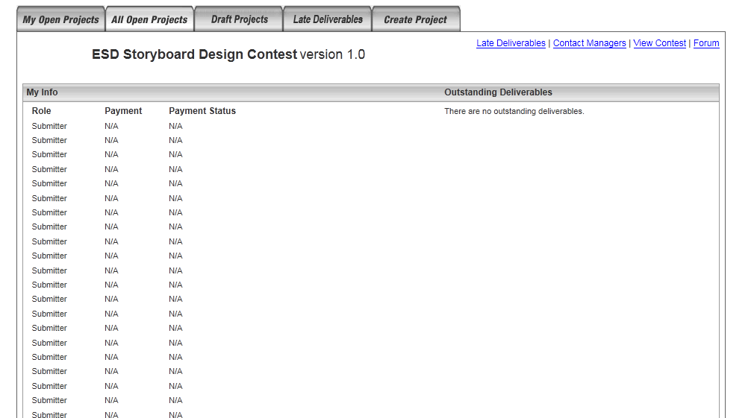
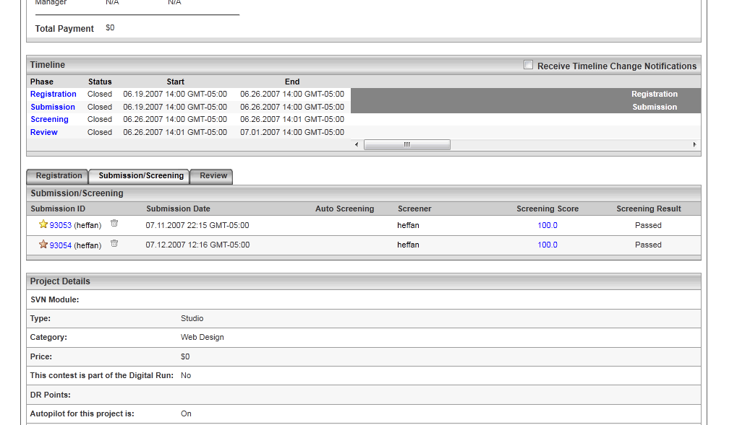

- If you meet the error something like this in Online Review
java.text.ParseException: Unparseable date: "10.19.2006 12:21 PM"
at java.text.DateFormat.parse(DateFormat.java:335)
at org.apache.taglibs.standard.tag.common.fmt.ParseDateSupport.doEndTag(Unknown Source)

Please remove the lines containing “fmt:parseDate” in
/home/tcs/jboss-4.0.2/server/default/deploy/review.war/includes/project/project_phase.jsp
and
/home/tcs/jboss-4.0.2/server/default/deploy/review.war/includes/project/project_resource.jsp

Resource Contact List

Name | Resource Email
TCSDEVELOPER

