TopCoder Cockpit Project Milestone and Activity Streams Specification Requirements Specification

This document outlines the Application Scope and Requirements for
TopCoder Cockpit Project Milestone and Activity Streams Specification 1.0

PRESENTED TO:  TopCoder | 
PRESENTED BY:
TopCoder

Revision History
Author | Revision Number | Date
Veve | 1.0 | Nov/12th/2011
Veve | 1.1 Final Fix | Nov/17th/2011

Application Requirements Specification 4
1. Scope 4
1.1 Overview 4
1.2 Objectives 4
1.3 Limitations & Assumptions 5
2. Logic Requirements 6
2.1 View Project Milestones in List 6
2.2 View Project Milestones in Calendar 9
2.3 View Project Milestone Progress 12
2.4 Add Project Milestone(s) 14
2.5 Edit Project Milestone(s) 18
2.6 Remove Project Milestone 21
2.7 Associate / Dissociate contests with Project Milestone 23
2.8 Mark Project Milestone as completed / uncompleted 24
2.9 View Project Activities Stream 26
2.10 Send daily / weekly project digest email 28
2.11 Send email notifications 29
General Requirements 31
2.12 Graphical User Interface Requirements 31
2.13 Performance Constraints 31
2.14 Security 31
3. Required Documentation 33
3.1 Specification Documentation 33
4. Help / User Documentation 33
5. Notes 33
6. Future Enhancements 33
7. Glossary 33
7.1 Acronyms 33

Application Requirements Specification

Scope

Overview
The TopCoder Cockpit application is increasingly getting more usage from clients, copilots and project managers alike as more and more projects are run through the platform. As the usage grows, the application’s workflows are tested with increased frequency and slight inefficiencies or areas in which there could be improvements made, start to be uncovered. Along with these inefficiencies appears the desire of the application’s users to have an upgraded system which would make their life easier.

This project will upgrade the Cockpit application and will add the most requested features to the existing application. The focus on the upgrade is to add project management related features to Cockpit such as project milestone, project metadata, project documents etc, and bring the concept of Project Dashboard which will be the central place for customer / TopCoder PM / Copilot to manage a cockpit project.

The goal of this project is to make it easier for the Customer, PM and copilots to manage their projects, upgrading the TopCoder Software Development Process to a new level. The project will also improve the user experiences and workflow when managing a cockpit project. The user does not need to navigate to a lot different pages in Cockpit to get project management stuff done.

This specification will provide the detailed requirements for Project Milestones and Project Activities Stream.

Project Milestone is a high level way to manage the project comparing to contest. Now Cockpit does not have a way to manage different stages in a cockpit project, that is, the idea of project milestones. Project milestones inside cockpit project help project managers to better schedule a cockpit project, allow project manager to much more accurately determine whether or not the project on the schedule. Project milestones provide a higher level view of cockpit project than contest so that managers can easily monitor the whole project progress and see the critical paths of the project.

Project Milestone related features will be delivered in two releases. In release 1, project milestone will only be an entry associated with the cockpit project, with a name, description, due date and responsible people. In release 2, contest association and notification email reminder features will be added to project milestone.

Project Activities Stream provides a view to see what happened in the last period of time with the cockpit project. The different activities include contest launch to milestone creation / completion or project task created / completed.

Project milestone and Project activities stream functionality will be added to the Project Dashboard for better project management.

Objectives
The objectives of this application are:
- To have a central place called Project Dashboard in order to simplify the management of a cockpit project.
- To add the Cockpit project milestones functionality to allow view and manage cockpit project milestones which help project manager to manage the critical paths of the project and view the project in a higher level.
- To aggregate and expose to the users a customizable activities stream which shows the recent user activities of the cockpit project.
- To provide the project users the ability to customize the activities stream.
- Send cockpit project digest email every day or every week to project resources with information like project milestones and activities etc.

Project Return on Investment (ROI Metrics):
No explicit specific metrics were provided by the client.
However, we can assume the following metrics from the client description:
- Reduced amount of time required to manage current running projects due to improvement of user interface and user workflow.
- Reduced number of man hours and saved money due to increases in management efficiency due to new tools and application features which simplify the user’s tasks.
- Simplification of the project evaluation tasks of the users, through project related information newly added, the number of clients will be increased because of the more user friendly interface and proportional revenue increase due to it.

General Capacity Metrics:
- The expected number of unique users will be around 500-1000.
- The expected number of concurrent users is 100 – 150.
- Performance requirements are that the page loading time should always be in a normal range of about < 2s.
- For data loading which affects the page loading time, like the activity stream architects should consider using AJAX for loading the data without blocking the load of the page.

General Usability Metrics:
- The GUI and user flows added by the new functionality should be user friendly and easy to use.

Limitations & Assumptions

Limitations
- The upgraded Cockpit application will be limited to the existing platform technology stack and technologies being used currently will likely be given priority over new unproven technologies, unlike in a new application.
- The activities stream need to pull data from

Assumptions
- The system will be used from different time zones.
- Users will access the application through a web-browser.
- This application is upgraded based on the current Cockpit application.
- The application authentication is out of the scope.
- The updated Cockpit application will use the same level of auditing used for the other Topcoder platforms. The audit function of the application is not updated by this project and is thus not addressed in this document.
- Topcoder will provide the existing database schemas to be upgraded by the updated Cockpit application and the existing Cockpit source codes.
- For UI parts, TopCoder will provide the existing prototype of Cockpit and the standard Cockpit UI design elements.

Technical assumptions from the client:
- Java technology stack is required.
- The technical solution choice should be compatible with the existing platform since the application will be built on top of it.
- The application will be implemented as a web application, network based and thin client.

Environment and technology requirements:
- Web Server: Apache
- Application Server : JBoss 4.2.3 GA
- Database Server: IBM Informix dynamic server 11.0
- MVC framework: Struts 2.0
- Application framework: Spring 2.5.6 and EJB 3.0
- Java 1.5.3
- JSP & Servlet

Logic Requirements
The following is the Use case diagram for the application:

The use case diagram uses the color schema defined in the following table to distinguish different types of use cases.

Use case color | Description
 | The blue use case is normal use case
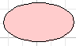 | The pink use case is aggregate/abstract use case.

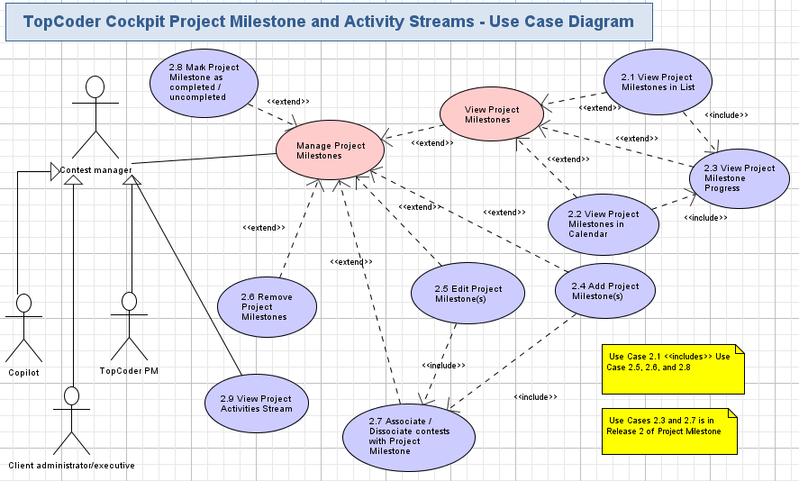

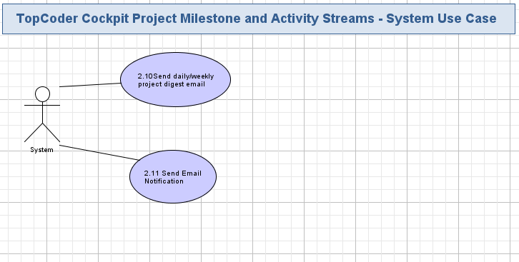

Use Cases Requirements Section

View Project Milestones in List
This use case provides a List View for the milestones of a cockpit project. The milestones of the project are listed one by one in 3 groups: Overdue (Late), Upcoming and Completed so user can see which milestones are late, which milestones are coming and which milestones are completed. User can edit the project milestones in the list view.

UI Design Reference: Not available at this time.
Conceptualization Reference: This use case is part of the task requirement 4.6.16 View milestone summaries in the conceptualization document.

- Pre-conditions: User has logged into the TopCoder Cockpit application and user has at least read permission on the project. User needs to have write permission to be able to edit the milestones.
- Post-conditions: The milestones of the project the user views are listed and presented to the user.

View Project Milestones in List activity diagram

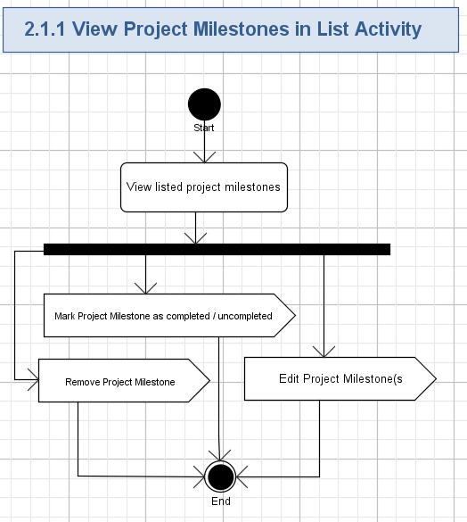

View listed project milestones

Project milestones are listed in 3 groups from up to bottom:
- The first group is the overdue (late) project milestones – project milestone’s due date is before current date but the milestone is not marked as completed. The overdue project milestones will be sorted by due date, the milestone with earlier due date gets listed first.
- The second group is the upcoming project milestones – project milestone’s due date is equal to or after current date and the milestone is not marked as completed. The upcoming project milestones will be sorted by due date, the milestone with earlier due date gets listed first.
- The third group is the completed project milestones – project milestone is marked as completed. The completed project milestones will be sorted by completion date. The latest completed get listed first.
Milestone group color:
Different groups will have different colors, either in the title of the group or the text of the project milestone name. It’s recommended to use RED color of to warn about overdue project milestones, use ORANGE to represent upcoming project milestones and use GREEN to represent completed project milestones.

Table 1
Status | Due date | Completed or not | Suggested color
Overdue (Late) | Due Date < Current Date | Uncompleted | RED
Upcoming | Due Date >= Current Date | Uncompleted | ORANGE
Completed | Any due date | Completed | GREEN

For each project milestone listed, the following information should be displayed in Release 1
Name | Description | Display Format | Required?
Milestone name (title) | The tile of the project milestone | Display in text format. For completed project milestone, it’s suggested to use cross-line over the name to represent it’s completed like : My Project Milestone One | Yes
Milestone description | The description of the project milestone. It’s used to describe what the project milestone is used for | Display in text format. If the description is long, do not fully display it. Display the first 100 characters and make the whole displayed when user hovers over the description. This saves the UI space. | Yes
Status | The status of the project milestone. It’s determined by the due date of the project milestone and whether the project milestone is completed. For an uncompleted milestone, If the due date is passed, it’s overdue or late. If the due date is not arrived, it’s upcoming. A completed milestone has status completed no matter the due date. | Display in text format like  - Overdue  - Upcoming  - Completed  Or use different icons to provide more meaningful representation. It’s up to the UI design to determine the best way | Yes
Due Date | The Due date of the project milestone | Display in text format. The date should be displayed with the Timezone of TopCoder’s time. The format will be MM/DD/YYYY ET (GMT-400) | Yes
People responsible | The handle of the people who is responsible for this project milestone. | Display in a link. The link text should be the handle the people. The link should link to the member profile of that people. Or displayed as “Unassigned” text if no people is assigned. | No

For the completed project milestone, the completion date will be displayed after the due date. The format of the completion date is the same as Due Date.

In Release 2 – contests association is added to project milestone. The completion percentage of the project milestone needs to be displayed.
- The completion percentage will be displayed for Overdue and Upcoming project milestones. Completed project milestone does not need it.
- The percentage will be calculated as :
The number of completed contest associated / Total Number of contests associate
- For the details on display the milestone progress, please refer to use case 2.3 View Project Milestone Progress

- Percentage can be displayed in various ways, its update to the UI designer to choose the best way. Refer to 2.3 View Milestone Status Report for requirements details.

Edit Project Milestones
Refer to user case 2.5 Edit Project Milestone(s) for requirement details.

Remove Project Milestones
Refer to user case 2.6 Remove Project Milestone(s) for requirement details.

Mark project milestone as completed / uncompleted
Refer to user case 2.8 Mark project milestone as completed / uncompleted for requirement details.

View Project Milestones in Calendar
This use case provides a Calendar View for the milestones of a cockpit project. The milestones of the project are shown in a monthly calendar, the overdue and upcoming project milestones are shown in their due date while the completed project milestones are shown in their completion date.

UI Design Reference: Not available at this time. In the requirement specification, a screenshot is provided as demonstration.
Conceptualization Reference: This use case is part of the task requirement 4.6.16 View milestone summaries in the conceptualization document.

- Pre-conditions: User has logged into the TopCoder Cockpit application and user has at least read permission on the project. User needs to have write permission to be able to edit the milestones.
- Post-conditions: The milestones of the project in current month are shown in a calendar by default and presented to the user.

View Project Milestones in Calendar Activity Diagram
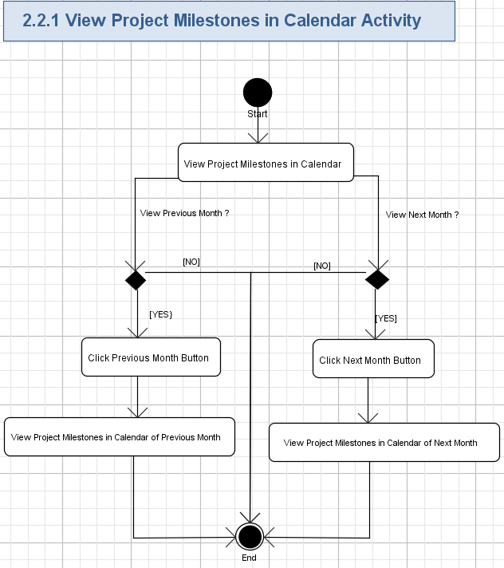

View Project Milestones in Calendar
The user views the project milestones in a MONTHLY calendar. By default, the project milestones of current month are displayed to user.

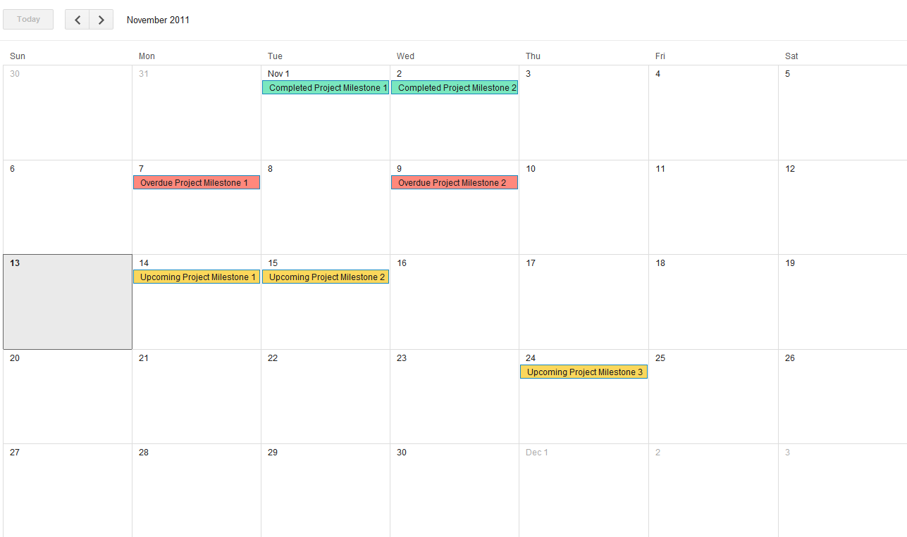

Project Milestone Calendar View Demonstration

Each project milestone will be displayed as a colored item in the date cell of the calendar:
  - If the project milestone is completed, it will be displayed on the date cell of its completion date with a background color like Green. It’s up to UI designer to decide which color to use during design phase.
  - If the project milestone is overdue / late, it will be displayed on the date cell of its due date with a background color like Red. It’s up to UI designer to decide which color to use during design phase.
  - If the project milestone is ‘Upcoming’, it will be displayed on the date cell if its due date with a background color like Orange. It’s up to UI designer to decide which color to use during design phase.

Please refer to the Table 1 to see how to determine the status of the project milestone.

General Calendar Display Requirements:
  - The today date cell will be highlighted in the color.
  - The Year and Month of the calendar should be displayed.
  - The calendar will have previous month / next month buttons to allow user browser project milestones of different months.

Click Previous Month Button
The calendar will have a Previous Month button to user to click to view the project milestones of the previous month. The user clicks the previous month button to jump to the previous month.

View Project Milestones in Calendar of Previous Month
After user clicks the Previous Month button, the project milestones of the previous month are displayed. Please note that the project milestones of previous months do not have upcoming project milestones.

Click Next Month Button
The calendar will have a Next Month button to user to click to view the project milestones of the next month. The user clicks the next month button to jump to the next month.

View Project Milestones in Calendar of Next Month
After user clicks the Next Month button, the project milestones of the next month are displayed. Please note that the project milestones of next months do not have overdue/late project milestones.

View Project Milestone Progress
This use case provides a visual representation of the project milestone progress. The project milestone progress is measured by the completion progress of the contests associated with the project milestone. Please note that this is a feature of the Release 2 of the Project Milestone functionality.

UI Design Reference: Not available at this time. In the requirement specification, screenshots are provided as demonstration.
Conceptualization Reference: This use case is mapped to the task requirement 4.6.21 View milestone status report in the conceptualization document.
Use case dependency: The use case 2.1 View Project Milestones in List depends on this use case to view project milestone progress.

- Pre-conditions: User has logged into the TopCoder Cockpit application and user has at least read permission on the project. User needs to have write permission to be able to edit the milestones and user enters the list view of the project milestones.
- Post-conditions: The milestone progress of each milestone is displayed to the user.

View Project Milestone Progress Activity Diagram
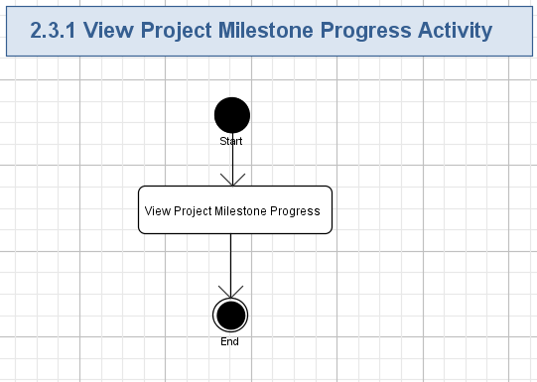

View Project Milestone Progress
The project milestone progress will be displayed for each project milestone in Project Milestones List View. The project milestone progress is measured by the completion progress of the contests associated with the project milestones.

The milestone progress can be represented by:
- Pie chart

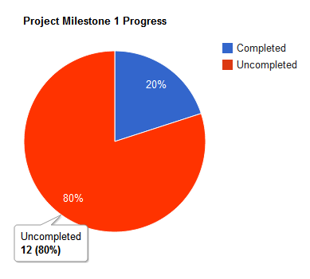

  - Pie chart contains two colors, one color represents the completed percentage, and the other represents the uncompleted percentage.
  - When hover over the completed pie, the tooltip shows the completed contests number with a percentage.
  - When hover over the uncompleted pie, the tooltip shows the uncompleted contests number with a percentage.
- Progress bar

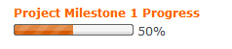
- Progress bar shows the completed percentage in the colored bar, the left empty bar indicates the uncompleted percentage.

Milestone Progress Calculation (percentage Calculation):

Milestone Progress percentage = 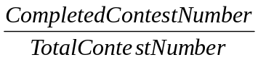
(Contest here all refer to contests associated with the project milestone)

The format of the percentage should be rounded to integer
- 65.8634% should be rounded to 66%
- 65.3443% should be rounded to 65%

Add Project Milestone(s)
This use case allows user to add project milestone to the project by clicking a button or link. In release 1, the user needs to fill the name, description, due date, person responsible when adding project milestone. In release 2 the user can choose which contest(s) to associate with the project milestone.

UI Design Reference: Not available at this time.
Conceptualization Reference: This use case is mapped to the task requirement 4.6.18 Manage Project Milestone in the conceptualization document.
Use case dependency: This use case depends on use case 2.7 Associate / Dissociate contests with Project Milestone which is functionality in Project Milestone Release 2.

- Pre-conditions: User has logged into the TopCoder Cockpit application and user has at least write permission on the project.
- Post-conditions: The project milestone has been created. In release 2, if user associates contests with the project milestone, the associations between contest(s) and project milestone are created.

Add Project Milestone(s Activity Diagram

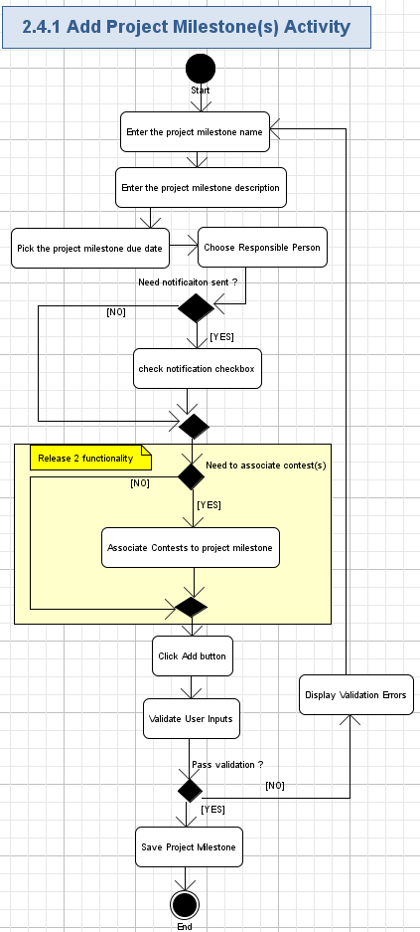
The user should be able to click a button or link to enter either a new page or be shown with a modal window to enter the new project milestone information. This is up to the UI designer.

Enter the project milestone name
To add a new project milestone, the user needs to enter the project name:
- The project name will be text-based
- The project name is required
- The project name cannot exceed 80 characters

Enter the project milestone description
The user can enter the description to describe the project milestone:
- The project description will be text- based
- The project description is optional
- The project description cannot exceed 250 characters if not empty

Pick the project milestone due date
The user can pick the due date of the project milestone from a date picker
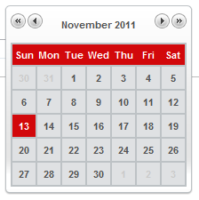
- The due date of the project milestone should be equal to or large than current date. The user cannot pick up a date early than current date.
- After pick the date, the date will be displayed as MM/DD/YYYY

Choose responsible person
The user can choose the responsible person for the project milestone from a dropdown
- The default value of the dropdown is “unassigned”
- The dropdown has these options:
  - The handles of the project copilots – the project copilots will be read from the copilot_project table.
  - The handles of the project managers – how to read the handles of the project managers is up to the architecture.
- Only one option can be chosen for the project milestone.

Check notification checkbox
A checkbox will be presented to the user for whether sending notification email reminder now & 48 hours before the milestone due.
- The checkbox is unchecked by default.
- If the check box is checked when adding the project milestone, an email will be sent immediately to creator and if the responsible permission is chosen, an email will also be sent immediately to responsible permission to notify a new project milestone is created.
- Another email will be sent when the project milestone is due in 48 hours to creator and person responsible.

Associate Contests to project milestone
The user can associate the contest(s) to project milestone in Release 2 of project milestone functionality. See use case 2.7 Associate / Dissociate contests with Project Milestone for requirements details.

Click Add button
The user can click the Add button to save the new project milestone. Validations should be taken before saving the new project milestone to the persistence. See the next section about validation details.

Validate User inputs
The following validations should be performed on previous inputs:
- Check whether the project milestone name is empty
ERROR MESSAGE: Project Milestone Name cannot be empty
- Check whether the project milestone name exceed 80 characters
ERROR MESSAGE: Project Milestone Name cannot exceed 80 characters
- Check whether the project milestone due date is equal to or larger than current date
ERROR MESSAGE: Project Milestone Due Date cannot be earlier than current date.
- Check if the project milestone description is not empty but exceeded 250 characters
ERROR MESSAGE: Project Milestone Due Date cannot exceed 250 characters.

Display Validation Errors
The validation errors should be displayed next to the input the validation fails. Refer to 2.4.2.8 for the error message.

Save Project Milestone
If the all the validations are passed, the new project milestone should be saved to the persistence. If there are contests associated with the project milestone, the association between the contest and the project milestone should be saved too.

After saving, a confirmation message should be displayed to the user. It’s up to the UI designer to determine what confirmation message is displayed and how to display.

Edit Project Milestone(s)
This use case allows user to edit the existing project milestone. In release 1, as there is no contest association with project milestone, user cannot edit them. In release 2, user can edit the contest associations.

UI Design Reference: Not available at this time.
Conceptualization Reference: This use case is mapped to the task requirement 4.6.18 Manage Project Milestone in the conceptualization document.
Use case dependency:
  - This use case depends on use case 2.7 Associate / Dissociate contests with Project Milestone. It is functionality in Project Milestone Release 2.
  - The use case 2.1 View Project Milestones in List depends on this use case.

- Pre-conditions: User has logged into the TopCoder Cockpit application, user has at least write permission on the project and user chooses a project milestone to edit.
- Post-conditions: The project milestone to edit has been updated. In release 2, if user updates associated contests with the project milestone, the associations between contest(s) and project milestone are updated.

Edit Project Milestone(s) Activity Diagram 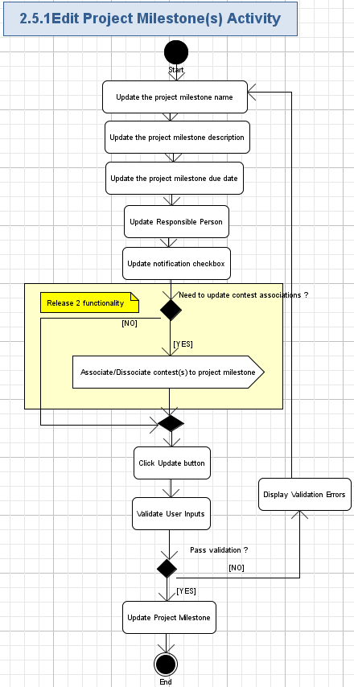

The user should be able to click the project milestone name (a link) or a button next to the existing project milestone to edit the project milestone in Project Milestone List View. The UI details are up to the UI Designer.

Update the project milestone name
The old name will be shown to the user in a input box, user can update the input box to update the project milestone name
  - The new project name will be text-based
- The new project name cannot be empty
- The new project name cannot exceed 80 characters

Update the project milestone description
The old project milestone description is shown to user in a textbox, user can update the text box to update the project milestone description
- The new project description will be text- based
- User can empty the text box to remove the project description
- The new project description cannot exceed 250 characters if not empty

Update the project milestone due date
The user can update the due date of the project milestone from a date picker
- The due date of the project milestone should be equal to or large than current date. The user cannot pick up a date early than current date.
- After pick the date, the date will be displayed as MM/DD/YYYY

Update responsible person
The dropdown will be displayed as current option selected. The user can update the responsible person for the project milestone from a dropdown by choosing a new value.
- The dropdown has these options:
  - The handles of the project copilots – the project copilots will be read from the copilot_project table.
  - The handles of the project managers – how to read the handles of the project managers is up to the architecture.
  - “Unassigned”

Update notification checkbox
The checkbox will be populated with existing selection. Use can modify the checkbox. If the checkbox is updated from checked to unchecked, no due date email notification will be sent to the creator and responsible person.

Associate/ Dissociate Contests to project milestone
The user can associate / dissociate the contest(s) to the project milestone in Release 2 of project milestone functionality. See use case 2.7 Associate / Dissociate contests with Project Milestone for requirements details.

Click Update button
The user can click the Update button to update the project milestone. Validations should be taken before updating the project milestone to the persistence.

Validate User inputs
Validations should be taken before updating the project milestone. The validation rules should be the same as the validation rules of Adding New Project milestones. Please refer to 2.4.1.8 for requirement details.

Display Validation Errors
The validation errors should be displayed next to the input the validation fails. Refer to 2.4.1.8 for the error message.

Update Project Milestone
If all the validations are passed, the project milestone should be updated and the updates are saved to the persistence.

The associations between contest and project should be updated in Release 2.

After updating, a confirmation message should be displayed to the user. It’s up to the UI designer to determine what confirmation message is displayed and how to display.

Remove Project Milestone
This use case allows user to remove the existing project milestone in the Project Milestones List View.

UI Design Reference: Not available at this time.
Conceptualization Reference: This use case is mapped to the task requirement 4.6.17 Remove Project Milestones in the conceptualization document.
Use case dependency:
  - The use case 2.1 View Project Milestones in List depends on this use case.

- Pre-conditions: User has logged into the TopCoder Cockpit application, user has at least write permission on the project and user chooses a project milestone to remove.
- Post-conditions: The project milestone to remove has been deleted. In release 2, if there are associations between the contests and the project milestone, the associations are deleted.

Remove Project Milestone Activity Diagram
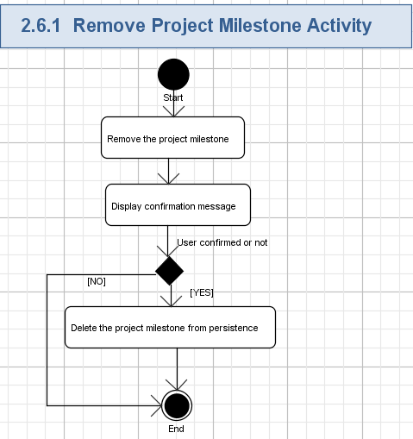

Remove the project milestone
User chooses the project milestone to remove by clicking a link or a button next the project milestone he/she wants to remove in the Project Milestone List View.

Display confirmation message
A confirmation message should be displayed to the user asking for confirmation, the message could be:

Are you sure you want to delete the project milestone? You cannot undo after removal.

There should be two buttons for the user to cancel or confirm.

Delete the project milestone from persistence
After the user confirm, the project milestone is deleted from the persistence. In release 2, if there is any association between the project milestone and contests, the associations are deleted too.

Associate / Dissociate contests with Project Milestone
This use case allows user to associate and dissociate project contests with the project milestone. Only unfinished / uncompleted contests can be associated with the project milestone.

UI Design Reference: Not available at this time.
Conceptualization Reference: This use case is mapped to the task requirement 4.6.19 Add/Remove contests to milestone in the conceptualization document.
Use case dependency:
  - The use case 2.4 Add Project Milestone(s), 2.5 Edit Project Milestone(s) depend on this use case.

- Pre-conditions: User has logged into the TopCoder Cockpit application, user has at least write permission on the project and user is either adding a new project milestone or editing an existing project milestone.
- Post-conditions: The contests have been associated or dissociated with the project milestone.

Associate / Dissociate contests with Project Milestone Activity Diagram
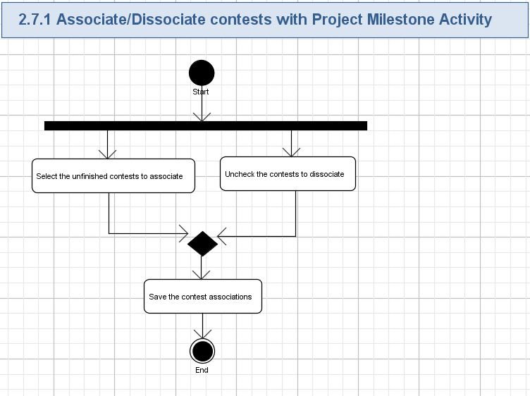

Select the unfinished contests to associated
A multi-select dropdown is displayed for user to associate / dissociate. The current associated contests will be selected be default, see a demonstration below:

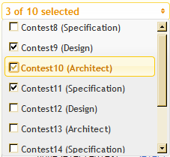

The dropdown options include:
  - All the unfinished contests of current project
  - The associated contests of the project milestone no matter finished or not.

Each contest option is displayed like

Name | Description | Format
Association Check box | Checked means to associate the contest with the project milestone. Unchecked means to dissociate the contest with the project milestone. | A checked, has a value checked / unchecked.
Contest Name | The name of the contest | Text format
Contest Type | The name of the contest type | Text format, put inside brackets and follow the contest name

Uncheck the contests to dissociate
The user can uncheck the checked contests to dissociate them from the project milestone.

Save the contest associations
The user saves the contest associations, the checked contests should be associated with the project milestone, unchecked contests should be dissociated with the project milestone.

Mark Project Milestone as completed / uncompleted
This use case allows user to mark an uncompleted project milestone as completed or mark a completed project milestone as uncompleted.

UI Design Reference: Not available at this time.
Conceptualization Reference: This use case is mapped to the task requirement 4.6.18 Manage Project Milestones in the conceptualization document.
Use case dependency:
  - The use case 2.1 View Project Milestones in List depends on this use case.

- Pre-conditions: User has logged into the TopCoder Cockpit application, user has at least write permission on the project and user is in Project Milestones List View
- Post-conditions: The uncompleted project milestones have been marked as completed, the completed project milestones have been marked as completed.

Mark project milestone as completed / uncompleted Activity Diagram
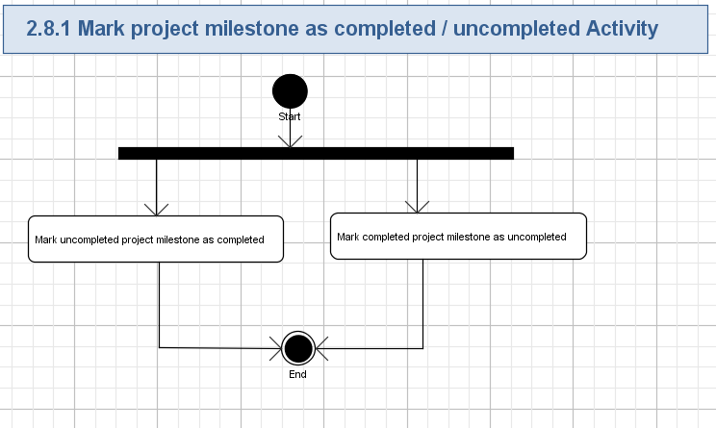

Mark uncompleted project milestone as completed
In the project milestones list view page, the user can mark the uncompleted project milestones in the group overdue or upcoming as completed.

For each uncompleted project milestone in the list view, there will be a checkbox unchecked or a button like “Mark as completed” for user to mark as completed.

User checks the checkbox or click the button will mark the project milestone as completed. The checked project milestone will be displayed in the completed group. It’s recommended to use AJAX for all the operations to improve the user experience.

Mark completed project milestone as uncompleted
In the project milestones list view page, the user can mark the completed project milestones in the group completed as uncompleted

For completed project milestone in the list view, there will be a checkbox checked or a button like “Mark as uncompleted” for user to mark as uncompleted.

User un-checks the checkbox or click the button will mark the project milestone as uncompleted. The unchecked project milestone will be displayed in the overdue group if the due date is late, or displayed in the upcoming group is the due date is not late.

It’s recommended to use AJAX for all the operations to improve the user experience.

View Project Activities Stream
This use case allows user to view the activities stream of a project. The activities stream contains contest related activities, project metadata related activities, and Project documents related activities and project document activities.

UI Design Reference: Not available at this time.
Conceptualization Reference: This use case is mapped to the task requirement 4.6.22 Display Project Activity Stream in the conceptualization document.

- Pre-conditions: User has logged into the TopCoder Cockpit application, user has at least READ permission on the project.
- Post-conditions: The activities stream of the project is displayed to the user.

View Project Activities Stream Activity Diagram
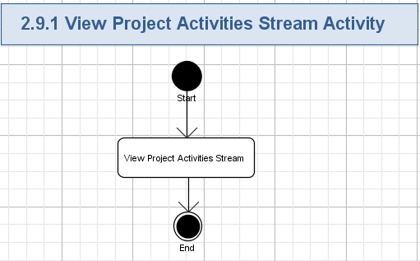

View Project Activities Stream
The activities stream of the cockpit project is displayed for project managers to know what's happening and what happened with the cockpit project.

Examples of activity types are quite different from contest launch to milestone completion or project task created / completed.

Contest related activities:
- <user> created a draft contest <contest name>
- <user> activated the contest <contest name>
- the contest specification of <contest name> is approved, the contest starts registration
- the contest specification of <contest name> is rejected
- <user> approved the contest <contest name>
- <user> deleted the contest <contest name>
- <user> extended the timeline of <phase> of <contest name>
- <phase name> phase of <contest name> is complete.
- <Contest name> is completed.
- Final fix of <contest name> is approved.
Studio contest specific
- the milestone winners have been locked for <contest name>
- the final winners have been locked for <contest name>

User clicks the contest name can go to the contest details page.
Project metadata related activities:

<user> updated the metadata <metadata key name> - <metadata key value>.
<user> added the metadata <metadata key name> - <metadata key value>..
For example, <user> updated the planned duration of cockpit project from 80 days to 110 days or <user> changed the budget from $ 150,000 to $215,000.

User clicks the metadata can go to the metadata page.
Project milestone related:
- <user> created the milestone <milestone>
- <user> updated the milestone <milestone>
- <user> completed the milestone <milestone>
Project documents related
- <user> uploaded the <filename>
- <user> deleted the <filename>
- <user> uploaded a new version of <filename>

User clicks the <filename> can download the file.

Project Task related
- <to do item> created by user
- <to do item> assigned to <user>
- <to do item> completed by <user>
Project activities stream will be separated day by day by default.

Another group option "Group by activity types" could be provided.
User Interface Design requirements:
The user interface design should figure out an intuitive way to present different types of activities. One suggestion is using different colors to distinguish different activity type.

The idea of the activity stream feature is to capture event or change of state for a project, contest, project metadata, project milestone etc and display it to user.

Send daily / weekly project digest email
This system use case generates and sends a digest email notification every day and every week to the project resources who have configured the notification option in their settings.

UI Design Reference: Not available at this time.
Conceptualization Reference: This use case is mapped to the task requirement 4.6.32 Send Daily / Weekly project digest email in the conceptualization document.

- Pre-conditions: The time configured to send daily / weekly digest email is reached.
- Post-conditions: The system generates the email contents and sends email to the project resources.

Send Daily / Weekly project digest email Activity Diagram
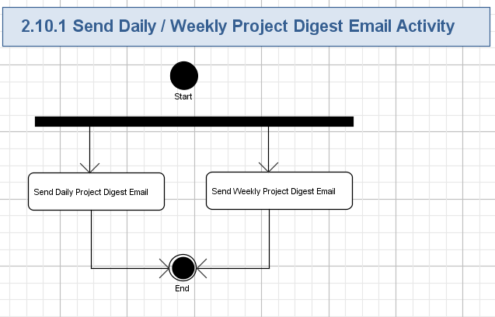

Send Daily project digest email

The daily project digest email should be sent at a configured time of the day to all the project resources every day. Project resources are all the people who have access to the cockpit project, typically they are clients, TopCoder Project Managers and TopCoder Copilots.

Information should be in the email:
- Today's project activities
- Completed project milestones today
- Upcoming project milestones in 3 days
- Overdue/Late project milestones

Send Weekly project digest email
The daily project digest email should be sent at a configured time of the weekend to all the project resources every week. Project resources are all the people who have access to the cockpit project; typically they are clients, TopCoder Project Managers and TopCoder Copilots.

Information should be in the email:
  - Completed contests this week
  - Contests scheduled for the next week.
  - Completed project milestones in this week
  - Upcoming project milestones in the next week
  - Overdue project milestones

Send email notifications
This system use case generates and sends a notification email when certain event happens
- Todo task is assigned to a user
- Project milestone is created
- Project milestone is due in 48 hours

UI Design Reference: Not available at this time.
Conceptualization Reference: This use case is mapped to the task requirement 4.6.33 Send Email Notifications in the conceptualization document.

- Pre-conditions: Any of the events described above happen.
- Post-conditions: The system generates the notification email and send to the resource.

Send email notifications activity
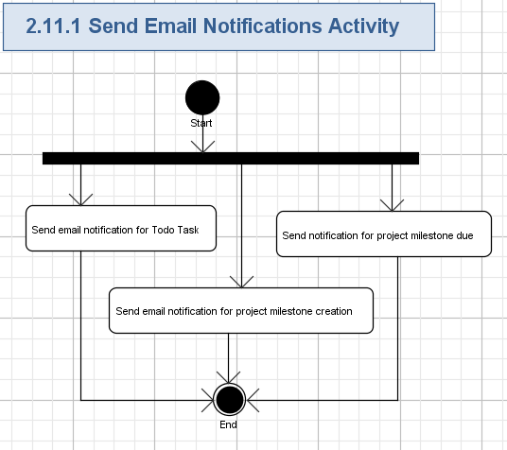

Send email notification for Todo Task
- An email notification should be sent to the assignee when a Todo task is created / updated with the assignee specified.
- The email should show the content of the Todo and the project this Todo is in.

Send email notification for project milestone creation
- An email notification should be sent to the creator and responsible person when a project milestone task is created.
- The email should show
  - The project name
  - The project milestone name
  - The project milestone description
  - The project milestone responsible person
  - The project milestone due date
  - Associated contests (Release 2) only

Send notification for project milestone due
- An email notification should be sent to the creator and responsible person when a project milestone task is due in 48 hours.
- The email should show
  - The project name
  - The project milestone name
  - The project milestone description
  - The project milestone responsible person
  - The project milestone due date
  - Associated contests (Release 2) only
With a warning message

The project milestone is due in 48 hours.

General Requirements

Graphical User Interface Requirements

Main GUI Goal
The new added GUI must be highly user-friendly and intuitive and must conform current TopCoder Cockpit UI.

Resolution
The minimum supported resolution is 1024x768. The application has to be fully workable under such resolution.

Browser Compatibility
- IE 6, 7, 8, 9
- Firefox 3+ on PC and Mac
- Safari 4+ on PC and Mac
- Chrome (All versions)

Performance Constraints
User Metrics Requirements:
- The expected number of unique users will be around 500-1000.
- The expected number of concurrent users is 100 – 150.
.

Performance Requirements
- Performance requirements are that the page loading time should always be in a normal range of about < 2s.
- For data loading which affects the page loading time, like the activity stream architects should consider using AJAX for loading the data without blocking the load of the page.

Security

Security Roles

Permissions
- The system will require all the users to login with unique identity. Except for viewing public pages all other activities require the user to log in. The public pages viewing ability is maintained as per the rest of the framework.
- Currently there is no SSO implemented through different tools, so users will need to login again when moving from one tool to another from example from the web site to Cockpit.
- Users can be assigned different roles based on projects and will be authenticated and authorized as such by different dependent applications. For the purpose of this conceptualization document, the differences between user roles are minimal. Please refer chapter 4.1 for details.
- The system will require the users to be registered and have an account before they can use the Cockpit application. An account will need to be setup (external action) as well.
- TopCoder LDAP server will be used for authentication.
- The Cockpit application works with client confidential data and can include such information as payment accounts and credit card numbers. Topcoder applications that work with this data already use SSL/HTTPS for communication.
- For all project related View use cases, the user should have read permission on the project, for all project related and write related use case, the user should have write permission on the project.

Roles
One or more permissions will be assigned to roles. This application will have one user role. Login and authorization will be handled generally by the external application. Below is a list of roles and permissions.

- Client Administrator (or Customer Administrator) are users which will run projects through the Cockpit application. A client will manage only the project assigned to their account (that they are paying for).

- Client Executive (or Customer Executives) are users who do not need detailed information about specific contests, but want to see the overall picture of what is going on which includes the information about which projects have been run, completed or scheduled.

- Topcoder Project Managers are users which will help clients manage their projects under the Topcoder competition platform. A Topcoder project manager will be able to manage any project.

- Client Project manager have the same prerogatives as Topcoder Project Managers.

- Copilots are users which will help clients manage their projects under the Topcoder competition platform. Copilots can sometimes have restrictions to the files that they can access. If the client sets a file to private or confidential, the copilots will not be able to access it.

- Contest Manager (abstract role) is users who set up, manage and run the contest. The contest holder can either be the client, copilot or TC platform manager. This is an abstract user role that is gained by a client, copilot or TC platform manager upon creating a project or upon being assigned with a particular role (copilot or PM) for a project.

It is self understood that the use cases referring to contest management functions which are displayed on the use case diagram only apply for the contests for which the user has been assigned. Also the users can only manage the cockpit projects that they have permission on.

Please note that for the scope of this specification we ignore the above differences and treat all roles the same from the perspective of contest manager.

 | Contest Manager | System
2.1 View Project Milestones in List | X
2.2 View Project Milestones in Calendar | X
2.3 View Project Milestone Progress | X
2.4 Add Project Milestone(s) | X
2.5 Edit Project Milestone(s) | X
2.6 Remove Project Milestones | X
2.7 Associate / Dissociate contests with Project Milestone | X
2.8 Mark Project Milestone as completed / uncompleted | X
2.9 View Project Activities Stream | X
2.10 Send daily/weekly project digest email |  | X
2.11 Send Email Notification |  | X

Required Documentation

Specification Documentation
- Requirements Specification (this document)
- High Level Use Case Diagrams
- Activity Diagrams

Help / User Documentation
N/A

Notes
N/A

Future Enhancements
N/A

Glossary

Acronyms

Name | Description
Direct/Cockpit | Direct/Cockpit is a TopCoder web application used by clients, copilots and TopCoder platform managers to manage their projects and contests.
Copilots | Copilots are TopCoder members familiar with the TopCoder development methodology who manage the TopCoder process for the client. Clients can optionally engage a copilot to manage their projects. The main responsibilities of the copilot are launching and running contests, providing forum support, running bug races, integrating the final submissions from the various contests and making sure the project is delivered on time and within budget.
TC web site | The main web site for the Topcoder platform. The place where all competitions get published. It contains links to various other systems like OR, JIRA, wiki and forums.
PM | Project manager/Platform Manager
Cockpit Project | Cockpit Project is a concept used in TopCoder Cockpit application to represent a project running on TopCoder platform. It contains various types of contests which build different assets needed for the project.
Cockpit Project Resources | All the people who have access to the cockpit project, typically they are clients, TopCoder project managers and TopCoder Copilots.

