Direct Struts Actions 2 1.0 Component Specification

1. Design
The design implements the actions described in the Requirement Specifications. It provides a class for every action. The actions are usual Struts 2 actions: they contains the setters and getters for the http parameters and the execute method where the business logic is performed. The facades are injected externally: they are used to persist or retrieve the TopCoder entities. An interceptor is provided to re-use the annotation validation of Struts 2 and the validation classes of Struts Framework TopCoder component. A converter is also provided to permit to use all the data of the TopCoder entities.
1.1 Design Patterns
The patterns used in this design are:
- Template method: the BaseDirectStrutsAction delegate the business logic to the abstract executeAction method implemented by the sub classes; in the PayContestAction the logic is delegated to the abstract methods
1.2 Industry Standards
None
1.3 Required Algorithms
1.4 Validation
The validation is performed by the usual annotations of Struts 2. The ValidationErrorsInterceptor will put the validation messages of Struts 2 into the Validation errors.
The Struts 2 annotations validation require a default message and an optional key.
Use an explicit default message that contains the meaning of the error. For example if the field is required and it must be a string with length max of 5 characters and it's set to 10 characters the create the message as “The field's length must be not empty and max 10 characters” where field is the name of field. The messages are up to developer. Set also the optional key so the message can be changed without re-compiling the project. The key must be constructed as: 'i18n.nameOfTheAction.nameOfFieldMeaningOfValidator”. For example in the previous case create the key 'i18n.saveDraftContestAction.contestNameRange'.
1.5 Component Class Overview

ContestAction
This is a base class only to hold the contest service facade shared among several actions
PayContestAction
This is the base class for the payment actions. It holds the main logic.
StudioOrSoftwareContestAction
This is the base class for the action which must decide if a studio or a software contest is managed based on the project or contest id.
It contains the common logic.

PayByBillingAccountAction
This action will make a payment for user using an existing billing account, as per ARS 2.11.1.2-3. This will use the processContestPurchaseOrderPayment method of ContestServiceFacade. It will also send an email to the user (unfortunately the PM at this time didn't answer how to retrieve the mail, so this will be fixed in the final fixes)
PayByCreditCardAction
This action will make a payment for user using a credit card, as per ARS 2.11.1.2-3. This will use the processContestCreditCardPayment method of ContestServiceFacade.
It will also send an email to the user
GetDocumentsContestAction
This action will return all documents of the contest by getting the contest itself. The software documents are available in the SoftwareCompetition.AssetDTO, in the documentation field.
Studio documents are in UploadedDocument instances, and Software documents are in the CompDocument instances.
GetDocumentFileContestAction
This action permits to download a document file from the data provided in the request. It's based on the ARS 2.8.1.8 . The class will be annotated with the annotation Result(name = ActionSupport.SUCCESS, type = "stream") to permit the Struts 2 framework to return a stream result
FileUploadAttachContestFileAction
This action permits to upload and attach a document to a contest.
It uses the FileUploadInterceptor: it will fill the fields contestFile, contestFileContentType and contestFileName. It's related to ARS 2.8.1.3.
It's will persist the related UploadDocument
GetContestTechnologiesAction
This action will return all available technologies using ContestServiceFacade's getActiveTechnologies.
DeleteDocumentContestAction
This action will delete the document. It will first remove the document from the contest then delete the document itself. This is done using the ContestServiceFacade's removeDocumentFromContest then removeDocument methods, respectively
GetContestCategoriesAction
This action will get a contest with the given id. Use ContestServiceFacadeÔs getContest or getSoftwareContestByProjectId based on whether this is a studio or non-studio contest.
MimeTypeRetriever
This one is an useful class to retrieve the mime type from the file name and the mime type id. It uses the MimetypesFileTypeMap to retrieve the mime type. The ids are hardcoded.

1.6 Component Exception Definitions
None
1.7 Thread Safety
The custom validator and the custom converter classes are thread safe because they are stateless and the parent classes are thread safe. The actions are not thread safe but the thread safety is not necessary because in Struts 2 the actions are created in every request: so they can be mutable, they are performed by a single thread. So at the conclusion the component, respect to the environment, is thread safe.
2. Environment Requirements
2.1 Environment
- Java 1.5/J2EE 1.5
- JBoss 4.0.2
- Informix 11
- MySQL 5.1
- Struts 2.1.8.1
- Spring 3.0
- Javascript 1.8
- Mozilla Firefox 2.0/3.0
- IE 6.0/7.0
- Google Chrome
- Safari 3/4

2.2 TopCoder Software Components
- Contest Service Façade 1.0: used to manage contests, to retrieve the contests (studio or software) and related entities
- Struts Framework 1.0: used as base framework, the bases classes extend from it
- Direct Struts Actions 1.0: used for required dependent classes, such as BaseDirectStrutsAction, ValidationErrorsInterceptor, etc.

NOTE: The default location for TopCoder Software component jars is../lib/tcs/COMPONENT_NAME/COMPONENT_VERSION relative to the component installation. Setting the tcs_libdir property in topcoder_global.properties will overwrite this default location.

2.3 Third Party Components
- Struts 2.1.8 : http://struts.apache.org/2.x/
3. Installation and Configuration
3.1 Package Name
com.topcoder.service.actions
3.2 Configuration Parameters
The facades and other properties of the action must be injected externally. An unique name is not present, for these configuration parameters, they can be injected using annotations (in the assembly) or Spring configuration files.
3.3 Dependencies Configuration
The TopCoder components and Struts 2 framework must be configured properly.
4. Usage Notes
None
4.1 Required steps to test the component
- Extract the component distribution.
- Follow the dependencies configuration.
- Download JBoss 4.0.2 and install it locally .(http://www.jboss.org/jbossas/downloads/).
- Set your JAVA_HOME to use JDK 1.5 as compiler.
- Edit build-dependencies.xml and configure jboss.home and junit.jar path.
- Execute ‘ant deployToJBoss’ within the directory that the distribution was extracted to in order to deploy the demo to JBoss.
- For instructions on how to use demo, see section 4.3.
- Execute ‘ant test’ within the directory that the distribution was extracted to.
4.2 Required steps to use the component
See the demo section for how to run the demo. Here is a sample struts.xml file:
<?xml version="1.0" encoding="UTF-8"?>
<!DOCTYPE struts PUBLIC
"-//Apache Software Foundation//DTD Struts Configuration 2.0//EN"
"http://struts.apache.org/dtds/struts-2.0.dtd">

<struts>
<constant name="struts.devMode" value="true" />
<constant name="struts.convention.action.disableScanning" value="true" />

<package name="tcs-default" extends="struts-default"
abstract="true">
<!-- Setup interceptors stack -->
<interceptors>
<interceptor name="authentication" class="authenticationInterceptor" />
<interceptor name="logging" class="loggingInterceptor" />
<interceptor name="validationErrors" class="validationErrorsInterceptor" />
<interceptor name="mock" class="mockActionInterceptor" />

<interceptor-stack name="defaultTCSStack">
<interceptor-ref name="authentication" />
<interceptor-ref name="logging" />
<interceptor-ref name="validationErrors" />
<interceptor-ref name="defaultStack" />
</interceptor-stack>
</interceptors>

<!--
Make the default one used for all actions unless otherwise
configured.
-->
<default-interceptor-ref name="defaultTCSStack" />

<!-- Configure global results -->
<global-results>
<result name="login">/login.jsp</result>
</global-results>

</package>

<package name="default" namespace="/" extends="tcs-default">

<interceptors>
<!-- for the login stack, we exclude the authentication interceptor -->
<interceptor-stack name="loginTCSStack">
<interceptor-ref name="logging" />
<interceptor-ref name="defaultStack" />
</interceptor-stack>

<interceptor-stack name="demoTCSStack">
<interceptor-ref name="authentication" />
<interceptor-ref name="logging" />
<interceptor-ref name="mock" />
<interceptor-ref name="validationErrors" />
<interceptor-ref name="defaultStack" />
</interceptor-stack>
</interceptors>

<action name="login" class="loginAction">
<interceptor-ref name="loginTCSStack" />
<result name="input">/login.jsp</result>
<result>/main.jsp</result>
</action>

<!-- ============================= -->
<!-- actions used for demo -->
<!-- ============================= -->

<action name="fileUploadAttachContestFileAction" class="fileUploadAttachContestFileAction">
<interceptor-ref name="demoTCSStack" />
<result name="input">/fileUpload.jsp</result>
<result name="success">/success.jsp?type=fileUpload</result>
</action>

<action name="payByCreditCardAction" class="mockPayByCreditCardAction">
<interceptor-ref name="demoTCSStack" />
<result name="input">/payByCreditCard.jsp</result>
<result name="success">/success.jsp?type=payByCreditCard</result>
</action>

<action name="payByBillingAccountAction" class="mockPayByBillingAccountAction">
<interceptor-ref name="demoTCSStack" />
<result name="input">/payByBillingAccount.jsp</result>
<result name="success">/success.jsp?type=payByBillingAccount</result>
</action>

<action name="getContestCategoriesAction" class="getContestCategoriesAction">
<interceptor-ref name="demoTCSStack" />
<result name="success">/success.jsp?type=getContestCategories</result>
</action>

<action name="getContestTechnologiesAction" class="getContestTechnologiesAction">
<interceptor-ref name="demoTCSStack" />
<result name="success">/success.jsp?type=getContestTechnologies</result>
</action>

<action name="deleteDocumentContestAction" class="deleteDocumentContestAction">
<interceptor-ref name="demoTCSStack" />
<result name="input">/deleteDocument.jsp</result>
<result name="success">/success.jsp?type=deleteDocument</result>
</action>

<action name="getDocumentFileContestAction" class="getDocumentFileContestAction">
<interceptor-ref name="demoTCSStack" />
<result name="input">/getFile.jsp</result>
<result name="success">/success.jsp?type=getFile</result>
</action>

<action name="getDocumentsContestAction" class="getDocumentsContestAction">
<interceptor-ref name="demoTCSStack" />
<result name="input">/getDocuments.jsp</result>
<result name="success">/success.jsp?type=getDocuments</result>
</action>

</package>
</struts>

4.3 Demo
- Be sure you have deployed demo to JBoss, refer to section 4.1 for details.
- Start JBoss.
- Navigate to http://localhost:8080/demo/login
- Use ‘topcoder’ for login name and ‘password’ for password (quotes added for clarity) when you get to the login screen.
- On next page, you will be presented with a list of actions you can demo (all major actions in the component have an associated demo page, as shown by the following screenshot)
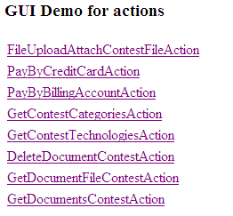
- FileUploadAttachContestFileAction
  - You can enter a contest file description and other related fields. You can then click the upload button.
  - If any required field isn’t present or is invalid, you will get an error message on the screen like the one shown below:
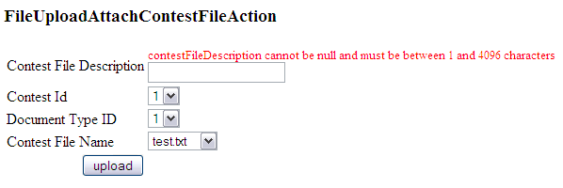
- PayByCreditCardAction
  - Enter all the required fields and click the pay button to pay by credit card. Note that state is not required unless country is US. Also note that only project ID or contest ID should be set, but not both.
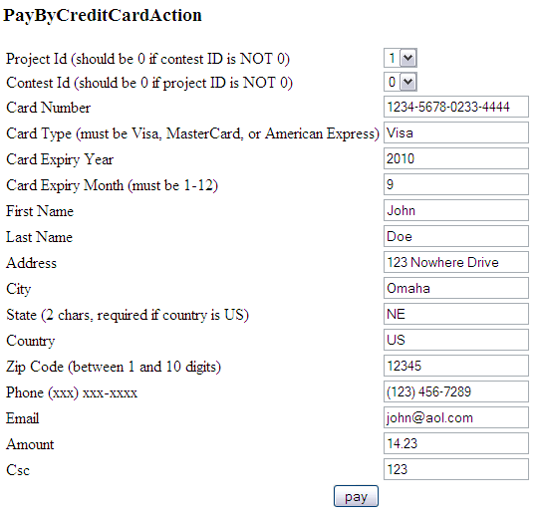
- PayByBillingAccountAction
  - Works similarly to PayByCreditCardAction
- GetContestCategoriesAction / GetContestTechnologiesAction
  - They just display the relevant items (categories or technologies) for the chosen action.
- DeleteDocumentContestAction
  - Allows for deleting a document from a contest. Choose the document ID and contest ID, both must be > 0.
- GetDocumentFileContestAction
  - Retrieves the document file for the given contest. Follow the instructions on the page.
- GetDocumentsContestAction
  - Gets the documents in the system and displays their file names.

5. Future Enhancements
It's possible to implement other actions.

