Jira/Bamboo/Confluence Login Project Specification

Introduction

The scope of this project is divided into 3 phases:

- Add members to the Jira, Bamboo and Confluence databases through their webservices.
- Use of TopCoder’s main password in Bamboo (Jira and Confluence are alread implemented)
- Automatically call the webservice to create the user upon registration for a software competition.

This document covers the Bamboo customization: custom authenticator and new REST services.

Bamboo authentication

Bamboo’s authentication mechanism can be extended by inheriting the BambooAuthenticator class and updating the WEB-INF\classes\seraph-config.xml file.

TopCoderAuthenticator extends BambooAuthenticator. This class will check if the user exists in Bamboo. If it does, it will validate the password against TC’s database. If the user does not exist in TC database, it will use standard Bamboo’s authentication. If the user is found, but the password does not match, it will deny the login. If the password matches, it will continue.
If user is not found in Bamboo’s database, search it in TC database. If it is not found, deny access. If it is found, create the user in Bamboo and authenticate the given password.
The e-mail is always updated from TC database.
The user is created and added to 2 groups:
- bamboo-users: always
- topcoder-staff: if a TC admin

Bamboo REST services

Bamboo does not offer a SOAP interface. It has a couple of methods executed through REST. In order to add users to Bamboo, 4 new REST services are added:
  - HasUser
  - HasGroup
  - AddUser
  - AddUserToGroup

BambooActionSupport class provides a Webwork framework to create new REST services. The UML diagram shows these classes in detail (TODO).

Bamboo Build process

This component has a war-build folder. Bamboo does not provide a way to rebuild the WAR files with custom changes as Jira or Confluence. Therefore, we had to create one. The idea is to un-jar bamboo’s war file under war-build/webapp folder.

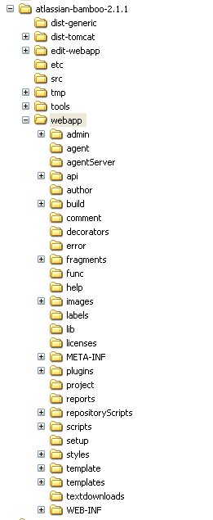

In the edit-webapp folder, there are several changes that the build process will override. To build the war file, run build.bat. To create an EAR file, run build.bat ear.

