Review Selection 1.0 Component Requirements Specification

Scope

Overview
TopCoder attempts to improve the competition review process and is in need for updating current systems for integrating with new review process outlined in separate Competition Review Process Conceptualization document.

Currently there are two applications involved in review process. TopCoder Website application is used by the reviewers for signing up for the review positions and listing the statistics for projects and users. Online Review application is actually used for managing the review process providing the users with abilities to upload submissions for contests, fill the screening and review scorecards, submitting and resolving appeals, performing contest results aggregation, submitting final fixes and approving the results of contests.

This component will implement the algorithms and the data structures required to implement the review selection algorithm.

Logic Requirements

Reviewer data structure update
Reviewer objects will now have general statistics associate with each of the competition type for which they are a member of the review board.

This is a very important aspect because different competition types have different review board requirements and different specifics. So review board members of design will be rated against other review board members of design and not other competition type like specification.

Pluggable selection algorithm
The component will create the ReviewSelection interface.
This interface defines the contract for different review selection algorithms. All connections to this component will be done through this interface so that the selection algorithms are pluggable.

Default implementation selection algorithm
The component comes with a default implementation of the selection algorithm.
This algorithm will do the following:
- Get project type
- Get average statistics of reviewers for the project’s competition type
- Compute best average statistics among the primary applications
- Assign the primary reviewer
- Compute the best 2 (or other configurable value) average statistics among the unselected primary reviewers
- Assign reviewer to application using RBoardApplicationBean
- Pass the assigned applications to the configured ReviewApplicationProcessor
- Passed the unassign applications to the configured ReviewApplicationProcessor

The formula to use for evaluating the most suitable reviewer is (based on statistics and workload)
Average Coverage * Average Accuracy * (Average Timeline Reliability – 0.5) * Workload Factor

The applicant reviewer having the best (largest) coefficient computed using the formula above will be assigned to the available position.

Note: Tie brakes will be solved by application date. The earlier application date will be assigned.

The workload factor is already stored in the reviewer table, the value is simply retrieved and plugged into the formula.

ReviewApplicationProcessor
The ReviewApplicationProcessor interface defines methods to be called after the assigned has been performed. These are operations.

Default implementation
A default implementation of the ReviewApplicationProcessor will be created.
This implementation will have the following features for the two methods:
- Update the number of concurrent reviews in the reviewer statistics, by incrementing this value, for the updateReviewAssignmentStatistics
- Issue back (restore) the primary eligibility review points to the primary applications that were not selected

Primary eligibility review points is a special measure that allow a reviewer to apply only for a limited number of primary positions proportional to the number of secondary positions that he/she applied for. To enforce this, the application algorithm decreases this number for each application that selects primary as an option.

Exceptions
Exceptions thrown from the manager should extend the exception from the interface diagram and should use BaseException defined classes.

Required Algorithms
None

Example of the Software Usage
This component provides the review selection functionality of the upgraded application.

Future Component Direction
None.

Enhancement policy
To avoid bloated enhancements that will slow down development without adding much value to the application, an enhancement policy will be used for this component.
Any major enhancement should be approved by the architect before being implemented. Not getting an enhancement approved is a risk of not only not getting the enhancement considered for review scoring but potentially being asked to remove it in final fix, should the given designer win the competition.

Enhancement approvals can be obtained by contacting the architect directly using the “[Send a message]” button from the member’s profile page. Please note that using Contact Managers button from Online review will not also contact the architect.

Any enhancement already mentioned in future direction is considered approved.

Interface Requirements

Graphical User Interface Requirements
None.

External Interfaces
Designs must adhere to the interface diagram definition found in the architecture TCUML file provided. Changes to the interfaces should be approved in the forum.

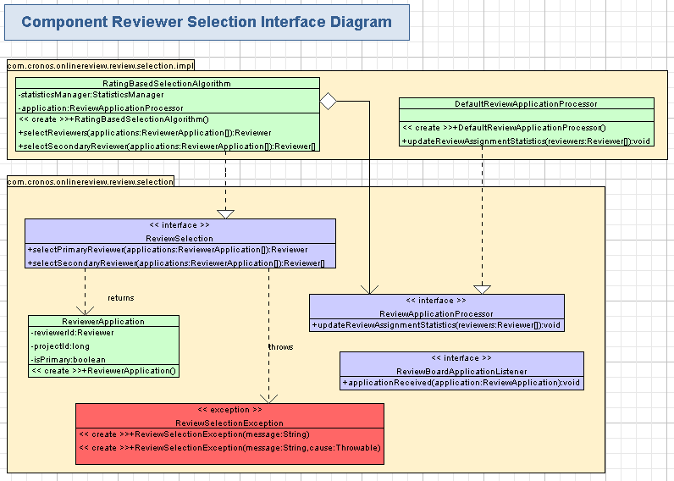

Environment Requirements
- Development language: Java1.5
- Compile target: Java1.5

Package Structure
com.cronos.onlinereview.review.selection

Software Requirements

Administration Requirements

What elements of the application need to be configurable?
- The statistics manager to use for the rating selection algorithm
- Other persistence managers for managing projects and review application instances
- Database connection information
- Any other manager subject to design decisions

Technical Constraints

Are there particular frameworks or standards that are required?
None

TopCoder Software Component Dependencies:
- Base Exception 2.0
- Project Management 1.2
- Resource Management 1.2

**Please review the TopCoder Software component catalog for existing components that can be used in the design.

Third Party Component, Library, or Product Dependencies:
None

QA Environment:
- Java 1.5
- Solaris 7
- RedHat Linux 7.1
- Windows 2000
- Windows 2003
- Oracle
- JBoss 4.2.2

Design Constraints
The component design and development solutions must adhere to the guidelines as outlined in the TopCoder Software Component Guidelines.

Required Documentation

Design Documentation
- Use-Case Diagram
- Class Diagram
- Sequence Diagram
- Component Specification

Help / User Documentation
- Design documents must clearly define intended component usage in the ‘Documentation’ tab of the TopCoder UML Tool.

