TopCoder Simplify Registration Process
and Improve Usability 1.0
Requirements Specification

This document outlines the Application Scope and Requirements for
TopCoder Simplify Registration Process and Improve Usability 1.0.

PRESENTED TO:  <Client Names> | <CLIENT LOGO>
PRESENTED BY:  <TopCoder Names> | 

Revision History
Author | Revision Number | Date
MiG-29 | 1.0 | 03/05/2011
MiG-29 | 1.1 | 03/10/2011

Application Requirements Specification 5
1. Scope 5
1.1 Overview 5
1.2 Objectives 6
1.3 Limitations & Assumptions 7
2. Logic Requirements 9
2.1 View Homepage 11
2.2 Login 15
2.3 Logout 19
2.4 Recover Forgotten Password 21
2.5 Create Account 25
2.6 Activate Account 30
2.7 Provide Profile Data on Application Request 32
2.8 View Profile 35
2.9 Edit Contacts Data 42
2.10 Edit Demographic Information 46
2.11 Edit Account Information 52
2.12 Provide Data for Forums Participation 56
2.13 Provide Data to Work with Wiki 59
2.14 View/upload Profile Photo 62
2.15 Remove Profile Photo 66
2.16 Configure Privacy 68
2.17 Configure E-mail Notifications 73
2.18 Configure Payment Preferences 76
2.19 Configure Registration Preferences 79
2.20 Configure Forum Preferences 82
2.21 Configure Referrals 89
2.22 Configure Cards/Badges 91
2.23 Become a Customer 94
2.24 Provide Data for Ordering Projects in TC Direct 96
2.25 Provide Data to Access Online Review Tool 99
2.26 Provide Data to Access JIRA 103
2.27 Provide Data to Access SVN 107
2.28 Provide Data to Access VM 111
2.29 Provide Data for Competitions Participation 116
2.30 Provide Data for CoPilot Contests Participation 119
2.31 Configure Affidavits 122
2.32 Check Payments 124
2.33 Configure Assignment Documents 126
2.34 Configure Visa Letter 128
2.35 Ask User to Provide More Profile Data 130
2.36 Perform Auditing 132
2.37 Perform Logging 133
2.38 Send E-mail Notifications 134
3. General Requirements 137
3.1 Graphical User Interface Requirements 137
3.2 Performance Constraints 137
3.3 Security 138
4. Required Documentation 139
4.1 Specification Documentation 139
5. Help / User Documentation 139
6. Notes 139
7. Future Enhancements 140
8. Glossary 140
8.1 Definitions 140
8.2 Acronyms 141

Application Requirements Specification

Scope

Overview
The TopCoder registration process to become a member of TopCoder is going to be redesigned. The main goal is to allow for a minimal set of required info that the user needs to enter to sign up (handle, email, and password).

The existing TC web registration process will ask a new user to enter a lot of data when he/she tries to register to TC web-site. The registration process takes a lot of time, so many users can simply break the registration process and leave non-registered

Thus there is a need of an easy to use and user friendly web-application for supporting registration on the new users and management of registered user profiles at TC web-site.

The main goal of this application is to simplify registration of the new users on TC web-site by minimizing the count of mandatory data fields for new account registration, and to improve usability of user profile management for the registered users. Any additional profile information will be requested from the user by the system as it is needed. For example, if a user registers to compete in an Assembly contest the site would prompt them for any required info that they have not yet entered.

The following use cases of the “Simplify Registration Process and Improve Usability” conceptualization are in scope. Please note, they are slightly renamed and modified (i.e. combined) in the specification document, but references to those original use cases are also provided.
- 4.4.1 Login
- 4.4.2 Logout
- 4.4.3 Recover Forgotten Password
- 4.4.4 Create New User Account
- 4.4.5 Confirm Account Creation
- 4.4.6 Get E-mail Notifications (this features will be integrated to other use cases)
- 4.4.7 Provide Profile Data on Application Request
- 4.4.8 View Profile
- 4.4.9 View Profile Fullness (a separate page is not implemented, so this use case was combined with other use cases)
- 4.4.10 Edit Profile
- 4.4.11 Rename User Handle
- 4.4.12 Provide Data for Forums Participation
- 4.4.13 Provide Data to Work with Wiki
- 4.4.14 Upload Photo
- 4.4.15 Remove Photo
- 4.4.16 Configure Privacy
- 4.4.17 Configure E-mail Notifications
- 4.4.18 Configure Forum Preferences
- 4.4.19 Configure Referrals
- 4.4.20 Configure Cards/Budges
- 4.4.21 Become a Customer
- 4.4.22 Provide Data for Ordering Projects in TC Direct
- 4.4.23 Provide Data to Access Online Review Tool
- 4.4.24 Provide Data to Access JIRA
- 4.4.25 Provide Data to Access SVN
- 4.4.26 Provide Data to Access VM
- 4.4.27 Provide Data for Competitions Participation
- 4.4.32 Configure Affidavits
- 4.4.33 Check Payments
- 4.4.34 Configure Assignment Documents
- 4.4.35 Configure Visa Letter
- 4.4.36 Ask User to Provide More Profile Data
- 4.4.37 Perform Auditing
- 4.4.38 Perform Logging
- 4.4.39 Send E-mail Notifications

All of the storyboards screens are in scope. This specification will define functionality for the following URLs:
https://www.topcoder.com/reg/
http://www.topcoder.com/tc?module=MyHome

Objectives
The business objectives of this project are listed below. Delivering these objectives will deliver the expected benefits of the application.
Must to have:
- To implement an easy to use and user friendly web-application for supporting simplified registration on the new users and management of registered user profiles at TC web-site.
- To greatly simplify user registration process and profile management/editing (including a convenient way to upload a user photo to the profile).
- To make new business process intuitive and user friendly. This application will be like a first interaction of the potentially new user with TC web-site. The first user impression needs to be good.
- To minimize set of data required for user registration.
- To redesign and mostly re-use (with minimal modifications) existing parts of TC web-site (GUI and code updates) according to the new registration process.
- To achieve that the new registration process is compatible with the current TopCoder workflow.
- To efficiently visualize user profile data in an easy to read/manage form.
- To migrate existing user accounts and profiles.

Nice to have:
- To implement a comprehensive page, displaying user profile fullness like skills of the game personage.
- To provide more useful configuration on community relations data for the user profile.
- To allow submitting assignment documents through My TopCoder page.
- To send helpful e-mail notifications to users in most important events during the application workflow (like new abilities to get access to more TC web-site applications when the user entered more data to his/her profile).
- [NOT IN SCOPE IN THIS VERSION OF THE APPLICATION] To support SSO for the user account through all TC web-site applications.

Project Return on Investment (ROI Metrics) are as following:
- To increase count of user registrations on TC web-site.
- To reduce difficulties during registration to TC web-site.
- To improve new TC users satisfaction on TC web-site by removing redundant activities from the initial step of a new account registration.
- To improve satisfaction of the existing TC users on TC web-site by simplifying updating of his/her profile and managing his/her picture (avatar).
- To reduce count of errors in user profiles due to simplification of its creation and updating.
- To reduce manual operations of TC Admins on managing user photos (avatars).

General Capacity Metrics:
- The maximum expected number of unique users is more than 250,000 (and growing) – this is a number of Observers, Competitors and Customers.
- Maximum count of concurrent users for this application (registration and profile management) will be quite small. There are totally about 1000 accesses to this application a day (including up-to 300 new registrations).

General Usability Metrics:
- The new application will be user friendly and support an easy registration of new users.
- The new registration process has to motivate new users to register to the application, use other features of the application and finally – provide more information about him/herself.

Limitations & Assumptions
The limitations of the new registration process are as following:
- TC admin functionality, related to registration business process and user profile managements, is out of scope for this application.

Assumptions critical to the success of this project are listed below:
- The application will be web-based and integrated with all the existing TC web-site parts.
- This is an update of the existing business process for user registration and account/profile management. The existing set of source code will be re-used when it is possible.
- The application will be accessible through a web-browser.
- The users of the application will access it from regular computers (PC, Mac, Linux) and mobile devices through Internet.
- The available hardware resources for the new application users will be the same as for the previous business process.
- The user credentials/accounts will be stored to database.
- Most of user profile data (like demographics) will be stored to the application database.
- The user photos references will be stored in the database and the images will be placed to the server file system.
- The application will be used from different time zones.
- International symbols have to be properly displayed in the application.
- The minimal set of the data for a new user registration is: a username (handle), e-mail address, password and turned on check box on Terms & Conditions of TC web-site usage.

Technical assumptions from the client:
- The application will follow the existing stack of technologies, used by TC web-site:
  - Everything is running on Red Hat Linux 4.1.2-46 operating system.
  - The application will be based on J2EE 1.5 technology, JSP and Struts.
  - Java version "1.6.0_04" language is used.
Spring 2.5.6 is used.
  - Hibernate 3.6 is used.
  - Informix 11.5 database is used.
  - Apache/2.2.4 and JBoss-4.0.4.GA servers are used.
  - VM image documentation can be found here: http://www.topcoder.com/wiki/display/docs/VM+Image+2.5
  - Jira 4.1.2 will be used.
  - Wiki is based on Confluence 2.7.
  - Jive Professional 4.2.5 forums are used.

Logic Requirements
Use case diagram is shown below:
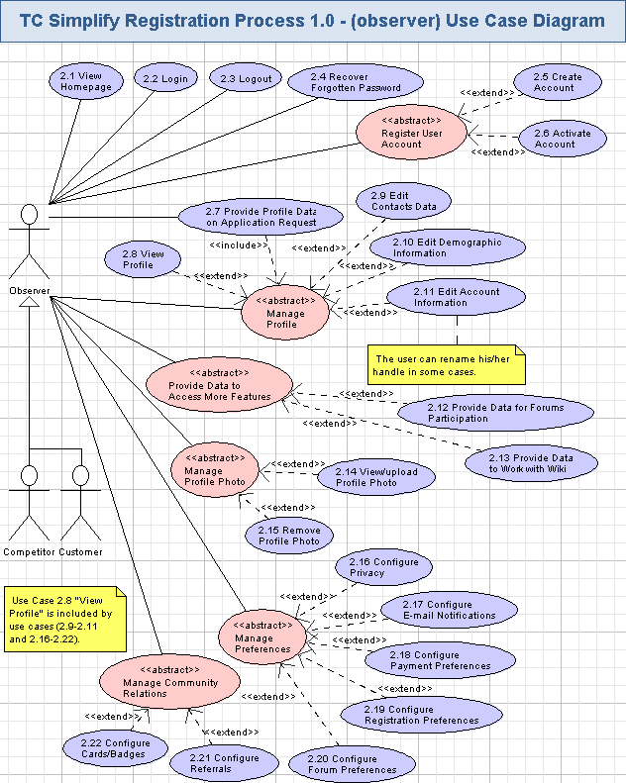
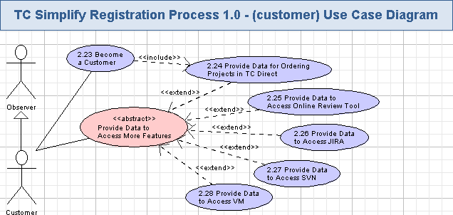

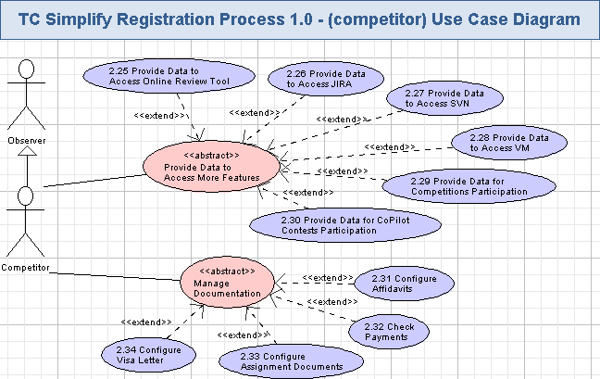

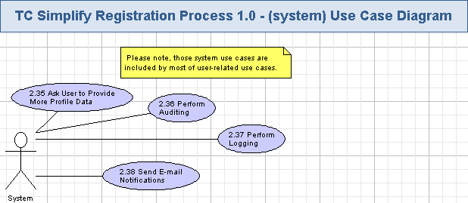

View Homepage
The user can view the homepage of the application. It will display the header, left navigation menu (if the user was logged in), main area and the footer. This page is like a template for displaying all the other web-pages of the application. Content of the main area in the homepage will depend on whether the user is logged in, or not.
Reference to initial use case in conceptualization: none.
Storyboard page: any page of the application, for example: “05_01_01_myprofile_name-n-contact.png”.
- Pre-conditions: the user just started the registration process, or logged in, or pressed “My Profile” hyperlink in the application.
- Post-conditions: the homepage (template) of the application was displayed and the user can choose some actions on that page.

View Homepage Activity
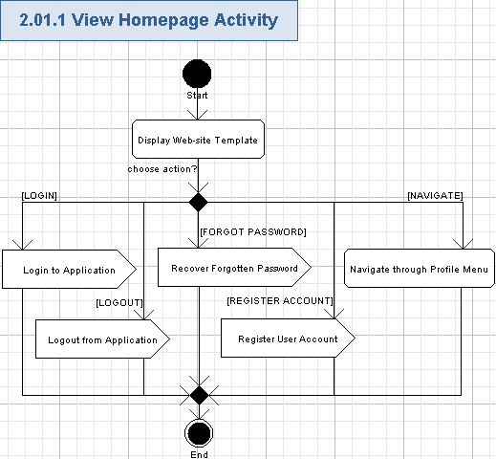

Display Web-site Template
- The application will display the template of the web-site.
- The template will be shown on any page of the application, so it will be described just once below.
- The template has a heading part, left navigation menu (for My Profile part of the web-site), main middle/center area, and a footer.
- The application displays a Client company logo (i.e. TopCoder) in the left top side of the header.
- The application will display a login/register/forgot password graphical part on the right of the header (please refer chapters 3.2, 3.5, and 3.4 for more details).
- The login/register/forgot password graphical part of the header will be replaced by the welcome part after user logged in, registered to the application or restored forgotten password (please refer chapters 3.2, 3.5, and 3.4 for more details).
- The application will display the “Logout” hyperlink in the rightmost part of the header after user logged in, registered to the application or restored forgotten password – please refer chapter 3.3 for details.
- The application will display the name of the page (like “MY PROFILE”, etc.) on the top of the main area (after the header).
- If the user works with the “My Profile” part of the application, then the navigation menu is displayed on the left side of the web-page – just below the header. And the user can navigate to various topics and options in that menu (please refer chapter 3.1.1.6 for more details).
- The application will use the main area for displaying the main data, which the user works with (for example, some page of the user profile, etc.). So, it can be recognized as a content area and will be highlighted by the white background.
- The application will use the footer below the main are of the web-page.
- The application will display copyright information (String, max 50 chars, non empty) in the footer.
- The screen example of the homepage and the web-site template is like following:
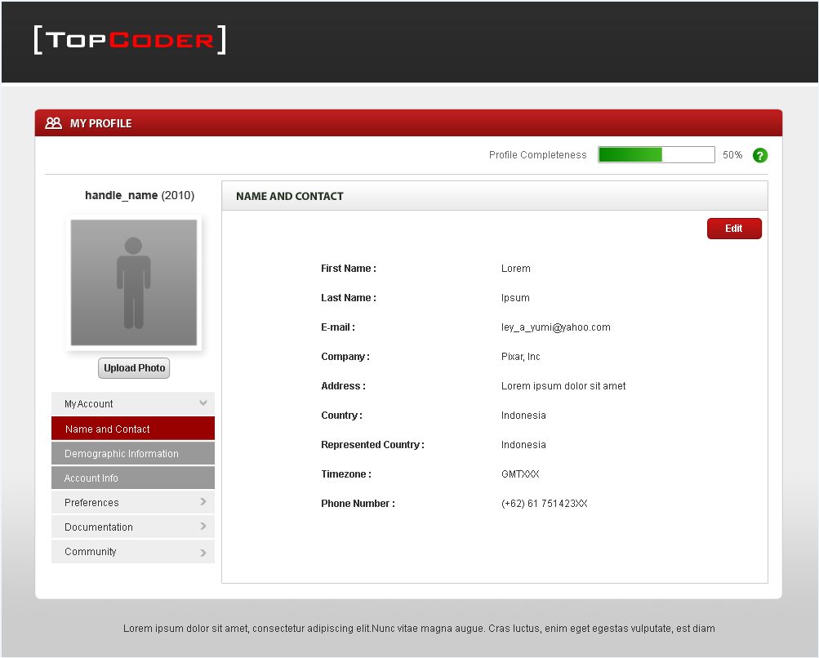

Login to Application
- The non-logged in user can press “Login” hyperlink on the homepage to initiate performing login to the application. Please refer chapter 3.2 for more details.

Logout from Application
- The logged in user can press “Logout” hyperlink on the homepage to logout from the application. Please refer chapter 3.3 for more details.

Recover Forgotten Password
- The user can press “Forgot your password?” hyperlink on the homepage to restore forgotten password. Please refer chapter 3.4 for details.

Register User Account
- The non-registered user pressed “Register now” hyperlink on the homepage to start registering his/her account for the application. Please refer chapter 3.5 for more details.

Navigate through Profile Menu
- The user can navigate to the following topics from the profile menu:
  - My Account,
  - Preferences,
  - Documentation,
  - Community.
- The chosen topic will expand its options in the menu.
- Just one topic can be selected at the moment. The options from all the other topics are collapsed.
- The currently chosen topic is specially marked (like by “v” icon), and the collapsed topics will be marked as well (like by “>” icon).
- The tree of all the topics and options in the profile menu are as following:
  - My Account
    - Name and Contact (please refer chapter 3.9 for more details)
    - Demographic Information (please refer chapter 3.10 for more details)
    - Account Info (please refer chapter 3.11 for more details)
  - Preferences
    - Privacy (please refer chapter 3.16 for more details)
    - Email Notification (please refer chapter 3.17 for more details)
    - Payment Preferences (please refer chapter 3.18 for more details)
    - Registration Preferences (please refer chapter 3.19 for more details)
    - Forum Preferences (please refer chapter 3.20 for more details)
  - Documentation
    - Affidavits (please refer chapter 3.31 for more details)
    - Payments (please refer chapter 3.32 for more details)
    - Assignment Documents (please refer chapter 3.33 for more details)
    - Visa Letter Status (please refer chapter 3.34 for more details)
  - Community
    - Referrals (please refer chapter 3.21 for more details)
    - Card / Badges (please refer chapter 3.22 for more details)
- The expanded options will be specially highlighted – like by a dark gray color.
- The currently selected option will be marked like by a red color.
- The screen example of the left navigation menu is like following:
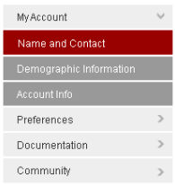

Login
The application will allow registered users to login. This functionality will be mostly re-used from the existing TC web-site. The application will provide a special part of the homepage for user login there the user will enter his/her credentials. The application validates user credentials and performs authentication/authorization. Remembering of user login to the application (through the user session and database) will be also supported and the user will not be asked to re-login again.
Reference to initial use case in conceptualization: “4.4.1”.
Storyboard page: http://www.topcoder.com/tc?&module=Login .
- Pre-conditions: the non logged-in user pressed “Login” hyperlink on the login part of the homepage.
- Post-conditions: the user was successfully logged in, can access application functionality, and his/her login to the application could be optionally remembered.

Login Activity
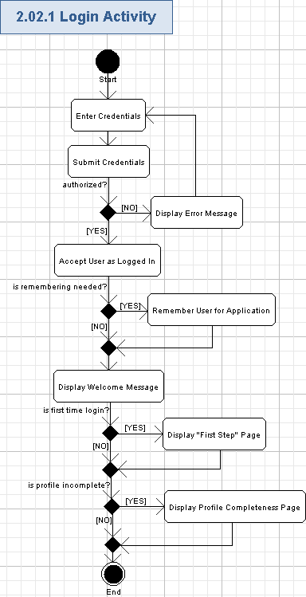

Enter Credentials
- In order to login into the website, the user will enter their handle (username) and password.
- The handle and password are according to the following table:
Data Element | Description | Format | R?
Username | The unique username (handle) for the account on the application | String, max length is the same as in previous database, non empty | Y
Password | The password of the user | String, min and max length is the same as in previous database, case sensitive alphanumeric characters.  Displayed with ‘*’ chars when entering | Y
- The screen example for login to the application is like following:
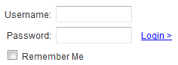

Submit Credentials
- The user presses “Login” hyperlink to perform login to the system.
- The system will validate the user credentials and authenticate/authorize the user.
- There will be own authentication/authorization sub-system to perform that action.
- Authentication and Authorization features from the existing business process are reused. User credentials are validated against Informix database.

Display Error Message
- If the user credentials was wrong (invalid format) then the application will display one of the following messages, informing the user about the problem:
Username is required,
Password is required,
Password has to be from <N> to <M> chars.
- Where <N> is a lowest possible count of chars in the password, and <M> is the greatest possible count of chars in the password. <N> and <M> values are the same as on the existing TC web-site.
- If the username was not found in the system or the passwords do not match, a message will be displayed to inform the user that the user name or password is invalid. A user will not be able to infer if the password is wrong or the user id is invalid from the error text. The message is like:
The username or password you provided is wrong
- The user has to re-enter his/her credentials to login.

Accept User as Logged In
- In case of successful login the application will recognized the user as logged in.
- The user will get access to the related functionality (according to user role) in the application.
- There can be multiple user roles assigned to any user.
  - All the users will have an Observer functionality.
  - The user can be a Customer for some contests and a Competitor for others.

Remember User for Application
- If the user turned On the “Remember Me” checkbox, then he/she will be specially remembered by the application (i.e. in database):
  - The application will ask the user to login just once – after that the user will stay logged in until he/she specially asks the application to logout.
  - The user login will be stored between web-browser sessions for the user.

Display Welcome Message
- The application will display the welcome message for the user after login:
Hello, <username>
- Where <username> is the unique username (handle) for the account on the application (String, max length is the same as in previous database, non empty). It will be a hyperlink to view the user’s competitions profile (out of scope for this specification). The username will be colored according to the user highest rating (in the same way as on the existing TC web-site).
- There will be “Logout” hyperlink (please refer chapter 3.3 for more details)

Display "First Step" Page
- The user will be presented with the “First Step” popup window, where he/she can configure his/her registration preferences (i.e. the preferable user role).
- The user will choose his/her registration preferences like described in chapter 3.19.

Display Profile Completeness Page
- The user will be presented with “Profile Completeness” page (with title “PLEASE COMPLETE YOUR INFORMATION”) asking the user to enter missing data to his/her profile.
- The application will automatically open the related page of the user’s profile and highlight the fields to be filled – please refer to chapter 3.8 for more details.
- The application will indicate how many optional fields of the user profile were filled yet.
  - The percentage filled bar will be displayed for that – like on usual social networks.
  - The indicator example is below (its value is from 0% to 100%, integer number value):
- The application will inform the user filling of which parts of the profile will open an access to more features at TC web-site.
  - It can be like tips, shown near-by block of data (say, “Fill personal data and contact to start posting on the forums”, “Upload signed assignment document to compete in contests requiring CCA”, etc.).
  - The user can press a small green “?” button nearby the “Profile Completeness” indicator and get the tip message (String, rich text formatted, max 2048 chars, non empty) like following:
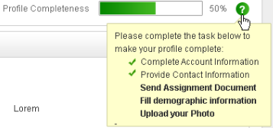
- The application will display specially visualized (like progress steps) several stages of user profile filling – simply like names (String, max 50 chars, non empty) of various pages of the user profile and account.
  - The already filled stages will be highlighted in red color, and the empty parts of the user profile will be shown in gray color – like following:
- There will be two buttons: “Remind Me Later” – for cancel entering new data to the profile, and “Submit” to add entered new data to the profile.
- The screen example of possible popup window is like following:
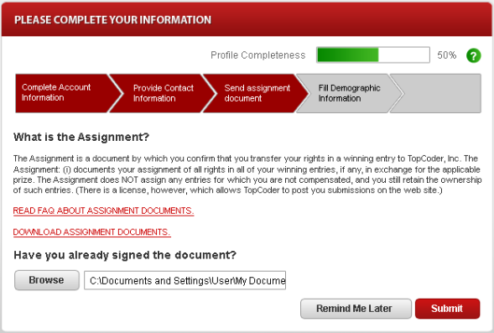

Logout
The user can logout at any time from the application to ensure high security. Most pages (except the login page and new account registration pages) of the application will display the hyperlink for logout (like “Logout”).
Reference to initial use case in conceptualization: “4.4.2”.
Storyboard page: none.
- Pre-conditions: the logged in user pressed “Logout” hyperlink.
- Post-conditions: the user was logged out from the application and cannot work with his/her profile until login again.

Logout Activity
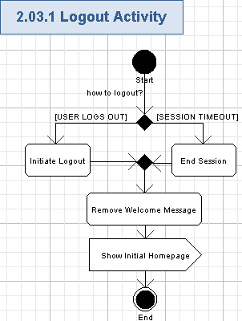

Initiate Logout
- The “Logout” hyperlink will be displayed on any page of the application (when the user is logged in).
- If a logout command is issued, the user’s session will be terminated and they will not be able to perform any functions of a logged in user (like the stored cookie will be removed).
- Logout functionality will be mostly re-used from the existing TC web-site.

End Session
- If the session timeout expires then the user will be automatically logged out and required to re-login (if performed some operation, available only for the logged-in user).
- The session timeout will be set to 120 minutes by default, but will be configurable.

Remove Welcome Message
- The application will remove welcome message and related data (described in chapter 3.2.1.6) from the header.

Show Initial Homepage
- The application will show the initial homepage (as described in chapter 3.1), so the user can login again.
- After logout, the user will have just functionality of the non registered user.

Recover Forgotten Password
The user can restore forgotten password of his/her account on the application. The user will be asked for username or e-mail address for his/her profile and the application will send an e-mail containing the hyperlink to reset user’s password in the application.
Reference to initial use case in conceptualization: “4.4.3”.
Storyboard page: “07_01_recover forgotten password.png”,
“07_01_recover forgotten password+error1.png”,
“07_01_recover forgotten password+error2.png”,
“07_01_recover forgotten password+error3.png”,
“07_02_recover forgotten password-succeed.png”.
- Pre-conditions: the non-logged in user pressed “Forgot your password?” hyperlink on the login part of the homepage. The user has to be registered to the application to successfully perform this action.
- Post-conditions: the application sent a password resetting e-mail to the user and he/she could access the application.

Recover Forgotten Password Activity
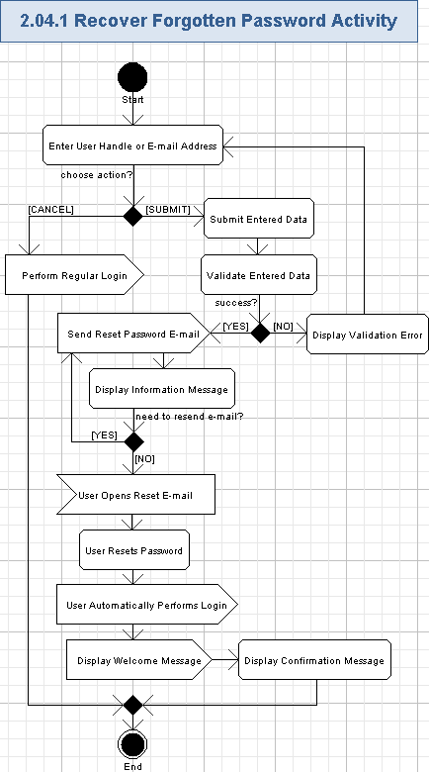

Enter User Handle or E-mail Address
- The user can press “Forgot your password?” hyperlink to resolve problems with forgotten password.
- The application will display a special page for recovering the forgotten password. The page title is as following:
RECOVER FORGOTTEN PASSWORD
- The user will be requested to enter one of the following fields for recovering his/her password:
Data Element | Description | Format | R?
Handle | The unique username (handle) for the account on the application | String, max length is the same as in previous database, non empty | One of those fields is required
Email Address | The user’s e-mail address, which was used for the user profile on the application | String, max length is the same as in previous database, non empty, must be a valid e-mail address | One of those fields is required
- Please note, several redundant fields (like First Name, Last Name, etc.) are no more needed for recovering the forgotten password and they have to be removed from the related page. Just handle of e-mail address are enough for password recovery.
- The screen example for the page for entering user’s password recovery data is as following:
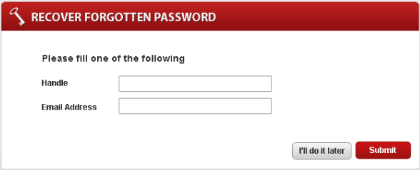

Perform Regular Login
- The user can press “I’ll do it later” button if he/she does not need to recover forgotten password.
- In this case the user will be simply redirected to the login page – please refer chapter 3.2 for more details.

Submit Entered Data
- The user can press “Submit” button to submit entered handle or e-mail address to the application for his/her password recovery.

Validate Entered Data
- The application will verify data, entered by the user.
- The application will validated entered data according to the table from chapter 3.4.1.1 and by searching for handle and/or e-mail address in the persistence of user accounts.

Display Validation Error
- The application will fill the wrong/empty fields in red color and display the validation error message nearby that field.
- If both fields are empty, then the application will display the following error messages:
Please fill you handle or
Please fill your email address
- Else, if the handle was entered, but is not valid or not found in the application, then the following error message will be shown:
Handle is not valid
- Else, if the e-mail address was entered, but is not valid or not found in the application, then the following error message will be shown:
Email address is not valid
- The user can not proceed to reset password until providing a present/valid handle or e-mail address for his/her account.

Send Reset Password E-mail
- The application will send the reset password e-mail.
- The e-mail subject will have the following data:
Reset password e-mail for your account on TopCoder web-site
- The e-mail body will contain the following message:
Your user handle on TopCoder web-site is: <UserHandle>

You can reset the password for your account by following this hyperlink: <PasswordResetHyperlink>
- Where <UserHandle> is the username for the account (String, max length is the same as in previous database, non empty), and <PasswordResetHyperlink> is a hyperlink to reset password of the user account on TopCoder web-site (String, max 256 chars, non empty, has to be a valid URL).
- The system will send the password reset e-mail to the e-mail address of the related user (from his/her account) through some E-mail server.

Display Information Message
- The application will display the following message:
Recover forgotten password has been sent into your e-mail.
Please check your email to recover your password.
If you don’t receive recovery password e-mail, Click here to send it again.
- If the recovery e-mail was not received by the user, then he/she can request to re-send it by pressing “Click here” hyperlink.

User Opens Reset E-mail
- The user will open a password reset e-mail message, delivered to his/her e-mail box.
- The user will perform that action externally – through his/her e-mail reader.

User Resets Password
- The user will press the hyperlink in the reset e-mail and get redirected to this application.
- The application will generate the new password (String, min and max length limits are as in the previous database, can contain alphanumeric chars) and assign it to the user’s account.

User Automatically Performs Login
- The application will automatically recognize the user as logged in according to his/her user role – please refer chapter 3.2.1.4 for more details.

Display Welcome Message
- The application will display the welcome message and a brief data from the user profile on the header – please refer chapter 3.2.1.6 for more details.

Display Confirmation Message
- The application will display the confirmation message (it can be an inline message or a popup – up-to the Studio designer):
You have successfully reset password for your account. New password is: <password>.
- There <password> is the password, automatically generated by the application and assigned to the user account during user’s password reset.
- The user will be able to change that password later if needed (please refer chapter 3.11 for more details).

Create Account
The user can register his/her account on the application. There will be a special page where the user will provide the minimal set of the required data (a handle (username), an e-mail address and the password) and get registered to the application. Just one account can be created per one user. Reference to initial use case in conceptualization: “4.4.4”, “4.4.5”, “4.4.6”.
Storyboard page: “01_01_register.png”,
“01_02_register_handle-not-available.png”,
“01_03_register_single-error.png”,
“01_04_register_multiple-error.png”,
“02_01_registered.png”,
- Pre-conditions: the non-registered user pressed “Register now” hyperlink on the login part of the homepage.
- Post-conditions: the user account was created, but not activated yet.

Create Account Activity
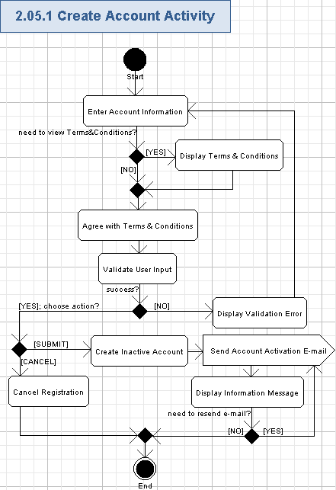

Enter Account Information
- The user will start registration of the new account by pressing the “Register now” hyperlink on the homepage.
- The application will provide a simple single page where just a few input fields will be present for new user registration.
- The minimal set of the required user data is: a handle (username), an e-mail address and the password. It will be like registration on the LinkedIn social network: https://www.linkedin.com/reg/join
- The application will display the registration page with empty fields for the account and user profile.
- The user can enter the brief information on the new account according to the following table:
Data Element | Description | Format | R?
First Name | The first name of the user | String, max length is the same as in previous database, can be empty | N
Last Name | The last name of the user | String, max length is the same as in previous database, can be empty | N
Handle | The unique username (handle) for the new account on the application | String, max length is the same as in previous database, non empty | Y
E-mail | The e-mail address of the user | String, max length is the same as in previous database, must be a valid e-mail, non empty | Y
Password | The password of the user | String, min and max length is the same as in previous database, case sensitive alphanumeric characters.  Displayed with ‘*’ chars when entering | Y
Confirm Password | The confirmation of the user’s password | String, min and max length is the same as in previous database, case sensitive alphanumeric characters. It must be the same as “Password” field.  Displayed with ‘*’ chars when entering. | Y
Verification code | The picture with CAPTCHA code to be entered by the user for validation that he/she is a human | A picture (dimensions are up-to the Studio designer) having a String, 3 chars, non empty.  The user will enter that code to the related text field | Y
Referrer handle  /* it was absent in storyboards, but it is really needed here */ | The username (handle) of the existing TC member, recommending TC web-site for the user. | String, max length is the same as in previous database, non empty | N
- Please note, values for First Name and Last Name fields will be now stored in the UserProfile entity (and the related table) – this is the difference with the previous TC web-site. Other fields in the table above will be stored in the User entity (and the related table) as previously. And the ID of Referrer is needed for the UserProfile entity and database.
- The application will automatically calculate the strength of the entered password while user is typing and display it as a colored progress bar (integer values from 0 (weak) to 4 (secure)).
- Please note, the “Referrer handle” field can be filled either manually, or automatically – if the user redirected to the registration page through the referring hyperlink (that hyperlink will contain the ID of the referrer in the database, and, therefore, the application can retrieve handle of the referrer from the database and place it to the “Referrer handle” field).
- If the user cannot recognize the currently shown CAPTCHA code, then he/she can ask for another CAPTCHA code by pressing “Try Another Code” hyperlink – the application will generate the different CAPTCHA code and show it on the screen for entering by the user.
- Just one registration account will be possible to each person. The application will not allow creating multiple accounts for a single e-mail address or a handle.
- The screen example of registering a user account is like following:
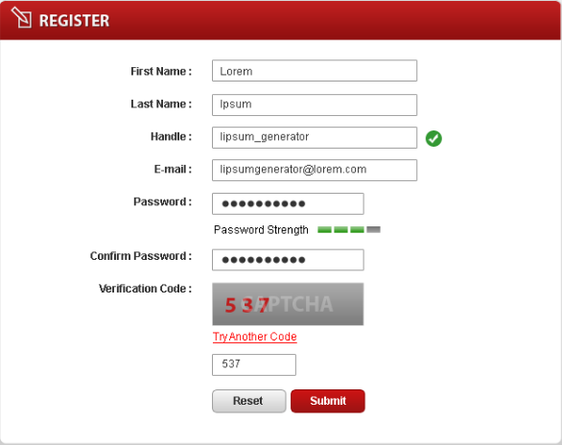

Display Terms & Conditions
- There will be “Terms & Conditions” hyperlink on the registration page.
- There will be an ability to read Term & Conditions page, because TC web-site is intended for users from 13 years old and several competitions can be allowed starting only from 18 years.
- The user can press that hyperlink to view the information on the application usage Terms and conditions.
- That information can be displayed on the popup window or on another page of the web-site (up-to the Studio designer).
- The Terms & Conditions information will be a rich formatted text (String, max 100 KB, non empty).

Agree with Terms & Conditions
- The user has to accept term and conditions to register to the application.
- It can be like a check box.
- The user have to explicitly mark that he/she is agreed to Terms & Conditions by turning On the check box – otherwise he/she can not register.

Validate User Input
- The application will automatically validate all the user input for all the required fields according to tables and rules from 3.5.1.1.
- The user can not proceed until providing the correct data.
- If entered user handle is valid and is not present in the application (i.e. free), then it will be specially marked, like by:

Display Validation Error
- If the entered user handle is valid, but is already present in the application (i.e. used), then it will be specially marked (like ) and the following error message will be shown:
not available
- If the validation failed, then the application will show the red validation message nearby that field – like this (concrete validation error relates to the failed field):
Please fill you <FieldName>.

Password not match.

Your verification code is not match.

// etc…
- The wrong field background will be highlighted in red color.
- The screen example with validation errors is like following:
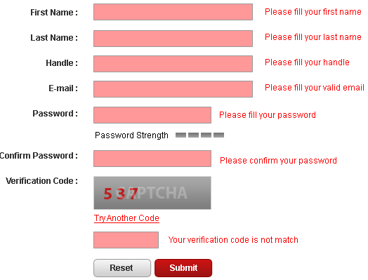

Cancel Registration
- The user can press “Reset” button to reject creation of the new account.
- All the fields on the account creation page will be cleared.
- No new account is created for the user.

Create Inactive Account
- The user can press “Submit” button and the new account data will be persisted to the database.
- All the information, entered by the user for the account and profile, will be persisted.
- Username (handle), password, and high level roles of the user will be stored to the database.
- The account will be initially disabled and will require activation.
- The user will not be able to login to the application until he/she activates the new account.
  - But the application will automatically remember that user (like by cookies) and if he/she tries to open the application again (before activation his/her account through the activation e-mail) then the application will get that user an ability to resend account activation e-mail. This feature is needed if the user did not receive an activation e-mail or missed it (like because of spam filter, or e-mail server problems, etc.).
- Inactivated accounts (and remembered user for that account) will be kept by the system for 2 weeks.
  - After that the inactive account will be removed (marked as removed in the database, but without actual deletion of the data) and the user will be forgotten by the application.
  - The user of the removed inactivated account can freely register to the application again.

Send Account Activation E-mail
- The application will send the account activation e-mail to the user.
- The system will place a brief explanation of the newly registered (but not activated yet) account to the e-mail and the hyperlink to activate the user’s account.
- The e-mail notification will be sent to the user through the TC e-mail server.
- The system will automatically re-send e-mail notification if that e-mail message was failed and not delivered to the related user. The Architect is free to define a robust and effective re-sending algorithm. There will be a manual ability to resend account activation e-mail by the user.

Display Information Message
- The application will show the “ACTIVATE YOUR ACCOUNT” popup (or inline message – up-to the Studio designer) with information that the new account was registered and is waiting for the user’s confirmation:
Your account has been registered

We will send you a confirmation email. Please check your email to activate your account. If you don’t receive any confirmation email, Click here to send the confirmation again.
- The user can re-send the account confirmation e-mail by pressing “Click here” hyperlink.

Activate Account
Account activation (i.e. through a confirmation e-mail, sent to the user) will be required to finish registration process. The user will activate his/her account after creating it in the application.
Reference to initial use case in conceptualization: “4.4.4”, “4.4.5”, “4.4.6”.
Storyboard page: “02_02_activated.png”,
“03_FirstStep.png”.
- Pre-conditions: the non-registered user created a new account in the application.
- Post-conditions: the user account was activated – so the user can login and access the application as a registered user.

Activate Account Activity
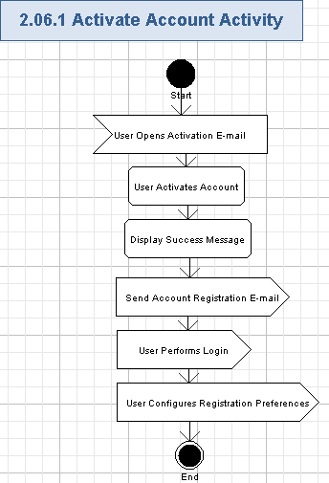

User Opens Activation E-mail
- The new user will get a confirmation e-mail just after registering his/her account.
- The user will open an account activation e-mail message, delivered to his/her e-mail box.
- The user will perform that action externally – through his/her e-mail reader.

User Activates Account
- The user will press the hyperlink in the activation e-mail and get redirected to this application.
- The application will activate the new user’s account.
- After that, the new user account becomes enabled and he/she can login to the application.

Display Success Message
- The application will display “CONGRATULATION” popup window (or inline message – up-to the Studio designer) with the information that the new account was activated:
Your account has been activated

Congratulation. Now you can use your account to participate in TopCoder. Please Login for the next step.

Send Account Registration E-mail
- The application will send the account success registration e-mail to the user.
- The system will place a brief explanation of the fully registered (and activated) account to the e-mail.
- The e-mail notification will be sent to the user through the TC e-mail server.
- The system will automatically re-send e-mail notification if that e-mail message was failed and not delivered to the related user. The Architect is free to define a robust and effective re-sending algorithm.

User Performs Login
- The user can perform regular login to the application by pressing “Login” hyperlink on the success message. Please refer chapter 3.2 for more details.

User Configures Registration Preferences
- The user will be presented with the popup window, there he/she can configure his/her registration preferences (i.e. the preferable user role). The user will choose his/her registration preferences like described in chapter 3.19.

Provide Profile Data on Application Request
The user will enter additional data for his/her profile, when he/she is trying to start using any feature on TC web-site requiring more data to be present in the user profile. The application will inform the user about a need to enter more data to the profile on some popup windows, tips, profile filling progress indicator, profile data completeness steps, and special filling of the profile topics in the navigation menu.
This use case includes viewing and editing the profile (i.e. use cases 3.8, 3.9, 3.10, and 3.11).
Reference to initial use case in conceptualization: “4.4.7”, “4.4.9”.
Storyboard page: “04_ProfileCompleteness.png”,
“05_01_01_myprofile_name-n-contact+tips.png”.
- Pre-conditions: the user tried to start using any feature on TC web-site, but if he/she does not provide enough data for the user profile. The user has to be logged in to the application to perform this action.
- Post-conditions: the user provided additional needed data for his/her profile and get access to the related features of the application.

Provide Profile Data on Application Request Activity
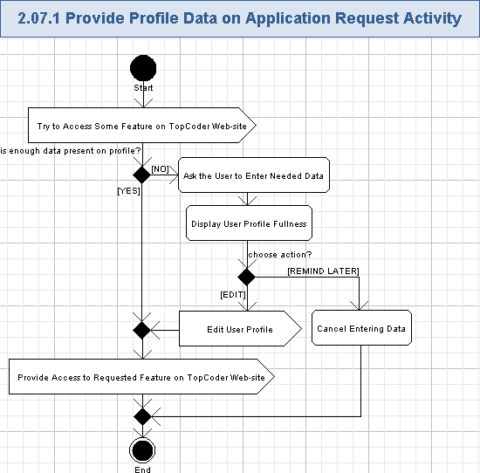

Try to Access Some Feature on TopCoder Web-site
- The user can try to start using any feature on TC web-site, but if he/she did not provide enough data for the user profile, then the application will not immediately provide access to that feature.
- TC web-site will check user profile data and if some data is absent, then the user need to provide that data before accessing the related feature on TC web-site.

Ask the User to Enter Needed Data
- The application will automatically ask the user about the required profile data to access the requested feature on TC web-site.
- Please note, there can be non obvious situations when the user has to enter some more information due to his/her achievements on TC web-site. The application will notify the user all the times he/she opens TC web-site about them. For example,
  - The user needs to enter size of his/her T-shirt if he/she won a T-shirt in some competition.
  - The user needs to provide assignment document if he/she registered to the competition requiring CCA.
  - The user needs to request a visa letter if he/she becomes eligible to onsite events (like TopCoder Open).
  - Etc.
- The application will show some kind of a popup window (with title “PLEASE COMPLETE YOUR INFORMATION”) asking the user to enter missing data to his/her profile.
- The application will automatically open the related page of the user’s profile and highlight the fields to be filled - please refer to chapters 3.8 for more details.
- The application will display the fullness of the user’s profile – please refer to chapter 3.7.1.3 for more details.
- There will be two buttons: “Remind Me Later” – for cancel entering new data to the profile, and “Submit” to add entered new data to the profile.
- The screen example of possible popup window is like following:

Display User Profile Fullness
- The application will indicate how many optional fields of the user profile were filled yet.
  - The percentage filled bar will be displayed for that – like on usual social networks.
  - The indicator example is below (its value is from 0% to 100%, integer number value):
- The application will inform the user filling of which parts of the profile will open an access to more features at TC web-site.
  - It can be like tips, shown near-by block of data (say, “Fill personal data and contact to start posting on the forums”, “Upload signed assignment document to compete in contests requiring CCA”, etc.).
  - The user can press a small green “?” button nearby the “Profile Completeness” indicator and get the tip message (String, rich text formatted, max 2048 chars, non empty) like following:
- The application will display specially visualized (like progress steps) several stages of user profile filling – simply like names (String, max 50 chars, non empty) of various pages of the user profile and account.
  - The already filled stages will be highlighted in red color, and the empty parts of the user profile will be shown in gray color – like following:

Edit User Profile
- The user will view his/her profile and enter the needed data to his/her profile – please refer to chapters 3.8, 3.9, 3.10, and 3.11 for more details).
- The popup window with data request will be closed when the user finished entering needed data and submitted them (by pressing “Submit” button) to the profile.

Cancel Entering Data
- The user can cancel entering more data to his/her profile by pressing “Remind Me Later” button.
- No needed data will be persisted to the user’s profile and, therefore, the user will not get access to the requested feature on TC web-site.
- The popup window with data request is simply closed.

Provide Access to Requested Feature on TopCoder Web-site
- The application will automatically proceed to the user requested part of TC web-site.
- The user will get access to the requested feature on TC web-site, because he/she provided all the needed data for that feature on his/her profile.

View Profile
The user can view his/her profile on a special part of the application – “My Profile”. The application will display a single page with the most important information about the user displayed on it. It will be possible to view more data on the profile on the same page – like by choosing the related profile topic on the navigation menu and the needed tabs of the page content.
This use case is included by use case “Provide Profile Data on Application Request” (please refer chapter 3.7 for details).
Reference to initial use case in conceptualization: “4.4.8”.
Storyboard page: “05_01_01_myprofile_name-n-contact.png”,
“05_01_01_myprofile_name-n-contact+tips.png”,
“05_02_01_myprofile_demographic-info.png”,
“05_03_01_AccountInfo.png”.
- Pre-conditions: the user pressed “My Profile” hyperlink on the application The user has to be logged in to the application to perform this action.
- Post-conditions: the user profile data was displayed.

View Profile Activity
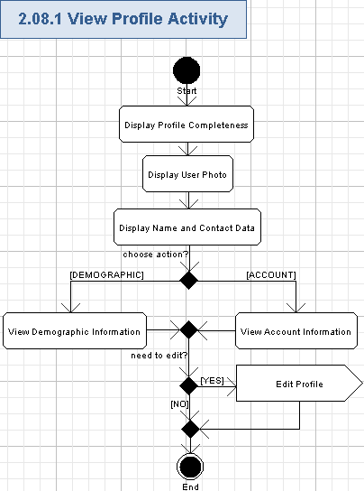

Display Profile Completeness
- The application will indicate how many optional fields of the user profile were filled yet and the tips for further filling of the account – please refer chapter 3.7.1.3 for more details.
- The screen example is like following:

Display User Photo
- The application will display the user’s photo (if any) – please refer to chapter 3.14 for more details.

Display Name and Contact Data
- The application will show the following fields with name and contact data from the user profile:
Data Element | Description | Format | R?
First Name | The first name of the user | String, max length is the same as in previous database, can be empty | N
Last Name | The last name of the user | String, max length is the same as in previous database, can be empty | N
E-mail | The user’s e-mail address | String, max length is the same as in previous database, non empty, must be a valid e-mail address | Y
Job Title | The user position in the company (like “Software Engineer”) | String, max length is the same as in previous database, can be empty | N
Company Name | The name of the user’s company | String, max length is the same as in previous database, can be empty | N
Current Address 1 | The line #1 of the user’s address | String, max length is the same as in previous database, can be empty | N
Current Address 2 | The line #2 of the user’s address | String, max length is the same as in previous database, can be empty | N
Current Address 3 | The line #3 of the user’s address | String, max length is the same as in previous database, can be empty | N
City | The city of the user | String, max length is the same as in previous database, can be empty | N
State | The state of the user – only for USA | String, max 2 chars, can be empty.  One of the USA state or DC. | N
Postal Code | The postal (ZIP) code of the user | String, max length is the same as in previous database, each char is a digit from [0-9], can be empty | N
Province | The province of the user | String, max length is the same as in previous database, can be empty | N
Country | The country of the user | String, max length is the same as in previous database, can be empty | N
Country to Represent | The country to be represented by the user | Single item selection list. Each item is String, max length is the same as in previous database, can be empty.  The values in the list are the same as in the previous database | N
Phone Number | The phone number of the user | String, like (+xxx) xxx xxx-xxxx, where “x” is a digit [0-9], max length is the same as in previous database, can be empty | N
Timezone | The user’s time zone relative to GMT | String, like “GTMzxx, where “z” is “+” or “-“, “x” is a digit [0-9], max length is the same as in previous database, can be empty. | N
- Those data fields will be retrieved from the UserProfile entity (and the related table from the database).
- The screen example is like following:
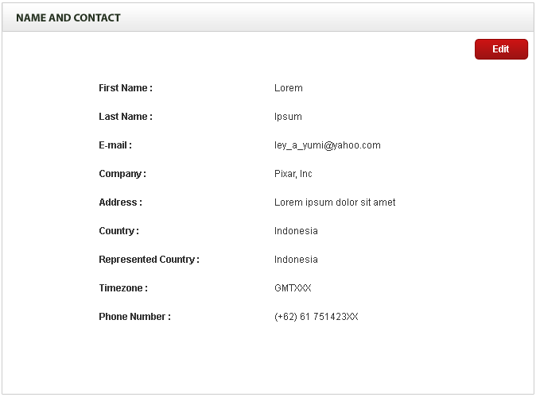

View Demographic Information
- The application will show the following fields with demographic data from the user profile:
Data Element | Description | Format | R?
Age | The age range, related to the user | String, max length is the same as in previous database, can be empty. | N
Gender | The gender of the user | String, max length is the same as in previous database, can be empty. | N
Ethnic Background | Ethnic background of the user | String, max length is the same as in previous database, can be empty. | N
Primary Interest in TopCoder | The user’s most important interest on TopCoder web-site | String, max length is the same as in previous database, can be empty. | N
Shirt Size | The size of user’s T-shirt | String, max length is the same as in previous database, can be empty. | N
College Major | The user’s major in college | String, max 30 chars, can be empty. | N
College Major Description | The description of user’s major in college | String, max 50 chars, can be empty. | N
Degree Program | The user’s degree program in college | String, max 20 chars, can be empty. | N
Graduation Date | The date of college graduation by the user | String, date format like “<Month> <Year>” (for example, “January 2011”), max 15 chars, can be empty. | N
Clubs / Organizations | The list of clubs or organizations the user is involved in | The comma separated list of items. Each item is String, max length is the same as in previous database, non empty.  If the list is empty, then “None” will be shown | Y
School | The name of the user’s school or college | String, max length is the same as in previous database, can be empty. | N
Show / Hide My School | The control flag indicating whether to show user’s school information on TC web-site or not | String, “Show” or “Hide” values, non empty. | Y
GPA | The GPA value of the user in the college | Floating point positive value from 0.00 to 100.00. Two digits precision. | N
GPA Scale | The scale of the GPA in the user school | String, max 20 chars, can be empty.  Like “0.00 – 100.00”. | N
Resume | The hyperlink to the user’s resume | String, max length is the same as in previous database, non empty. Size of the resume document is the same as in previous database | N
- Those data fields will be retrieved from the UserProfile entity (and the related table from the database).
- The following fields are new and were not present in the previous TC web-site. They have to be added to the UserProfile entity (and to the related table in the database):
  - College Major,
  - College Major Description,
  - Degree Program,
  - Graduation Date,
  - GPA,
  - GPA Scale.
- The user can press hyperlink to his/her resume and download the related document through the web-browser.
- The screen example is like following:
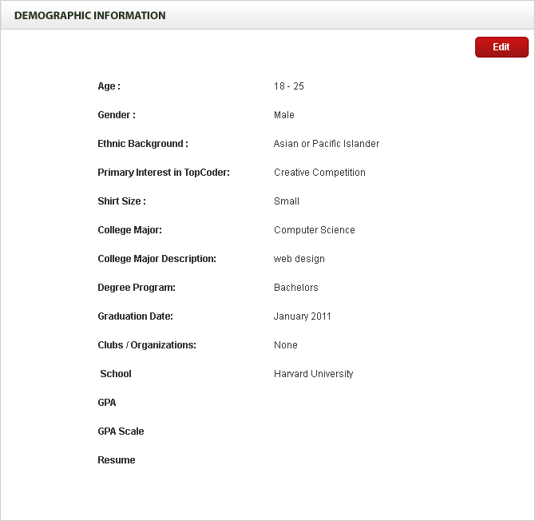

View Account Information
- The application will show the following fields with account data from the user profile:
Data Element | Description | Format | R?
Username | The unique username (handle) for the account on the application | String, max length is the same as in previous database, non empty | Y
Password | The password of the user | String, min and max length is the same as in previous database, case sensitive alphanumeric characters.  Displayed with ‘*’ chars | Y
Secret question | The secret question for the user account | String, max length is the same as in previous database, non empty. | N
Secret question response | The user’s answer to the secret question | String, max length is the same as in previous database, non empty. | N
Student / Professional | A competitor status – the indicator defining whether the user is a student or a professional | String, max length is the same as in previous database, non empty. | N
Security Key | The SSH key of the user | String, max length is the same as in previous database, non empty | N
Referrer handle  /* it was absent in storyboards, but it is really needed here */ | The username (handle) of the existing TC member, recommending TC web-site for the user. | String, max length is the same as in previous database, non empty | N
- Almost all of those data fields will be retrieved from the User entity (and the related table from the database).
- The ID of Referrer is needed for the UserProfile entity and database.
- The screen example is like following:
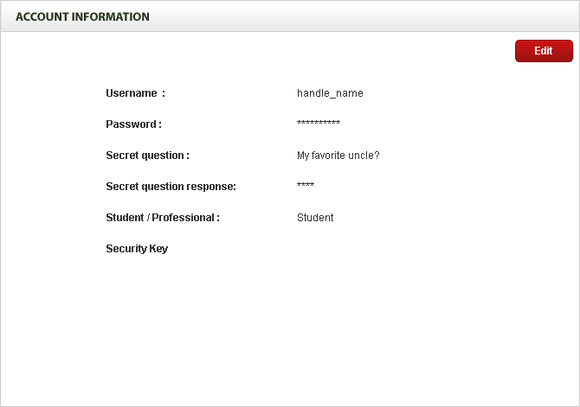

Edit Profile
- The user can press “Edit” button to edit the currently displayed page of his/her profile – please refer chapters 3.9, 3.10, and 3.11 for more details.

Edit Contacts Data
The user can freely edit all of his/her contacts data. If some personal data is absent (i.e. empty, not filled yet), then the user can add that data for his/her profile. All the data of the user profile will be editable on a single page without complex redirection to other pages at TC web-site and without user profile page reloading.
This use case is included by use case “Provide Profile Data on Application Request” (please refer chapter 3.7 for details).
Reference to initial use case in conceptualization: “4.4.10”, “4.4.11”.
Storyboard page: “05_01_02_myprofile_name-n-contact-edit.png”,
“05_01_02_myprofile_name-n-contact-edit+error.png”.
- Pre-conditions: the user pressed “Edit” button on the “Name and Contact” page of “My Profile”. The user has to be logged in to the application to perform this action.
- Post-conditions: the name and contacts data of the user were edited and updated to the profile. The user could enter some new personal data as well.

Edit Contacts Data Activity
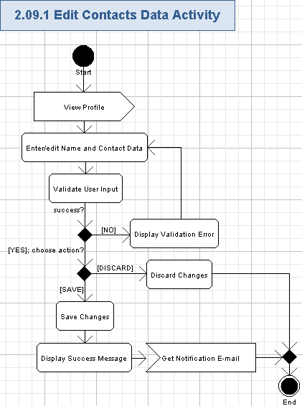

View Profile
- The user will view the related page of his/her profile like described in chapter 3.8.
- The user will press “Edit” button to initiate editing of the data fields for the currently shown profile page.

Enter/edit Name and Contact Data
- The user will be able to edit existing data or enter new data directly on the displayed profile page. The following fields can be modified:
Data Element | Description | Format | R?
First Name | The first name of the user | String, max length is the same as in previous database, can be empty | N
Last Name | The last name of the user | String, max length is the same as in previous database, can be empty | N
E-mail | The user’s e-mail address | String, max length is the same as in previous database, non empty, must be a valid e-mail address | Y
Job Title | The user position in the company (like “Software Engineer”) | String, max length is the same as in previous database, can be empty | N
Company Name | The name of the user’s company | String, max length is the same as in previous database, can be empty | N
Current Address 1 | The line #1 of the user’s address | String, max length is the same as in previous database, can be empty | N
Current Address 2 | The line #2 of the user’s address | String, max length is the same as in previous database, can be empty | N
Current Address 3 | The line #3 of the user’s address | String, max length is the same as in previous database, can be empty | N
City | The city of the user | String, max length is the same as in previous database, can be empty | N
State | The state of the user – only for USA | String, max 2 chars, can be empty.  One of the USA state or DC. | N
Postal Code | The postal (ZIP) code of the user | String, max length is the same as in previous database, each char is a digit from [0-9], can be empty | N
Province | The province of the user | String, max length is the same as in previous database, can be empty | N
Country | The country of the user | Single item selection list. Each item is String, max length is the same as in previous database, non empty.  The values in the list are the same as in the previous database. It is not required to choose any value in the list. | N
Country to Represent | The country to be represented by the user | Single item selection list. Each item is String, max length is the same as in previous database, non empty.  The values in the list are the same as in the previous database. It is not required to choose any value in the list. | N
Phone Number | The phone number of the user | String, like (+xxx) xxx xxx-xxxx, where “x” is a digit [0-9], max length is the same as in previous database, can be empty | N
Timezone | The user’s time zone relative to GMT | Single item selection list. Each item is String, like “GTMzxx, where “z” is “+” or “-“, “x” is a digit [0-9], max length is the same as in previous database, can be empty.  The values in the list are the same as in the previous database | N
- Those data fields will be stored to the UserProfile entity (and the related table from the database).
- The user can enter new data to the empty fields of the user profile.
- The user can remove data from most fields on the his/her profile (except the minimal set of required data) to make them empty.
- All the data of the user profile will be editable on a single page without complex redirection to other pages at TC web-site and without user profile page reloading.
- The screen example of editing name and contact data of the user profile is like following:
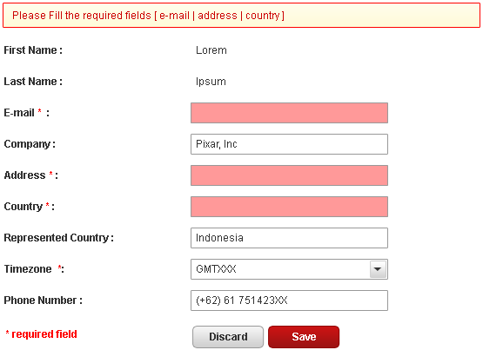

Validate User Input
- The application will automatically validate all the user input for all the required fields according to tables, mentioned in chapter 3.9.1.2.
- The user can not proceed until providing the correct data.

Display Validation Error
- If the validation failed, then the application will show the red validation message on the top of the profile page being edited. The message is like this (concrete validation error relates to the failed field):
Please fill the required fields [<FieldName1>, <FieldName2>, etc.]
- The wrong field background will be highlighted in red color.

Discard Changes
- The user can cancel entered/updated data by pressing “Discard” button on the user profile.
- The data of the current profile’s page will be reverted to last saved state.
- The screen fields of the user profile will be updated accordingly.
- Nothing is saved to the database in this case.

Save Changes
- The user can press the “Save” button to persist edited data of the profile.
- The application will save those changes of the name and contacts data to the database.

Display Success Message
- The application will display the inline message like following:
Your profile changes were successfully updated.

Get Notification E-mail
- The application will inform the user that he/she changed name and contacts data on the profile.
- The notification e-mail will have the descriptive subject and body with information about on the user changes of the name and contacts data.
- The notification e-mail will contain the link to the name and contacts data on the user’s profile, so newcomers can quickly get comfortable where they are placed.

Edit Demographic Information
The user can freely edit all of his/her demographic data. If some demographic data is absent (i.e. empty, not filled yet), then the user can add that data for his/her profile. All the data of the user profile will be editable on a single page without complex redirection to other pages at TC web-site and without user profile page reloading.
This use case is included by use case “Provide Profile Data on Application Request” (please refer chapter 3.7 for details).
Reference to initial use case in conceptualization: “4.4.10”.
Storyboard page: “05_02_02_myprofile_demographic-info-edit.png”,
“05_02_02_myprofile_demographic-info-edit+error.png”.
- Pre-conditions: the user pressed “Edit” button on the “Demographic Information” page of “My Profile”. The user has to be logged in to the application to perform this action.
- Post-conditions: the demographic data of the user was edited and updated to the profile. The user could enter some new demographic data as well.

Edit Demographic Information Activity
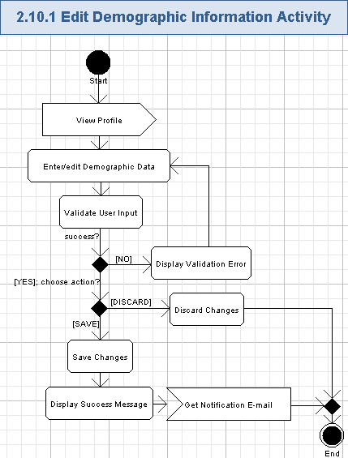

View Profile
- The user will view the related page of his/her profile like described in chapter 3.8.
- The user will press “Edit” button to initiate editing of the data fields for the currently shown profile page.

Enter/edit Demographic Data
- The user will be able to edit existing data or enter new data directly on the displayed profile page. The following fields can be modified:
Data Element |  | Description | Format | R?
Age |  | The age range, related to the user | Single item selection list. Each item is String, max length is the same as in previous database, non empty.  The values in the list are the same as in the previous database. It is not required to choose any value in the list. | N
Gender |  | The gender of the user | Single item selection list. Each item is String, max length is the same as in previous database, non empty.  The values in the list are the same as in the previous database. It is not required to choose any value in the list. | N
Ethnic Background |  | Ethnic background of the user | Single item selection list. Each item is String, max length is the same as in previous database, non empty.  The values in the list are the same as in the previous database. It is not required to choose any value in the list. | N
Primary Interest in TopCoder |  | The user’s most important interest on TopCoder web-site | Single item selection list. Each item is String, max length is the same as in previous database, non empty.  The values in the list are the same as in the previous database. It is not required to choose any value in the list. | N
Shirt Size |  | The size of user’s T-shirt | Single item selection list. Each item is String, max length is the same as in previous database, non empty.  The values in the list are the same as in the previous database. It is not required to choose any value in the list. | N
College Major |  | The user’s major in college | Single item selection list. Each item is String, max 30 chars, non empty.  The values in the list are the same as in the previous database. It is not required to choose any value in the list. | N
College Major Description |  | The description of user’s major in college | String, max 50 chars, can be empty. | N
Degree Program |  | The user’s degree program in college | Single item selection list. Each item is String, max 20 chars, non empty.  The values in the list are the same as in the previous database. It is not required to choose any value in the list. | N
Graduation Date | Month | The month of college graduation by the user | Single item selection list. Each item is String, max 9 chars, non empty.  The values are from “January” to “December”. It is not required to choose any value in the list. | N
Graduation Date | Year | The year of college graduation by the user | Single item selection list. Each item is positive integer from 1910 to 2100 (with the current year automatically selected in the list).  It is not required to choose any value in the list. | N
Clubs / Organizations | Choose all that apply | The set of clubs or organizations the user is involved in | Set of named checkboxes (IEEE, Systers, SHPE, ACM, NSBE, ACSU, Other). The user can turn on/off any of those checkboxes | N
Clubs / Organizations | Other | The free form text for the “other” club/organization | String, max length is the same as in previous database, can be empty. | N
School |  | The name of the user’s school or college | String, max length is the same as in previous database, can be empty. | N
Show / Hide My School |  | The control flag indicating whether to show user’s school information on TC web-site or not | Boolean, “Show” or “Hide” values. | Y
GPA |  | The GPA value of the user in the college | Floating point positive value from 0.00 to 100.00. Two digits precision. | N
GPA Scale |  | The scale of the GPA in the user school | Single item selection list. Each item is String, max length is 20 chars, the entry is non empty. Like “0.00 – 100.00”.  The values in the list are the same as in the previous database. It is not required to choose any value in the list. | N
Resume |  | The path to the user’s resume on his/her local file system | String, max length is the same as in previous database, non empty. Size of the resume document is the same as in previous database. | N
- Those data fields will be stored to the UserProfile entity (and the related table from the database).
- The following fields are new and were not present in the previous TC web-site. They have to be added to the UserProfile entity (and to the related table in the database):
  - College Major,
  - College Major Description,
  - Degree Program,
  - Graduation Date,
  - GPA,
  - GPA Scale.
- Those data fields will be stored to the UserProfile entity (and the related table from the database).
- The user can enter new data to the empty fields of the user profile.
- The user can remove data from most fields on the his/her profile (except the minimal set of required data) to make them empty.
- All the data of the user profile will be editable on a single page without complex redirection to other pages at TC web-site and without user profile page reloading.
- The user can press “Browse” button to choose the needed “Resume” document on his/her local file system for uploading to the application.
- The screen example of editing demographic data of the user profile is like following:
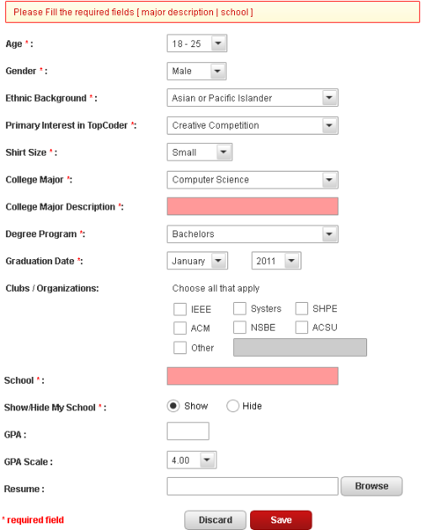

Validate User Input
- The application will automatically validate all the user input for all the required fields according to tables, mentioned in chapter 3.10.1.2.
- The user can not proceed until providing the correct data.

Display Validation Error
- If the validation failed, then the application will show the red validation message on the top of the profile page being edited. The message is like this (concrete validation error relates to the failed field):
Please fill the required fields [<FieldName1>, <FieldName2>, etc.]
- The wrong field background will be highlighted in red color.

Discard Changes
- The user can cancel entered/updated data by pressing “Discard” button on the user profile.
- The data of the current profile’s page will be reverted to last saved state.
- The screen fields of the user profile will be updated accordingly.
- Nothing is saved to the database in this case.

Save Changes
- The user can press the “Save” button to persist edited data of the profile.
- The application will save those changes of the demographic data to the database.
- The application will upload the user’s resume to his/her profile (if the path of the resume document was chosen by the user).

Display Success Message
- The application will display the inline message like following:
Your profile changes were successfully updated.

Get Notification E-mail
- The application will inform the user that he/she changed demographic information on the profile.
- The notification e-mail will have the descriptive subject and body with information about on the user changes of the demographic information.
- The notification e-mail will contain the link to the demographic information on the user’s profile, so newcomers can quickly get comfortable where they are placed.

Edit Account Information
The user can freely edit almost all of his/her account data. If some account data is absent (i.e. empty, not filled yet), then the user can add that data for his/her profile. All the data of the user profile will be editable on a single page without complex redirection to other pages at TC web-site and without user profile page reloading. The user handle can be edited in some cases (like when the user was not involved in any recorded activities).
This use case is included by use case “Provide Profile Data on Application Request” (please refer chapter 3.7 for details).
Reference to initial use case in conceptualization: “4.4.10”.
Storyboard page: “05_03_02_AccountInfo-edit.png”,
“05_03_02_AccountInfo-edit+error.png”,
“05_03_02_AccountInfo-edit+storessh.png”.
- Pre-conditions: the user pressed “Edit” button on the “Account Information” page of “My Profile”. The user has to be logged in to the application to perform this action.
- Post-conditions: the account data of the user was edited and updated to the profile. The user can enter some new account data as well.

Edit Account Information Activity
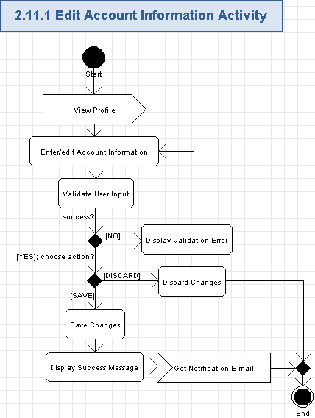

View Profile
- The user will view the related page of his/her profile like described in chapter 3.8.
- The user will press “Edit” button to initiate editing of the data fields for the currently shown profile page.

Enter/edit Account Information
- The user will be able to edit existing data or enter new data directly on the displayed profile page. The following fields can be modified:
Data Element |  | Description | Format | R?
Username |  | The unique username (handle) for the account on the application. Usually, it is non editable. But it can be changed if the user was not involved in any recorded activity on TC web-site | String, max length is the same as in previous database, non empty | Y
Password |  | The password of the user | String, min and max length is the same as in previous database, case sensitive alphanumeric characters.  Displayed with ‘*’ chars when entering | Y
Confirm Password |  | The confirmation of the user’s password | String, min and max length is the same as in previous database, case sensitive alphanumeric characters. It must be the same as “Password” field.  Displayed with ‘*’ chars when entering. | Y
Secret question |  | The secret question for the user account | String, max length is the same as in previous database, non empty. | N
Secret question response |  | The user’s answer to the secret question | String, max length is the same as in previous database, non empty. | N
Student / Professional |  | A competitor status – the indicator defining whether the user is a student or a professional | Single item selection list. Each item is String, max length is the same as in previous database, non empty.  The values in the list are the same as in the previous database. It is not required to choose any value in the list. | N
Security Key | <link> | The hyperlink to open/close the text field for viewing/editing the Security Key data | “Click here to store your SSH public key” hyperlink | N
Security Key | <text> | The SSH key of the user. It is not shown by default. The user need to press the hyperlink above to show this text field | String, max length is the same as in previous database, non empty | N
Referrer handle  /* it was absent in storyboards, but it is really needed here */ |  | The username (handle) of the existing TC member, recommending TC web-site for the user. | String, max length is the same as in previous database, non empty | N
- Almost all of those data fields will be stored to the User entity (and to the related table from the database).
- The ID of Referrer is needed for the UserProfile entity and database.
- The user can enter new data to the empty fields of the user profile.
- The user can remove data from most fields on the his/her profile (except the minimal set of required data) to make them empty.
- All the data of the user profile will be editable on a single page without complex redirection to other pages at TC web-site and without user profile page reloading.
- The user can edit his/her handle if he/she was no involved in any recorded activity.
- The user can press “Click here to store your SSH public key” hyperlink to view the editable field for his/her SSH security key. Then, the user can replace (or enter) his/her SSH security key.
- The screen example of editing contacts information of the user profile is like following:
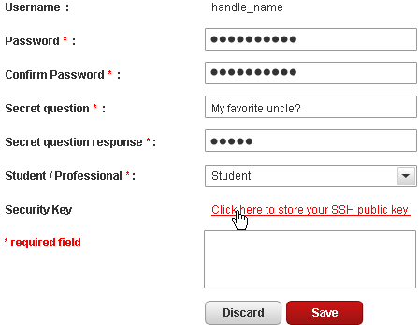

Validate User Input
- The application will automatically validate all the user input for all the required fields according to tables, mentioned in chapter 3.11.1.2.
- The user can not proceed until providing the correct data.

Display Validation Error
- If the validation failed, then the application will show the red validation message on the top of the profile page being edited. The message is like this (concrete validation error relates to the failed field):
Please fill the required fields [<FieldName1>, <FieldName2>, etc.]
- The wrong field background will be highlighted in red color.

Discard Changes
- The user can cancel entered/updated data by pressing “Discard” button on the user profile.
- The data of the current profile’s page will be reverted to last saved state.
- The screen fields of the user profile will be updated accordingly.
- Nothing is saved to the database in this case.

Save Changes
- The user can press the “Save” button to persist edited data of the profile.
- The application will save those changes of the accounts information to the database.
- If changing of the username was allowed and the user changed his/her handle, then the application will update it in the database and on the entire TC web-site.
- If the user changed/entered his/her security code then the application will update it to the database and to the entire TC web-site.

Display Success Message
- The application will display the inline message like following:
Your profile changes were successfully updated.

Get Notification E-mail
- The application will inform the user that he/she changed account data on the profile.
- The notification e-mail will have the descriptive subject and body with information about on the user changes of the account data.
- The notification e-mail will contain the link to the account data on the user’s profile, so newcomers can quickly get comfortable where they are placed.

Provide Data for Forums Participation
The user has to provide some additional data (like contacts information and age) to participate in forums. The user will enter that information to his/her profile and automatically gets full access to the public forums on TC web-site. The already entered contacts data can be viewed and edited as well.
Reference to initial use case in conceptualization: “4.4.12”.
Storyboard page: “05_01_02_myprofile_name-n-contact-edit.png”,
“05_02_02_myprofile_demographic-info-edit.png”.
- Pre-conditions: the user needs to participate in forums and pressed “Edit” button on the “Name and Contact” page of “My Profile”; or the user was asked to enter data for forum participation by the application when trying to start forum participation. The user has to be logged in to the application to perform this action.
- Post-conditions: the user entered all the needed data for forum participation and got access to forums.

Provide Data for Forums Participation Activity
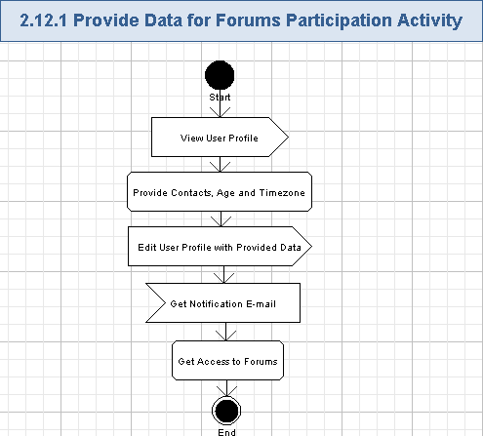

View User Profile
- The user will open and view his/her profile – please refer to chapter 3.8 for more details.

Provide Contacts, Age and Timezone
- The user has to provide the following data (in addition to the minimal set of required fields) to get full access to the public forums (i.e. an ability to reply and post own threads to the forum):
Data Element | Description | Format | R?
First Name | The first name of the user | String, max length is the same as in previous database, non empty | Y
Last Name | The last name of the user | String, max length is the same as in previous database, non empty | Y
Age | The age range, related to the user | Single item selection list, each list item is String, max length is the same as in previous database, non empty.  The values of the list are like in the previous database | Y
Current Address 1 | The line #1 of the user’s address | String, max length is the same as in previous database, non empty | Y
Current Address 2 | The line #2 of the user’s address | String, max length is the same as in previous database, can be empty | N
Current Address 3 | The line #3 of the user’s address | String, max length is the same as in previous database, can be empty | N
City | The city of the user | String, max length is the same as in previous database, non empty | Y
State | The state of the user – only for USA | String, max 2 chars, can be empty.  One of the USA state or DC. | N
Postal Code | The postal (ZIP) code of the user | String, max length is the same as in previous database, each char is a digit from [0-9], non empty | Y
Province | The province of the user | String, max length is the same as in previous database, can be empty | N
Country | The country of the user | Single item selection list. Each item is String, max length is the same as in previous database, can be empty.  The values in the list are the same as in the previous database | Y
Phone Number | The phone number of the user | String, like (+xxx) xxx xxx-xxxx, where “x” is a digit [0-9], max length is the same as in previous database, non empty | Y
Timezone | The user’s time zone relative to GMT | Single item selection list, each list item is String, like “GTMzxx, where “z” is “+” or “-“, “x” is a digit [0-9], max length is the same as in previous database, non empty.  The values of the list are like in the previous database | Y
- Please note, all those fields will be now stored in the UserProfile entity (and the related table) – this is the difference with the previous TC web-site.

Edit User Profile with Provided Data
- The user will edit the related fields (listed in the chapter 3.12.1.2) through the regular profile editing functionality described in chapters 3.9 and 3.10 for more details.

Get Notification E-mail
- The application will inform the user that he/she was assigned rights to full access the public forums on TC web-site.
- The users will be notified by e-mail about new accessible forum feature on TC web-site as the user enters enough data to his/her profile.
- The e-mail notification will be also sent to the user if he/she removed some data from the profile and his/her access rights were reduced, because of that.
- The notification e-mail will have the descriptive subject and body with information about on the user’s allowed (or restricted) access to the forum on TC web-site.
- The notification e-mail will contain the link to the forum feature, so newcomers can quickly get comfortable where they are placed.

Get Access to Forums
- The user will enter that needed information to his/her profile and automatically gets full access to the public forums on TC web-site.
- Please note, access to the private/restricted forums will require more permissions from the user (like participating in some competitions, having a signed CCA on file, or to be a Customer of some projects, or get an explicit access rights from TC admins, etc.).
- If the user removed some data from his/her profile that is required to access the forum, then he/she will lost the access to the forum on TC web-site.

Provide Data to Work with Wiki
The user has to provide some additional data (like contacts information and age) to post comments and own pages to the wiki. The user will enter that information to his/her profile and automatically gets full access to the public wiki pages on TC web-site. The already entered contacts data can be viewed and edited as well.
Reference to initial use case in conceptualization: “4.4.13”.
Storyboard page: “05_01_02_myprofile_name-n-contact-edit.png”,
“05_02_02_myprofile_demographic-info-edit.png”.
- Pre-conditions: the user needs to work with wiki pages and pressed “Edit” button on the “Name and Contact” page of “My Profile”; or the user was asked to enter data for accessing wiki pages by the application when trying to start accessing the wiki. The user has to be logged in to the application to perform this action.
- Post-conditions: the user entered all the needed data for working with wiki pages and got access to the wiki.

Provide Data to Work with Wiki Activity
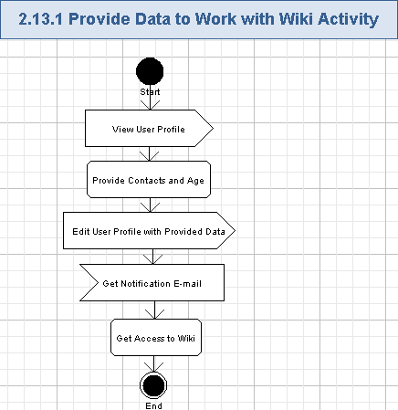

View User Profile
- The user will open and view his/her profile – please refer to chapter 3.8 for more details.

Provide Contacts and Age
- The user has to provide the following data (in addition to the minimal set of required fields) to get full access to the wiki (i.e. an ability to post comments and own pages to the wiki):
Data Element | Description | Format | R?
First Name | The first name of the user | String, max length is the same as in previous database, non empty | Y
Last Name | The last name of the user | String, max length is the same as in previous database, non empty | Y
Age | The age range, related to the user | Single item selection list, each list item is String, max length is the same as in previous database, non empty.  The values of the list are like in the previous database | Y
Current Address 1 | The line #1 of the user’s address | String, max length is the same as in previous database, non empty | Y
Current Address 2 | The line #2 of the user’s address | String, max length is the same as in previous database, can be empty | N
Current Address 3 | The line #3 of the user’s address | String, max length is the same as in previous database, can be empty | N
City | The city of the user | String, max length is the same as in previous database, non empty | Y
State | The state of the user – only for USA | String, max 2 chars, can be empty.  One of the USA state or DC. | N
Postal Code | The postal (ZIP) code of the user | String, max length is the same as in previous database, each char is a digit from [0-9], non empty | Y
Province | The province of the user | String, max length is the same as in previous database, can be empty | N
Country | The country of the user | Single item selection list. Each item is String, max length is the same as in previous database, can be empty.  The values in the list are the same as in the previous database | Y
Phone Number | The phone number of the user | String, like (+xxx) xxx xxx-xxxx, where “x” is a digit [0-9], max length is the same as in previous database, non empty | Y
- Please note, all those fields will be now stored in the UserProfile entity (and the related table) – this is the difference with the previous TC web-site.

Edit User Profile with Provided Data
- The user will edit the related fields (listed in the chapter 3.13.1.2) through the regular profile editing functionality described in chapters 3.9 and 3.10 for more details.

Get Notification E-mail
- The application will inform the user that he/she was assigned rights to full access the public wiki on TC web-site.
- The users will be notified by e-mail about new accessible wiki feature on TC web-site as the user enters enough data to his/her profile.
- The e-mail notification will be also sent to the user if he/she removed some data from the profile and his/her access rights were reduced, because of that.
- The notification e-mail will have the descriptive subject and body with information about on the user’s allowed (or restricted) access to the wiki on TC web-site.
- The notification e-mail will contain the link to the wiki feature, so newcomers can quickly get comfortable where they are placed.

Get Access to Wiki
- The user will enter that needed information to his/her profile and automatically gets full access to the public wiki on TC web-site.
- Please note, access to the private/restricted wiki pages will require more permissions from the user (like participating in some competitions, or to be a Customer of some projects, or get an explicit access rights from TC admins, etc.).
- If the user removed some data from his/her profile that is required to access wiki, then he/she will lost the access to the wiki on TC web-site.

View/upload Profile Photo
The user can freely upload his/her picture to the profile. The uploaded picture will be shown on the application together with the user-related posts on TC web-site.
Reference to initial use case in conceptualization: “4.4.14”, “4.4.15”.
Storyboard page: “06_01_uploadPhoto.png”,
“06_02_uploaded.png”
- Pre-conditions: the user pressed “Upload Photo” button below the picture of his/her profile (on “My Profile” page) . The user has to be logged in to the application to perform this action.
- Post-conditions: the user uploaded his/her picture on the profile.

View/upload Profile Photo Activity
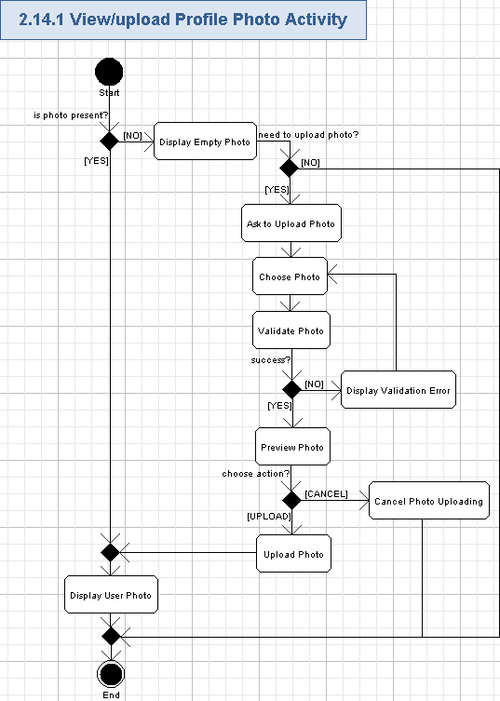

Display Empty Photo
- The application will display the empty user photo (picture, dimensions are up-to the Studio designer) on his/her profile.
- The following data will be shown together with the empty photo:
Data Element | Description | Format | R?
(username) | The unique username (handle) for the account on the application. | String, max length is the same as in previous database, non empty | Y
(year joining) | The year when the user registered to TC web-site | Positive integer number from 2000 to 2100. | Y
- The user can press “Upload Photo” button to upload his/her photo to the profile – please refer chapter 3.14.1.2 for more details.
- The screen example of displaying a user photo is like following:
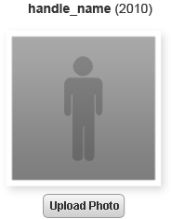

Ask to Upload Photo
- The user can ask the application to upload his/her photo to the profile by pressing “Upload Photo” button.
- The photo uploading popup window (“UPLOAD YOUR PHOTO”) will be shown with the following fields:
Data Element | Description | Format | R?
(Preview Image) | The photo preview to be shown when the user chose the picture file | Picture, can be empty dimensions are up-to the Studio designer. | N
(path) | The path to the picture file on the user’s local file system | String, max 1024 chars, can be empty if no picture is chosen | N
- The application will display the help message on the possible photo formats:
Photo should be in *.JPG (or *.GIF, or *.PNG) format file. Minimum width and height are xx by yy.
- The screen example of the popup window is like following:
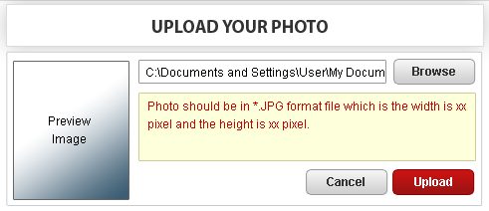

Choose Photo
- The user can upload the picture from his/her local file system to the TC web-site.
- The user will choose needed file on his/her local file system by pressing “Browse” button.
- The application will automatically start uploading the photo (through AJAX) after the user chosen it – like it is performed for e-mail attachments in Google. Please note, that uploading will be performed just for validation and preview, but no actual placing of the photo to the user profile will be performed.

Validate Photo
- The application will automatically validate the chosen photo file.
- The application will limit the size of the uploaded picture (like by 2 Megabytes, configurable).
- The type of the acceptable picture will be also limited (like to jpg, png and gif images).
- The application has to perform basic checking on whether the uploaded file is actually a picture of the given type and not a virus/exploit.
- The dimensions of the chosen photo file will be validated too.
- The user can not proceed until providing the correct photo file.

Display Validation Error
- If the validation failed, then the application will display the validation message like this (concrete validation error relates to the failed rule):
Photo file is too large (maximum 2 MB is allowed)

The format of photo file is unknown.

// etc.

Preview Photo
- The user can preview uploaded picture on his/her profile. The chosen photo file will be automatically scaled and shown on the “Preview Image” picture (dimensions are up-to the architect).
- The user can (automatically or manually) properly place it over TC default picture background (i.e. gray gradient).
  - The application will try to automatically cut the user’s head and shoulder from the initial picture background and paste it to the TC default background.
  - The user will be able to manually point where his/her head and shoulder are present on the picture to help the application to properly cut his/her head and shoulders – it can be useful if the automatic moving of user’s head and shoulders pixels from the initial photo to TC default picture background has failed.

Cancel Photo Uploading
- The user can cancel uploading of the chosen photo file by pressing “Cancel” button on the popup window.
- The user picture on the profile stays unchanged (i.e. empty).
- Nothing is saved to the database in this case.
- The popup window for uploading user photo will be closed.

Upload Photo
- The user can press “Upload” button to finally submit chosen and validated user photo to his/her profile.
- The uploaded, automatically checked and processed user photo will be attached to the user profile.
- The application will store the user photo to the database.
- No intervention of TC admin will be required, but he/she can definitely view uploaded photo and remove bad photos as needed (though that feature is out of scope for this specification).
- The popup window for uploading user photo will be closed.

Display User Photo
- The application will show the uploaded user photo (picture, dimensions are up-to the Studio designer) on his/her profile.
- The attached photo will be immediately used by TC web-site and displayed in all the related parts (profile, forums, statistics, etc.) without pre-moderation.
- The following data will be shown together with the uploaded photo:
Data Element | Description | Format | R?
(username) | The unique username (handle) for the account on the application. | String, max length is the same as in previous database, non empty | Y
(year joining) | The year when the user registered to TC web-site | Positive integer number from 2000 to 2100. | Y
- The user can press “Remove Photo” button to delete his/her photo from the profile – please refer chapter Error: Reference source not found for more details. This feature can be also used for replacing of the user’s photo.
- The screen example of uploaded user photo is like following:
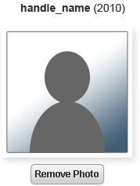

Remove Profile Photo
The user can remove his/her picture from the profile as well. It will be possible to load a new picture after removing the old one – like replacing of the user’s picture.
Reference to initial use case in conceptualization: “4.4.14”, “4.4.15”.
Storyboard page: “06_02_uploaded.png”,
“06_03_RemovePhoto.png”.
- Pre-conditions: the user pressed “Remove Photo” button below the picture of his/her profile (on “My Profile” page) . The user has to be logged in to the application to perform this action.
- Post-conditions: the user removed his/her picture on the profile.

Remove Profile Photo Activity
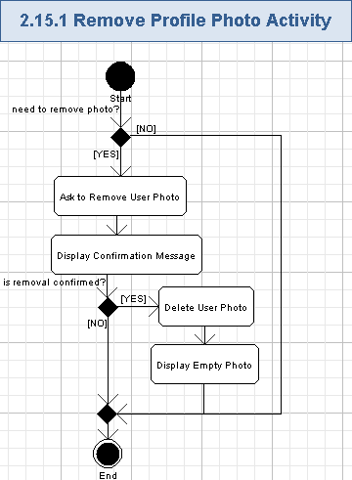

Ask to Remove User Photo
- The user will ask the application to remove currently displayed user photo by pressing “Remove Photo” button.

Display Confirmation Message
- The application will display the confirmation popup window with the confirmation message on the user photo removal:
REMOVE PHOTO

Are you sure to remove this photo?

<Yes>, <No>
- The current photo (picture, dimensions are up-to the Studio designer) of the user will be also shown on this confirmation window.
- The user can press “No” button to cancel removal of the user photo.
- Or the user can press “Yes” button to remove the user photo.
- The confirmation popup window will be closed in both cases.
- The screen example of confirmation message is like following:
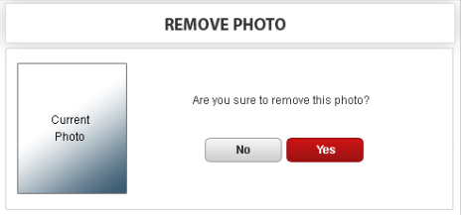

Delete User Photo
- The application will remove the current user photo from the database.
- The concrete removal implementation is up-to Architect, but it is suggested to simply mark the user photo as removed without actual removal of the data from the database. It will help for the further audit of the application.
- The application will show an empty user photo on his/her profile an on other parts of TC web-site.

Display Empty Photo
- The application will display the empty user photo (picture, dimensions are up-to the Studio designer) on his/her profile.
- The following data will be shown together with the empty photo:
Data Element | Description | Format | R?
(username) | The unique username (handle) for the account on the application. | String, max length is the same as in previous database, non empty | Y
(year joining) | The year when the user registered to TC web-site | Positive integer number from 2000 to 2100. | Y
- The screen example of displaying a user photo is like following:

Configure Privacy
The application will provide several privacy options for the user. The user can choose whether to show or hide his/her earnings on TC web-site. It will be also possible to configure an ability for other member to contact him/her through private messages. The user can edit the black list of persons, which are not allowed to contact him/her through private messages.
Reference to initial use case in conceptualization: “4.4.16”.
Storyboard page: “05_04_Privacy.png”,
“05_04_Privacy+error.png”.
- Pre-conditions: the user pressed “Privacy” option in “Preferences” topic of the navigation menu on “My Profile” part of the application. The user has to be logged in to the application to perform this action.
- Post-conditions: the user changed his/her privacy options as needed.

Configure Privacy Activity
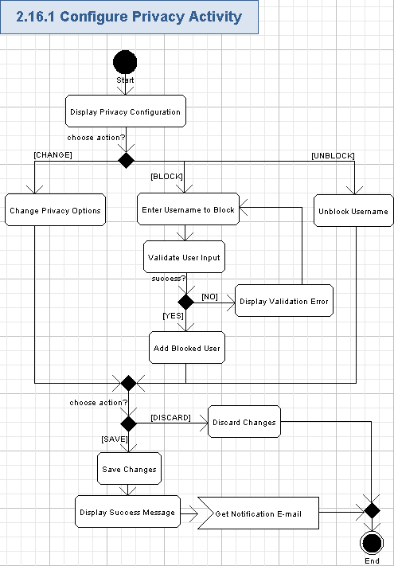

Display Privacy Configuration
- The user can view the currently configured privacy options on his/her profile.
- This feature will be mostly re-used from the existing business process.
- There will be no navigation to other pages from My TopCoder, but the privacy options can be viewed/edited on the same page where the user profile data is shown.
- The privacy options itself will be the same as in the previous business process, just its visualization and management will be changed.
- The following boolean options will be shown:
  - Show/Hide My Earning (values: Show, Hide).
  - Allow members to send messages (values: Yes, No).
- The bullet list of blocked usernames (handles) will be shown. Each username is String, max length is the same as in previous database, non empty.
- There will be “Unblock” hyperlink nearby each item in the list of blocked users.
- The screen example of displaying privacy options is as following:
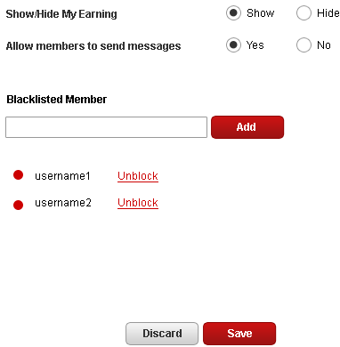

Change Privacy Options
- The user can change values of privacy options (like by using their radio buttons).
- He/she can choose if show/hide his/her earnings (received from TC) and configure an ability for other member to contact him/her through private messages.

Enter Username to Block
- The user can edit the black list of persons, which are not allowed to contact him/her through private messages.
- The user can enter the following field:
Data Element | Description | Format | R?
Blacklisted Member | The unique username (handle) of the user to be blocked to access the profile owner | String, max length is the same as in previous database, non empty | Y

Validate User Input
- The application will automatically validate all the user input for all the required fields according to table, mentioned in chapter 3.16.1.3.
- The user can not proceed until providing the correct data.

Display Validation Error
- If the validation failed, then the application will show the red validation message nearby the failed field. The message is like this (concrete validation error relates to the failed field):
there are no member named “<username>”
- The wrong field background will be highlighted in red color like shown below:
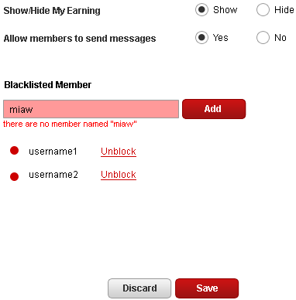

Add Blocked User
- The user can press “Add” button to add an entered and validated username to the black list of blocked users on his/her profile.
- The username will be added to the black list and shown on the screen – please note, that addition is on screen only. So, the user need to save changes on the privacy configuration page until the added usernames to the black list will be persisted to the database.

Unblock Username
- The user can remove any username from the black list of blocked users by pressing “Unblock” hyperlink nearby the related username.
- The related username will be removed from the black list and updated on the screen – please note, that removal is on screen only. So, the user need to save changes on the privacy configuration page until the removal of usernames from the black list will be persisted to the database.

Discard Changes
- The user can cancel entered/updated data by pressing “Discard” button on the user profile.
- The data of the current profile’s page (including the black list) will be reverted to last saved state.
- The screen fields of the user profile will be updated accordingly.
- Nothing is saved to the database in this case.

Save Changes
- The user can press the “Save” button to persist edited data of the profile.
- The application will save those changes of the privacy configuration to the database.
- Please note, added/removed username for the black list of blocked users will be saved to the database as well.

Display Success Message
- The application will display the inline message like following:
Your profile changes were successfully updated.

Get Notification E-mail
- The application will inform the user that he/she changed privacy configuration on the profile.
- The notification e-mail will have the descriptive subject and body with information about on the user changes of the privacy configuration.
- The notification e-mail will contain the link to the privacy configuration on the user’s profile, so newcomers can quickly get comfortable where they are placed.

Configure E-mail Notifications
The application will provide several e-mail notification options for the user. The user can choose for which competition types to receive notification e-mails. Notifications on other opportunities (like employment, TC news & events) can be also configured by the user.
Reference to initial use case in conceptualization: “4.4.17”.
Storyboard page: “05_05_emailnotification.png”.
- Pre-conditions: the user pressed “Email Notification” option in “Preferences” topic of the navigation menu on “My Profile” part of the application. The user has to be logged in to the application to perform this action.
- Post-conditions: the user changed his/her e-mail notification options as needed.

Configure E-mail Notifications Activity
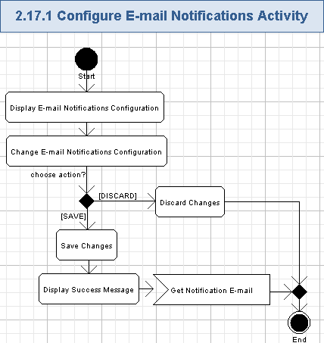

Display E-mail Notifications Configuration
- The user can view the currently configured e-mail notification options on his/her profile.
- This feature will be mostly re-used from the existing business process.
- There will be no navigation to other pages from My TopCoder, but the e-mail notification options can be viewed/edited on the same page where the user profile data is shown.
- The following e-mail notification options (each is checkbox, On/Off values) will be shown in the “Competition Announcement” group:
  - Algorithm Competition,
  - Software Development Opportunities,
  - TopCoder Studio Competitions,
  - PayPal X Contests and Opportunities.
- The following e-mail notification options (each is checkbox, On/Off values) will be shown in the “Other” group:
  - Employment Opportunities,
  - TopCoder News & Events,
  - User Profile Change (ability to get notifications on when the user profile was changed and more TC web-site becomes available because of that).
- There will be an additional option (checkbox, On/Off values) – All Notifications (ability to turn on/off all the e-mail notification).
- The screen example of displaying of displaying e-mail notification options is as following:
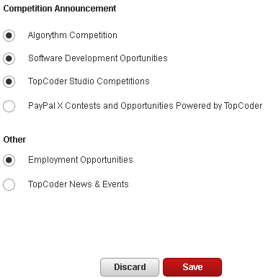

Change E-mail Notifications Configuration
- The user can change values of e-mail notification options (like by using their check boxes).
- He/she can fully turn off/on that notification, or choose individual preferences on notification for competition announcements, TopCoder news & events, and employment opportunities.

Discard Changes
- The user can cancel updated data by pressing “Discard” button on the user profile.
- The data of the current profile’s page will be reverted to last saved state.
- The screen fields of the user profile will be updated accordingly.
- Nothing is saved to the database in this case.

Save Changes
- The user can press the “Save” button to persist edited data of the profile.
- The application will save those changes of the e-mail notifications configuration to the database.

Display Success Message
- The application will display the inline message like following:
Your profile changes were successfully updated.

Get Notification E-mail
- The application will inform the user that he/she changed e-mail notifications configuration on the profile.
- The notification e-mail will have the descriptive subject and body with information about on the user changes of the e-mail notification options.
- The notification e-mail will contain the link to the e-mail notifications configuration on the user’s profile, so newcomers can quickly get comfortable where they are placed.

Configure Payment Preferences
The application will provide an option to set a threshold of earnings amount when the actual payment will be performed. The user can set some value (like $1000), and the system will automatically postpone actual payments until he/she won (summary) at least that predefined amount of money (i.e. $1000 in this example). Total won money (which generally can be greater than predefined threshold value) will be paid on the next month.
Reference to initial use case in conceptualization: none.
Storyboard page: “05_06_Payment Preferences.png”,
“05_06_Payment Preferences+error.png”.
- Pre-conditions: the user pressed “Payment Preferences” option in “Preferences” topic of the navigation menu on “My Profile” part of the application. The user has to be logged in to the application to perform this action.
- Post-conditions: the user changed his/her payment preferences as needed.

Configure Payment Preferences Activity
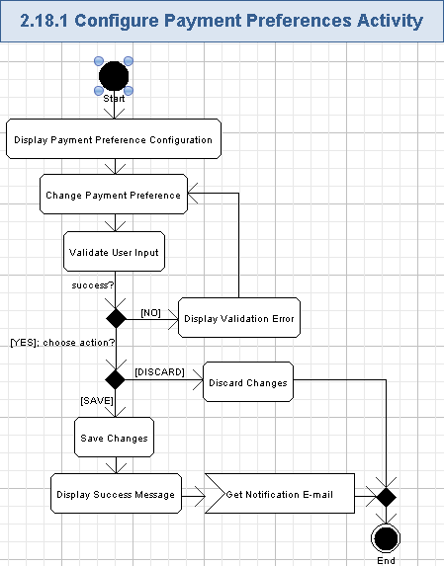

Display Payment Preference Configuration
- The user can view the currently configured payment preference on his/her profile.
- This feature will be mostly re-used from the existing business process.
- There will be no navigation to other pages from My TopCoder, but the payment privacy can be viewed/edited on the same page where the user profile data is shown.
- The information message will be shown like following:
This is where you can set your payment threshold amount to any amount above $25 so that once your prize winnings reach this limit your prize money will be paid out to you in the next scheduled payment. Your prize winnings will not go into “owed status” until they have reached your set payment threshold amount. You can only set a dollar amount threshold here. You cannot specify a future payment date to release your prize winnings on.
- The application will display the following data field:
Data Element | Description | Format | R?
Payment Actual Amount | The minimal payment amount | Positive integer number in dollars, greater or equal to $25. | Y
- The screen example of displaying payment preference is like following:
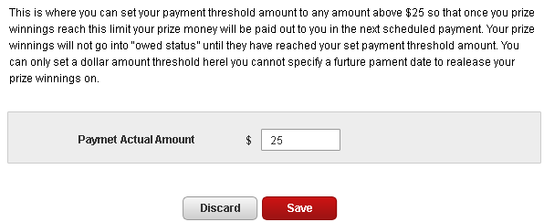

Change Payment Preference
- The user can change payment preference by entering another value in dollars according to the table from chapter 3.18.1.1.

Validate User Input
- The application will automatically validate all the user input for all the required fields according to table, mentioned in chapter 3.18.1.1.
- The user can not proceed until providing the correct data.

Display Validation Error
- If the validation failed, then the application will show the red validation message nearby the wrong field. The message is like this (concrete validation error relates to the failed rule):
It should be a number

The minimum possible value is 25

// etc…
- The wrong field background will be highlighted in red color like shown below:
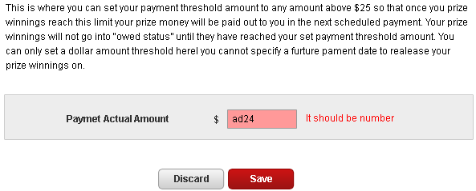

Discard Changes
- The user can cancel entered/updated data by pressing “Discard” button on the user profile.
- The data of the current profile’s page will be reverted to last saved state.
- The screen fields of the user profile will be updated accordingly.
- Nothing is saved to the database in this case.

Save Changes
- The user can press the “Save” button to persist edited data of the profile.
- The application will save those changes of the payment preference configuration to the database.

Display Success Message
- The application will display the inline message like following:
Your profile changes were successfully updated.

Get Notification E-mail
- The application will inform the user that he/she changed payment preference configuration on the profile.
- The notification e-mail will have the descriptive subject and body with information about on the user changes of the payment preference.
- The notification e-mail will contain the link to the payment preferences configuration on the user’s profile, so newcomers can quickly get comfortable where they are placed.

Configure Registration Preferences
The application will provide an option to choose in which parts of the TC web-site the user is mostly interested in: TopCoder Direct, TopCoder competitions (i.e. TC), or TopCoder Studio. This information can be used by the application to determine the user’s preferred role: an Observer, a Customer, or a Competitor.
Reference to initial use case in conceptualization: none.
Storyboard page: “05_07_RegistrationPreferences.png”,
“03_FirstStep.png”.
- Pre-conditions: the user pressed “Registration Preferences” option in “Preferences” topic of the navigation menu on “My Profile” part of the application. The user has to be logged in to the application to perform this action.
- Post-conditions: the user changed his/her registration preferences as needed.

Configure Registration Preferences Activity
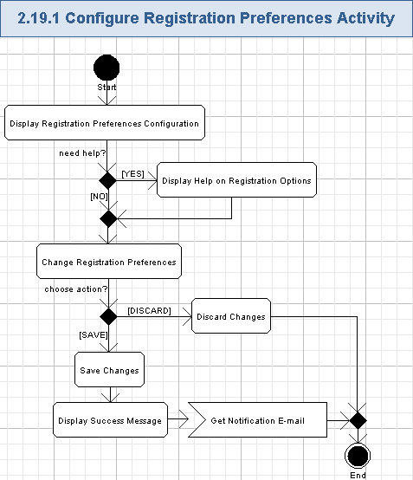

Display Registration Preferences Configuration
- The user can view the currently configured registration preferences on his/her profile.
- This feature will be mostly re-used from the existing business process.
- There will be no navigation to other pages from My TopCoder, but the registration preference options can be viewed/edited on the same page where the user profile data is shown.
- The application will display the information message like this:
This is where you can update your registration preferences

WHAT WOULD YOU LIKE TO DO?
- The application will display the following option (boolean checkbox, On/Off values) in “Run My Own Contest” group:
  - I want to start using TopCoder Direct.
- The application will display the following options (boolean checkboxes, On/Off values) in “I Want to Compete” group:
  - on TopCoder,
  - on TopCoder Studio.
- The screen example of displaying registration preferences is like following:
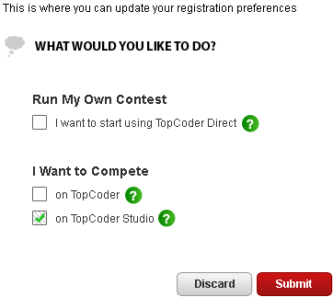

Display Help on Registration Options
- The user can press green “?” button nearby the related registration option to get a tip popup window with the help information for the chosen registration option.
- The messages on the popup windows will be the same as it was used on the current TC web-site – please refer the following link (registration is needed, and then press “tell me more” hyperlinks): https://www.topcoder.com/reg/?nrg=false
- The popup window can be closed as usual.

Change Registration Preferences
- The user can change values of registration preference options (like by using their check boxes).
- The user can choose which parts of the TC web-site is most interesting for him/her and inform the application on the needed user role (like Competitor or Customer).

Discard Changes
- The user can cancel entered/updated data by pressing “Discard” button on the user profile.
- The data of the current profile’s page (including the black list) will be reverted to last saved state.
- The screen fields of the user profile will be updated accordingly.
- Nothing is saved to the database in this case.

Save Changes
- The user can press the “Save” button to persist edited data of the profile.
- The application will save those changes of the registration preferences configuration to the database.
- If the user chosen that he/she needs to start using TC Direct, then the TC Admin will also get this information and can approve a Customer user role for that user. Please note, TC Admin actions are out of scope for this specification.

Display Success Message
- The application will display the inline message like following:
Your profile changes were successfully updated.

Get Notification E-mail
- The application will inform the user that he/she changed registration preferences configuration on the profile.
- The notification e-mail will have the descriptive subject and body with information about on the user changes of the registration preferences.
- The notification e-mail will contain the link to the registration preferences configuration on the user’s profile, so newcomers can quickly get comfortable where they are placed.

Configure Forum Preferences
The application will provide a lot of options of forum configurations for the user. The user can choose various options for forums on “General Settings”, “Watch Preferences”, and “Rating Preferences” categories. Those options will allow the user to control personal visualization of the forums on TC web-site and choose default watching behavior. The user can also view his/her current watches on the forum and forum posts.
Reference to initial use case in conceptualization: “4.4.18”.
Storyboard page: “05_08_01_ForumPreferences_generalsetting.png”,
“05_08_02_ForumPreferences_watchpreferences.png”,
“05_08_03_ForumPreferences_ratingpreferences.png”.
- Pre-conditions: the user pressed “Forum Preferences” option in “Preferences” topic of the navigation menu on “My Profile” part of the application. The user has to be logged in to the application to perform this action.
- Post-conditions: the user changed his/her forum preferences as needed.

Configure Forum Preferences Activity
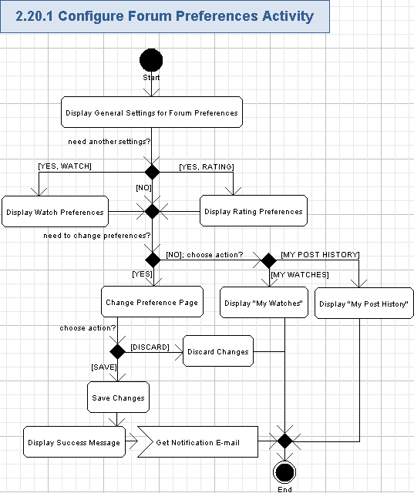

Display General Settings for Forum Preferences
- The user can view the currently configured forum preference options on his/her profile.
- This feature will be mostly re-used from the existing business process.
- There will be no navigation to other pages from My TopCoder, but the forum options can be viewed/edited on the same page where the user profile data is shown. It will be divided by three collapsible panels (“General Settings”, “Watch Preferences”, and “Rating Preferences) shown on “User Setting” tab.
  - Two more tabs (“My Watches” and “My Post History”) will be used to show additional information on forum settings – please refer chapters 3.20.1.9 and 3.20.1.10 for more details.
  - The “User Settings” tab will be shown by default.
  - The “General Settings” panel will be expanded on the “User Settings” tab by default.
- The application will display the following fields:
Data Element |  | Description | Format | R?
Forums per Category page |  | The count of forums to display per category page | Single item selection list, each item is positive integer number – like in the previous database.  The values are like in the previous database | Y
Threads per Forum page |  | The count of threads to display per forum page | Single item selection list, each item is positive integer number – like in the previous database.  The values are like in the previous database | Y
Messages per Thread page |  | The count of messages to display per thread page | Single item selection list, each item is positive integer number – like in the previous database.  The values are like in the previous database | Y
Messages per Post History page |  | The count of messages to display per post history page | Single item selection list, each item is positive integer number – like in the previous database.  The values are like in the previous database | Y
Messages | per Search page | The count of message to display per search page | Single item selection list, each item is positive integer number – like in the previous database.  The values are like in the previous database | Y
Categories | per Search page | The count of categories to display per search page | Single item selection list, each item is positive integer number – like in the previous database.  The values are like in the previous database | Y
Default thread page view |  | The default type of thread page view | Single item selection list, each item is String, max length is like in the previous database, non empty.  The values are like in the previous database | Y
Default flat page view |  | The default ordering on a flat page view | Single item selection list, each item is String, max length is like in the previous database, non empty.  The values are like in the previous database | Y
Collapse read messages |  | The control flag defining whether to collapse already read message on the following rules – see below | Boolean check box, On/Off | Y
days old |  | The count of days to be used for collapsing old messages | Single item selection list, each item is positive integer number – like in the previous database.  The values are like in the previous database | Y
with … or more messages (threaded view only) |  | The count of messages in thread to be used for collapsing old messages | Single item selection list, each item is positive integer number – like in the previous database.  The values are like in the previous database | Y
Do not collapse posts with new replies |  | The control flag defining whether to collapse posts with new replies or not | Boolean check box, On/Off | Y
Show previous/next threads |  | The control flag defining whether to show previous threads or not | Boolean radio button, Yes/No | Y
Display my member photo |  | The control flag defining whether to display the user’s own photo on his/her posts | Boolean radio button, Yes/No | Y
Display member photos |  | The control flag defining whether to show other members photos on the forum | Boolean radio button, Yes/No | Y
- If this panel is collapsed, then the user can press “GENERAL SETTINGS” header to expand and view general settings. Other panels on “User Settings” tab will be collapsed.
- The screen example of displaying general settings panel of forum preferences is as following:
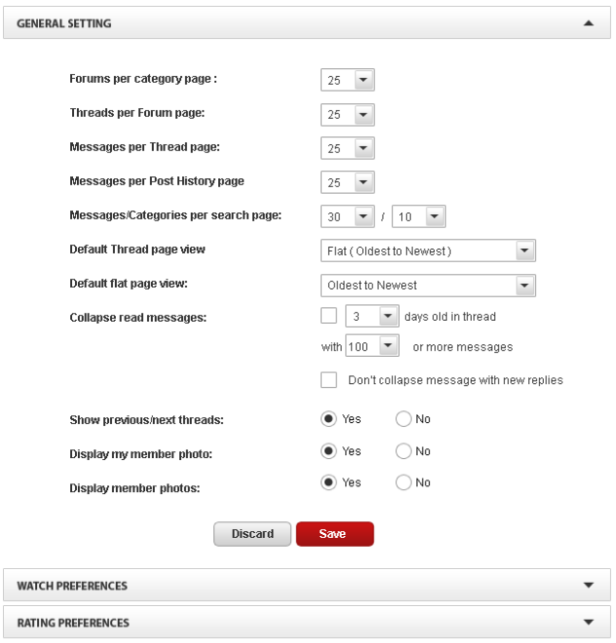

Display Watch Preferences
- The user can press “WATCH PREFERENCES” header to expand and view watch preferences. Other panels on “User Settings” tab will be collapsed.
- The application will display the following fields:
Data Element | Description | Format | R?
Always watch threads I create | The control flag defining whether to always watch threads, created by the user or not | Boolean radio button, Yes/No | Y
Always watch threads I reply to | The control flag defining whether to always watch threads the user replied to or not | Boolean radio button, Yes/No | Y
Mark watched threads as read | The control flag defining whether to automatically mark watched threads as read or not | Boolean radio button, Yes/No | Y
Send watch emails | The type of how to send notification e-mails when forum watch matched | Single item selection list, each item is String, max length is like in the previous database, non empty.  The values are like in the previous database | Y
- The screen example of displaying watch preferences panel of forum preferences is as following:
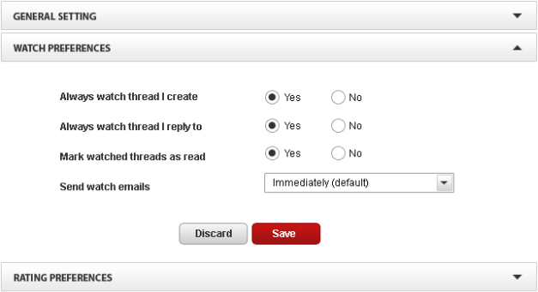

Display Rating Preferences
- The user can press “RATING PREFERENCES” header to expand and view rating preferences. Other panels on “User Settings” tab will be collapsed.
- The application will display the following fields:
Data Element | Description | Format | R?
Show ratings | The control flag defining whether to show user ratings on the forum or not | Boolean radio button, Yes/No | Y
Highlight posts … or higher rating | The rule to highlight forum posts – rating percentage | Single item selection list, each item is positive integer number – like in the previous database.  The values are like in the previous database | Y
with … or more votes | The rule to highlight forum posts – count of votes | Single item selection list, each item is positive integer number – like in the previous database.  The values are like in the previous database | Y
Collapse posts … or lower rating | The rule to collapse posts – rating percentage | Single item selection list, each item is positive integer number – like in the previous database.  The values are like in the previous database | Y
with … or more votes | The rule to collapse posts – count of votes | Single item selection list, each item is positive integer number – like in the previous database.  The values are like in the previous database | Y
in threads with … or more messages | The rule to collapse posts – count of threads in messages | Single item selection list, each item is positive integer number – like in the previous database.  The values are like in the previous database | Y
- The screen example of displaying rating preferences panel of forum preferences is as following:
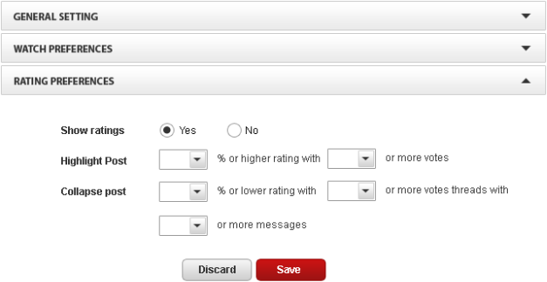

Change Preference Page
- The user can change values on the currently expanded preference panel.
- The values will be changed according to panel data fields descriptions, provided in tables of chapters 3.20.1.1 (for “GENERAL SETTINGS” preferences page), 3.20.1.2 (for “WATCH PREFERENCES” preferences page), and 3.20.1.3 (for “RATING PREFERENCES” preferences page).

Discard Changes
- The user can cancel entered/updated data by pressing “Discard” button on any of the preference panels.
- The data of the of the current profile’s page (all preference panels) will be reverted to last saved state.
- The screen fields of the user profile will be updated accordingly.
- Nothing is saved to the database in this case.

Save Changes
- The user can press the “Save” button on any of the preference panels to persist edited data of the profile.
- The application will save those changes of the forum preferences from all panels to the database.

Display Success Message
- The application will display the inline message like following:
Your profile changes were successfully updated.

Get Notification E-mail
- The application will inform the user that he/she changed forum preferences on the profile.
- The notification e-mail will have the descriptive subject and body with information about on the user changes of the forum preferences.
- The notification e-mail will contain the link to the forum preferences configuration on the user’s profile, so newcomers can quickly get comfortable where they are placed.

Display "My Watches"
- The user can press “My Watches” tab to view his/her currently chosen watches on the forum and have an ability to update those watches.
- This feature will be fully the same as it was present on the existing TC web-site (but just shown inside panel of “My Watches” tab): http://forums.topcoder.com/?module=Watches

Display "My Post History"
- The user can press “My Post History” tab to view his/her recent posts on the forum.
- This feature will be fully the same as it was present on the existing TC web-site (but just shown inside panel of “My Post History” tab): http://forums.topcoder.com/?module=History

Configure Referrals
The application will allow the user to view the list of other users, referring to him/her. It will be also possible to generate a hyperlink to be used by new comers to refer to the user during registration of their account on the application.
Reference to initial use case in conceptualization: “4.4.19”.
Storyboard page: “05_13_Referral.png”.
- Pre-conditions: the user pressed “Referrals” option in “Community” topic of the navigation menu on “My Profile” part of the application. The user has to be logged in to the application to perform this action.
- Post-conditions: the user changed his/her referrals preferences as needed.

Configure Referrals Activity
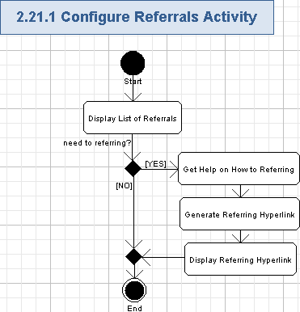

Display List of Referrals
- The application will display the brief information about referral program:
The following is a list of member who have named you as a reference when they registered to become a TopCoder members. Should they earn any money as a competitor on TopCoder Studio, the referring member (you) will receive a referral commission equal to 10% of any amounts earned or won by the referred member during the 12 months following registrations!
- The application will display the list of referrals for the user. The list will contain the following fields:
Data Element | Description | Format | R?
Handle | The unique username (handle) for the referral user account on the application | String, max length is the same as in previous database, non empty | Y
Member Since | The date of referral registration | String, date format like “MM/DD/YYYY”, 10 chars, non empty | Y
- The screen example of the referrals list is as following:
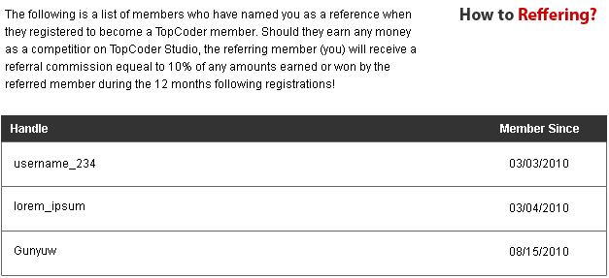

Get Help on How to Referring
- The user can press “How to Referring?” hyperlink to get a popup window with the information on how to provide TC web-site references to other users.
- It will be a simple instructing page saying that the user can either give his/her handle to the referral or a reference hyperlink.
- This popup window can be closed as usual.

Generate Referring Hyperlink
- The application will generate the referring hyperlink according to the user handle.
- It is suggested to implement a hyperlink as an URL (String, max 1024 chars, non empty) with ciphered information of the referring user handle (like a reference ID to be stored in the database).

Display Referring Hyperlink
- The application will show the referring hyperlink on the popup window.
- The user can copy that hyperlink for usage on other web-sites.

Configure Cards/Badges
The user can view the information about his/her achievements on the special cards and badges. The user can choose various visualization options and get images of his/her cards/badges.
Reference to initial use case in conceptualization: “4.4.20”.
Storyboard page: “05_14_Card-Badges.png”.
- Pre-conditions: the user pressed “Card / Badges” option in “Community” topic of the navigation menu on “My Profile” part of the application. The user has to be logged in to the application to perform this action.
- Post-conditions: the user configured his/her cards/badges and got their images as needed.

Configure Cards/Badges Activity
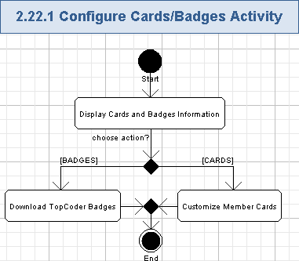

Display Cards and Badges Information
- The application will display a brief information on how to show user’s skills, about member badge and cards.
- The message of the how to show user’s skills is like following:
Show your skills

Ever wanted to show off your TopCoder skills on your personal site? Want that ace in the hole at your next job interview? The TopCoder Member Badges and Cards are the answer, and they're free!
- The information about member badges is like following:
Member Badges

A TopCoder Badge is the perfect seal of approval for anyone trying to make their experience stand out. Just place one of the TopCoder Badge images on your resume or website and you're sure to grab some attention. Each graphic shows that you are a TopCoder rated member, signifying your skill as one of the best programmers around. On our downloads page we have several sizes and variations for you to choose from. So go pick your favorite and start showing off.

Go to the TopCoder Badges downloads page
- The information about member cards is like following:
Member Cards

Like collectible cards? How about a digital card that never gets worn out? How about a card with statistics that are always up-to-the-second accurate? Now how about a card where you are the star? Sound good?

That is exactly what the TopCoder Member Card is. It is a digital tool that lets you show off your skills at coding and software development anywhere on your personal website, and it does it in a stylish way. Covered with member statistics and always accurate, the TopCoder Member Card is truly something no TopCoder should be without. Click below to see a preview of what your card will look like!

Know any other TopCoder Members? Why not build a TopCoder Member Card collection. You could have a site to represent your college where anyone can go to see every member's card on your campus. You could build a site where you and all your coworkers can compare stats, see who else they work with, and find out who is the best in the company. It's all possible with the TopCoder Member Cards.

See your TopCoder Card preview
- There will be a picture of a simple “TopCoder Rated Member” banner, like following:

- The screen example of the cards and badges page is shown below:
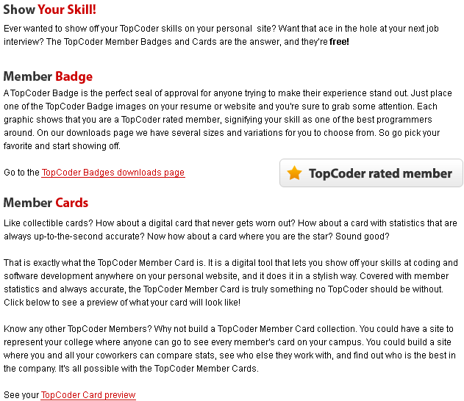

Download TopCoder Badges
- The user can download a picture of the TopCoder badge.
- The badges information itself will be the mostly similar as in the previous business process, just its visualization and management will be changed.
- The user will press “TopCoder Badges download page” hyperlink to view the badges available for downloading. There will be no navigation to other pages from My TopCoder, but the badges can be viewed on the same page where the user profile data is shown – some sort of tabs or expandable/collapsible tables can be used.
- The user can get badges like shown on the following page: http://www.topcoder.com/card?module=Downloads

Customize Member Cards
- The user can get the customizable member card.
- The cards information itself will be the mostly similar as in the previous business process, just its visualization and management will be changed.
- The user will press “your TopCoder Card preview” hyperlink to view the prepared card. There will be no navigation to other pages from My TopCoder, but the cards can be viewed on the same page where the user profile data is shown – some sort of tabs or expandable/collapsible tables can be used.
- The user can get cards like shown on the following page:
http://www.topcoder.com/card?module=Preview
- The following additional features are suggested:
  - To add more badge pictures with integrating a user handle to them.
  - To improve the user card by adding more competition tracks and an ability to choose the track to be displayed on the rating distribution. I.e. to make that card more customizable.

Become a Customer
The application will allow the user to become a Customer. The user will provide more information for the profile (like contacts data) and ask TC Admin to assign a Customer user role to him/her. After get assigned to a Customer user role, the user will be able to access customer-related functionality in the application.
This use case includes use case “Provide Data for Ordering Projects in TC Direct” (please refer chapter 3.24).
Reference to initial use case in conceptualization: “4.4.21”.
Storyboard page: “03_FirstStep.png”,
“05_07_RegistrationPreferences.png”.
- Pre-conditions: the user provided additional data, required for a Customer user role, to the profile and pressed a special checkbox on a registration preferences page to request a Customer user role assignment from the Admin. The user has to be logged in to the application to perform this action.
- Post-conditions: a Customer user role was assigned to the user; or the TC Admin rejected the user’s request and did not assign a Customer user to him/her.

Become a Customer Activity
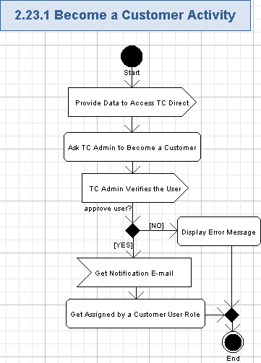

Provide Data to Access TC Direct
- The user will provide all the needed profile data to access TC Direct – please refer chapter 3.24 for more details.

Ask TC Admin to Become a Customer
- The user will turn on “I want to start using TopCoder Direct” check box on the registration preferences page (please refer chapter 3.19 for more details).
- The screen example if like following:
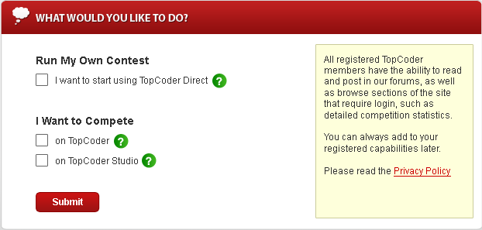

TC Admin Verifies the User
- TC administrators will manage assignment of a Customer role to the users – it is out of scope for this specification.
- TC Admin will receive the information about the user from the application (like by e-mail) and manually assign proper role of a Customer to that user.
- The final decision to allow ordering on TC Web-site for the user will be from the TC Admin (out of scope for this specification).

Display Error Message
- If TC Admin rejected user to become a Customer, then the application will show a special message on that user profile (like inline message):
TC Admin rejected your request to become a Customer.
- In this case, the user will not get a Customer user role.

Get Notification E-mail
- The application will inform the user that he/she was assigned a Customer user role.
- The users will be notified by e-mail about features of his/her new user role (a Customer) on TC web-site.
- The e-mail notification will be also sent to the user if he/she removed some data from the profile and his/her access rights were reduced, because of that.
- The notification e-mail will have the descriptive subject and body with information about on the user’s approval (or rejection) on the Customer user role.
- The notification e-mail will contain the link to Customer features, so newcomers can quickly get comfortable where they are placed.

Get Assigned by a Customer User Role
- The user will enter that needed information to his/her profile, get an approval from TC Admin, and automatically gets full access to the Customer user role’s features on TC Web-site.
- If the user removed some data from his/her profile that is required to be a Customer, then he/she will lost the assignment to a Customer user role.

Provide Data for Ordering Projects in TC Direct
The Customer has to provide some additional data (like contacts information, age, timezone, gender, title and company name) to order projects on TC Direct. The Customer will enter that information to his/her profile and automatically gets full access to the TC Direct. The already entered contacts data can be viewed and edited as well.
This use case is included by use case “Become a Customer” (please refer chapter 3.23).
Reference to initial use case in conceptualization: “4.4.22”.
Storyboard page: “05_01_02_myprofile_name-n-contact-edit.png”,
“05_02_02_myprofile_demographic-info-edit.png”.
- Pre-conditions: the Customer needs to work with TC Direct and pressed “Edit” button on the “Name and Contact” page of “My Profile”; or the user was asked to enter profile data for accessing TC Direct by the application when trying to start accessing TC Direct. The user has to be logged in to the application to perform this action.
- Post-conditions: the user entered all the needed data for working with TC Direct and got access to TC Direct application.

Provide Data for Ordering Projects in TC Direct Activity
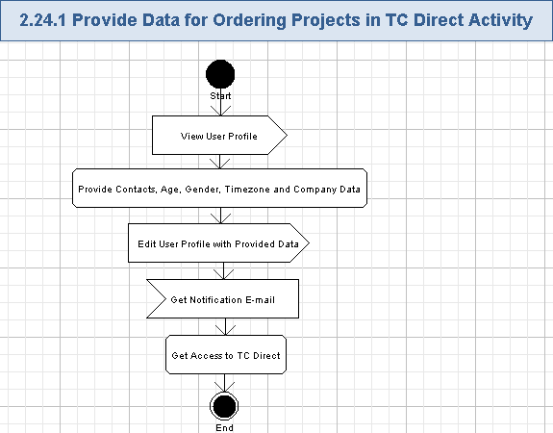

View User Profile
- The user will open and view his/her profile – please refer to chapter 3.8 for more details.

Provide Contacts, Age, Gender, Timezone and Company Data
- The user has to provide the following data (in addition to the minimal set of required fields) to get an ability to order projects on /TC or Studio through TC Direct (Cockpit):
Data Element | Description | Format | R?
First Name | The first name of the user | String, max length is the same as in previous database, non empty | Y
Last Name | The last name of the user | String, max length is the same as in previous database, non empty | Y
Job Title | The user position in the company (like “Software Engineer”) | String, max length is the same as in previous database, non empty | Y
Company Name | The name of the user’s company | String, max length is the same as in previous database, non empty | Y
Age | The age range, related to the user | Single item selection list, each list item is String, max length is the same as in previous database, non empty.  The values of the list are like in the previous database | Y
Gender | The gender of the user | Single item selection list, each list item is String, max length is the same as in previous database, non empty.  The values of the list are like in the previous database | Y
Current Address 1 | The line #1 of the user’s address | String, max length is the same as in previous database, non empty | Y
Current Address 2 | The line #2 of the user’s address | String, max length is the same as in previous database, can be empty | N
Current Address 3 | The line #3 of the user’s address | String, max length is the same as in previous database, can be empty | N
City | The city of the user | String, max length is the same as in previous database, non empty | Y
State | The state of the user – only for USA | String, max 2 chars, can be empty.  One of the USA state or DC. | N
Postal Code | The postal (ZIP) code of the user | String, max length is the same as in previous database, each char is a digit from [0-9], non empty | Y
Province | The province of the user | String, max length is the same as in previous database, can be empty | N
Country | The country of the user | Single item selection list. Each item is String, max length is the same as in previous database, can be empty.  The values in the list are the same as in the previous database | Y
Phone Number | The phone number of the user | String, like (+xxx) xxx xxx-xxxx, where “x” is a digit [0-9], max length is the same as in previous database, non empty | Y
Timezone | The user’s time zone relative to GMT | Single item selection list, each list item is String, like “GTMzxx, where “z” is “+” or “-“, “x” is a digit [0-9], max length is the same as in previous database, non empty.  The values of the list are like in the previous database | Y
- Please note, all those fields will be now stored in the UserProfile entity (and the related table) – this is the difference with the previous TC web-site.

Edit User Profile with Provided Data
- The user will edit the related fields (listed in the chapter 3.24.1.2) through the regular profile editing functionality described in chapters 3.9 and 3.10 for more details.

Get Notification E-mail
- The application will inform the user that he/she was assigned rights to full access the Cockpit (TC Direct).
- The users will be notified by e-mail about new accessible TC Direct feature on TC web-site as the user enters enough data to his/her profile.
- The e-mail notification will be also sent to the user if he/she removed some data from the profile and his/her access rights were reduced, because of that.
- The notification e-mail will have the descriptive subject and body with information about on the user’s allowed (or restricted) access to TC Direct (Cockpit).
- The notification e-mail will contain the link to TC Direct feature, so newcomers can quickly get comfortable where they are placed.

Get Access to TC Direct
- The user will enter that needed information to his/her profile and automatically gets full access to TC Direct (Cockpit).
- There will be no need to additionally register the Customer to TC Direct.
- If the user removed some data from his/her profile that is required to access TC Direct, then he/she will lost the access to TC Direct (Cockpit).

Provide Data to Access Online Review Tool
The Customer and Competitor has to provide some additional data (like contacts information and age) to get access to the Online Review tool. The user will enter that information to his/her profile and automatically gets full access to the Online Review tool. The already entered contacts data can be viewed and edited as well. The user will be restricted to view details on just competitions related to him/her (i.e. ordered by him/her, or registered to by him/her) in the Online Review tool.
Reference to initial use case in conceptualization: “4.4.23”.
Storyboard page: “05_01_02_myprofile_name-n-contact-edit.png”,
“05_02_02_myprofile_demographic-info-edit.png”,
“05_03_02_AccountInfo-edit.png”.
- Pre-conditions: the Customer or the Competitor needs to work with TC Online Review tool and pressed “Edit” button on the “Name and Contact” page of “My Profile”; or the user was asked to enter profile data for accessing TC Online Review tool by the application when trying to start accessing the Online Review tool. The user has to be logged in to the application to perform this action.
- Post-conditions: the user entered all the needed data for working with TC Online Review tool and got access to the Online Review tool application.

Provide Data to Access Online Review Tool Activity
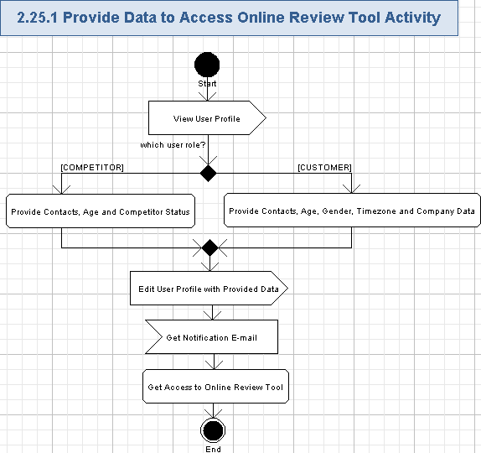

View User Profile
- The user will open and view his/her profile – please refer to chapter 3.8 for more details.

Provide Contacts, Age and Competitor Status
- If the user is a Competitor, then he/she has to provide the following data (in addition to the minimal set of required fields) to get access to the OR tool.
Data Element | Description | Format | R?
First Name | The first name of the user | String, max length is the same as in previous database, non empty | Y
Last Name | The last name of the user | String, max length is the same as in previous database, non empty | Y
Age | The age range, related to the user | Single item selection list, each list item is String, max length is the same as in previous database, non empty.  The values of the list are like in the previous database | Y
Current Address 1 | The line #1 of the user’s address | String, max length is the same as in previous database, non empty | Y
Current Address 2 | The line #2 of the user’s address | String, max length is the same as in previous database, can be empty | N
Current Address 3 | The line #3 of the user’s address | String, max length is the same as in previous database, can be empty | N
City | The city of the user | String, max length is the same as in previous database, non empty | Y
State | The state of the user – only for USA | String, max 2 chars, can be empty.  One of the USA state or DC. | N
Postal Code | The postal (ZIP) code of the user | String, max length is the same as in previous database, each char is a digit from [0-9], non empty | Y
Province | The province of the user | String, max length is the same as in previous database, can be empty | N
Country | The country of the user | Single item selection list. Each item is String, max length is the same as in previous database, can be empty.  The values in the list are the same as in the previous database | Y
Phone Number | The phone number of the user | String, like (+xxx) xxx xxx-xxxx, where “x” is a digit [0-9], max length is the same as in previous database, non empty | Y
Student / Professional | A competitor status – the control flag defining whether the user is a student or a professional | Single item selection list, each list item is String, max length is the same as in previous database, non empty.  The values of the list are like in the previous database | Y
- Please note, almost all those fields will be now stored in the UserProfile entity (and the related table) – this is the difference with the previous TC web-site. Just Status (Student / Professional) will be stored to the User entity (and the related table) as in the pervious TC web-site.

Provide Contacts, Age, Gender, Timezone and Company Data
- If the user is a Customer, then he/she has to provide the following data (in addition to the minimal set of required fields) to get access to the OR tool.
Data Element | Description | Format | R?
First Name | The first name of the user | String, max length is the same as in previous database, non empty | Y
Last Name | The last name of the user | String, max length is the same as in previous database, non empty | Y
Job Title | The user position in the company (like “Software Engineer”) | String, max length is the same as in previous database, non empty | Y
Company Name | The name of the user’s company | String, max length is the same as in previous database, non empty | Y
Age | The age range, related to the user | Single item selection list, each list item is String, max length is the same as in previous database, non empty.  The values of the list are like in the previous database | Y
Gender | The gender of the user | Single item selection list, each list item is String, max length is the same as in previous database, non empty.  The values of the list are like in the previous database | Y
Current Address 1 | The line #1 of the user’s address | String, max length is the same as in previous database, non empty | Y
Current Address 2 | The line #2 of the user’s address | String, max length is the same as in previous database, can be empty | N
Current Address 3 | The line #3 of the user’s address | String, max length is the same as in previous database, can be empty | N
City | The city of the user | String, max length is the same as in previous database, non empty | Y
State | The state of the user – only for USA | String, max 2 chars, can be empty.  One of the USA state or DC. | N
Postal Code | The postal (ZIP) code of the user | String, max length is the same as in previous database, each char is a digit from [0-9], non empty | Y
Province | The province of the user | String, max length is the same as in previous database, can be empty | N
Country | The country of the user | Single item selection list. Each item is String, max length is the same as in previous database, can be empty.  The values in the list are the same as in the previous database | Y
Phone Number | The phone number of the user | String, like (+xxx) xxx xxx-xxxx, where “x” is a digit [0-9], max length is the same as in previous database, non empty | Y
Timezone | The user’s time zone relative to GMT | Single item selection list, each list item is String, like “GTMzxx, where “z” is “+” or “-“, “x” is a digit [0-9], max length is the same as in previous database, non empty.  The values of the list are like in the previous database | Y
- Please note, all those fields will be now stored in the UserProfile entity (and the related table) – this is the difference with the previous TC web-site.

Edit User Profile with Provided Data
- The user will edit the related fields (listed in the chapter 3.25.1.2 or 3.25.1.3 – according to his/her user role) through the regular profile editing functionality described in chapters 3.9, 3.10 and 3.11 for more details.

Get Notification E-mail
- The application will inform the user that he/she was assigned rights to full access the Online Review tool.
- The users will be notified by e-mail about new accessible Online Review feature on TC web-site as the user enters enough data to his/her profile.
- The e-mail notification will be also sent to the user if he/she removed some data from the profile and his/her access rights were reduced, because of that.
- The notification e-mail will have the descriptive subject and body with information about on the user’s allowed (or restricted) access to Online Review tool.
- The notification e-mail will contain the link to Online Review feature, so newcomers can quickly get comfortable where they are placed.

Get Access to Online Review Tool
- The user will enter that needed information to his/her profile and automatically gets full access to Online Review Tool.
- The user will be restricted to view details on just competitions related to him/her (i.e. ordered by him/her, or registered to by him/her).
- If the user removed some data from his/her profile that is required to access Online Review, then he/she will lost the access to TC Online Review Tool.

Provide Data to Access JIRA
The Customer and Competitor has to provide some additional data (like contacts information and age) to get access to the JIRA. The user will enter that information to his/her profile and automatically gets full access to the JIRA. The already entered contacts data can be viewed and edited as well. All the bug races will be available to access by all the Customers and Competitors.
Reference to initial use case in conceptualization: “4.4.24”.
Storyboard page: “05_01_02_myprofile_name-n-contact-edit.png”,
“05_02_02_myprofile_demographic-info-edit.png” ,
“05_03_02_AccountInfo-edit.png”.
- Pre-conditions: the Customer or the Competitor needs to work with JIRA tool and pressed “Edit” button on the “Name and Contact” page of “My Profile”; or the user was asked to enter profile data for accessing JIRA by the application when trying to start accessing JIRA. The user has to be logged in to the application to perform this action.
- Post-conditions: the user entered all the needed data for working with JIRA and got access to JIRA application.

Provide Data to Access JIRA Activity
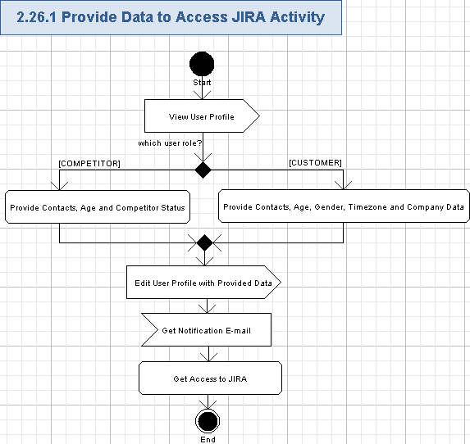

View User Profile
- The user will open and view his/her profile – please refer to chapter 3.8 for more details.

Provide Contacts, Age and Competitor Status
- If the user is a Competitor, then he/she has to provide the following data (in addition to the minimal set of required fields) to get access to the JIRA.
Data Element | Description | Format | R?
First Name | The first name of the user | String, max length is the same as in previous database, non empty | Y
Last Name | The last name of the user | String, max length is the same as in previous database, non empty | Y
Age | The age range, related to the user | Single item selection list, each list item is String, max length is the same as in previous database, non empty.  The values of the list are like in the previous database | Y
Current Address 1 | The line #1 of the user’s address | String, max length is the same as in previous database, non empty | Y
Current Address 2 | The line #2 of the user’s address | String, max length is the same as in previous database, can be empty | N
Current Address 3 | The line #3 of the user’s address | String, max length is the same as in previous database, can be empty | N
City | The city of the user | String, max length is the same as in previous database, non empty | Y
State | The state of the user – only for USA | String, max 2 chars, can be empty.  One of the USA state or DC. | N
Postal Code | The postal (ZIP) code of the user | String, max length is the same as in previous database, each char is a digit from [0-9], non empty | Y
Province | The province of the user | String, max length is the same as in previous database, can be empty | N
Country | The country of the user | Single item selection list. Each item is String, max length is the same as in previous database, can be empty.  The values in the list are the same as in the previous database | Y
Phone Number | The phone number of the user | String, like (+xxx) xxx xxx-xxxx, where “x” is a digit [0-9], max length is the same as in previous database, non empty | Y
Student / Professional | A competitor status – the control flag defining whether the user is a student or a professional | Single item selection list, each list item is String, max length is the same as in previous database, non empty.  The values of the list are like in the previous database | Y
- Please note, almost all those fields will be now stored in the UserProfile entity (and the related table) – this is the difference with the previous TC web-site. Just Status (Student / Professional) will be stored to the User entity (and the related table) as in the pervious TC web-site.

Provide Contacts, Age, Gender, Timezone and Company Data
- If the user is a Customer, then he/she has to provide the following data (in addition to the minimal set of required fields) to get access to the JIRA.
Data Element | Description | Format | R?
First Name | The first name of the user | String, max length is the same as in previous database, non empty | Y
Last Name | The last name of the user | String, max length is the same as in previous database, non empty | Y
Job Title | The user position in the company (like “Software Engineer”) | String, max length is the same as in previous database, non empty | Y
Company Name | The name of the user’s company | String, max length is the same as in previous database, non empty | Y
Age | The age range, related to the user | Single item selection list, each list item is String, max length is the same as in previous database, non empty.  The values of the list are like in the previous database | Y
Gender | The gender of the user | Single item selection list, each list item is String, max length is the same as in previous database, non empty.  The values of the list are like in the previous database | Y
Current Address 1 | The line #1 of the user’s address | String, max length is the same as in previous database, non empty | Y
Current Address 2 | The line #2 of the user’s address | String, max length is the same as in previous database, can be empty | N
Current Address 3 | The line #3 of the user’s address | String, max length is the same as in previous database, can be empty | N
City | The city of the user | String, max length is the same as in previous database, non empty | Y
State | The state of the user – only for USA | String, max 2 chars, can be empty.  One of the USA state or DC. | N
Postal Code | The postal (ZIP) code of the user | String, max length is the same as in previous database, each char is a digit from [0-9], non empty | Y
Province | The province of the user | String, max length is the same as in previous database, can be empty | N
Country | The country of the user | Single item selection list. Each item is String, max length is the same as in previous database, can be empty.  The values in the list are the same as in the previous database | Y
Phone Number | The phone number of the user | String, like (+xxx) xxx xxx-xxxx, where “x” is a digit [0-9], max length is the same as in previous database, non empty | Y
Timezone | The user’s time zone relative to GMT | Single item selection list, each list item is String, like “GTMzxx, where “z” is “+” or “-“, “x” is a digit [0-9], max length is the same as in previous database, non empty.  The values of the list are like in the previous database | Y
- Please note, all those fields will be now stored in the UserProfile entity (and the related table) – this is the difference with the previous TC web-site.

Edit User Profile with Provided Data
- The user will edit the related fields (listed in the chapter 3.26.1.2 or 3.26.1.3 – according to his/her user role) through the regular profile editing functionality described in chapters 3.9, 3.10 and 3.11 for more details.

Get Notification E-mail
- The application will inform the user that he/she was assigned rights to full access the JIRA.
- The users will be notified by e-mail about new accessible JIRA feature on TC web-site as the user enters enough data to his/her profile.
- The e-mail notification will be also sent to the user if he/she removed some data from the profile and his/her access rights were reduced, because of that.
- The notification e-mail will have the descriptive subject and body with information about on the user’s allowed (or restricted) access to the JIRA.
- The notification e-mail will contain the link to JIRA feature, so newcomers can quickly get comfortable where they are placed.

Get Access to JIRA
- The user will enter that needed information to his/her profile and automatically gets full access to the JIRA.
- All the bug races will be available to access by all the Customers and Competitors.
- If the user removed some data from his/her profile that is required to access the JIRA, then he/she will lost the access to the JIRA.

Provide Data to Access SVN
The Customer and Competitor has to provide some additional data (like contacts information and age) to get access to the SVN. The user will enter that information to his/her profile, get approval from the TC Admin, and automatically gets access to the SVN. The already entered contacts data can be viewed and edited as well.
Reference to initial use case in conceptualization: “4.4.25”.
Storyboard page: “05_01_02_myprofile_name-n-contact-edit.png”,
“05_02_02_myprofile_demographic-info-edit.png” ,
“05_03_02_AccountInfo-edit.png”.
- Pre-conditions: the Customer or the Competitor needs to work with SVN tool and pressed “Edit” button on the “Name and Contact” page of “My Profile”; or the user was asked to enter profile data for accessing SVN by the application when trying to start accessing SVN. The user has to be logged in to the application to perform this action.
- Post-conditions: the user entered all the needed data for working with SVN, received a confirmation from TC Admin and got access to SVN application; or TC Admin rejected user access to SVN.

Provide Data to Access SVN Activity
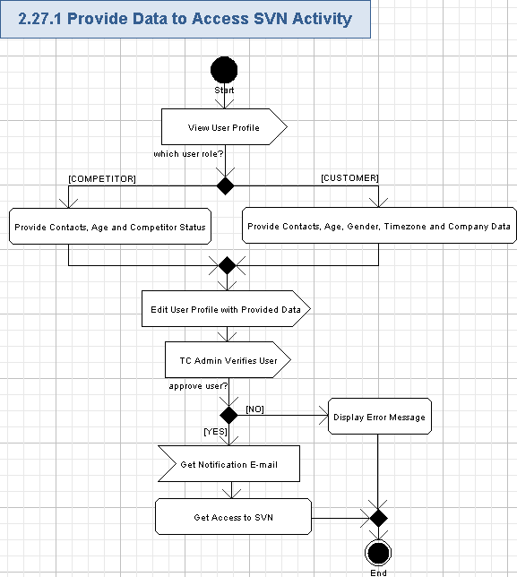

View User Profile
- The user will open and view his/her profile – please refer to chapter 3.8 for more details.

Provide Contacts, Age and Competitor Status
- If the user is a Competitor, then he/she has to provide the following data (in addition to the minimal set of required fields) to get access to the SVN.
Data Element | Description | Format | R?
First Name | The first name of the user | String, max length is the same as in previous database, non empty | Y
Last Name | The last name of the user | String, max length is the same as in previous database, non empty | Y
Age | The age range, related to the user | Single item selection list, each list item is String, max length is the same as in previous database, non empty.  The values of the list are like in the previous database | Y
Current Address 1 | The line #1 of the user’s address | String, max length is the same as in previous database, non empty | Y
Current Address 2 | The line #2 of the user’s address | String, max length is the same as in previous database, can be empty | N
Current Address 3 | The line #3 of the user’s address | String, max length is the same as in previous database, can be empty | N
City | The city of the user | String, max length is the same as in previous database, non empty | Y
State | The state of the user – only for USA | String, max 2 chars, can be empty.  One of the USA state or DC. | N
Postal Code | The postal (ZIP) code of the user | String, max length is the same as in previous database, each char is a digit from [0-9], non empty | Y
Province | The province of the user | String, max length is the same as in previous database, can be empty | N
Country | The country of the user | Single item selection list. Each item is String, max length is the same as in previous database, can be empty.  The values in the list are the same as in the previous database | Y
Phone Number | The phone number of the user | String, like (+xxx) xxx xxx-xxxx, where “x” is a digit [0-9], max length is the same as in previous database, non empty | Y
Student / Professional | A competitor status – the control flag defining whether the user is a student or a professional | Single item selection list, each list item is String, max length is the same as in previous database, non empty.  The values of the list are like in the previous database | Y
- Please note, almost all those fields will be now stored in the UserProfile entity (and the related table) – this is the difference with the previous TC web-site. Just Status (Student / Professional) will be stored to the User entity (and the related table) as in the pervious TC web-site.

Provide Contacts, Age, Gender, Timezone and Company Data
- If the user is a Customer, then he/she has to provide the following data (in addition to the minimal set of required fields) to get access to the SVN.
Data Element | Description | Format | R?
First Name | The first name of the user | String, max length is the same as in previous database, non empty | Y
Last Name | The last name of the user | String, max length is the same as in previous database, non empty | Y
Job Title | The user position in the company (like “Software Engineer”) | String, max length is the same as in previous database, non empty | Y
Company Name | The name of the user’s company | String, max length is the same as in previous database, non empty | Y
Age | The age range, related to the user | Single item selection list, each list item is String, max length is the same as in previous database, non empty.  The values of the list are like in the previous database | Y
Gender | The gender of the user | Single item selection list, each list item is String, max length is the same as in previous database, non empty.  The values of the list are like in the previous database | Y
Current Address 1 | The line #1 of the user’s address | String, max length is the same as in previous database, non empty | Y
Current Address 2 | The line #2 of the user’s address | String, max length is the same as in previous database, can be empty | N
Current Address 3 | The line #3 of the user’s address | String, max length is the same as in previous database, can be empty | N
City | The city of the user | String, max length is the same as in previous database, non empty | Y
State | The state of the user – only for USA | String, max 2 chars, can be empty.  One of the USA state or DC. | N
Postal Code | The postal (ZIP) code of the user | String, max length is the same as in previous database, each char is a digit from [0-9], non empty | Y
Province | The province of the user | String, max length is the same as in previous database, can be empty | N
Country | The country of the user | Single item selection list. Each item is String, max length is the same as in previous database, can be empty.  The values in the list are the same as in the previous database | Y
Phone Number | The phone number of the user | String, like (+xxx) xxx xxx-xxxx, where “x” is a digit [0-9], max length is the same as in previous database, non empty | Y
Timezone | The user’s time zone relative to GMT | Single item selection list, each list item is String, like “GTMzxx, where “z” is “+” or “-“, “x” is a digit [0-9], max length is the same as in previous database, non empty.  The values of the list are like in the previous database | Y
- Please note, all those fields will be now stored in the UserProfile entity (and the related table) – this is the difference with the previous TC web-site.

Edit User Profile with Provided Data
- The user will edit the related fields (listed in the chapter 3.27.1.2 or 3.27.1.3 – according to his/her user role) through the regular profile editing functionality described in chapters 3.9, 3.10 and 3.11 for more details.

TC Admin Verifies User
- TC administrators will manage Competitors and Customers access to the SVN – it is out of scope for this specification.
- TC Admin can approve the user to access the SVN, or reject the user as well.

Display Error Message
- If TC Admin rejected user to access SVN, then the application will show a special message on that user profile (like inline message):
TC Admin rejected your access to SVN.
- In this case, the user will not get access to the SVN.

Get Notification E-mail
- The application will inform the user that he/she was assigned rights to full access the SVN.
- The users will be notified by e-mail about new accessible SVN feature on TC web-site as the user enters enough data to his/her profile.
- The e-mail notification will be also sent to the user if he/she removed some data from the profile and his/her access rights were reduced, because of that.
- The notification e-mail will have the descriptive subject and body with information about on the user’s allowed (or restricted) access to the SVN.
- The notification e-mail will contain the link to SVN feature, so newcomers can quickly get comfortable where they are placed.

Get Access to SVN
- The user will enter that needed information to his/her profile, get an approval from TC Admin, and automatically gets full access to the SVN.
- If the user removed some data from his/her profile that is required to access the SVN, then he/she will lost the access to the SVN.

Provide Data to Access VM
The Customer and Competitor has to provide some additional data (like contacts information, SSH key and age) to get access to the SVN. The user will enter that information to his/her profile, get approval from the TC Admin, and automatically gets access to the VM. The already entered contacts data can be viewed and edited as well.
Reference to initial use case in conceptualization: “4.4.26”.
Storyboard page: “05_01_02_myprofile_name-n-contact-edit.png”,
“05_02_02_myprofile_demographic-info-edit.png” ,
“05_03_02_AccountInfo-edit.png”,
05_03_02_AccountInfo-edit+storessh.png.
- Pre-conditions: the Customer or the Competitor needs to work with the VM and pressed “Edit” button on the “Name and Contact” page of “My Profile”; or the user was asked to enter profile data for accessing VM by the application when trying to start accessing the VM. The user has to be logged in to the application to perform this action.
- Post-conditions: the user entered all the needed data for working with VM, received a confirmation from TC Admin and got access to VM application; or TC Admin rejected user access to the VM.

Provide Data to Access VM Activity
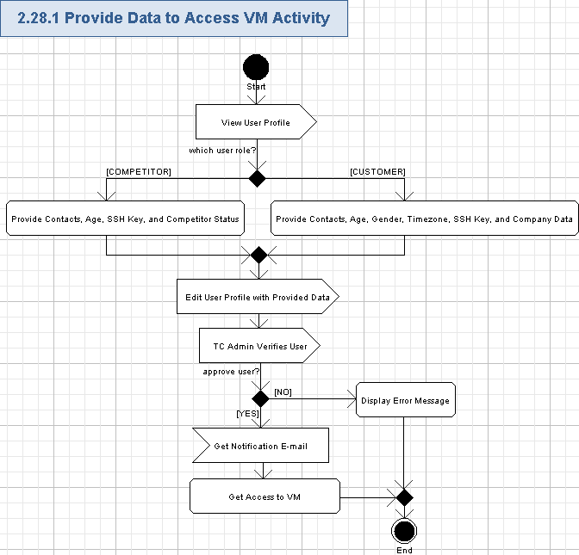

View User Profile
- The user will open and view his/her profile – please refer to chapter 3.8 for more details.

Provide Contacts, Age, SSH Key, and Competitor Status
- If the user is a Competitor, then he/she has to provide the following data (in addition to the minimal set of required fields) to get access to the VM.
Data Element | Description | Format | R?
First Name | The first name of the user | String, max length is the same as in previous database, non empty | Y
Last Name | The last name of the user | String, max length is the same as in previous database, non empty | Y
Age | The age range, related to the user | Single item selection list, each list item is String, max length is the same as in previous database, non empty.  The values of the list are like in the previous database | Y
Current Address 1 | The line #1 of the user’s address | String, max length is the same as in previous database, non empty | Y
Current Address 2 | The line #2 of the user’s address | String, max length is the same as in previous database, can be empty | N
Current Address 3 | The line #3 of the user’s address | String, max length is the same as in previous database, can be empty | N
City | The city of the user | String, max length is the same as in previous database, non empty | Y
State | The state of the user – only for USA | String, max 2 chars, can be empty.  One of the USA state or DC. | N
Postal Code | The postal (ZIP) code of the user | String, max length is the same as in previous database, each char is a digit from [0-9], non empty | Y
Province | The province of the user | String, max length is the same as in previous database, can be empty | N
Country | The country of the user | Single item selection list. Each item is String, max length is the same as in previous database, can be empty.  The values in the list are the same as in the previous database | Y
Phone Number | The phone number of the user | String, like (+xxx) xxx xxx-xxxx, where “x” is a digit [0-9], max length is the same as in previous database, non empty | Y
Student / Professional | A competitor status – the control flag defining whether the user is a student or a professional | Single item selection list, each list item is String, max length is the same as in previous database, non empty.  The values of the list are like in the previous database | Y
Security Key | The SSH key of the user | String, max length is the same as in previous database, non empty | Y
- Please note, almost all those fields will be now stored in the UserProfile entity (and the related table) – this is the difference with the previous TC web-site. Just Status (Student / Professional) and Security Key will be stored to the User entity (and the related table) as in the pervious TC web-site.

Provide Contacts, Age, Gender, Timezone, SSH Key, and Company Data
- If the user is a Customer, then he/she has to provide the following data (in addition to the minimal set of required fields) to get access to the VM.
Data Element | Description | Format | R?
First Name | The first name of the user | String, max length is the same as in previous database, non empty | Y
Last Name | The last name of the user | String, max length is the same as in previous database, non empty | Y
Job Title | The user position in the company (like “Software Engineer”) | String, max length is the same as in previous database, non empty | Y
Company Name | The name of the user’s company | String, max length is the same as in previous database, non empty | Y
Age | The age range, related to the user | Single item selection list, each list item is String, max length is the same as in previous database, non empty.  The values of the list are like in the previous database | Y
Gender | The gender of the user | Single item selection list, each list item is String, max length is the same as in previous database, non empty.  The values of the list are like in the previous database | Y
Current Address 1 | The line #1 of the user’s address | String, max length is the same as in previous database, non empty | Y
Current Address 2 | The line #2 of the user’s address | String, max length is the same as in previous database, can be empty | N
Current Address 3 | The line #3 of the user’s address | String, max length is the same as in previous database, can be empty | N
City | The city of the user | String, max length is the same as in previous database, non empty | Y
State | The state of the user – only for USA | String, max 2 chars, can be empty.  One of the USA state or DC. | N
Postal Code | The postal (ZIP) code of the user | String, max length is the same as in previous database, each char is a digit from [0-9], non empty | Y
Province | The province of the user | String, max length is the same as in previous database, can be empty | N
Country | The country of the user | Single item selection list. Each item is String, max length is the same as in previous database, can be empty.  The values in the list are the same as in the previous database | Y
Phone Number | The phone number of the user | String, like (+xxx) xxx xxx-xxxx, where “x” is a digit [0-9], max length is the same as in previous database, non empty | Y
Timezone | The user’s time zone relative to GMT | Single item selection list, each list item is String, like “GTMzxx, where “z” is “+” or “-“, “x” is a digit [0-9], max length is the same as in previous database, non empty.  The values of the list are like in the previous database | Y
Security Key | The SSH key of the user | String, max length is the same as in previous database, non empty | Y
- Please note, almost all those fields will be now stored in the UserProfile entity (and the related table) – this is the difference with the previous TC web-site. Just Security Key will be stored to the User entity (and the related table) as in the pervious TC web-site.

Edit User Profile with Provided Data
- The user will edit the related fields (listed in the chapter 3.28.1.2 or 3.28.1.3 – according to his/her user role) through the regular profile editing functionality described in chapters 3.9, 3.10 and 3.11 for more details.

TC Admin Verifies User
- TC administrators will manage Competitors and Customers access to VMs – it is out of scope for this specification.
- TC Admin can approve the user to access the VM, or reject the user as well.

Display Error Message
- If TC Admin rejected user to access VMs, then the application will show a special message on that user profile (like inline message):
TC Admin rejected your access to VM.
- In this case, the user will not get access to the VM.

Get Notification E-mail
- The application will inform the user that he/she was assigned rights to full access the VM.
- The users will be notified by e-mail about new accessible VM feature on TC web-site as the user enters enough data to his/her profile.
- The e-mail notification will be also sent to the user if he/she removed some data from the profile and his/her access rights were reduced, because of that.
- The notification e-mail will have the descriptive subject and body with information about on the user’s allowed (or restricted) access to the VM.
- The notification e-mail will contain the link to VM feature, so newcomers can quickly get comfortable where they are placed.

Get Access to VM
- The user will enter that needed information to his/her profile, get an approval from TC Admin, and automatically gets full access to the VM.
- If the user removed some data from his/her profile that is required to access the VM, then he/she will lost the access to the VM.

Provide Data for Competitions Participation
The user has to provide some additional data (like contacts information and age) to become a Competitor and participate in contests on TC web-site. The user will enter that information to his/her profile and automatically gets a Competitor user role. The already entered contacts data can be viewed and edited as well.
Reference to initial use case in conceptualization: “4.4.27”.
Storyboard page: “03_FirstStep.png”,
“05_01_02_myprofile_name-n-contact-edit.png”,
“05_02_02_myprofile_demographic-info-edit.png”,
“05_03_02_AccountInfo-edit.png”.
- Pre-conditions: the user needs to compete (i.e. to become a Competitor) and he/she pressed “Edit” button on the “Name and Contact” page of “My Profile”; or the user was asked to enter profile data for participating competitions by the application when trying to start competing. The user has to be logged in to the application to perform this action.
- Post-conditions: the user entered all the needed data for to be a Competitor and get assigned with a Competitor user role.

Provide Data for Competitions Participation Activity
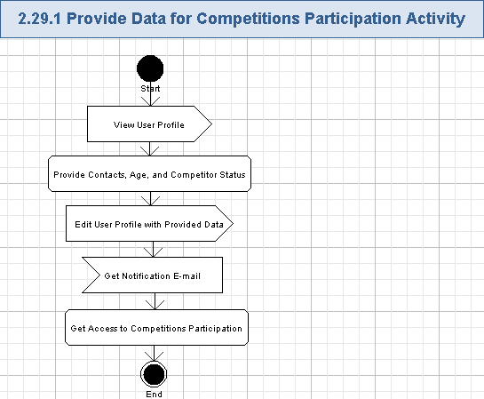

View User Profile
- The user will open and view his/her profile – please refer to chapter 3.8 for more details.

Provide Contacts, Age, and Competitor Status
- The user has to provide the following data (in addition to the minimal set of required fields) to start competing on /TC or Studio:
Data Element | Description | Format | R?
First Name | The first name of the user | String, max length is the same as in previous database, non empty | Y
Last Name | The last name of the user | String, max length is the same as in previous database, non empty | Y
Age | The age range, related to the user | Single item selection list, each list item is String, max length is the same as in previous database, non empty.  The values of the list are like in the previous database | Y
Current Address 1 | The line #1 of the user’s address | String, max length is the same as in previous database, non empty | Y
Current Address 2 | The line #2 of the user’s address | String, max length is the same as in previous database, can be empty | N
Current Address 3 | The line #3 of the user’s address | String, max length is the same as in previous database, can be empty | N
City | The city of the user | String, max length is the same as in previous database, non empty | Y
State | The state of the user – only for USA | String, max 2 chars, can be empty.  One of the USA state or DC. | N
Postal Code | The postal (ZIP) code of the user | String, max length is the same as in previous database, each char is a digit from [0-9], non empty | Y
Province | The province of the user | String, max length is the same as in previous database, can be empty | N
Country | The country of the user | Single item selection list. Each item is String, max length is the same as in previous database, can be empty.  The values in the list are the same as in the previous database | Y
Country to Represent | The country to be represented by the user | Single item selection list. Each item is String, max length is the same as in previous database, can be empty.  The values in the list are the same as in the previous database | Y
Phone Number | The phone number of the user | String, like (+xxx) xxx xxx-xxxx, where “x” is a digit [0-9], max length is the same as in previous database, non empty | Y
Student / Professional | A competitor status – the control flag defining whether the user is a student or a professional | Single item selection list, each list item is String, max length is the same as in previous database, non empty.  The values of the list are like in the previous database | Y
- Please note, almost all those fields will be now stored in the UserProfile entity (and the related table) – this is the difference with the previous TC web-site. Just Status (Student / Professional) will be stored to the User entity (and the related table) as in the pervious TC web-site.

Edit User Profile with Provided Data
- The user will edit the related fields (listed in the chapter 3.29.1.2) through the regular profile editing functionality described in chapters 3.9, 3.10, and 3.11 for more details.

Get Notification E-mail
- The application will inform the user that he/she was assigned rights to full access the competitions participation on TC web-site.
- The users will be notified by e-mail about new accessible competitions participation feature on TC web-site as the user enters enough data to his/her profile.
- The e-mail notification will be also sent to the user if he/she removed some data from the profile and his/her access rights were reduced, because of that.
- The notification e-mail will have the descriptive subject and body with information about on the user’s allowed (or restricted) access to the competitions participation on TC web-site.
- The notification e-mail will contain the link to the competitions participation feature, so newcomers can quickly get comfortable where they are placed.

Get Access to Competitions Participation
- The user will enter that needed information to his/her profile and automatically gets full access to the competitions participation on TC web-site.
- Please note, some competitions can require signed CCA from the user, so he/she has to submit an assignment document to participate in them (please refer chapter 3.33).
- Please note, some competitions can required affirmed affidavits from the user, so he/she has to affirm an affidavit to participate in them (please refer chapter 3.31).
- If the user removed some data from his/her profile that is required to access competitions participation, then he/she will lost the access to the competitions participation on TC web-site.

Provide Data for CoPilot Contests Participation
The user has to provide some additional data (like contacts information and age) to become a Competitor and participate in CoPilot-related contests on TC web-site. The user will enter that information to his/her profile and automatically gets a Competitor user role. The already entered contacts data can be viewed and edited as well. The user has to successfully compete in three different tracks and meet several special rules to get access to CoPilot contests.
Reference to initial use case in conceptualization: “4.4.27”.
Storyboard page: “03_FirstStep.png”,
“05_01_02_myprofile_name-n-contact-edit.png”,
“05_02_02_myprofile_demographic-info-edit.png”,
“05_03_02_AccountInfo-edit.png”.
- Pre-conditions: the user needs to compete in CoPilot contests and he/she pressed “Edit” button on the “Name and Contact” page of “My Profile”; or the user was asked to enter profile data for participating CoPilot competitions by the application when trying to start competing in CoPilot contests. The user has to be logged in to the application to perform this action.
- Post-conditions: the user entered all the needed data for to be a Competitor and get assigned with a Competitor user role with ability to participate in CoPilot contests.

Provide Data for CoPilot Contests Participation Activity
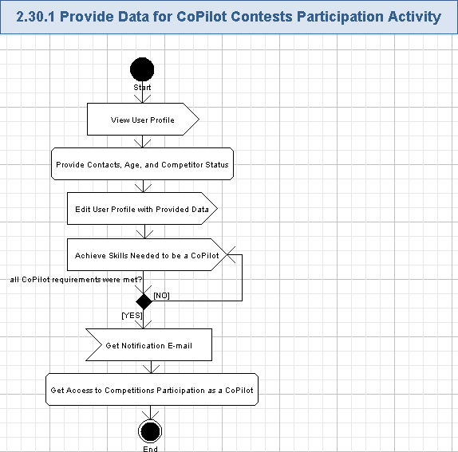

View User Profile
- The user will open and view his/her profile – please refer to chapter 3.8 for more details.

Provide Contacts, Age, and Competitor Status
- The user has to provide the following data (in addition to the minimal set of required fields) to start competing on /TC or Studio:
Data Element | Description | Format | R?
First Name | The first name of the user | String, max length is the same as in previous database, non empty | Y
Last Name | The last name of the user | String, max length is the same as in previous database, non empty | Y
Age | The age range, related to the user | Single item selection list, each list item is String, max length is the same as in previous database, non empty.  The values of the list are like in the previous database | Y
Current Address 1 | The line #1 of the user’s address | String, max length is the same as in previous database, non empty | Y
Current Address 2 | The line #2 of the user’s address | String, max length is the same as in previous database, can be empty | N
Current Address 3 | The line #3 of the user’s address | String, max length is the same as in previous database, can be empty | N
City | The city of the user | String, max length is the same as in previous database, non empty | Y
State | The state of the user – only for USA | String, max 2 chars, can be empty.  One of the USA state or DC. | N
Postal Code | The postal (ZIP) code of the user | String, max length is the same as in previous database, each char is a digit from [0-9], non empty | Y
Province | The province of the user | String, max length is the same as in previous database, can be empty | N
Country | The country of the user | Single item selection list. Each item is String, max length is the same as in previous database, can be empty.  The values in the list are the same as in the previous database | Y
Country to Represent | The country to be represented by the user | Single item selection list. Each item is String, max length is the same as in previous database, can be empty.  The values in the list are the same as in the previous database | Y
Phone Number | The phone number of the user | String, like (+xxx) xxx xxx-xxxx, where “x” is a digit [0-9], max length is the same as in previous database, non empty | Y
Student / Professional | A competitor status – the control flag defining whether the user is a student or a professional | Single item selection list, each list item is String, max length is the same as in previous database, non empty.  The values of the list are like in the previous database | Y
- Please note, almost all those fields will be now stored in the UserProfile entity (and the related table) – this is the difference with the previous TC web-site. Just Status (Student / Professional) will be stored to the User entity (and the related table) as in the pervious TC web-site.

Edit User Profile with Provided Data
- The user will edit the related fields (listed in the chapter 3.29.1.2) through the regular profile editing functionality described in chapters 3.9, 3.10, and 3.11 for more details.

Achieve Skills Needed to be a CoPilot
- The user has to compete in several different types of contests on TC web-site and achieve several predefined skills until getting an access to CoPilot contests.
- The required skills are mentioned here: http://apps.topcoder.com/wiki/display/tc/How+to+Compete+in+Copilot+Opportunities
- The currently required skills are:
  - Submitted a passing submission to at least 3 different types of TopCoder contests in the past 12 months. Marathon and Algorithm contests do not count towards the 3 contests.
  - Must have a rating in at least 1 contest type of green or better.
  - Been on the review board in the past 12 months for any contest type and have not been suspended from any review board during that same period.
  - Have not been suspended from the Copilot Pool in the past 6 months.

Get Notification E-mail
- The application will inform the user that he/she was assigned rights to full access the competitions participation on TC web-site.
- The users will be notified by e-mail about new accessible competitions participation feature on TC web-site as the user enters enough data to his/her profile.
- The e-mail notification will be also sent to the user if he/she removed some data from the profile and his/her access rights were reduced, because of that.
- The notification e-mail will have the descriptive subject and body with information about on the user’s allowed (or restricted) access to the competitions participation on TC web-site.
- The notification e-mail will contain the link to the competitions participation feature, so newcomers can quickly get comfortable where they are placed.

Get Access to Competitions Participation as a CoPilot
- The user will enter that needed information to his/her profile, completed all the required rules for CoPilots, and automatically gets full access to the CoPilot competitions participation on TC web-site.
- Please note, some competitions can require signed CCA from the user, so he/she has to submit an assignment document to participate in them (please refer chapter 3.33).
- Please note, some competitions can required affirmed affidavits from the user, so he/she has to affirm an affidavit to participate in them (please refer chapter 3.31).
- If the user removed some data from his/her profile that is required to access competitions participation, then he/she will lost the access to the CoPilot competitions participation on TC web-site.
- If the user lost any of required CoPilot skills, then he/she will lost the access to the CoPilot competitions participation on TC web-site.

Configure Affidavits
The user can view the information about his/her affidavits. He/she can view pending or “all” affidavits and confirm pending affidavits as needed.
Reference to initial use case in conceptualization: “4.4.32”.
Storyboard page: “05_09_affidavits.png”.
- Pre-conditions: the user pressed “Affidavits” option in “Documentation” topic of the navigation menu on “My Profile” part of the application. The user has to be logged in to the application to perform this action.
- Post-conditions: the user viewed and updated his/her affidavits as needed.

Configure Affidavits Activity
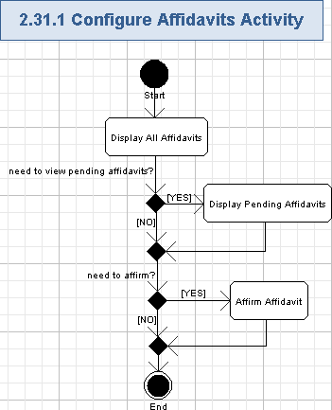

Display All Affidavits
- The application will display the list of user’s affidavits, present in the system.
- By default, all the affidavits (pending and affirmed) will be shown on the list.
- The following fields of the affidavits will be shown:
Data Element | Description | Format | R?
Description | The description of the affidavit | String, max length as in the previous database, non empty. | Y
Affirmation | The information of whether the affidavits is affirmed (and the date of affirmation in this case) or not.  It will be a hyperlink to affirm non-affirmed affidavit | 1) For non-affirmed affidavit:  “Affirm now” hyperlink, non empty.  1) For affirmed affidavit:  String, like “Affirmed on MM/DD/YYYY”, where MM/DD/YYYY is a short date, non empty. | Y
Time Left | The time left until the affidavit affirmation deadline | String, containing a positive integer number in days like “<X> days” for non-affirmed waiting affidavit, can be empty for affirmed affidavit, or “-“ for non-affirmed expired affidavit. | N
Net Payment | The final payment amount | Positive money value (or $0.00) in dollar and cents. Can be empty for affidavits, where money is not related to | N
Notarized | The indicator whether the affidavit is notarized or not | String, “yes” or “no” values, non empty | Y
Status | The status of the affidavit – affirmed or pending | String, “Affirmed” or “Pending” values, non empty | Y
Date Paid | The date when the money amount for affidavit is paid | String, short date format like “MM/DD/YYYY”. Can be empty for affidavits, where money is not related to | N
- The list of affidavits can be ordered by any column (ascending, descending).
- If there are no affidavits for the user then the application will simply show the following message instead of the list:
There are no affidavits
- The screen example of affidavits is like following (please note, it is from TC web-site, because the screen shot with affidavits in storyboard is empty):
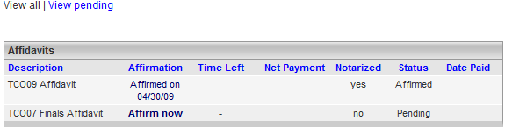

Display Pending Affidavits
- The user can press “View pending” hyperlink to filter the list of affidavits.
- The pending affidavits (i.e. not affirmed yet) will be shown on the list.
- The list of affidavits will be like described in chapter 3.31.1.1 above.

Affirm Affidavit
- The user can press “Affirm now” hyperlink for the chosen affidavit on the list of affidavits.
- The related affidavit will be affirmed in the system.
- The status of the affidavit and affirmation date will be changed.
- The list of affidavits will be updated according to the affirmed affidavit.

Check Payments
The application will allow users to get the information about their earnings and view pending, paid, and “all” payments from TC. The information about how to get paid will be also available to the user.
Reference to initial use case in conceptualization: “4.4.33”.
Storyboard page: “05_10_payments.png”.
- Pre-conditions: the user pressed “Payments” option in “Documentation” topic of the navigation menu on “My Profile” part of the application. The user has to be logged in to the application to perform this action.
- Post-conditions: the user viewed his/her payments as needed.

Check Payments Activity
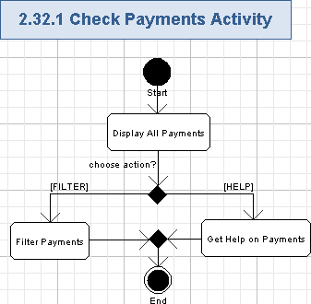

Display All Payments
- The user can retrieve information about his/her payments from TC
- By default, all the pending, paid, owed (etc.) payment will be shown on the list.
- This feature will be mostly re-used from the existing business process: http://www.topcoder.com/PactsMemberServlet?module=PaymentHistory
- The payments data will be retrieved from PACTs system.
- There will be no navigation to other pages from My TopCoder, but the payments can be viewed on the same page where the user profile data is shown – some sort of tabs or expandable/collapsible tables can be used.
- The payments data itself will be the same as in the previous business process, just its visualization and management will be changed.
- The list of payments will contain the following fields:
Data Element | Description | Format | R?
Description | The description of the payment.  For some payments, it can be a hyperlink to view the related project | String, max length as in the previous database, non empty. | Y
Payment | The final payment amount | Positive money value (or $0.00) in dollar and cents. Cents value will be absent if the payment has an integer value. | Y
Date Paid | The date when the money amount is paid | String, short date format like “MM/DD/YYYY”, non empty. | Y
Status | The status of the payment – Pending, Owed, Paid, etc. | String, max length as in the previous database, non empty.  Possible values are the same as in the current database | Y
- The list can be sorted by any column (ascending, descending).
- The list will be shown by Due Date field by default.
- The description of some projects can be hyperlinks to the related projects. The user can press that hyperlink and get redirected to the project page.
- The screen example of the displaying payments is like following:
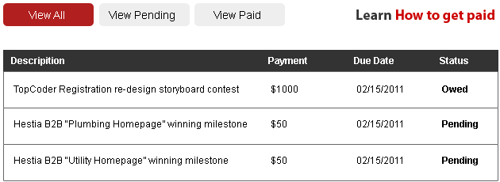

Filter Payments
- The user can filter payments, shown on the list, by “Pending”, “Paid” and “All” statuses by pressing “View Pending”, “View Paid” and “View All” buttons.
- The resulted list with filtered payments will be shown like described in chapter 3.32.1.1.

Get Help on Payments
- The user can get more information on how to get paid by pressing “Learn How to get paid” hyperlink.
- The help page will be shown like following: http://www.topcoder.com/wiki/display/tc/How+to+Get+Paid+for+Competing

Configure Assignment Documents
The application will allow the user to view pending or “all” assignment documents and download an assignment document. An ability to submit the assignment document by the user directly from his/her profile will be also implemented. The information about what is the assignment document will be provided as well.
Reference to initial use case in conceptualization: “4.4.34”.
Storyboard page: “05_11_assignment.png”,
“04_ProfileCompleteness.png”.
- Pre-conditions: the user pressed “Assignment Documents” option in “Documentation” topic of the navigation menu on “My Profile” part of the application. The user has to be logged in to the application to perform this action.
- Post-conditions: the user viewed and submitted his/her assignment documents as needed.

Configure Assignment Documents Activity
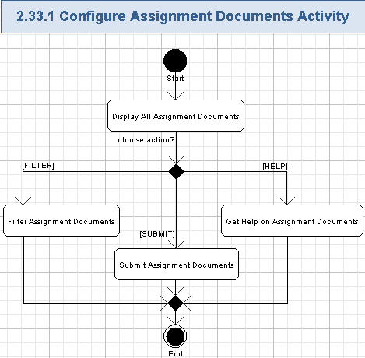

Display All Assignment Documents
- The application will display the assignment documents for the user on his/her profile.
- By default, all the pending and accepted assignment documents will be shown on the list.
- This feature will be mostly re-used from the existing business process: http://www.topcoder.com/PactsMemberServlet?module=AssignmentDocumentHistory
- There will be no navigation to other pages from My TopCoder, but the assignment documents can be viewed on the same page where the user profile data is shown – some sort of tabs or expandable/collapsible tables can be used.
- The assignment documents data itself will be the same as in the previous business process, just its visualization and management will be changed.
- The list of assignment documents will contain the following fields:
Data Element | Description | Format | R?
Assignment Document | The description of the assignment document (i.e. its name)  It will be a be a hyperlink to download the assignment document file | String, max length as in the previous database, non empty. | Y
Status | The status of the assignment document | Picture, allowed values are:  - accepted,  - pending. | Y
- The list can be sorted by status (first – accepted documents, next – pending documents).
- The name of the document will be a hyperlink to the related file. The user can press that hyperlink and download the chosen assignment document from the application to his/her local file system.
- The screen example of displaying assignment documents is like following:
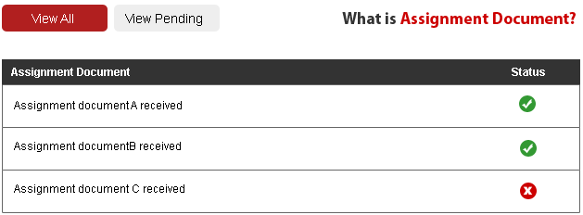

Filter Assignment Documents
- The user can filter assignment documents, shown on the list, by “Pending” and “All” statuses by pressing “View Pending” and “View All” buttons.
- The resulted list with the filtered assignment documents will be shown like described in chapter 3.33.1.1.

Submit Assignment Documents
- The user can submit the assignment document by the user directly from his/her profile.
- There will be a “Browse” button, so the user can choose an assignment document file on his/her local file system and submit it to the application by pressing “Submit” button.
- The application will automatically reject to long documents (i.e. more than 10 MB, configurable) or of a wrong type (only .PDF, .JPG, .PNG documents are allowed).
- The successfully checked document will be stored to the application and shown on the user’s profile.
- The TC Admin has to manually check the uploaded assignment document and either approve it (set “Accepted” status), or not. The TC Admin actions are out of scope for this specification.

Get Help on Assignment Documents
- The user can get more information on the assignment document by pressing “What is Assignment Document?” hyperlink.
- The help page will be shown like following: http://www.topcoder.com/wiki/display/tc/The+Assignment+Document

Configure Visa Letter
The application will allow the user for view pending and “all” statuses of their visa. The information on how to request the visa letter will be provided. That page will also allow to request the visa letter as well.
Reference to initial use case in conceptualization: “4.4.35”.
Storyboard page: “05_12_visaletter.png”.
- Pre-conditions: the user pressed “Visa Letter Status” option in “Documentation” topic of the navigation menu on “My Profile” part of the application. The user has to be logged in to the application to perform this action.
- Post-conditions: the user viewed and requested his/her visa letter as needed.

Configure Visa Letter Activity
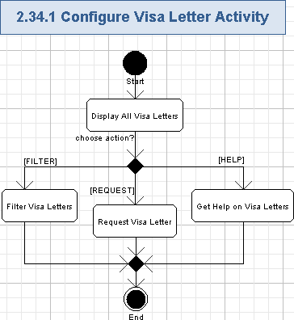

Display All Visa Letters
- The application will display the visa letters for the user on his/her profile.
- By default, all the pending and sent visa letters will be shown on the list.
- This feature will be mostly re-used from the existing business process: http://www.topcoder.com/tc?module=VisaSelection
- There will be no navigation to other pages from My TopCoder, but the visa letters can be viewed/requested on the same page where the user profile data is shown – some sort of tabs or expandable/collapsible tables can be used.
- The visa letters data itself will be the same as in the previous business process, just its visualization and management will be changed.
- The list of visa letters will contain the following fields:
Data Element | Description | Format | R?
Visa Letter | The description of the visa letter (i.e. its name) | String, max length as in the previous database, non empty. | Y
Status | The status of the visa letter | Picture, allowed values are:  - sent,  - pending. | Y
- The list can be sorted by status (first – sent visa letters, next – pending visa letters).
- The screen example of displaying visa letters is like following:
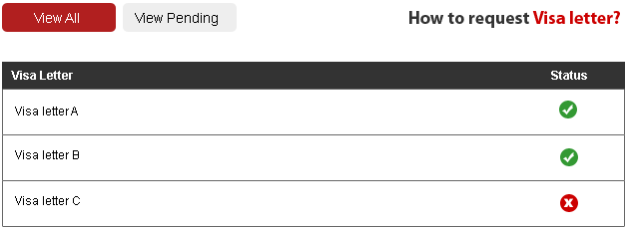

Filter Visa Letters
- The user can filter visa letters, shown on the list, by “Pending” and “All” statuses by pressing “View Pending” and “View All” buttons.
- The resulted list with the filtered visa letters will be shown like described in chapter 3.34.1.1.

Request Visa Letter
- The user can request for a visa letter – there will be a special hyperlink (“Request Visa Letter”) for this in case, when the user is eligible to get visa letter from TopCoder.
- The user will press that hyperlink and the new visa letter will be requested from the application.
- That request will be sent to TC Admin for further processing – out of scope for this specification.
- The application will add new visa letter with the “Pending” status to the list.
- TC Admin will be able to issue the related visa letter and update its status to the “Sent” in the application – all TC Admin actions are out of scope for this specification.

Get Help on Visa Letters
- The user can get more information on the visa letter by pressing “How to request Visa Letter?” hyperlink.
- The help page will be shown with the information on how to request the visa letter.

Ask User to Provide More Profile Data
The application will automatically ask the user to enter more information to his/her profile when he/she tries to access some features on TC web-site, which require more data on the user profile. This feature will work like on demand request of the not enough data exactly the moment the user tries to start using the related feature requiring more data in the user profile.
Reference to initial use case in conceptualization: “4.4.36”.
Storyboard page: none.
- Pre-conditions: the user tries to access any feature on TC web-site, but his/her profile has not enough data for that feature.
- Post-conditions: the user entered needed data to his/her profile and got access to the requested feature on TC web-site.

Ask User to Provide More Profile Data Activity
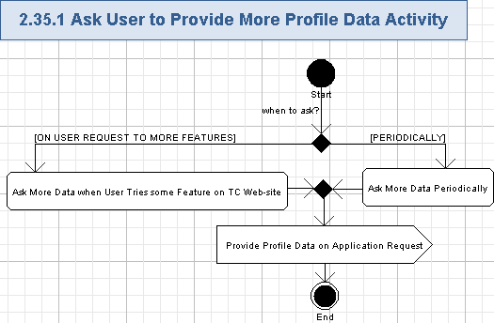

Ask More Data when User Tries some Feature on TC Web-site
- The system will automatically determine whether enough data is present on the user profile or not when the user trying to start using any feature on TC web-site (like try to post on the forum or wiki, try to press “1: Register” button to register as a submitter for some competition, try to register as a reviewer for some competition. etc.).
- The application will show some kind of a popup window asking the user to enter missing data to his/her profile.
  - For example, the new Observer tries to register for competition, but the application can show some sort of a popup window with clarification that he/she has to enter his/her name, age, contacts, country, country to compete for (etc.) data before starting competitions as a Competitor.
  - Or the Observer tries to post some threads on the forum, but did not provide some personal information about him/her – there will be a special popup asking for entering that data.
  - Or the Observer tries to access TC Direct, but he/she did not provide enough data to becomes a Customer – there will be a special popup asking for entering that data.
- This feature will work like on demand request of the not enough data exactly the moment the user tries to start using the related feature requiring more data in the user profile.

Ask More Data Periodically
- The system will regularly check the user profiles for determining how much required and optional data was already filled by the user.
  - The system will randomly (like once a month) ask the user if he/she would like to fill some optional or required data to his/her profile.
  - It can be performed like through a popup, when the user looks through TC web-site pages.
  - The user is free to enter the needed data or reject that popup.
  - The application will remember which piece of the user profile data was not entered, but rejected by the user – the application will not repeatedly ask the user to enter that data on the regular data (but can ask for them if that data is required for some feature, requested by the user).

Provide Profile Data on Application Request
- The user will enter needed data for his/her profile like described in chapter 3.7.
- The user will get access to the requested feature after providing all the needed data (please refer chapter 3.7 for more details).

Perform Auditing
The application will automatically audit user actions when he/she works with the application. That information will be stored to the database for further analysis and processing.
Reference to initial use case in conceptualization: “4.4.37”.
Storyboard page: none.
- Pre-conditions: the application was started and it will constantly audit all the user actions.
- Post-conditions: all the user actions were audited to the database.

Perform Auditing Activity
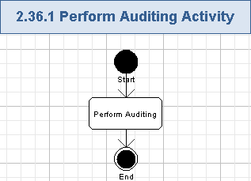

Perform Auditing
- The application will persist all the changes, additions and removals of the profile data, performed by the user.
- Other user actions will be audited as well (like registration, activation of the user account, etc.).
- The list of operations to be audited is as following:
  - Recover forgotten password,
  - Create Account,
  - Activate Account,
  - Provide Profile Data on Application Request,
  - Edit Contacts Data,
  - Edit Demographic Information,
  - Edit Account Information,
  - Provide Data for Forums Participation,
  - Provide Data to Work with Wiki,
  - Upload Profile Photo,
  - Remove Profile Photo,
  - Configure Privacy,
  - Configure E-mail Notifications,
  - Configure Registration Preferences,
  - Configure Forum Preferences,
  - Configure Referrals,
  - Configure Cards/Badges,
  - Become a Customer,
  - Provide Data for Ordering Projects in TC Direct,
  - Provide Data to Access Online Review Tool,
  - Provide Data to Access JIRA,
  - Provide Data to Access SVN,
  - Provide Data to Access VM,
  - Provide Data to Access Online Review Tool,
  - Provide Data for Competitions Participation,
  - Provide Data for CoPilot Contests Participation,
  - Configure Affidavits,
  - Configure Assignment Documents,
  - Configure Visa Letter,
  - Etc. – up-to the Architect.
- The following data will be persisted:
  - Operation type (like create new account, change demographic data, etc., String, max 100 chars, non empty),
  - Username of the person (String, max 20 chars, non empty),
  - User IP address (String, max 20 chars, non empty),
  - Previous value (if present, String, max 4096 chars, can be empty),
  - New value (if present, String, max 4096 chars, can be empty),
  - Date/time stamp (String, full date/time format, max 30 chars, non empty),
  - Etc. – up-to Architect.
- The saved audit data will be available for the future maintenance, testing and evaluation of the application by the service staff.

Perform Logging
The application will automatically log errors, exceptions, warnings and debug information during its execution. Logging information will be stored to files on the server side.
Reference to initial use case in conceptualization: “4.4.38”.
Storyboard page: none.
- Pre-conditions: the application was started and it will constantly log all problems during its execution.
- Post-conditions: all errors, exceptions, warnings and debug information was logged to log files.

Perform Logging Activity
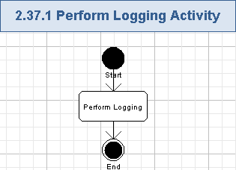

Perform Logging
- The system will log all the errors, exceptions, warning and debug information during the application execution.
- The following data will be logged:
  - Method name (String, max 100 chars, non empty),
  - Description of problem (String, max 1024 chars, non empty),
  - Input arguments (if any, String, max 4096 chars, can be empty),
  - Output results (if any, String, max 4096 chars, can be empty),
  - Date and timestamp (String, full date/time format, max 30 chars, non empty),
  - Etc. – up-to Architect.
- Logging will be performed to the log files on the server side.
- The logged information must not contain user credentials or financial data.

Send E-mail Notifications
The system will automatically send various e-mail notifications to various users in several events during the application execution. Notifications will be sent to users, which turned ON receiving such notifications on their profiles.
Reference to initial use case in conceptualization: “4.4.39”.
Storyboard page: none.
- Pre-conditions: the application was started and it will automatically notify users by e-mail about changes in their profiles, activation/confirmation of the account, and on the progress of possible access to more features on TC web-site due to entered amount of user profile data.
- Post-conditions: the notification e-mail with information on profile changes and other actions in the application was sent to the related user.

Send E-mail Notifications Activity
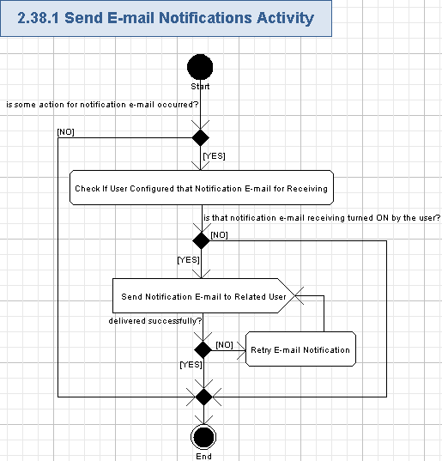

Check If User Configured that Notification E-mail for Receiving
- If some situation for sending notification e-mail to the user has occurred (like change of the user profile, or allowed access to some new features, etc.), then the application will check the notification e-mail configuration options for the related user.
- The user can configure e-mail notifications, so the system will send e-mail notifications only if the user need that and according to the user provided preferences.

Send Notification E-mail to Related User
- If the user configured to receive the related notification e-mail, then it will be sent by the system to the user through some e-mail server.
- The following e-mail can be sent by the application (the related chapters with the detailed information on the needed e-mail message are listed below too):
  - Reset password e-mail – chapter 3.4.1.6.
  - Account activation e-mail – chapter 3.5.1.8.
  - Account registration e-mail – chapter 3.6.1.4.
  - Edit name/contacts data e-mail – chapter 3.9.1.8.
  - Edit demographic data e-mail – chapter 3.10.1.8.
  - Edit account information e-mail – chapter 3.11.1.8.
  - Forum access e-mail – chapter 3.12.1.4.
  - Wiki access e-mail – chapter 3.13.1.4.
  - Privacy change e-mail – chapter 3.16.1.11.
  - Notifications change e-mail – chapter 3.17.1.6.
  - Payment preferences change e-mail – chapter 3.18.1.8.
  - Registration preferences change e-mail – chapter 3.19.1.7.
  - Forum preferences change e-mail - chapter 3.20.1.8.
  - Become a customer e-mail – chapter 3.23.1.5.
Get access to TC Direct e-mail – chapter 3.24.1.4.
  - Get access to Online Review Tool e-mail – chapter 3.25.1.5.
  - Get access to JIRA e-mail – chapter 3.26.1.5.
  - Get access to SVN e-mail – chapter 3.27.1.7.
  - Get access to VM e-mail – chapter 3.28.1.7.
  - Get access to competitions e-mail – chapter 3.29.1.4.
  - Get access to CoPilot competitions e-mail – chapter 3.30.1.5.

Retry E-mail Notification
- The system will automatically re-send e-mail notification if that e-mail message was failed and not delivered to the related user.
- The system will determine when the e-mail was not delivered to the user (like by receiving a failure message from the related e-mail server) and retry sending the related notification e-mail to the user (like in 24 hours after the first e-mail, up-to 3 times). The Architect is free to define a robust and effective re-sending algorithm.

General Requirements

Graphical User Interface Requirements

Main GUI Goal
The new application will be user friendly and support an easy registration of new users. The new registration process has to motivate new users to register to the application, use other features of the application and finally – provide more information about him/herself.

The GUI will follow the wireframes (actually, they are storyboards) provided on the wiki: http://www.topcoder.com/wiki/display/~hello-c/Specification+-+TopCoder+Simplify+Registration+Process+and+Improve+Usability

The application’s look and feel will be designed according to the storyboards.

Resolution
The users can access the application though various computer configurations with different screen sizes, based on the specific client capabilities. Therefore, the application has to support various resolutions.

Supported Browsers
- MS Internet Explorer from version 6 to the latest version,
- Mozilla Firefox latest version,
- Safari latest version.
- Google Chrome latest version.

Performance Constraints
User Metrics Requirements:
- The maximum expected number of unique users is more than 250,000 (and growing) – this is a number of Observers, Competitors and Customers.
- Maximum count of concurrent users for this application (registration and profile management) will be quite small. There are totally about 1000 accesses to this application a day (including up-to 300 new registrations).

Performance Requirements:
- The system will be available 24x7 and it will achieve 99.5% uptime (or greater).
- Web pages will load in 2 seconds (or less) after initial hit.

Security

Security Roles

Permissions
All security checks will occur against permissions. Each function in the system will validate a user’s permission against the required permission for the task. Non-registered users will have read-only access to the application (like viewing home page and register to the application).

Roles
One or more permissions will be assigned to roles. A user may have more than one role. Below is a list of roles and permissions. The System user role was added for clarity.
 | Observer | Customer | Competitor | System
View Homepage | X | X | X
Login | X | X | X
Logout | X | X | X
Recover Forgotten Password | X | X | X
Create Account | X | X | X
Activate Account | X | X | X
Provide Profile Data on Application Request | X | X | X
View Profile | X | X | X
Edit Contacts Data | X | X | X
Edit Demographic Information | X | X | X
Edit Account Information | X | X | X
Provide Data for Forums Participation | X | X | X
Provide Data to Work with Wiki | X | X | X
View/upload Profile Photo | X | X | X
Remove Profile Photo | X | X | X
Configure Privacy | X | X | X
Configure E-mail Notifications | X | X | X
Configure Payment Preferences | X | X | X
Configure Registration Preferences | X | X | X
Configure Forum Preferences | X | X | X
Configure Referrals | X | X | X
Configure Cards/Badges | X | X | X
Become a Customer |  | X
Provide Data for Ordering Projects in TC Direct |  | X | X
Provide Data to Access Online Review Tool |  | X | X
Provide Data to Access JIRA |  | X | X
Provide Data to Access SVN |  | X | X
Provide Data to Access VM |  | X | X
Provide Data for Competitions Participation |  |  | X
Provide Data for CoPilot Contests Participation |  |  | X
Configure Affidavits |  |  | X
Check Payments |  |  | X
Configure Assignment Documents |  |  | X
Configure Visa Letter |  |  | X
Ask User to Provide More Profile Data |  |  |  | X
Perform Auditing |  |  |  | X
Perform Logging |  |  |  | X
Send E-mail Notifications |  |  |  | X

Administrators
There is no Administrator use role for this project. All the functionality of TC Admins was intentionally left out of scope.

Password Logic

Password Rules
For security reasons passwords must meet a minimum criteria. To be consistent with standards the following rules for passwords have been defined.
- Password may consist of any combination of alphanumeric characters.
- Passwords minimum limit is the same as in the previous TC registration process. The maximum limit is the same as in the previous TC registration process.
- Password matching will be case sensitive.

Password Expiration Rules
There are no password expiration rules.

Password Storage
Passwords stored in the data store must be encrypted (like stored as hashed in the database). This will prevent unauthorized users from viewing the passwords.

Forget Password
Users frequently forget their passwords. A user can enter their username or e-mail address and have password resetting e-mail sent to them.
- Given a username or user’s e-mail address, send an e-mail containing the hyperlink to reset user’s password in the application.

Required Documentation

Specification Documentation
- Requirements Specification (this document)
- High Level Use Case Diagrams
- Activity Diagrams
- Logical data model (as needed)
- Quality Assurance Plan (out of scope for this competition)

Help / User Documentation
None at this time.

Notes
None at this time.

Future Enhancements
- To implement some features of social networking, so the users will be able to customize their TC presence.
- To make a simple centralized set My TopCoder pages with the user account and profile data, preferences, options, documents (etc.) combined with all of the user related data, achievement, activities/tasks/events and statistics. It means, making an integration of Statistics pages (shown when pressing on the user handle) and My TopCoder pages.
- To implement a separate page for “4.4.9 View Profile Fullness” use case.

Glossary

Definitions
Definition | Description
TC Cockpit,  TC Direct | A part of TC web-site where customers can order applications and launch their competitions. It can be found here: http://www.topcoder.com/direct
Forums | A part of TC web-site where various discussions between competitors, customers and other TC members can be performed.  Forums are located here: http://forums.topcoder.com/
My TopCoder | The page on TC web-site with the user profile information: http://www.topcoder.com/tc?module=MyHome
Studio | A part of TC web-site where graphical design competitions take place: http://studio.topcoder.com/
Wiki | A part of TC web-site with a large count of linked web-pages, which can be easily created and edited through a simplified markup language or a visual text editor. It is based on the Confluence: http://www.atlassian.com/software/confluence/  The wiki is located here: http://www.topcoder.com/wiki
Observer | Any new user will register to the TC by providing a minimal set of the required data and gets and Observer role with a basic set of access right to TC web-site. The Observer can view/manage his/her profile, preferences/options on the profile and a photo. He/she can provide more information for the user profile and get access to more parts of TC web-site.
Customer | The client of TopCoder. The Customer will order for software applications or graphical design. He/she will register by providing a minimal set of the required information and can later enter more information to his/her profile to become a Customer with an ability to order applications from TC.  The Customer will have all the functionality of the Observer user role.
Competitor | This is a TopCoder community member, which compete on /TC or Studio competitions. He/she will register by providing a minimal set of the required information and can later enter more information to his/her profile to start competing on /TC or Studio contests.  The Customer will have all the functionality of the Observer user role.

Acronyms
Definition | Description
CCA | Competition Confidentiality Agreement
GUI | Graphical User Interface
HTML | HyperText Markup Language
HTTPS | HyperText Transfer Protocol Secure
JIRA | Issue tracking tool, http://www.atlassian.com/software/jira/
LDAP | Lightweight Directory Access Protocol [NOT IN SCOPE IN THIS VERSION OF THE APPLICATION]
OR | Online Review Tool.  It is placed here: https://software.topcoder.com/review/
PACTs | A part on TC web-site where payments, affidavits, assignment documents are placed
SSL | Secure Sockets Layer
SSO | Single Sign On [NOT IN SCOPE IN THIS VERSION OF THE APPLICATION]
SVN | Subversion, http://subversion.tigris.org/
TC | TopCoder
/TC | A part of the TC web-site where software competitions take place: http://www.topcoder.com/tc
VM | Virtual Machine
URL | Uniform Resource Locator
ZIP | Postal code

