TopCoder System Test Data Generator Deployment Guide

Revision History
Author | Revision Number | Date
isv | 1.0 | 01/31/2011
isv | 1.1 | 01/01/2012

Deployment Instructions 3
1. Organization of Submission 3
2. Application Setup 3
2.1 Ant .Properties File 3
2.2 Build Scripts Setup 4
3. Database Setup 4
4. Deployment Instructions 4
5. Starting 5
6. Verification 5
7. Resource Contact List 5

Deployment Instructions

Organization of Submission

The submission follows directory structure provided below:

docs

Contains this document which is the Deployment Guide for the TopCoder System Test Data Generator assembly.

lib

Contains the binary distributions for TopCoder and external components used by the TopCoder System Test Data Generator assembly.

src

Contains the sources for TopCoder System Test Data Generator tool developed in the course of this assembly.

test_files

Contains the helper files to be used for testing/review purposes only.

build.xml

Build script for TopCoder System Test Data Generator tool developed in the course of this assembly.

Application Setup

The application is expected to be deployed to the following environment:

JRE 1.5
Informix DS 11.0

Ant .Properties File

Property Name | File property is stored | Example Setting
number_of_clients | build.properties | Number of client accounts to be generated
min_number_of_billing_accounts_per_client | build.properties | Minimum number of billing account per client to be generated
max_number_of_billing_accounts_per_client | build.properties | Maximum number of billing account per client to be generated
min_number_of_direct_projects_per_account | build.properties | Minimum number of TC Direct projects per billing account to be generated
max_number_of_direct_projects_per_account | build.properties | Maximum number of TC Direct projects per billing account to be generated
min_number_of_contests_per_project | build.properties | Minimum number of contests per TC Direct project to be generated
max_number_of_contests_per_project | build.properties | Maximum number of contests per TC Direct project to be generated
id_generator_start | build.properties | The initial starting ID for all ID generation sequences
out | build.properties | A path to a file to write generated SQL statements to
db_host | build.properties | A host running the database server
db_port | build.properties | A port for running database server
db_server | build.properties | A name of the database server instance
db_user | build.properties | A username used to establishing connection to database
db_password | build.properties | A password used to establishing connection to database
studioSubmissionIdsFile | build.properties | A path to text file listing the Studio submission IDs available in Production environment (look at test_files/studioSubmissionIds.txt for reference)
submissionDeclarationsFile | build.properties | A path to a text file to write the generated data for submission declarations to
INFORMIXDIR | build.properties | A path to installation of Informix DB server
DBACCESS | build.properties | A path to DBACCESS tool provided by Informix
INFORMIXSERVER | build.properties | A name of Informix server instance
INFORMIXLOCALE | build.properties | Locale set for Informix server instance

Build Scripts Setup

The build script (build.xml) provides the following targets which are to be used:

- compile – compiles the TopCoder System Test Data Generator tool
- run - runs the TopCoder System Test Data Generator tool for generating the SQL scripts for sample projects
- bulk-test-data-load – loads the database tables with sample data for projects generated by the tool (this task is to be used only for testing/review purposes in VM environment).
- submission-declarations-load – loads the database tables with sample data for submission declarations generated by the tool

Database Setup

No changes to existing database schema have been introduced with this assembly.

For testing the tool on VM environment run test_files/setup.sql script to set some lokup data which currently may not be set in the database.

Deployment Instructions

- Setup the parametes for TopCoder System Test Data Generator tool in build.properties file
- Run TopCoder System Test Data Generator tool using ant run command to generate the SQL scripts
- Run SQL scripts generated by TopCoder System Test Data Generator tool using ant bulk-test-data-load command
- Run SQL scripts for submission declarations generated by TopCoder System Test Data Generator tool using ant submission-declarations-load command (Note that this command uses dbaccess tool and must be run by user granted permission to execute that tool, 'informix' for instance).

Starting

- Build TopCoder System Test Data Generator tool
- Run TopCoder System Test Data Generator tool to generate data for sample projects
- Run the generated SQL scripts against target database

Verification

- Work with the Online Review application
  - The generated projects must be displayed correctly in Online Review application and application must be functioning without issues

- Work with the TopCoder Direct application
The generated projects must be displayed correctly in TopCoder Direct application and application must be functioning without issues
For Studio contests which have submissions the submissions must be viewable in submission viewer.

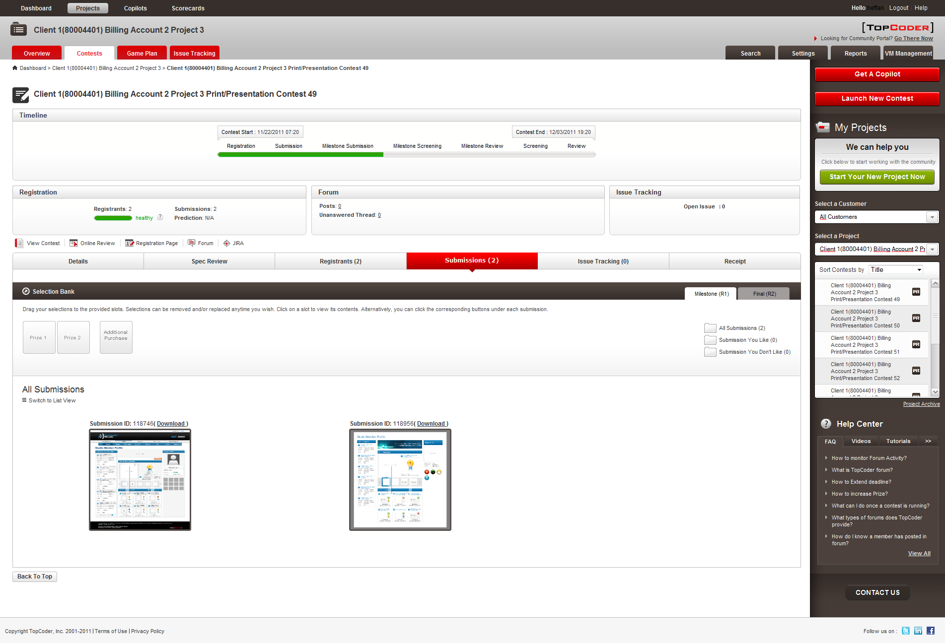

- Open Game Plan page for desired TC Direct project
The contests associated with project must use a wide range of dates

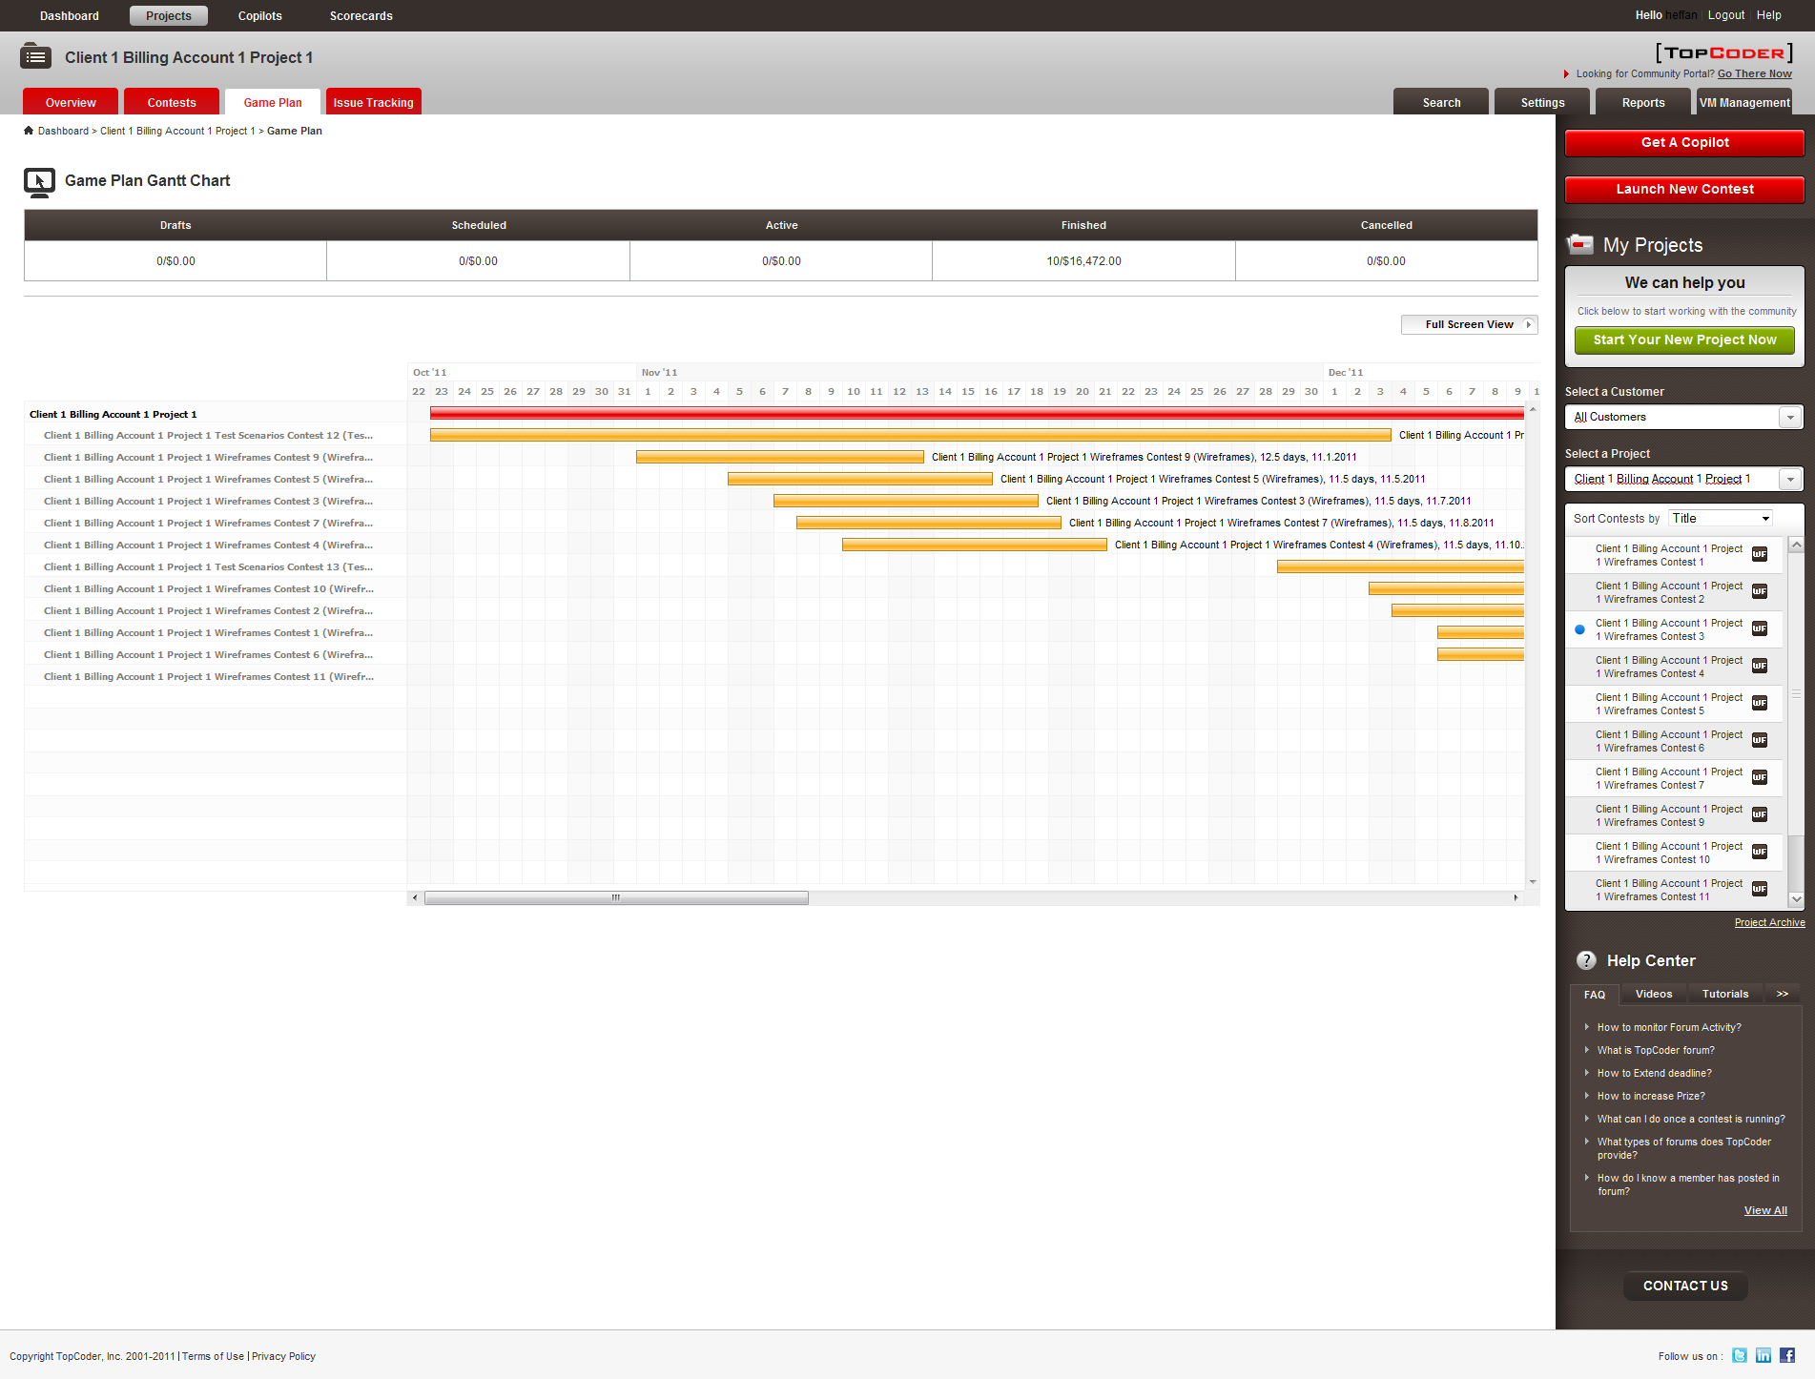

- Open Contest Details page for desired contest with multiple rounds
The multiround data and phases must be set correctly for such a contest

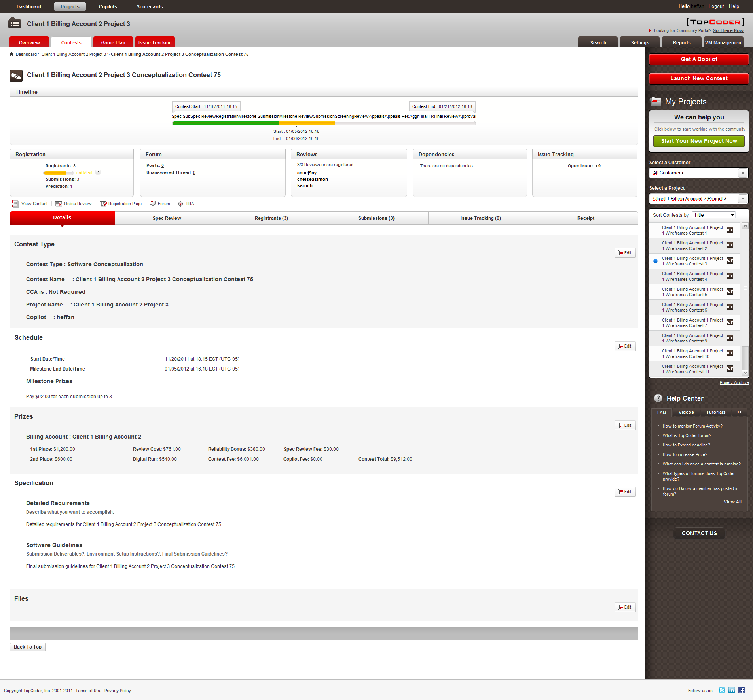

Resource Contact List

Name | Resource Email
isv

