Jigsaw Puzzle 1.0 Requirements Specification

Scope

Overview
This component provides a jigsaw-style puzzle type for use with the TopCoder Puzzle Framework component. This version provides a puzzle renderer that targets dynamic HTML and avoids embedding the puzzle solution in its representation, except incidentally.

Logic Requirements

Jigsaw Puzzle Type
The component will provide a PuzzleType (see section 2.1.2) implementation for use within the TopCoder Puzzle Framework that supports jigsaw puzzles. It will report its name as “jigsaw”, and in this version it will support only “DHTML” as a medium. The other requirements describe the characteristics of the generator and renderer that it provides.

Puzzle Generator
- The PuzzleGenerator (see section 2.1.2) provided by the component’s PuzzleType (section1.2.1) will accept a base image and the piece-wise dimensions of the desired puzzle. It will create images of the individual pieces from the base image, and these will be no larger than necessary to display the visible portion of the pieces. The pieces will be shaped similar to traditional physical jigsaw puzzle pieces.
- The PuzzleData the generator creates will have the base image and the piece images as resources, and it will have attributes representing the base image dimensions (in pixels), the puzzle dimensions (in pieces), and for each piece an ID string, unique within the scope of the puzzle and not inherently encoding the piece’s correct position in the puzzle.
- Puzzle series created by this generator will comprise puzzles without any special relationships among them (i.e. equivalent to what might have been achieved by generating the same number of puzzles individually). It is desirable that there be some variation in piece shapes among different puzzles in each series, but that is not a requirement of this version.
Examples of DHTML jigsaw puzzles are available at http://slayeroffice.com/arcade/jigsaw/ and http://www.vantasia.org/jigsaw.html; a nice Flash version is available at http://dsc.discovery.com/fansites/monstergarage/puzzles/puzzles.html. (The Flash example is for reference only. No Flash renderer is required in this version.)

Puzzle Generator Attributes
The PuzzleGenerator provided by this component will make use of the following attributes:
Attribute Name | Type | Description
“image” | com.topcoder.util.image.manipulation.Image | The base image from which to create the puzzle
“width” | java.lang.Integer | The width of the desired puzzle, in pieces
“height” | java.lang.Integer | The height of the desired puzzle, in pieces

DHTML Puzzle Renderer
- The component will provide a PuzzleRenderer (see section 2.1.2) that renders puzzle data such as generated by the provided generator (section 1.2.2) in dynamic HTML (HTML + JavaScript).
- The rendition will present the base image and the piece images, and will allow the user to assemble the pieces to complete the puzzle in their browser. It will provide a JavaScript function “submitSolution()” by which the client can submit the current state of the puzzle to a configured (on the host PuzzleType) URL, where the state of the puzzle consists of the piece IDs, in a sequence indicative of their positions in the puzzle as placed by the human solver.
- This puzzle rendition is expected to NOT provide direct feedback to the user as to whether pieces have been placed correctly or whether the puzzle has been solved; this is to make puzzle solution difficult to automate.
- It is preferred that the rendition be an HTML fragment suitable for inclusion in a larger page (i.e. the whole thing is one <DIV>), but if absolutely necessary then it can be a complete page (i.e. the whole thing in an <HTML>).
- If the rendering is a complete page then it will also include a button for submitting the solution (via the submitSolution() function) and a countdown timer (starting time to be configured on the PuzzleType).
- The DHTML must be compatible with Microsoft Internet Explorer 5 and above, and with Mozilla Firefox 1.0 and above.
- This renderer will be associated with the media type “DHTML” in the provided PuzzleType.

Solution Tester
The SolutionTester (see section 2.1.2) provided by the DHTML puzzle renderer will accept as input a Map from request parameter names (Strings) to value arrays (String[]) such as is provided by javax.servlet.ServletRequest.getParameterMap(). It will expect the parameters to be in the form issued by the submitSolution() function described in requirement 1.2.3.

Required Algorithms
None

Example of the Software Usage
An entertainment web site uses the Jigsaw Puzzle in conjunction with the Puzzle Framework to support an automated “Puzzle of the Day” feature that daily generates a puzzle of one of several configured types for presentation on the site. The site enters successful solvers in a drawing for a weekly prize, relying on the Jigsaw Puzzle’s resistance to automated solution to protect it against cheating.

Future Component Direction
Usability enhancements and additional renderers are the likely future updates for this component.

Interface Requirements

Graphical User Interface Requirements
The component will generate DHTML renditions of jigsaw puzzles as described in requirement 1.2.3.

External Interfaces
The component will provide and / or use implementations of these interfaces from the TopCoder Puzzle Framework component:

/**
* An interface defining the behavior of objects that represent the
* semantics of particular types of puzzles.
*/
public interface PuzzleType {

/**
* Returns the name of this puzzle type, which should be
* considered an opaque label, significant only within the scope
* spanned by this component's configuration.
*
* @return
*/
public String getName();

/**
* Creates and returns a new PuzzleGenerator that can prepare
* puzzle data appropriate for this puzzle type
*
* @return
* @throws PuzzleException if a checked exception prevents this
* method from completing successfully
*/
public PuzzleGenerator createGenerator() throws PuzzleException;

/**
* Creates and returns a new puzzle renderer appropriate for
* rendering puzzles of this type in the named medium. Which
* medium names are supported by this type can be determined via
* getSupportedMedia(), but the names should themselves be
* considered opaque labels, significant only within the scope of
* this components configuration.
*
* @param medium
* @return
* @throws PuzzleException if the medium is not supported or if a
* checked exception prevents this method from completing
* normally
*/
public PuzzleRenderer createRenderer(String medium)
throws PuzzleException;

/**
* Returns an array of the medium names supported by this puzzle
* type
*
* @return
*/
public String[] getSupportedMedia();

/**
* Tests whether the specified puzzle data is consistent with
* this puzzle type. The result is determined on a best-effort
* basis, so an affirmative response should not be interpreted as
* a guarantee that the data conform to this type, or that any of
* this type's renderers would produce a sensible output from
* them.
*
* @param puzzle
* @return
* @throws PuzzleException if a checked exception prevents
* successful completion of this method
*/
public boolean isPuzzleValid(PuzzleData puzzle)
throws PuzzleException;
}

/**
* An interface defining generic behavior of objects that create puzzle
* data for a particular puzzle type. Users set attributes on an
* instance to configure details of the puzzle to generate, then
* generate either a single puzzle or a series of related puzzles, as
* they wish. PuzzleGenerators are stateful, and typically not thread
* safe.
*/
public interface PuzzleGenerator {

/**
* Generates puzzle data for one puzzle, appropriate for use with
* the PuzzleType supported by this generator.
*
* @return
* @throws PuzzleException if a checked exception prevents this
* method from completing successfully
*/
public PuzzleData generatePuzzle() throws PuzzleException;

/**
* Generates puzzle data for a series of the specified number of
* puzzles, appropriate for use with the PuzzleType supported by
* this generator. The puzzles may be variations on a theme, or
* even identical, depending on the implementation.
*
* @param size
* @return
* @throws PuzzleException if a checked exception prevents this
* method from completing successfully
*/
public PuzzleData[] generatePuzzleSeries(int size)
throws PuzzleException;

/**
* Sets the named attribute of this PuzzleGenerator to the
* specified value object, provided that an attribute of the
* specified name is supported and the value is of suitable type.
*
* @param name
* @param value
* @throws PuzzleException if the named attribute is not
* supported, or if the specified value is of an unsupported type
*/
public void setAttribute(String name, Object value)
throws PuzzleException;
}

/**
* An interface defining the behavior of puzzle data, which is a named
* collection of named attributes and resources. Attributes are simply
* name / value pairs, whereas resources are named blocks of binary
* data bearing appropriate MIME media types that. PuzzleData
* implementations or usage environments may restrict attribute names,
* attribute values, and resource names to be relatively short strings,
* but details may vary. Users are advised to keep these strings to
* less than 256 characters, though that is not guaranteed to be a
* sufficiently restrictive upper bound for every environment.
*/
public interface PuzzleData {

/**
* The standard attribute name used to store a puzzle type's name
* among a puzzle's attributes
*/
public static final String PUZZLE_TYPE_ATTRIBUTE;

/**
* Gets the name of the puzzle represented by this data
*
* @return
*/
public String getName();

/**
* Returns the value of the named attribute of this puzzle data,
* or null if this data has no attribute of the specified name
*
* @param name
* @return
*/
public String getAttribute(String name);

/**
* Returns all the attributes of this puzzle data in the form of
* an unmodifiable Map from attribute names to attribute values
*
* @return
*/
public java.util.Map getAllAttributes();

/**
* Returns the named resource of this puzzle data, or null if
* this data has no resource of the specified name
*
* @param name
* @return
*/
public PuzzleResource getResource(String name);

/**
* Returns all theresources of this puzzle data in the form of an
* unmodifiable Map from resource names to PuzzleResource objects
*
* @return
*/
public java.util.Map getAllResources();
}

/**
* A named and typed block of data associated with a puzzle, such as an
* image, an audio clip, or a lengthy piece of text
*/
public interface PuzzleResource {

/**
* Retrieves the name of this puzzle resource as a String
*
* @return
*/
public String getName();

/**
* Retrieves the MIME media type of this resource as a String
*
* @return
*/
public String getMediaType();

/**
* Retrieves the data content of this resource as a byte[]
*
* @return
*/
public byte[] getData();
}

/**
* An interface describing the behavior of an object that can render a
* puzzle of a specific type to a particular medium. Implementations
* are stateful, and typically not thread safe.
*/
public interface PuzzleRenderer {

/**
* Returns the name of the medium in which this renderer will
* render puzzles, for instance 'HTML', 'Postscript', or 'Flash'.
* This is according to renderer configuration and not
* significant outside the scope of that configuration – there
* is not (currently) a defined dictionary of canonical medium
* names.
*
* @return
*/
public String getMediumName();

/**
* Renders the specified puzzle data to the provided byte stream
* in a manner appropriate to puzzle type and medium to which
* this renderer is specific, and returns a SolutionTester with
* which to test potential solutions to the rendered puzzle to
* determine whether they are correct. If the rendering contains
* character data then this renderer will choose an encoding
* based on configuration, attributes, or internal logic.
*
* Implementations of this method are not required to be
* idempotent -- they are permitted to create different
* renderings (in the same medium) of the same puzzle data on
* different runs.
*
* @param puzzle
* @param target
* @return
* @throws PuzzleException if a checked exception prevents the
* successful completion of this method
*/
public SolutionTester renderPuzzle(PuzzleData puzzle,
java.io.OutputStream target) throws PuzzleException;

/**
* Renders the specified puzzle data to the provided character
* stream in a manner appropriate to puzzle type and medium to
* which this renderer is specific, and returns a SolutionTester
* with which to test potential solutions to the rendered puzzle
* to determine whether they are correct. If the rendering
* contains non-character data then this method will throw an
* exception.
*
* Implementations of this method are not required to be
* idempotent -- they are permitted to create different
* renderings (in the same medium) of the same puzzle data on
* different runs.
*
* @param puzzle
* @param target
* @return
* @throws PuzzleException rendering produces binary data or if a
* checked exception prevents the successful completion
* of this method
*/
public SolutionTester renderPuzzle(PuzzleData puzzle,
java.io.Writer target) throws PuzzleException;

/**
* Sets the named attribute of this PuzzleRenderer to the
* specified value object, provided that an attribute of the
* specified name is supported and the value is of suitable type.
*
* @param name
* @param value
* @throws PuzzleException if the named attribute is not
* supported, or if the specified value is of an
* unsupported type
*/
public void setAttribute(String name, Object value)
throws PuzzleException;
}

/**
* An interface describing the behavior of objects that test
* prospective puzzle solutions for correctness. Instances are
* specific to particular renderings of specific puzzles, and it is
* recommended that they be thread safe.
*/
public interface SolutionTester {

/**
* Tests the specified solution object to determine whether it is
* a correct solution, returning true if it is correct or false
* if it is wrong
*
* @param solution
* @return
* @throws PuzzleException if the solution object is of incorrect
* type, or if a checked exception prevents successful
* completion of this method
*/
public boolean testSolution(Object solution)
throws PuzzleException;
}

/**
* A catch-all exception indicating that some unspecified thing failed
* in the operation of a Puzzle Framework implementation object.
*/
public class PuzzleException
extends com.topcoder.util.errorhandling.BaseException {
}

Example Sequences
The following high-level sequences may help to clarify how implementations of the various interfaces are expected to be used together. The PuzzleTypeSource interface on the first diagram is out of scope for this component and can safely be ignored. The specific puzzle type and rendering medium names used on these diagrams are examples, and not relevant to this component.
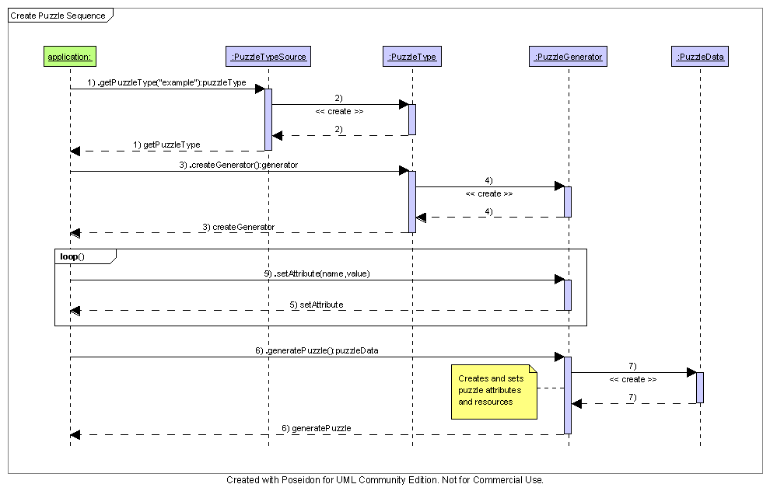

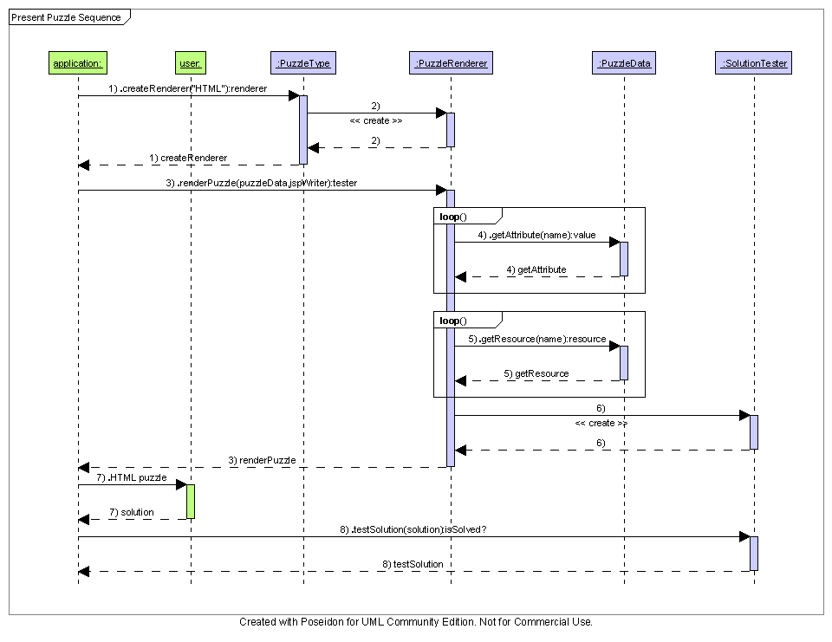

Environment Requirements
- Development language: Java1.4
- Compile target: Java1.4

Package Structure
com.topcoder.util.puzzle.jigsaw

Software Requirements

Administration Requirements

What elements of the application need to be configurable?
- solution submission URL for the DHTML renderer
- countdown time for the DHTML renderer (only if full-page rendering is performed)

Technical Constraints

Are there particular frameworks or standards that are required?
HTML
JavaScript

TopCoder Software Component Dependencies:
Puzzle Framework 1.0
Image Manipulation 1.0
**Please review the TopCoder Software component catalog for existing components that can be used in the design.

Third Party Component, Library, or Product Dependencies:
None.

QA Environment:
- Solaris 7
- RedHat Linux 7.1
- Windows 2000, XP, 2003

Design Constraints
The component design and development solutions must adhere to the guidelines as outlined in the TopCoder Software Component Guidelines. Modifications to these guidelines for this component should be detailed below.

Required Documentation

Design Documentation
- Use-Case Diagram
- Class Diagram
- Sequence Diagram
- Component Specification

Help / User Documentation
- Design documents must clearly define intended component usage in the ‘Documentation’ tab of Poseidon.

