Puzzle Framework 1.0 Requirements Specification

Scope

Overview
Puzzles of various types can be used as entertaining diversions, as attention grabbers, and even as security tools to ensure that a human is involved in interactions with the secured resource. This component provides a framework for representing puzzles’ general structure and essential data, creating puzzles from specifications and base resources, creating puzzle representations in a variety of media, and testing puzzle solutions for correctness.

Logic Requirements

Puzzle Framework Interfaces
The component will include the interfaces and the exception defined in section 2.1.2. Methods may be added to the interfaces, unchecked exceptions may be defined on the existing methods, and the exceptions defined on the existing methods may be narrowed at the designer’s discretion.

PuzzleTypeSource Implementation
The component will provide an implementation of the PuzzleTypeSource interface that relies on an XML configuration file to associate puzzle type names with PuzzleType implementation classes.

Configurable PuzzleType Implementation
The component will provide a general-purpose implementation of the PuzzleType interface that relies on an XML configuration file to associate a generator classes, renderer classes, and validators with named instances so that the class can be used to support a wide variety of puzzle types. The class will be able to support multiple distinct puzzle types in the same application via differently-configured instances.

PuzzleData and PuzzleResource Implementations
The component will provide general-purpose implementations of the PuzzleData and PuzzleResource interfaces.

Required Algorithms
None

Example of the Software Usage
An entertainment web site uses the Puzzle Framework to support an automated “Puzzle of the Day” feature that daily generates a puzzle of one of several configured types for presentation on the site. The site benefits from a common puzzle object model, rendering API, and solution-checking API, which enable it to streamline storage and presentation of the puzzles.

Future Component Direction
Useability enhancements are likely, but no specific future features have been identified.

Interface Requirements

Graphical User Interface Requirements
None.

External Interfaces
The component will provide these interfaces and exceptions:

/**
* An interface defining the behavior of objects that serve as
* registries or factories of PuzzleType objects
*/
public interface PuzzleTypeSource {

/**
* Provides the named PuzzleType object, if it is available
*
* @param name
* @return
* @throws PuzzleException if the named puzzle type does not
* exist or cannot be provided because of a checked
* exception
* @throws IllegalArgumentException if the argument is null
*/
public PuzzleType getPuzzleType(String name)
throws PuzzleException;

/**
* Determines whether a puzzle type corresponding to the
* specified name is available from this source
*
* @param name
* @return
* @throws PuzzleException if a checked exception prevents this
* method from completing successfully
* @throws IllegalArgumentException if the argument is null
*/
public boolean hasPuzzleType(String name);
}

/**
* An interface defining the behavior of objects that represent the
* semantics of particular types of puzzles.
*/
public interface PuzzleType {

/**
* Returns the name of this puzzle type, which should be
* considered an opaque label, significant only within the scope
* spanned by this component's configuration.
*
* @return
*/
public String getName();

/**
* Creates and returns a new PuzzleGenerator that can prepare
* puzzle data appropriate for this puzzle type
*
* @return
* @throws PuzzleException if a checked exception prevents this
* method from completing successfully
*/
public PuzzleGenerator createGenerator() throws PuzzleException;

/**
* Creates and returns a new puzzle renderer appropriate for
* rendering puzzles of this type in the named medium. Which
* medium names are supported by this type can be determined via
* getSupportedMedia(), but the names should themselves be
* considered opaque labels, significant only within the scope of
* this components configuration.
*
* @param medium
* @return
* @throws PuzzleException if the medium is not supported or if a
* checked exception prevents this method from completing
* normally
*/
public PuzzleRenderer createRenderer(String medium)
throws PuzzleException;

/**
* Returns an array of the medium names supported by this puzzle
* type
*
* @return
*/
public String[] getSupportedMedia();

/**
* Tests whether the specified puzzle data is consistent with
* this puzzle type. The result is determined on a best-effort
* basis, so an affirmative response should not be interpreted as
* a guarantee that the data conform to this type, or that any of
* this type's renderers would produce a sensible output from
* them.
*
* @param puzzle
* @return
* @throws PuzzleException if a checked exception prevents
* successful completion of this method
*/
public boolean isPuzzleValid(PuzzleData puzzle)
throws PuzzleException;
}

/**
* An interface defining generic behavior of objects that create puzzle
* data for a particular puzzle type. Users set attributes on an
* instance to configure details of the puzzle to generate, then
* generate either a single puzzle or a series of related puzzles, as
* they wish. PuzzleGenerators are stateful, and typically not thread
* safe.
*/
public interface PuzzleGenerator {

/**
* Generates puzzle data for one puzzle, appropriate for use with
* the PuzzleType supported by this generator.
*
* @return
* @throws PuzzleException if a checked exception prevents this
* method from completing successfully
*/
public PuzzleData generatePuzzle() throws PuzzleException;

/**
* Generates puzzle data for a series of the specified number of
* puzzles, appropriate for use with the PuzzleType supported by
* this generator. The puzzles may be variations on a theme, or
* even identical, depending on the implementation.
*
* @param size
* @return
* @throws PuzzleException if a checked exception prevents this
* method from completing successfully
*/
public PuzzleData[] generatePuzzleSeries(int size)
throws PuzzleException;

/**
* Sets the named attribute of this PuzzleGenerator to the
* specified value object, provided that an attribute of the
* specified name is supported and the value is of suitable type.
*
* @param name
* @param value
* @throws PuzzleException if the named attribute is not
* supported, or if the specified value is of an unsupported type
*/
public void setAttribute(String name, Object value)
throws PuzzleException;
}

/**
* An interface defining the behavior of puzzle data, which is a named
* collection of named attributes and resources. Attributes are simply
* name / value pairs, whereas resources are named blocks of binary
* data bearing appropriate MIME media types that. PuzzleData
* implementations or usage environments may restrict attribute names,
* attribute values, and resource names to be relatively short strings,
* but details may vary. Users are advised to keep these strings to
* less than 256 characters, though that is not guaranteed to be a
* sufficiently restrictive upper bound for every environment.
*/
public interface PuzzleData {

/**
* The standard attribute name used to store a puzzle type's name
* among a puzzle's attributes
*/
public static final String PUZZLE_TYPE_ATTRIBUTE;

/**
* Gets the name of the puzzle represented by this data
*
* @return
*/
public String getName();

/**
* Returns the value of the named attribute of this puzzle data,
* or null if this data has no attribute of the specified name
*
* @param name
* @return
*/
public String getAttribute(String name);

/**
* Returns all the attributes of this puzzle data in the form of
* an unmodifiable Map from attribute names to attribute values
*
* @return
*/
public java.util.Map getAllAttributes();

/**
* Returns the named resource of this puzzle data, or null if
* this data has no resource of the specified name
*
* @param name
* @return
*/
public PuzzleResource getResource(String name);

/**
* Returns all theresources of this puzzle data in the form of an
* unmodifiable Map from resource names to PuzzleResource objects
*
* @return
*/
public java.util.Map getAllResources();
}

/**
* A named and typed block of data associated with a puzzle, such as an
* image, an audio clip, or a lengthy piece of text
*/
public interface PuzzleResource {

/**
* Retrieves the name of this puzzle resource as a String
*
* @return
*/
public String getName();

/**
* Retrieves the MIME media type of this resource as a String
*
* @return
*/
public String getMediaType();

/**
* Retrieves the data content of this resource as a byte[]
*
* @return
*/
public byte[] getData();
}

/**
* An interface describing the behavior of an object that can render a
* puzzle of a specific type to a particular medium. Implementations
* are stateful, and typically not thread safe.
*/
public interface PuzzleRenderer {

/**
* Returns the name of the medium in which this renderer will
* render puzzles, for instance 'HTML', 'Postscript', or 'Flash'.
* This is according to renderer configuration and not
* significant outside the scope of that configuration – there
* is not (currently) a defined dictionary of canonical medium
* names.
*
* @return
*/
public String getMediumName();

/**
* Renders the specified puzzle data to the provided byte stream
* in a manner appropriate to puzzle type and medium to which
* this renderer is specific, and returns a SolutionTester with
* which to test potential solutions to the rendered puzzle to
* determine whether they are correct. If the rendering contains
* character data then this renderer will choose an encoding
* based on configuration, attributes, or internal logic.
*
* Implementations of this method are not required to be
* idempotent -- they are permitted to create different
* renderings (in the same medium) of the same puzzle data on
* different runs.
*
* @param puzzle
* @param target
* @return
* @throws PuzzleException if a checked exception prevents the
* successful completion of this method
*/
public SolutionTester renderPuzzle(PuzzleData puzzle,
java.io.OutputStream target) throws PuzzleException;

/**
* Renders the specified puzzle data to the provided character
* stream in a manner appropriate to puzzle type and medium to
* which this renderer is specific, and returns a SolutionTester
* with which to test potential solutions to the rendered puzzle
* to determine whether they are correct. If the rendering
* contains non-character data then this method will throw an
* exception.
*
* Implementations of this method are not required to be
* idempotent -- they are permitted to create different
* renderings (in the same medium) of the same puzzle data on
* different runs.
*
* @param puzzle
* @param target
* @return
* @throws PuzzleException rendering produces binary data or if a
* checked exception prevents the successful completion
* of this method
*/
public SolutionTester renderPuzzle(PuzzleData puzzle,
java.io.Writer target) throws PuzzleException;

/**
* Sets the named attribute of this PuzzleRenderer to the
* specified value object, provided that an attribute of the
* specified name is supported and the value is of suitable type.
*
* @param name
* @param value
* @throws PuzzleException if the named attribute is not
* supported, or if the specified value is of an
* unsupported type
*/
public void setAttribute(String name, Object value)
throws PuzzleException;
}

/**
* An interface describing the behavior of objects that test
* prospective puzzle solutions for correctness. Instances are
* specific to particular renderings of specific puzzles, and it is
* recommended that they be thread safe.
*/
public interface SolutionTester {

/**
* Tests the specified solution object to determine whether it is
* a correct solution, returning true if it is correct or false
* if it is wrong
*
* @param solution
* @return
* @throws PuzzleException if the solution object is of incorrect
* type, or if a checked exception prevents successful
* completion of this method
*/
public boolean testSolution(Object solution)
throws PuzzleException;
}

/**
* A catch-all exception indicating that some unspecified thing failed
* in the operation of a Puzzle Framework implementation object.
*/
public class PuzzleException
extends com.topcoder.util.errorhandling.BaseException {
}

Example Sequences
The following high-level sequences may help to clarify how implementations of the various interfaces are expected to be used together:
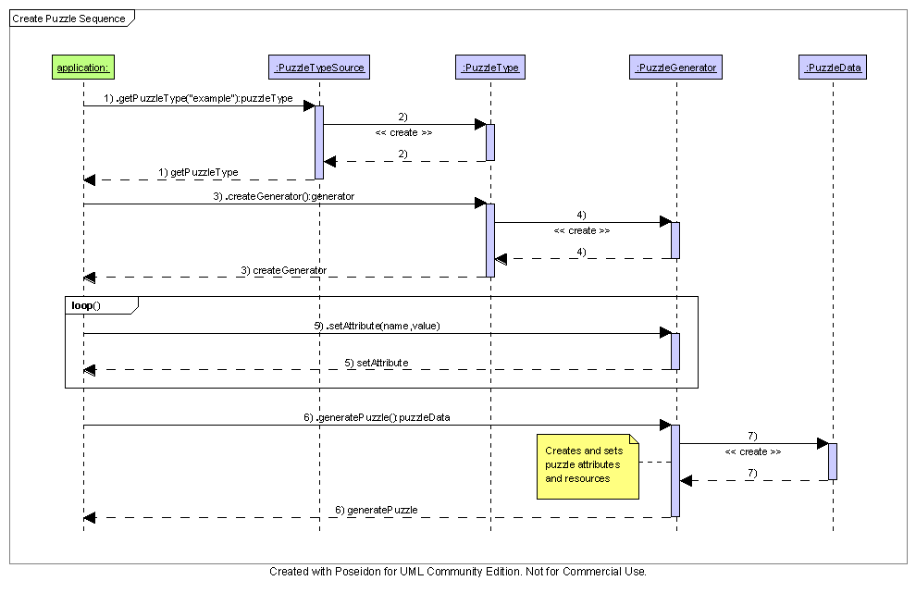
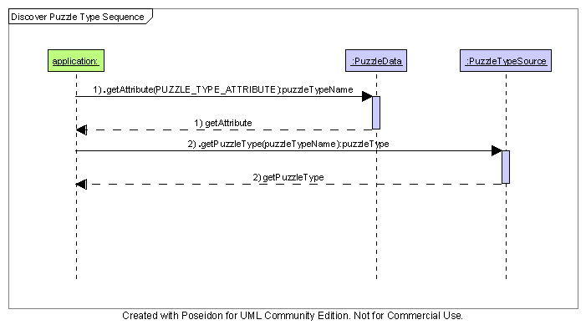
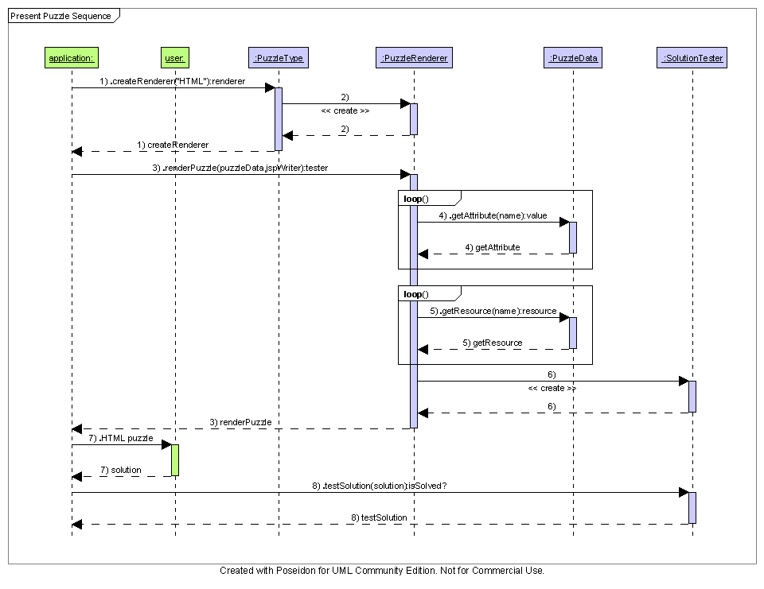

Environment Requirements
- Development language: Java1.4
- Compile target: Java1.4

Package Structure
com.topcoder.util.puzzle

Software Requirements

Administration Requirements

What elements of the application need to be configurable?
- The correspondence between puzzle type names and corresponding PuzzleType implementations must be configurable.

Technical Constraints

Are there particular frameworks or standards that are required?
None.

TopCoder Software Component Dependencies:
None.
**Please review the TopCoder Software component catalog for existing components that can be used in the design.

Third Party Component, Library, or Product Dependencies:
None.

QA Environment:
- Solaris 7
- RedHat Linux 7.1
- Windows 2000, XP, 2003

Design Constraints
The component design and development solutions must adhere to the guidelines as outlined in the TopCoder Software Component Guidelines. Modifications to these guidelines for this component should be detailed below.

Required Documentation

Design Documentation
- Use-Case Diagram
- Class Diagram
- Sequence Diagram
- Component Specification

Help / User Documentation
- Design documents must clearly define intended component usage in the ‘Documentation’ tab of Poseidon.

