Requirements Specification

Scope

Overview
Provided the name of a top-level node, the Template Loader then creates, caches, and returns an object representation of the template hierarchy.

Logic Requirements

Read the template hierarchy out of the TopCoder component database. The database schema in Figure 1.0 needs to be created (does not currently exist) for this component. Each template node (temp_hier) can have zero, one, or many template associations. The temp_hier_maping table represents these associations. The parent level template node’s must have unique names (all other level names uniqueness only matters with relation to the parent node). There can be multiple top-level nodes within the same schema. Additionally, the parent identification (parent_temp_hier_id) and identification (temp_hier_id) are the same for top-level nodes. For all other nodes the parent identification points to that node’s parent node (they are not the same). Figure 1.0 outlines the template hierarchy database schema used by this component.
f
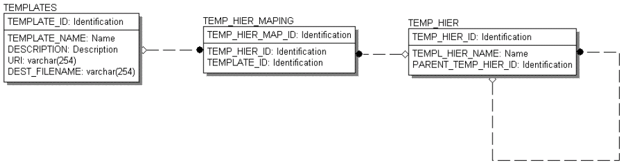 Figure 1.0 Template schema

Return the template hierarchy object outlined below in Figure 2.0. The component is responsible for the design and development of the template hierarchy classes. Part of these classes public methods have been outlined to support external dependencies. These public methods must be implemented in the design and development of these classes. Each node in the template hierarchy can have zero or more template associations.

package com.topcoder.buildutility.template;

/**
* <p>This class diagram for the template hierarchy class is by no means fully completed. It is merely a stubbed
* representation of the functionality such that other dependent components can know what to expect.
* The underlying implementation is left to the designer responsible for this class.</p>
*/
public class TemplateHierarchy {

/**
* <p>Returns the template hierarchy node's name. The name of the node in the template hierarchy
* is used as part of the template selection process. The name corresponds to either technology types
* or component attributes.</p>
*
*
* @return The name of the node in the template hierarchy is used as part of the template selection process. The name corresponds to either technology types or component attributes.
*/
public String getName() {…}

/**
* <p>Each node in the template hierarchy can have zero to many template associations. An empty array must be returned, a null return value is not allowed..</p>
*
* @return Template[] Each node in the template hierarchy can have zero to many template associations. An empty array must be returned, a null return value is not allowed.
*/
public com.topcoder.buildutility.template.Template[] getTemplates() {…}

/**
* <p>Returns all of the template hierarchy nodes directly below the current node in the hierarchy.</p>
*
* @return Returns all of the template hierarchy nodes directly below the current node in the hierarchy. An empty array must be returned if there are no children, a null value must not be returned.
*/
public com.topcoder.buildutility.template.TemplateHierarchy[] getChildren() {…}
}

/**
* <p>This class diagram for the template class is by no means fully completed. It is merely a stubbed
* representation of the functionality such that other dependent components can know what to expect.
* The underlying implementation is left to the designer responsible for this class.</p>
*/
public final class Template {

/**
* <p>Returns the name of the template. Each template name must uniquely identify that template (i.e. no two templates can have the same name).</p>
*
* @return Returns the name of the template.
*/
public String getName() {…}

/**
* <p>Returns the description of this template. Descriptions are optionaly but they will help a great deal when developers are trying to determine the purpose of the template.</p>
*
* @return String Description of the temlpate
*/
public String getDescription() {…}

/**
* <p>Returns the intended or suggested file name corresponding to the template. This file name is more than likely not the
* name used to store the content on the server side. This file name was designed to be the suggested name when
* the transformation occurs from the template to the actual file and the file is written in destination location.
* The file name is required and cannot be null.</p>
*
* @return Suggested file name, cannot be null.
*/
public String getFileName() {…}

/**
* <p>Returns the tempalte as a data stream. A template must contain data.</p>
*
* @return Returns the tempalte as a data stream.
*/
public java.io.InputStream getData() {…}
}
Figure 2.0 Template class hierarchy

A configuration setting drives the ability of this component to cache the returned hierarchies as they are created by the top-level node’s name. The top-level node’s name must be unique from all other top-level nodes. The configuration turns ON or OFF the caching option. When OFF, the data representation of the template hierarchies are not cached for future use. When ON, the data representation of the template hierarchies are cached for future use; thus, increasing performance by avoiding subsequent database calls to build the data objects. The caching occurs on demand as the objects are requested. The first time a user requests a template hierarchy (assuming caching Is turned ON) the object is created and then added to the cache. Instead of loading all of the objects into the cache when the application starts.

The uri column in the Templates table contains a URI relative to a configurable file server. The URI contains the filename and path. The filename column is only for the application. This column tells the application the suggested name of the output file.

Required Algorithms
None

Example of the Software Usage

Figure 3.0 Template hierarchy sample

A template hierarchy must be populated by the end-user of the build script generation tool as part of the deployment and setup process. This hierarchy allows the tool to automatically choose a template based on the technology types and attributes associated with each component-version. Figure 3.0 outlines an example of this hierarchy.

Future Component Direction
This custom component is being developed for use with a build script generation application. The application uses the template hierarchy to select one or more templates.

Interface Requirements

Graphical User Interface Requirements
None

External Interfaces
None

Environment Requirements
- Development language: Java 1.4
- Compile target: Java 1.3, Java 1.4
- Database: Informix 9.21

Package Structure
com.topcoder.buildutility.template

Software Requirements

Administration Requirements

What elements of the application need to be configurable?

Database connection information.

Caching on/off (see 2.2.3)

Technical Constraints

Are there particular frameworks or standards that are required?
None

TopCoder Software Component Dependencies:

XML 2 SQL
BaseException
Simple Cache
DB Connection Factory
Logging Wrapper

**Please review the TopCoder Software component catalog for existing components that can be used in the design.

Third Party Component, Library, or Product Dependencies:
None

QA Environment:
- Windows 2000
- Windows 2003
- RedHat Linux 7.1
- Solaris 7

Design Constraints
The component design and development solutions must adhere to the guidelines as outlined in the TopCoder Software Component Guidelines. Modifications to these guidelines for this component should be detailed below.

Required Documentation

Design Documentation
- Use-Case Diagram
- Class Diagram
- Sequence Diagram
- Component Specification
- XML Schema

Help / User Documentation
- Design documents must clearly define intended component usage in the ‘Documentation’ tab of Poseidon

