**Title: How to use Data science Deep Learning Process**

**Author:** Rajendra Prasad T

**Track Category:** Design

**Subcategory:** Python

**Tags:** Deep learning, Python

**Read Time:** 5 to 8 mins

**Banner Image:** <https://gateway.newton.ac.uk/sites/default/files/styles/leading/public/asset/img/1901/iStock-1006679120.jpg?itok=NmcdxTMS>

Deep learning comes part of Machine Learning (ML), in which a model learns to perform classification tasks directly from pictures, text, or sound. Deep learning sometimes enforced, employing a neural network architecture. The term "deep" refers to the quality of layers within the network—A lot of layers, the deeper the network. Ancient neural networks contain only two or three layers, whereas deep networks will have a whole lot.

Deep Learning is the most fun and influential branch of Machine Learning. Deep Learning models will use for a spread of advanced tasks:

Here are just a few samples of deep learning at work:

* A self-driving vehicle slows down because it approaches a pedestrian path.
* An ATM rejects a counterfeit banknote.
* A smartphone app provides a second translation of an overseas sign.
* Deep learning is very well-suited to identification applications like face recognition, text translation, voice recognition, and advanced driver help systems, including lane classification and traffic sign recognition.

. 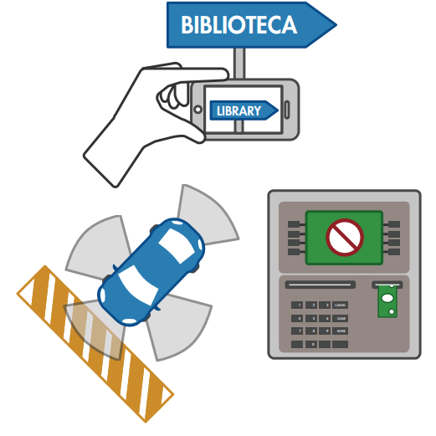

* Artificial Neural Networks for Regression and Classification
* Convolutional Neural Networks for PC Vision
* Recurrent Neural Networks for Statistical Analysis
* Self-Organizing Maps for Feature Extraction
* Deep Boltzmann Machines for Recommendation Systems
* Auto Encoders for Recommendation Systems

**What is the Difference between Machine and Deep Learning?**

Deep learning is a subform of machine learning. With machine learning, you manually extract the appropriate options of a picture. With in-depth knowledge, you feed the raw images directly into a deep neural network that learns the options mechanically.

Deep learning usually needs many thousands or innumerable pictures for the most effective results. It's additionally computationally intensive and requires a superior GPU. 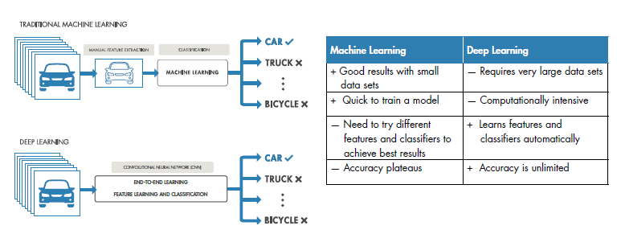

In this part, you may perceive and learn the way to implement the subsequent Deep Learning models:

1. Artificial Neural Networks for a Business downside

2. Convolutional Neural Networks for a PC Vision task

**1. Artificial Neural Networks for a Business downside**

Neural Networks give Solutions to Real-World Problems: Powerful new algorithms to explore, classify, and determine patterns in knowledge

Inspired by analysis into the functioning of the human brain, artificial neural networks area unit ready to learn from experts. These powerful downside solvers area units extremely useful wherever is ancient. The formal analysis would be robust or not possible. Their strength lies in the ability to create sense out of advanced, noisy, or nonlinear knowledge. Neural networks will give reliable solutions to issues in an extensive selection of disciplines, significantly areas involving classification, prediction, filtering, improvement, pattern recognition, and performance approximation.

Since neural networks area unit best at distinctive patterns or trends in knowledge, they're like-minded for prediction or forecasting wants including:

* Sales forecasting
* Industrial process control
* Customer analysis
* Data validation
* Risk management
* Target marketing

**Neural networks in medicine**

Artificial Neural Networks (ANN) is a 'hot' analysis space in drugs.

It's believed that they're going to receive an intensive application to medical specialty systems within the next few years. The instant, the analysis is usually on modeling parts of the human body and recognizing diseases from varied scans (e.g., cardiograms, CAT scans, ultrasonic scans, etc.).

Neural networks area unit ideal in recognizing illness exploitation scans since there's no got to give a selected formula on the way to determine the disease. Neural networks learn by example, that the details of a way to acknowledge the illness don't seem to be required. What's needed could be a set of standards that area unit representative of all the variations of the disease. The number of examples isn't as vital because of the 'quantity.'

**2. Convolutional Neural Networks for a Computer Vision task**

A convolutional neural network (CNN) is one in all the foremost in style algorithms for deep learning with pictures and video. Like different neural networks, CNN consists of the associate input layer, associate output layer, and plenty of hidden layers in between.

Feature Detection Layers These layers perform one in all three sorts of operations on the data: convolution, pooling, or rectified linear unit (ReLU).

**Classification Layers**

After feature detection, the design of CNN shifts to the classification algorithm.

This vector contains the chances for every category of any image classified.

The final layer of the CNN design uses a softmax operate to supply the classification output.

There is no actual formula for choosing layers. The most straightforward approach is to undertake some and see, however well they work— or to use a pre-trained network. There is no actual formula for choosing layers. The most straightforward approach is to undertake some and see, however well they work— or to use a pre-trained network.