**Title**: Demonstrate process of Data science clustering algorithm

**Author**: Rajendra Prasad T

**Track Category**: Design

**Subcategory**: Python

**Tags**: Clustering, Python,

**Read Time**: 5-8 mins

**Banner Image: https://lh3.googleusercontent.com/mfLoGSAb1h0XDBIcCKByU6M5HgqF2BgZ8mgCAU1z0dquC01fI1uglW-bGSy97psn7Qaq8Eo=s163**

**Introduction:**Clustering defines as the same as classification, but the basis is different. When we use cluster algorithms on your dataset, unexpected things will suddenly pop-like structures, clusters, and groupings, and you'd have not thought of otherwise.

In this part, you'll perceive and learn the way to implement the subsequent Machine Learning cluster models:

K-Means Clustering

Hierarchical Clustering

**K-means Clustering Python**-. K-Means Clustering is an unattended machine learning algorithm(ML). N distinction to ancient supervised machine learning algorithms, K-Means attempts to classify data without having first been trained with tagged data.

Once the algorithm runs, the teams will define, any new data will assign to the first group.

The real-world applications of K-Means include:

customer profiling

market segmentation

computer vision

search engines

astronomy

**How it works**

**1. Select value K (i.e., 2) random points as cluster centers called centroids**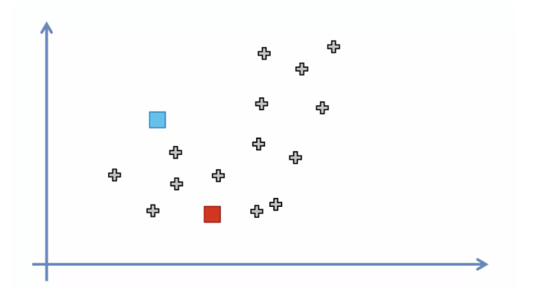

1. Assign a value for each data point to the closest cluster by calculating its distance concerning each centroid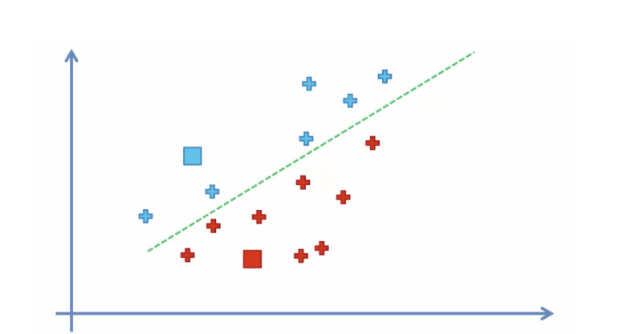

1.Determine the new cluster center(NCC) by computing the average value of the assigned points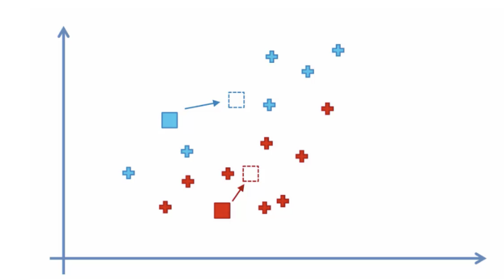2.Repeat the steps 2 and 3 until none of the cluster assignments change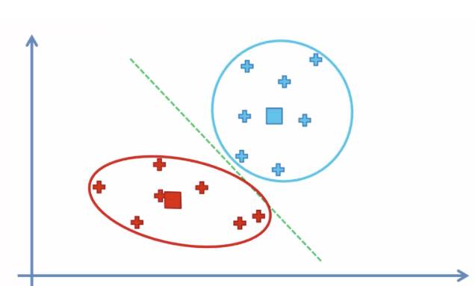

**Choosing the right number of clusters**

Often the info you'll be operating with can have multiple dimensions creating it troublesome to visual. As a consequence, the optimum range of clusters is not any longer apparent. The simplest way of decisive this mathematically.

We graph the link between the number of clusters and the Cluster price of total Squares (WCSS). We tend to choose the number of clusters wherever the modification in WCSS begins to change surface (elbow method)

WCSS outlined because of the addition squared distance between every member of the cluster and its center of mass.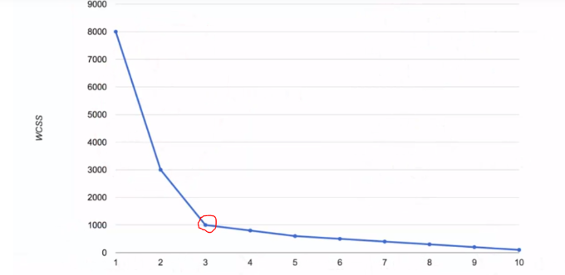

WCSS outlined because of the addition squared distance between every member of the cluster and its center of mass..

For example, the computed WCSS for figure one would be more significant than the WCSS calculated see below picture. Figure1

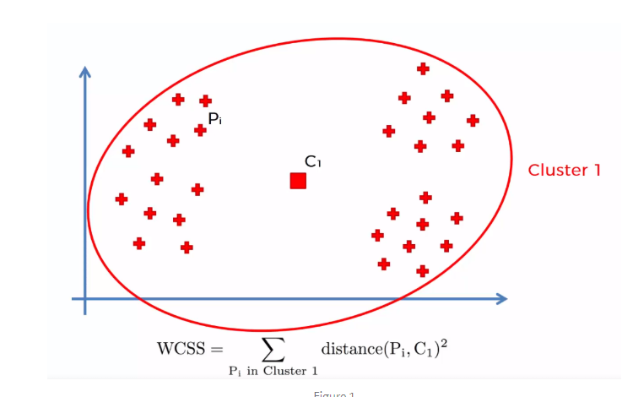

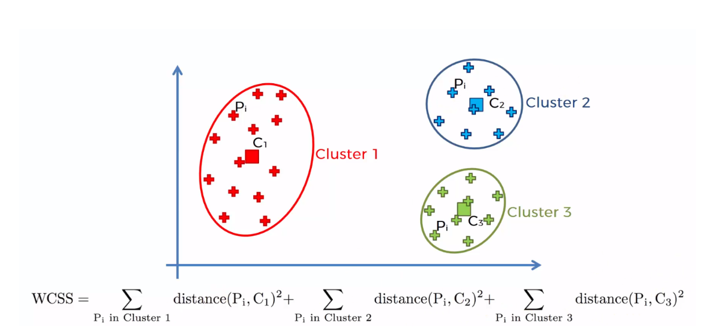

Figure2

**Hierarchical cluster Technical technique :**

Hierarchical cluster process(HCP) is one among the popular and straightforward to grasp bunch technique.

This bunch technique split into two types:

1. Agglomerative

2. Divisive

Agglomerative ranked the cluster Technique: during this technique, every datum is account as a personal cluster. At every iteration, similar clusters merge with alternative clusters till one cluster or K clusters area unit shaped.

• Compute the proximity matrix

• Let every knowledge price purpose be a cluster

• Repeat: Merge the two nearest clusters and update the proximity matrix

• Until solely one cluster remains

Essential operation is the computation of the proximity of 2 clusters

To understand higher, let's see a representation of the clustered ranked bunch Technique. Shall we say we've got six knowledge points?

• Step- 1: within the initial stage, we tend to calculate the proximity of individual points and contemplate the six knowledge points as distinct clusters, as shown within the image below.

