Style Panel 1.1 Requirements Specification

Scope

Overview
The Style Panel component provides a SWING panel that allows the user to set the position, the size, the colors, and the font properties for elements and groups of elements. It also provides a way to signal the listeners of changes.

This update to the component will modify the layout of the component to save space and be a little bit more user friendly. It will also provide a second layout used in a different part of the UML Tool.

Logic Requirements

Control layout
The layout of the control must be updated to match the new layout, seen in the prototype images provided.
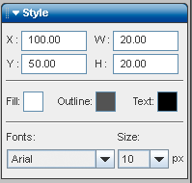

Note that the header for the panel, with the grab bar, down arrow and “Style” text are not part of this component update.

Resizing
Currently, the style panel resizes like this:

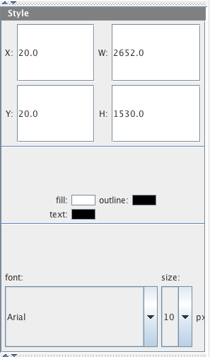

The resizing should change to keep the vertical spacing and size of elements intact, filling in empty space at the bottom of the panel if the panel is resized. Resizing won’t necessarily be an issue in the upcoming changes to the UML Tool, but the component should still resize better than what is shown above.
1.2.3 Separate layout
A separate layout should be added, with a constructor and flag to be used to create the secondary layout. This layout will be shown as part of the upper toolbar in the UML tool when the side menu is closed. All functionality should remain intact, the only thing different is the layout of the elements

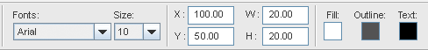

Required Algorithms
None

Example of the Software Usage
This component will be used in the TopCoder UML Tool to update the style properties of elements

Future Component Direction
None

Interface Requirements

Graphical User Interface Requirements
The updated layout must match what is shown on the prototype images supplied

External Interfaces
None

Environment Requirements
- Development language: Java 1.5
- Compile target: Java 1.5

Namespace
com.topcoder.gui.panels.style

Software Requirements

Administration Requirements

What elements of the application need to be configurable?
- The names of the properties in the DiagramElements
- The font families and font sizes
- The color picker colors

Technical Constraints

Are there particular frameworks or standards that are required?
None.

TopCoder Software Component Dependencies:
- Configuration Manager 2.1.5
- Diagram Interchange 1.0.1
**Please review the TopCoder Software component catalog for existing components that can be used in the design.

Third Party Component, Library, or Product Dependencies:
None

QA Environment:
- Solaris 7
- RedHat Linux 7.1
- Windows 2000
- Windows 2003

Design Constraints
The component design and development solutions must adhere to the guidelines as outlined in the TopCoder Software Component Guidelines. Modifications to these guidelines for this component should be detailed below.

Required Documentation

Design Documentation
- Use-Case Diagram
- Class Diagram
- Sequence Diagram
- Component Specification

Help / User Documentation
XML documentation must provide sufficient information regarding component design and usage.

