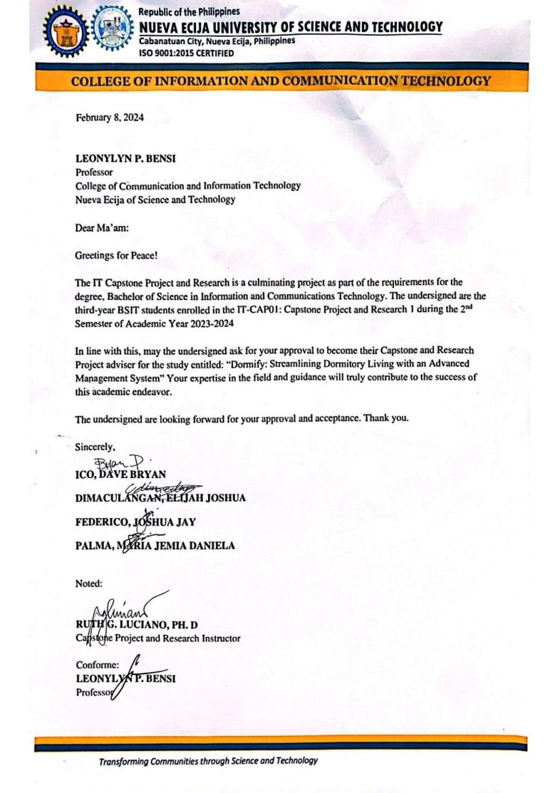
APPENDICES

Appendix A

Request Letter for Adviser

169

Appendix

Research
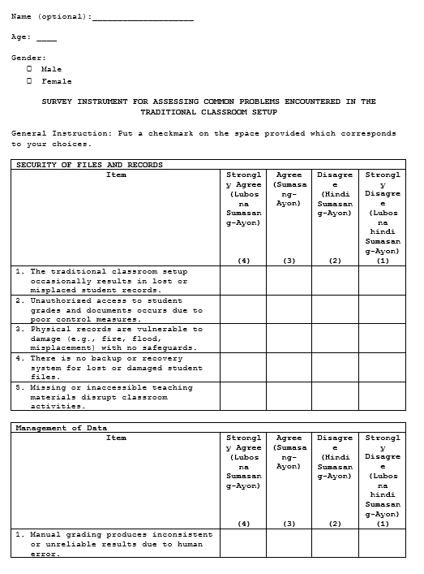
B

Instrument 1

172
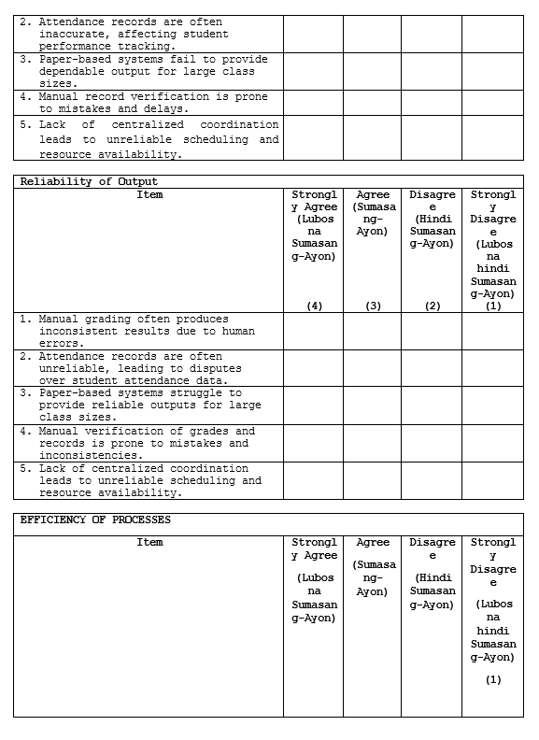

173
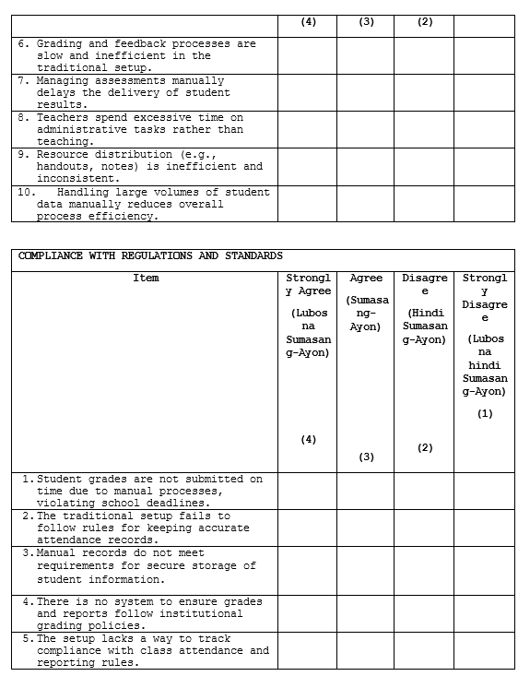

Appendix

Research
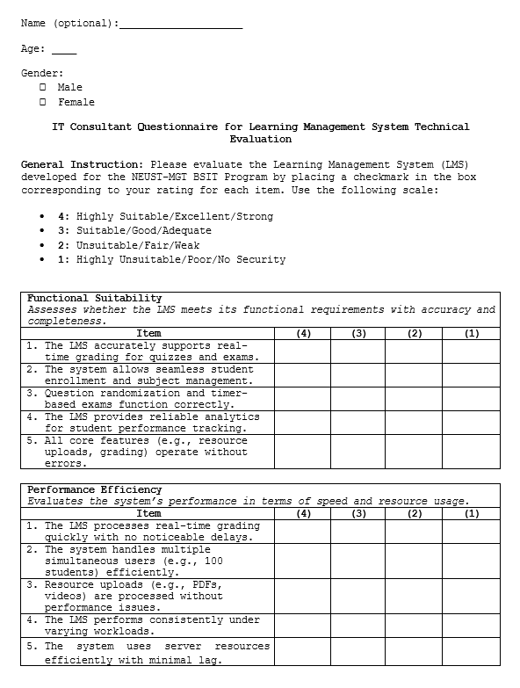
C

Instrument 2

174
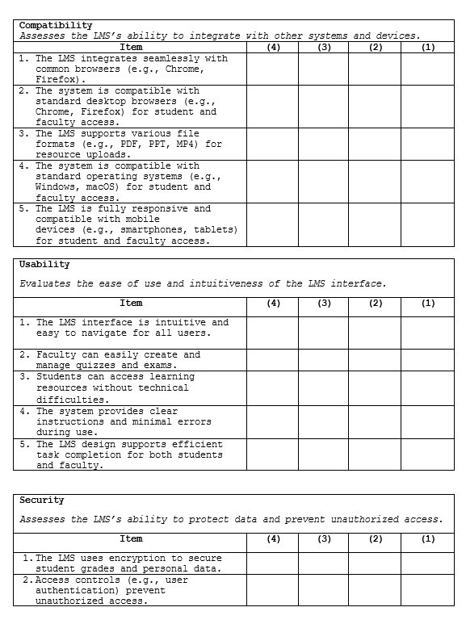



175

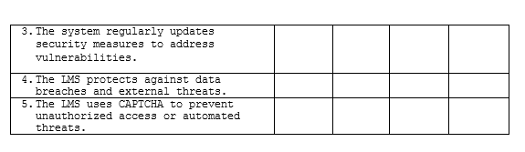

176

Appendix

Research
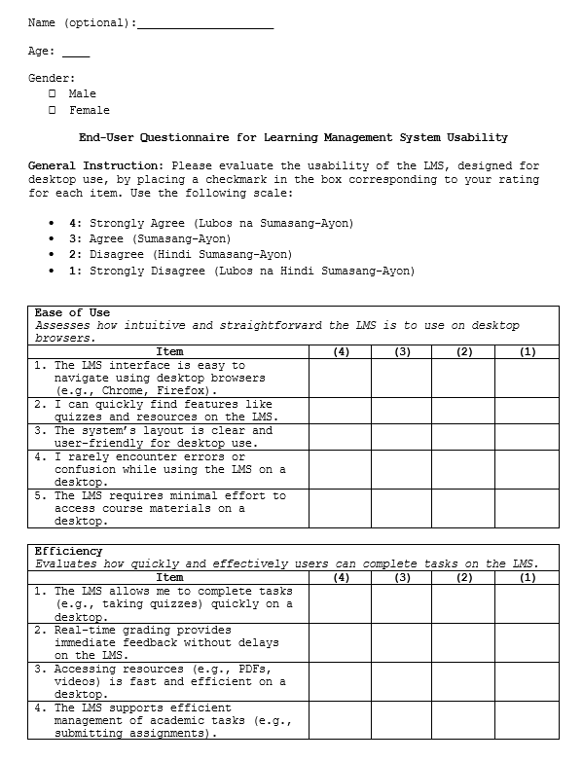
D

Instrument 3

180

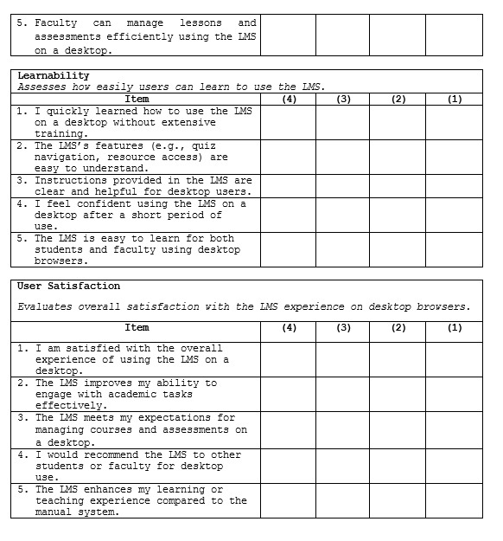

181
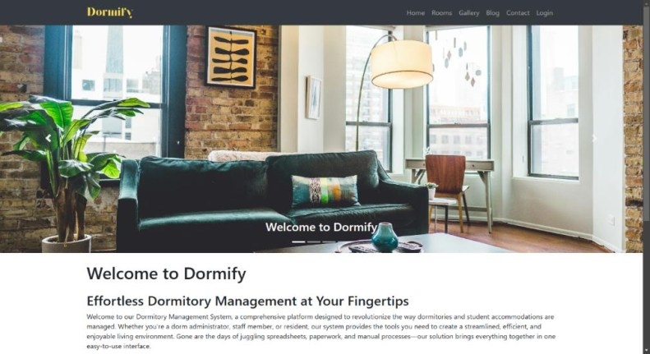
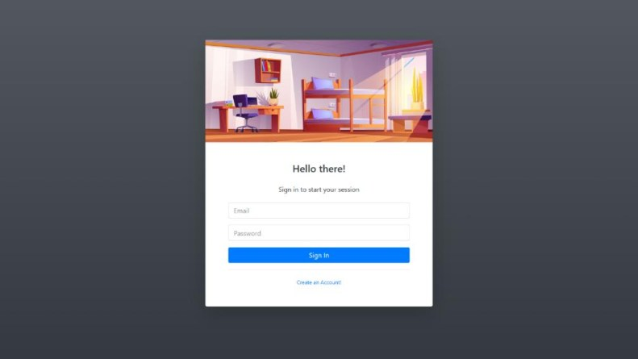
Appendix F

User Manual

1.How to Login / Sign up

1.1 On the landing page, click the Login button.
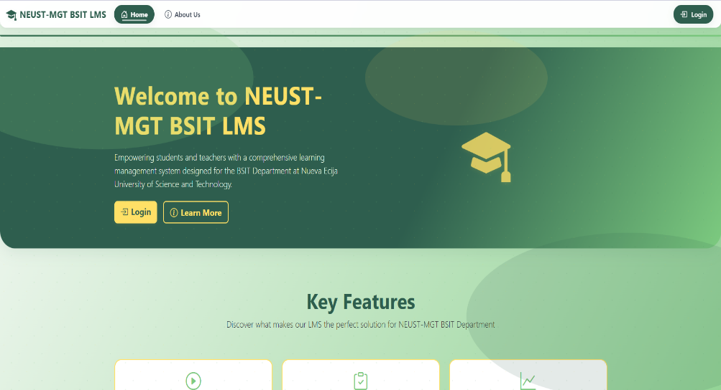

1.2 To log in, fill out the information and

click the Log In button.

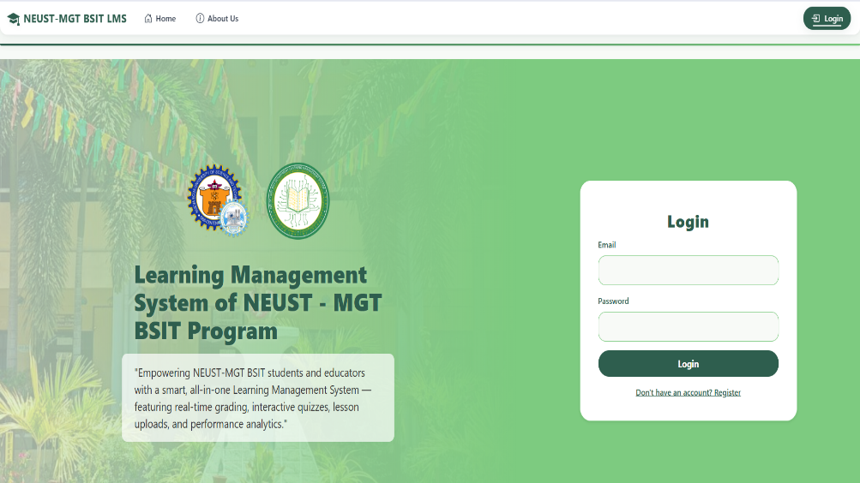

183

1.3 For new student users, click Don’t have an account? Register and fill out the registration form.
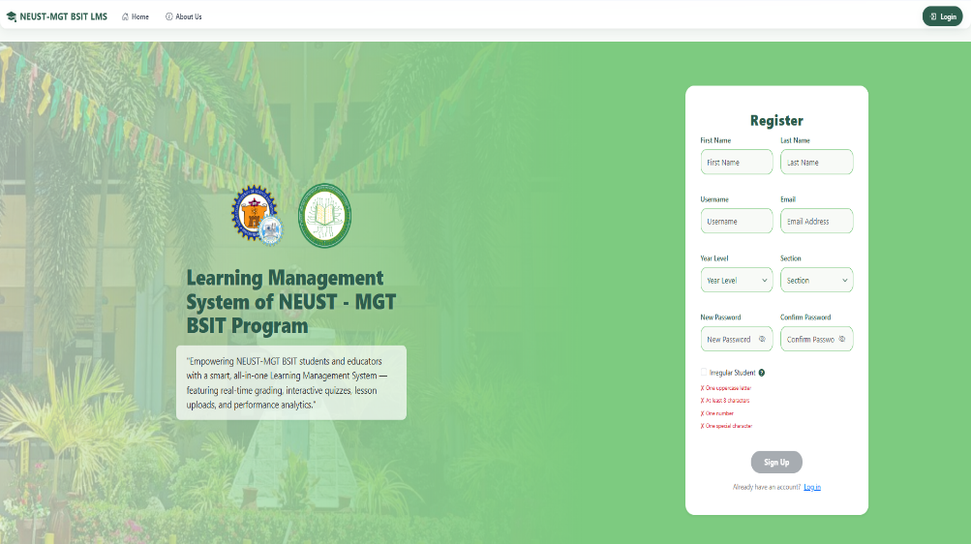

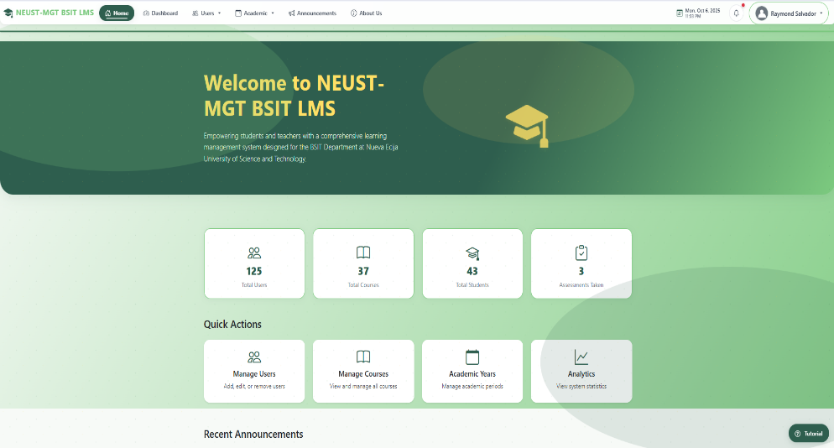
2.Navigating through the system as admin. 2.1 After logging in, the system redirects to your dashboard.

184

2.2 Use the navbar navigation to access system modules.
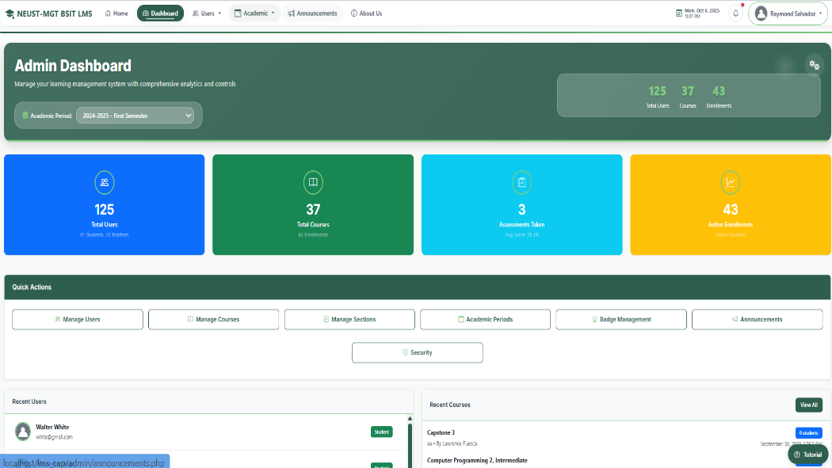

2.3 The notification bell at the top shows real-time updates.
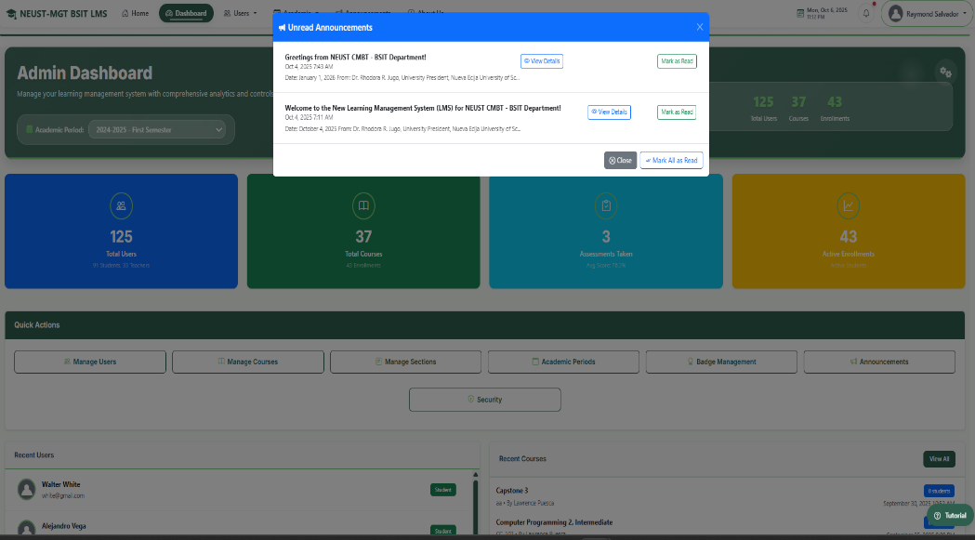

185

2.4 The profile icon with user name allows you to manage your account settings.

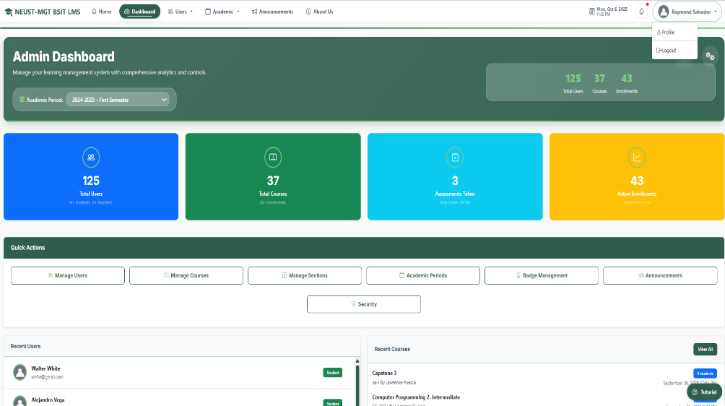

3. Admin Dashboard Functions 3.1 Manage users, click Manage Users in the sidebar.

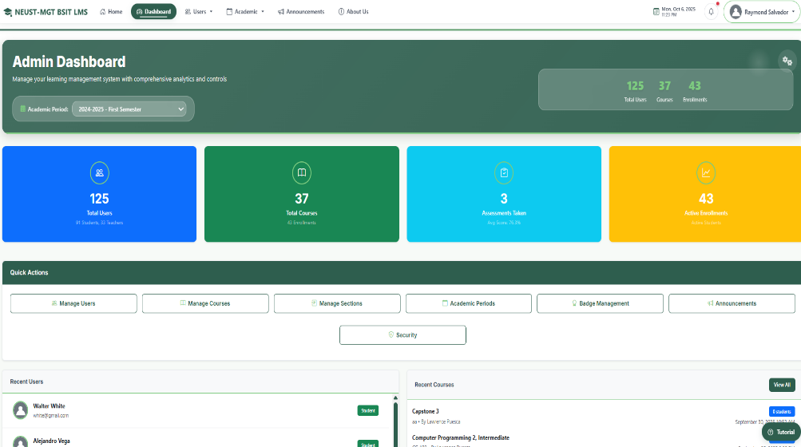

186

3.2. View, add, edit, or deactivate user accounts.

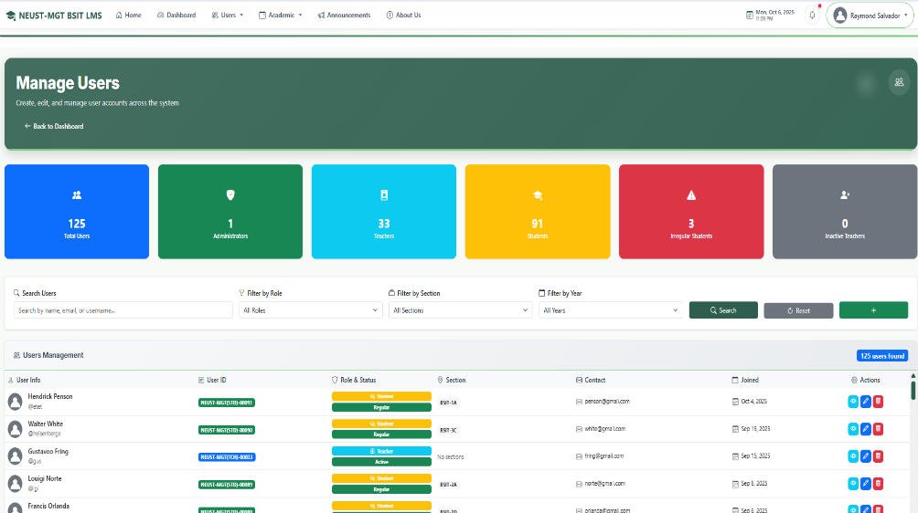

4. Manage Courses 4.1. Click Academic from menu and Course.

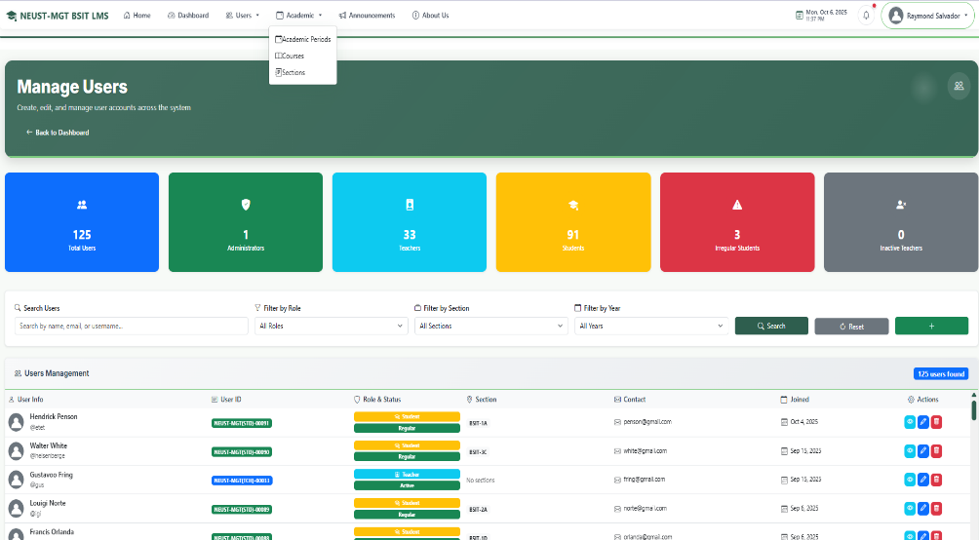

187

4.2. Click create course then Add new course and assign them to Teachers.

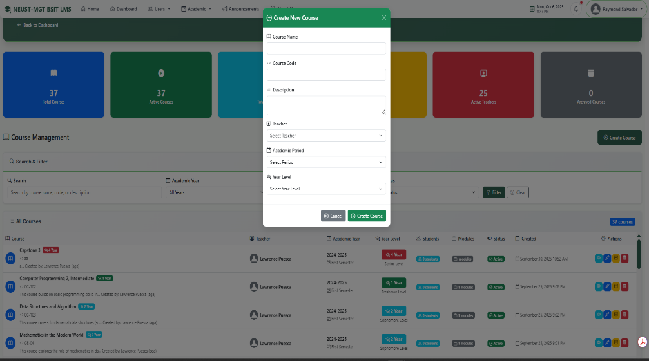

5. Manage Section 5.1. Click Academic from menu and Section.
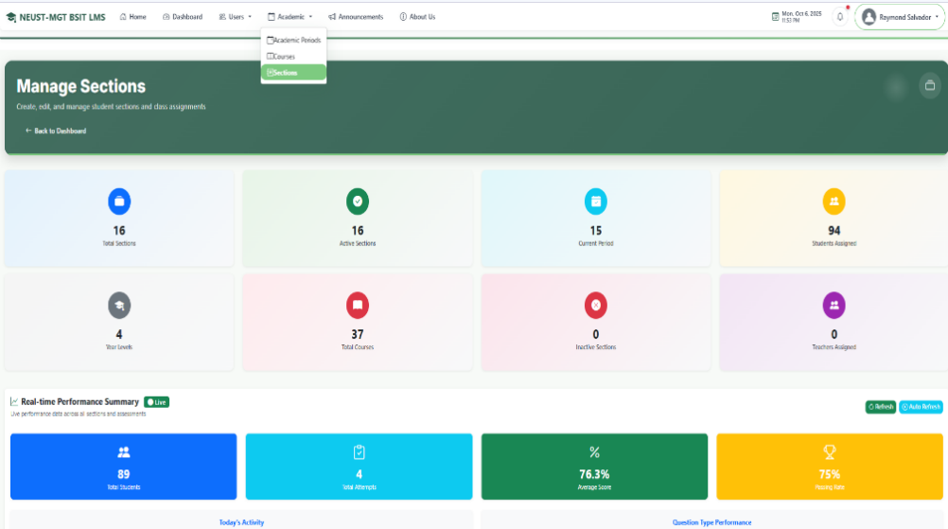

188

5.2. Click create section then Add new section and assign them to courses.
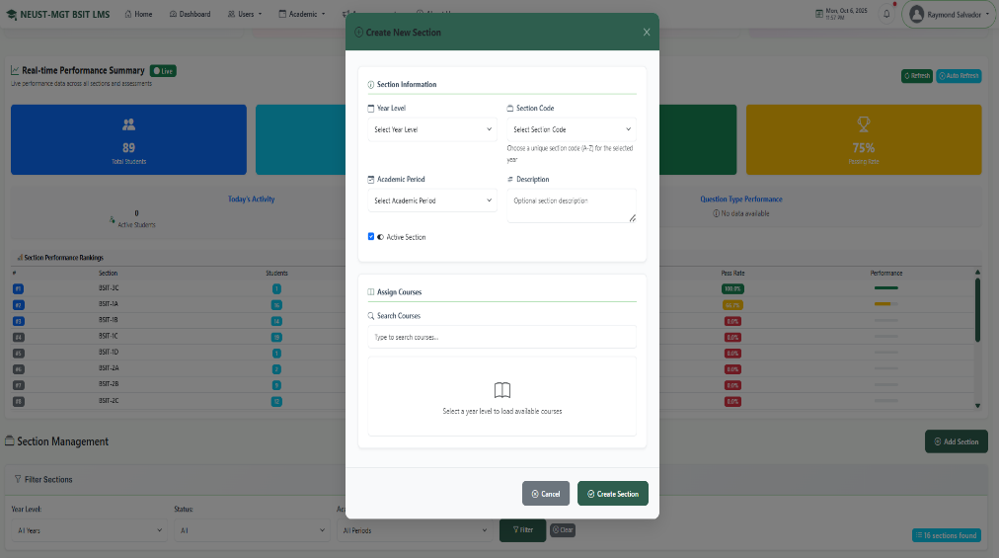

5.2.1. To add student to each section click add button.
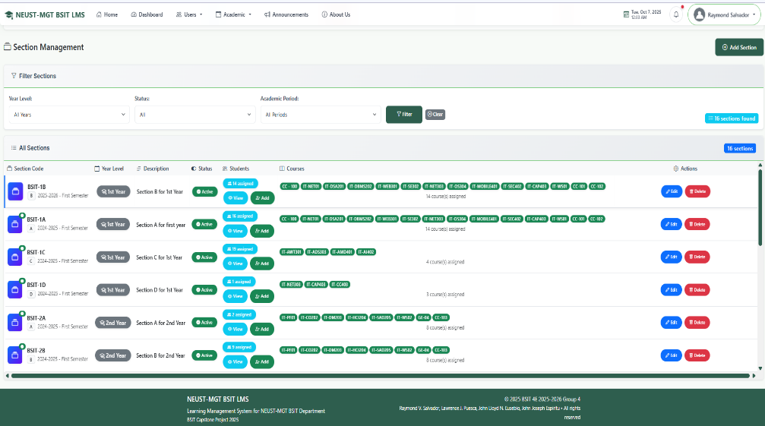

189

5.2.2. Click checkbox to add student to section.

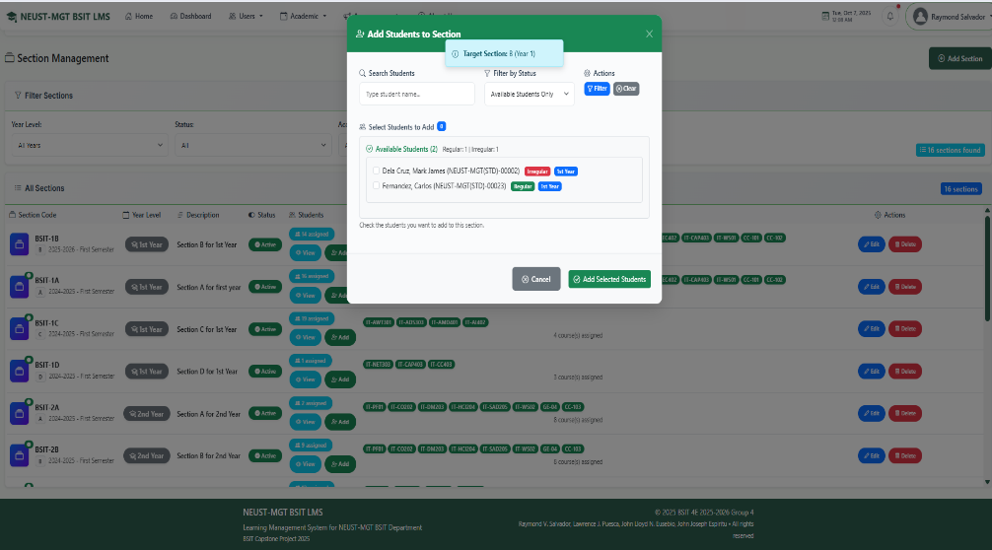

6. Add New Academic Period 6.1. Click Academic from menu and Academic Periods.
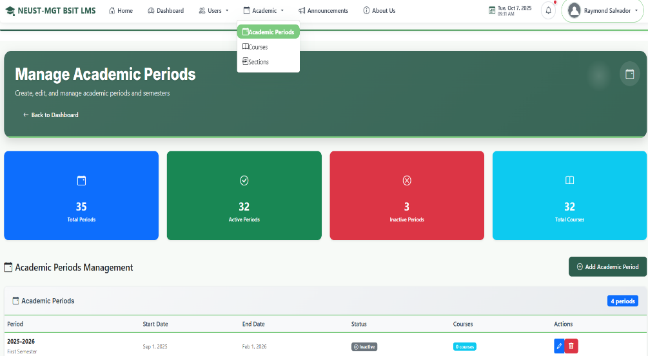

190

6.2. Fill out the form with information

and click Add Period.

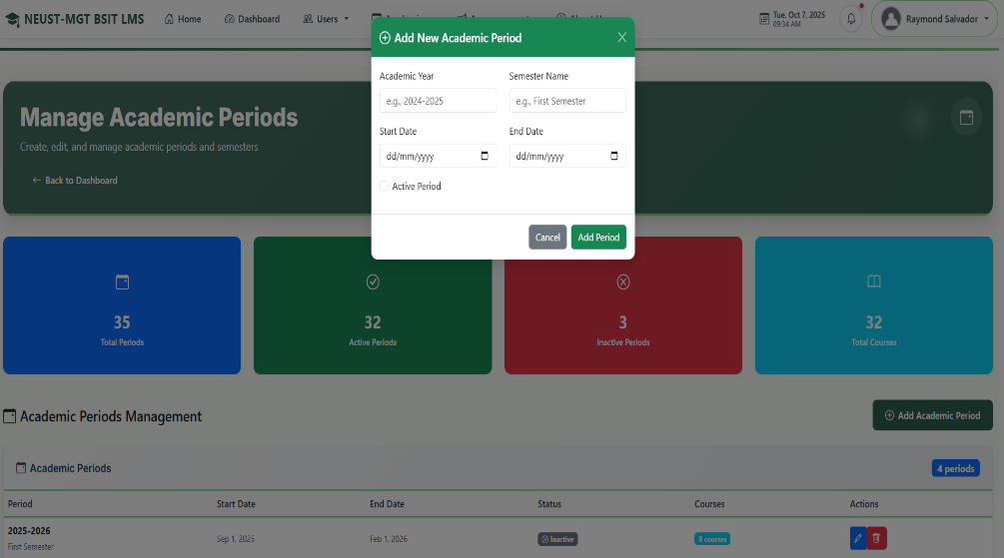

6. Navigate to Announcement page 6.1. Click Announcements from menu.
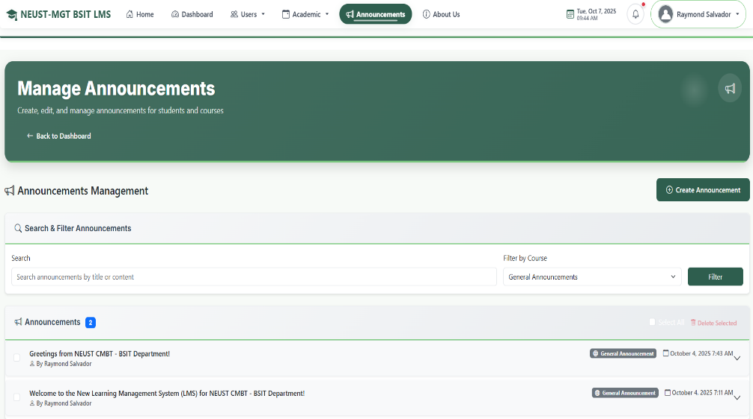

191

6.2. Fill out to create announcement, then click Create Announcement to publish.
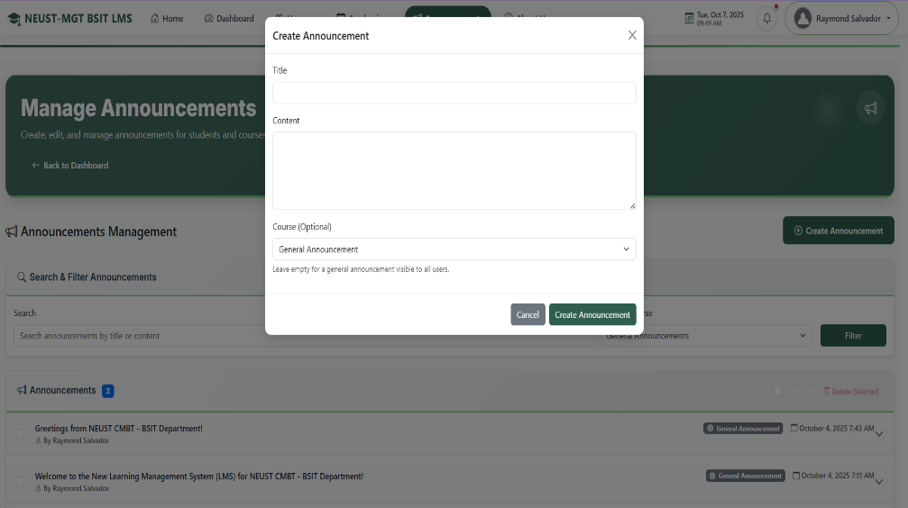

7.Navigating through the system as Teacher. 7.1. After logging in, the system redirects to your teacher dashboard.
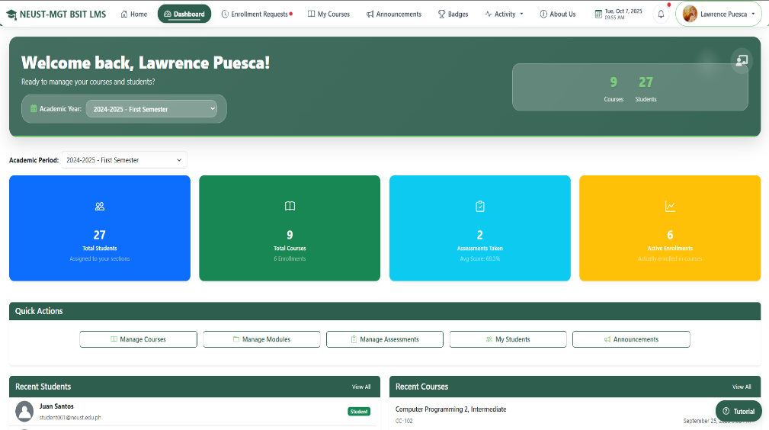

192

7.2. Navigate to Enrollment Requests page from menu on this page you manage request of student
.

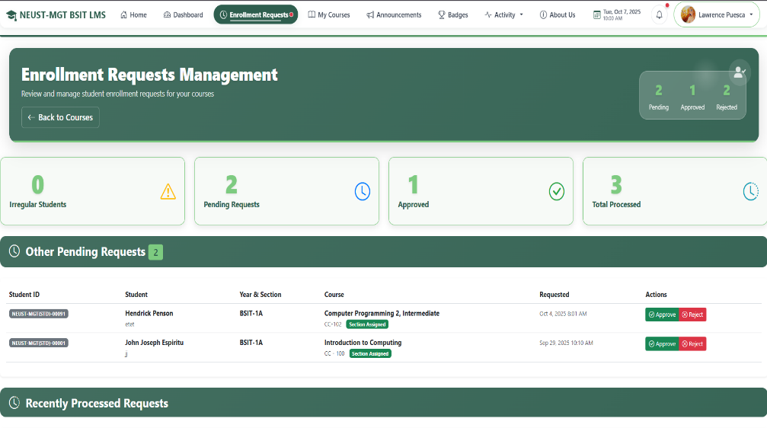

7.3. Navigate to Courses from menu you can scroll down.

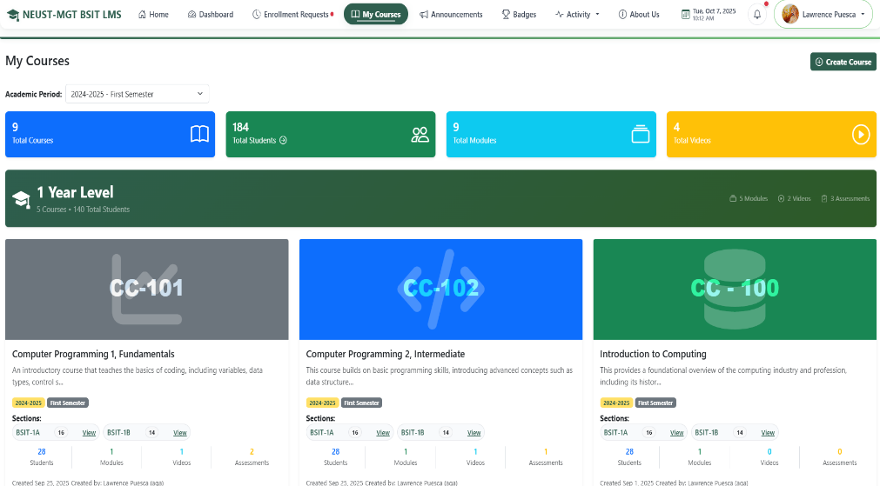

193

7.3.1. To manage specific courses, click Manage Courses

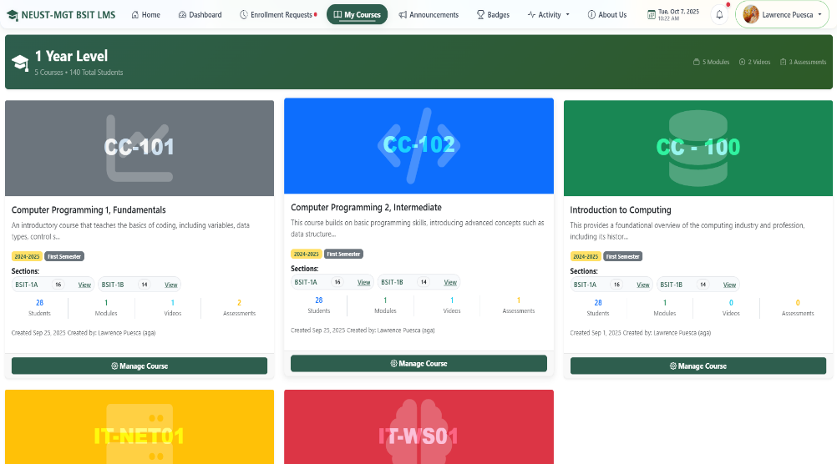

7.3.2. When clicked the Manage Course, you can Manage each module from courses from this page and can add module click the plus sign.
.
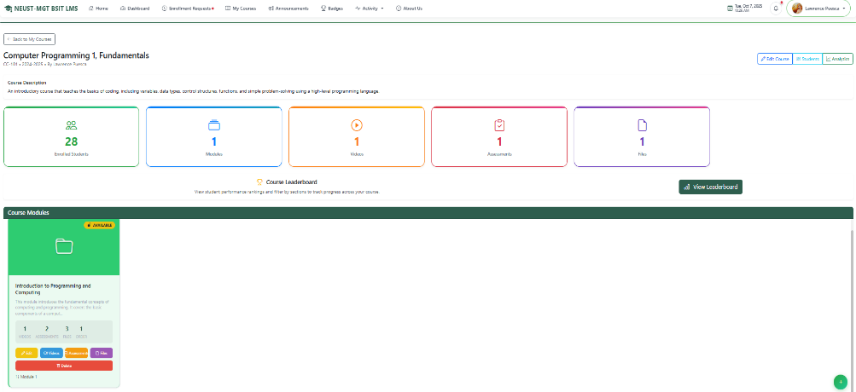

194

7.4. Navigating to Announcement from menu.

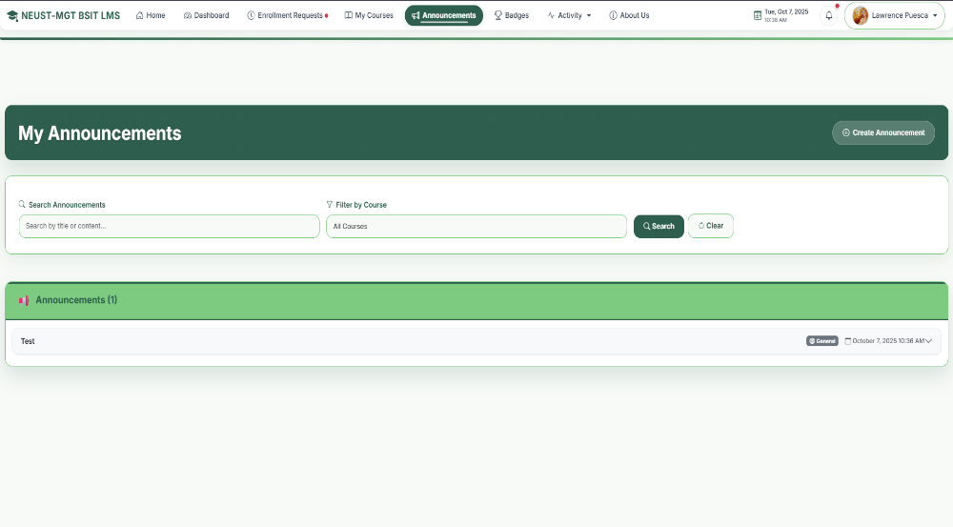

7.4.1. To add announcement, click the Create Announcement button.

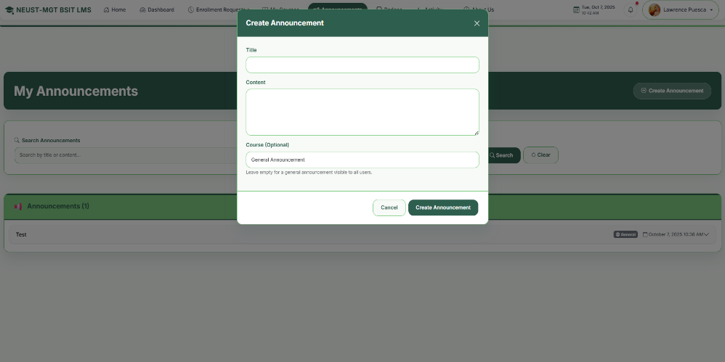

195

7.5. Navigate to Badge Page from menu.

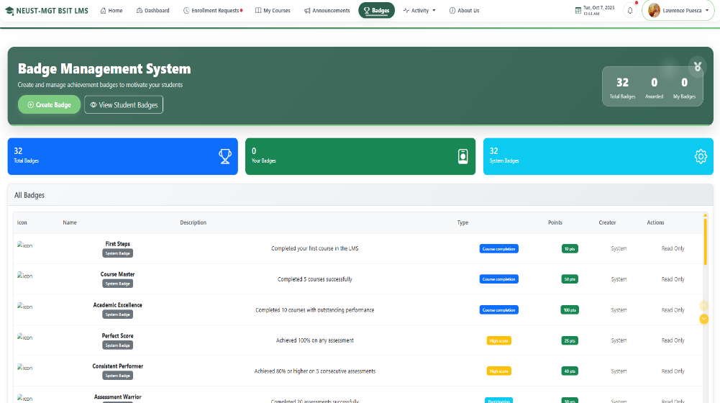

7.5.1. To create Badge from Badge page click Create Badge and fill up the form.
.

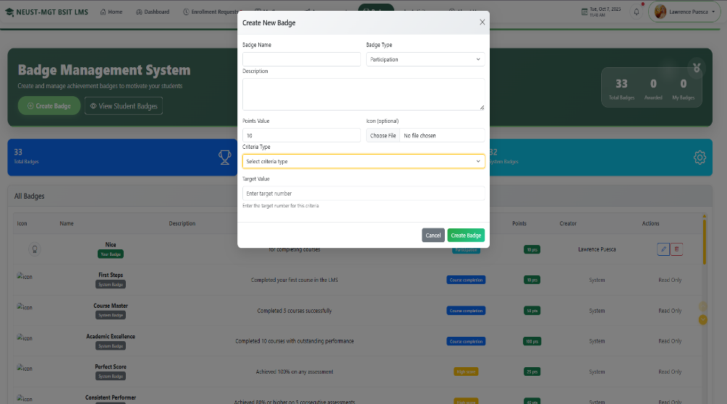

196

7.6. Navigate to Activity menu then Modules on this page display list of available modules.

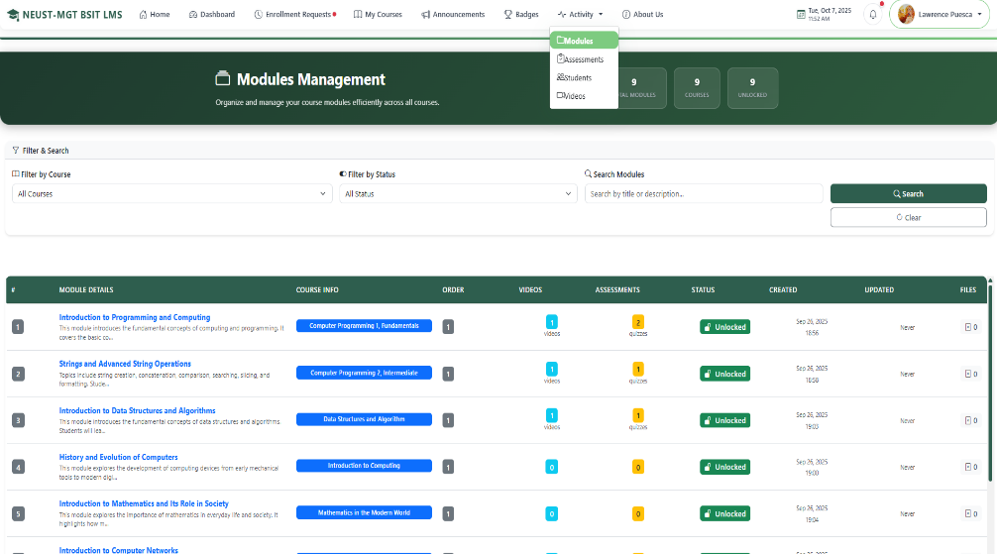

7.6.1. Next navigate to Activity menu the Assessments this page displayed list of available assessments.
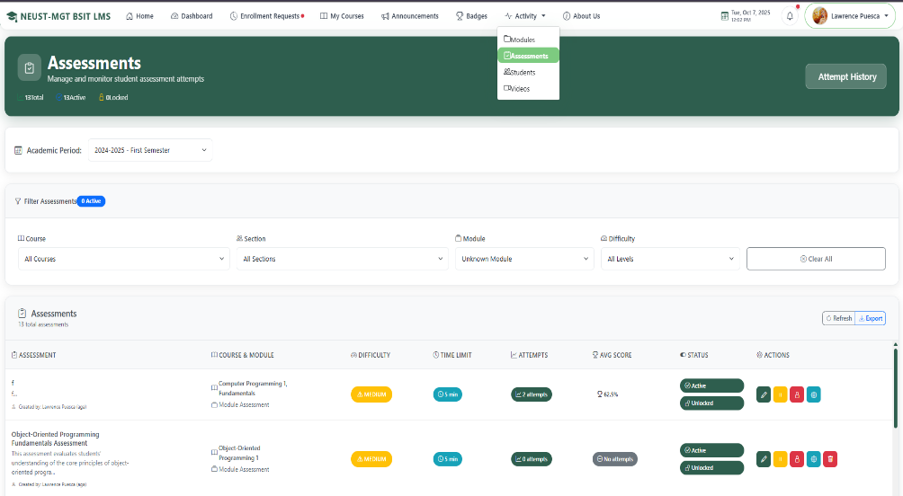

197

7.6.2. Next navigate to Activity menu then Students this page displayed list of students.

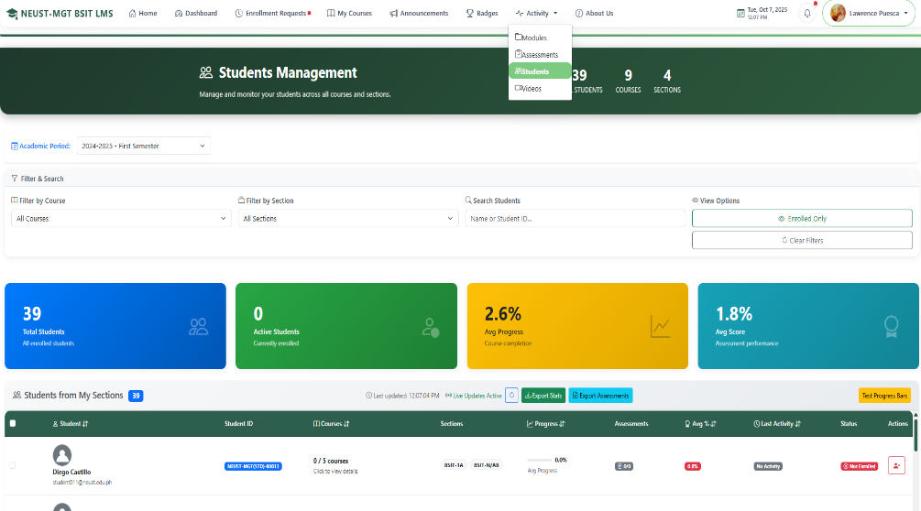

7.6.3. Next navigate to Activity menu then Videos this page displayed list of videos.

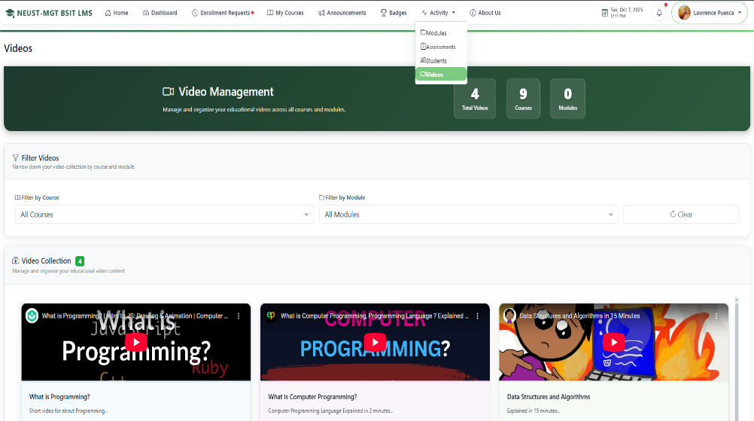

198

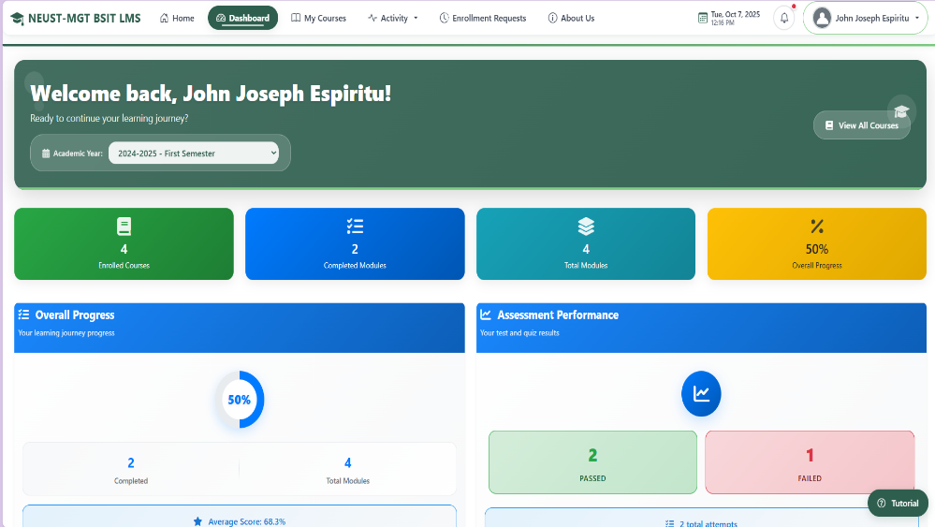
8.Navigating through the system as Student. 8.1. After logging in, the system redirects to your student dashboard.

8.2. Navigate to My Courses from menu.

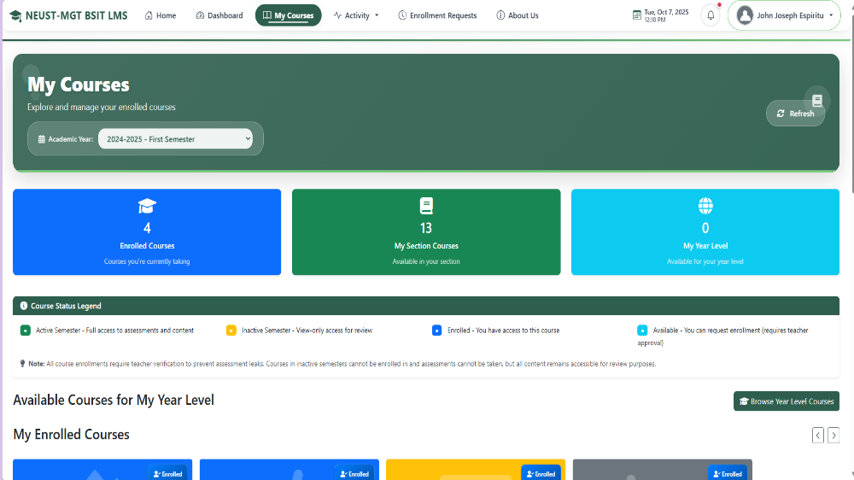

199

8.2.1. To take courses scroll down and click Continue Learning button.
.
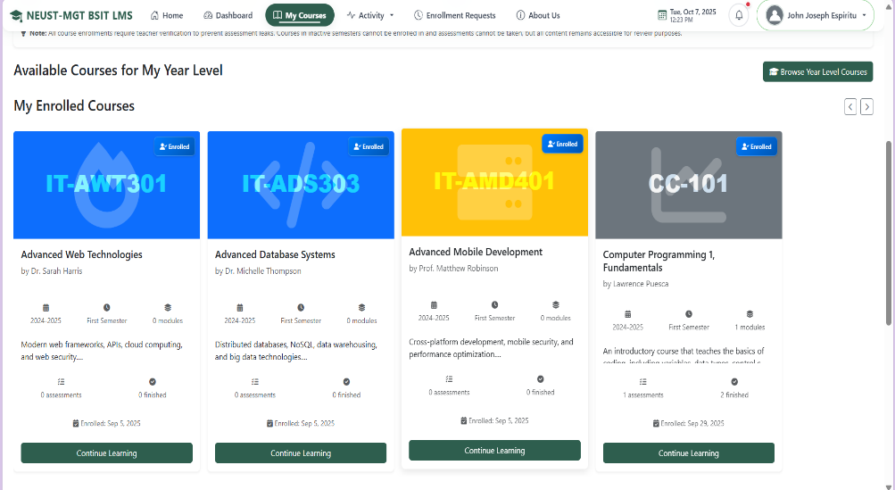

8.2.2. This page displays the available modules and statistic from the course and click the review module button.

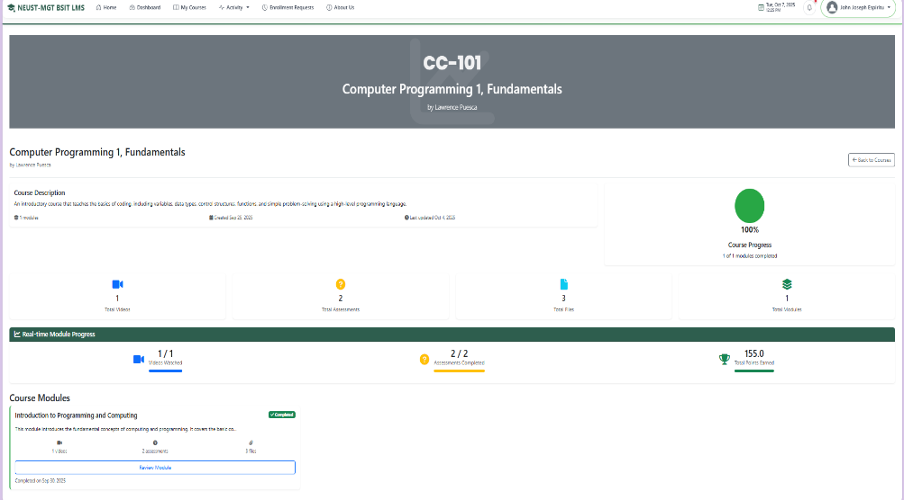

200

8.2.3. After clicked the review module button it will redirect to module assessments and videos list that students can take.

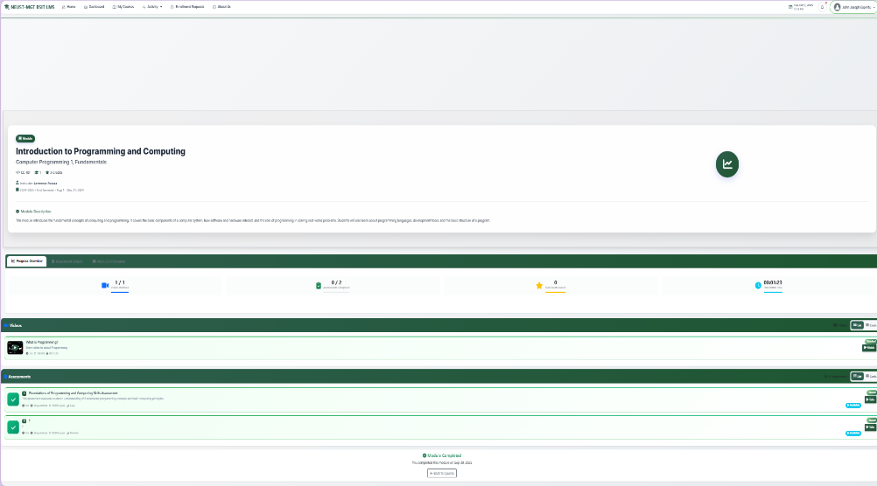

9. Navigating to Activity from menu Assessments link. 9.1. Click Assessment it redirect on this page, this page displayed list and progress of each assessments.

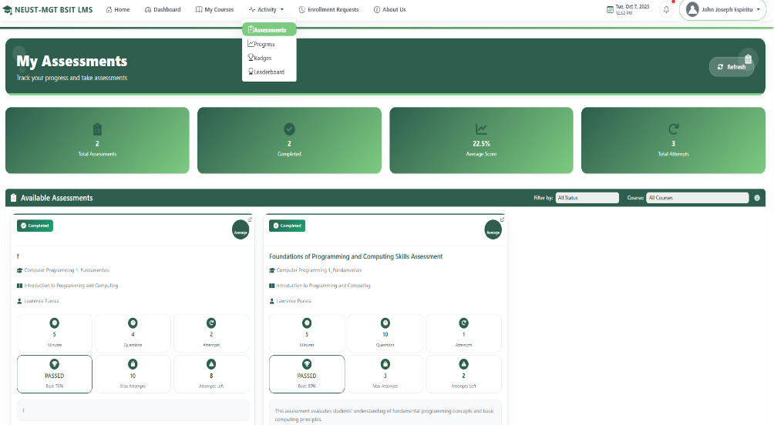

201

9.2. Click Progress it redirect on this page, this page displayed overall progress of each courses assigned to student.

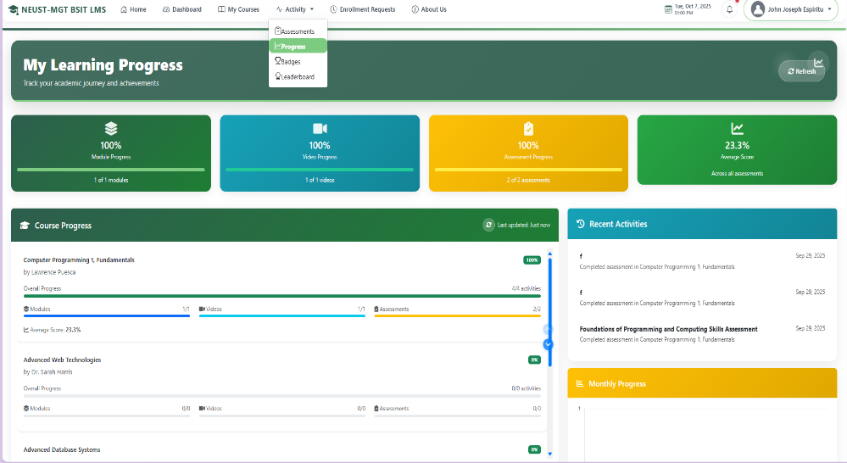

9.3. Click Badges it redirect on this page this page displayed earned badges of the student.

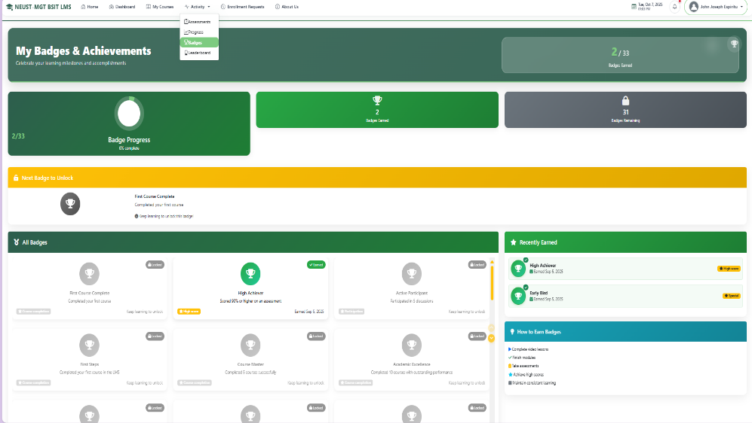

202

9.3. Click Leaderboard it redirect on this page this page displayed the overall ranking of the students base on their progress.

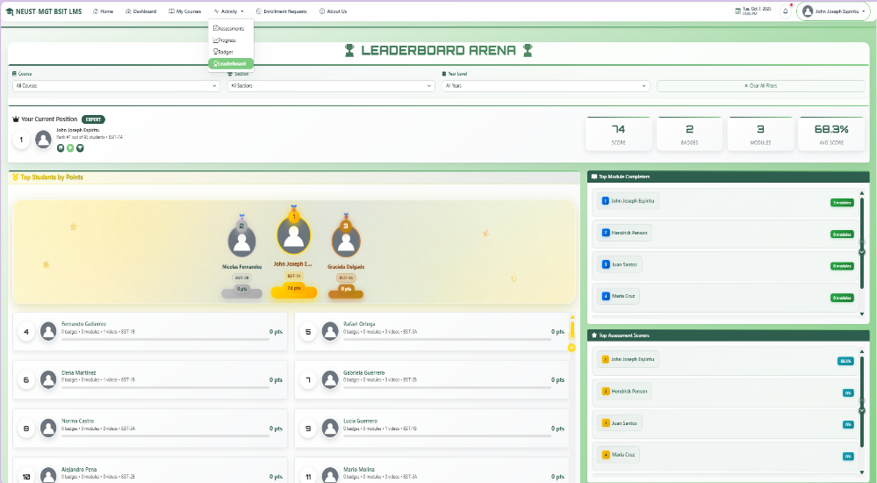

10. Navigating to Enrollment Requests.
10.1. Click Enrollment Requests from menu. This page show the status of student requests.

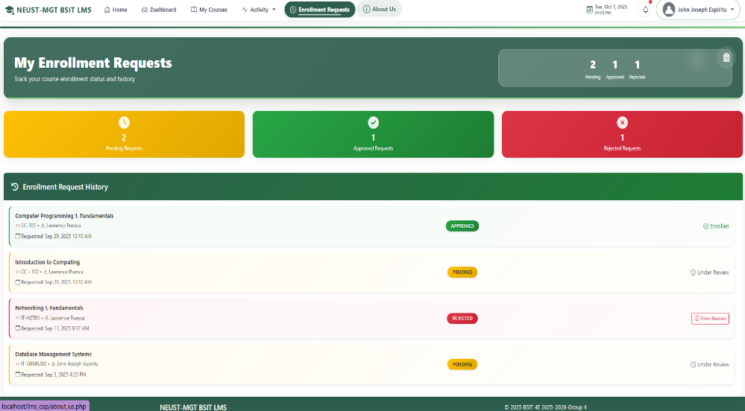

203

11. About Us page.
11.1. Click About Us from menu for all role to redirect to this page that displayed about us contents.

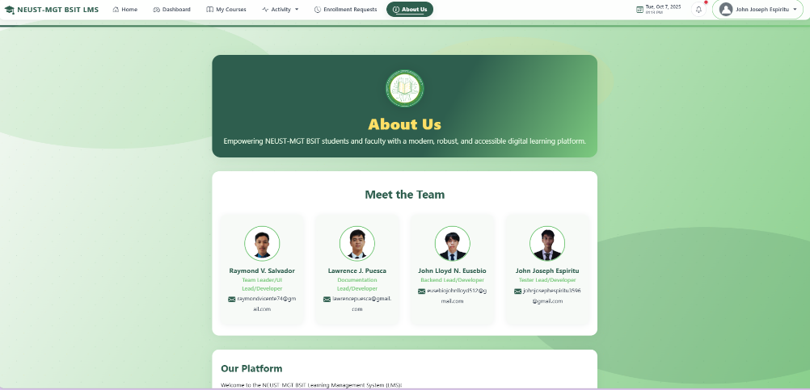

Appendix G

Picture and Documentation

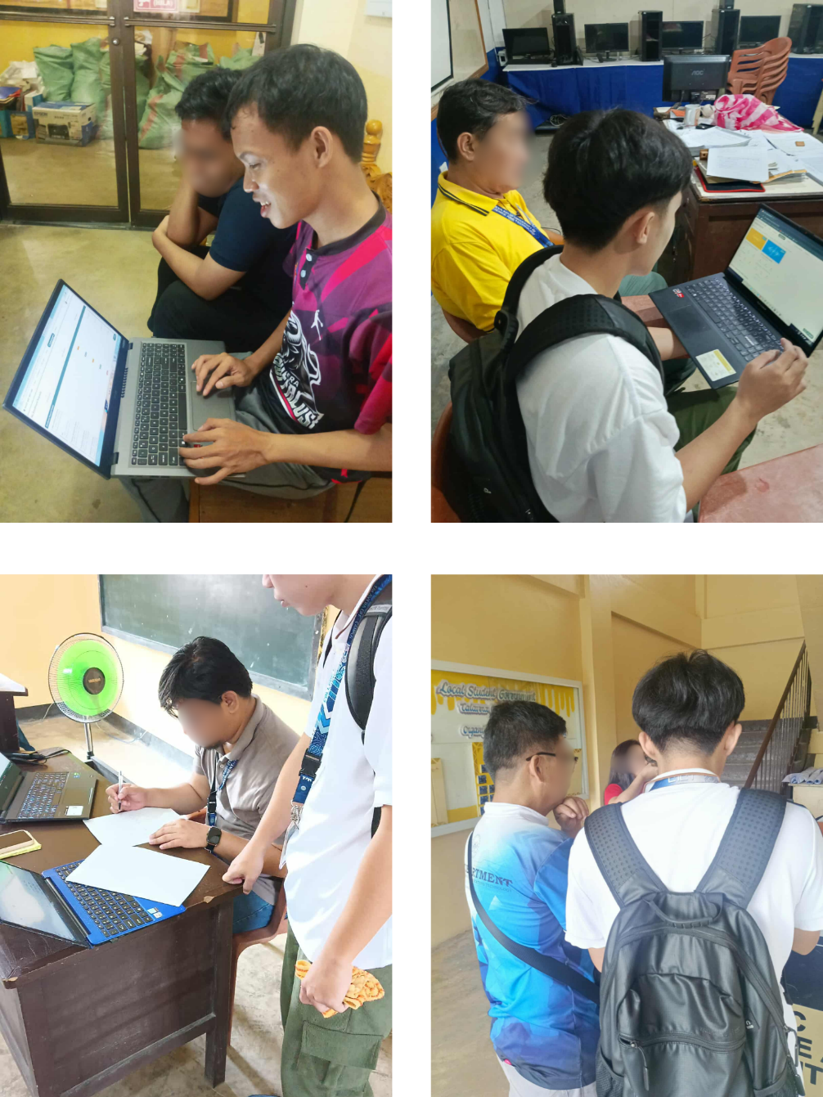

211


Appendix H

Curriculum Vitae

I. Personal Information

Name: Dave Bryan Ico

Contact Number: 09997008880

Email: davebryanico@gmail.com

Age: 21

Sex:Male

Address: Aduas Centro, Cabanatuan City

Birthdate: August 10, 2003

Citizenship: Filipino

II. Educational Attainment

Primary:Bibiclat Elementary School

(Bibiclat, Aliaga)

Secondary:Nueva Ecija High School

(Llanera St., Cabanatuan City)

Course: Bachelor of Science in Information Technology

Major: Database Systems Technology

212


Curriculum Vitae

I. Personal Information

Name: Maria Jemia Daniela Palma

Contact Number: 09369559658

Email: palmajemia@gmail.com

Age: 21

Sex:Female

Address: Caridad, Cabanatuan City

Birthdate: April 23, 2003

Citizenship: Filipino

II. Educational Attainment

Primary:Wesleyan University - Philippines

(Mabini Street Extension, Cabanatuan City)

Secondary:Nueva Ecija High School

(Llanera St., Cabanatuan City)

Course: Bachelor of Science in Information Technology

Major: Database Systems Technology

213


Curriculum Vitae

I. Personal Information

Name: Elijah Joshua Dimaculangan

Contact Number: 09208342568

Email: joshuaelijahad@gmail.com

Age: 22

Sex:Male

Address: Purok 6 San Casimiro, Licab

Birthdate: November 5, 2002

Citizenship: Filipino

II. Educational Attainment

Primary:Solomon’s Excellence Academy

(Quezon, Nueva Ecija)

Secondary:Cabanatuan City Senior High-school

(Sta Arcadia, Cabanatuan City)

Course: Bachelor of Science in Information Technology

Major: Database Systems Technology

214


Curriculum Vitae

I. Personal Information

Name: Joshua Jay Federico

Contact Number: 09667469228

Email: joshuajay8847@gmail.com

Age: 21

Sex:Male

Address: Bangad, Cabanatuan City

Birthdate: June 8, 2003

Citizenship: Filipino

II. Educational Attainment

Primary:Cabanatuan East Central School

(Maharlika Highway, Cabanatuan City)

Secondary:PHINMA- Araullo University

(Bitas, Cabanatuan City)

Course: Bachelor of Science in Information

Technology

Major: Database Systems Technology

215

