SURN ITNM REGISTRY
A National Real-World Outcomes Registry for Implantable Tibial Neuromodulation Devices
Sponsored by the SUFU Research Network · AUA 2026

WHAT IS IT?  A prospective, multi-center real-world outcomes registry for patients receiving implantable tibial neuromodulation (iTNM) devices — including Revi™, eCoin™, and Altaviva™. IRB-approved and open to all U.S. centers.  WHY JOIN?  - Track your own patient outcomes in a live provider dashboard  - Contribute to the first national iTNM real-world evidence dataset  - No additional clinical visits or procedures required  - Patients complete surveys remotely — $10 gift card per survey  - Patient enrollment opens Summer 2026 — register now to be ready  HOW IT WORKS  1 Register your site 2 minutes online  2 Share enrollment link Post QR code or share link at point of care  3 Patients complete surveys Baseline → 1, 3, 6, and 12 months  4 View your outcomes Live provider dashboard updated in real time | REGISTER YOUR SITE  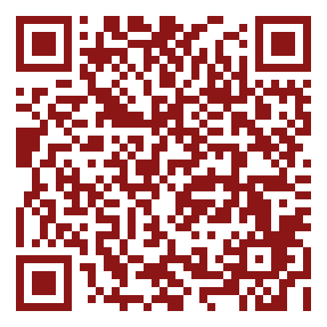  ITNMDatabase.surn.stanford.edu  ✓ IRB-approved, multi-center  ✓ Open to all U.S. centers  ✓ Patient enrollment: Summer 2026  ✓ $10 gift card per patient survey  Questions?  SUFUResearch@stanford.edu

SURN ITNM Registry | SUFUResearch@stanford.edu | ITNMDatabase.surn.stanford.edu
Sponsored by the SUFU Research Network · Stanford University School of Medicine

