**Csci 43500-02**

**Group project**

The syllabus requires you to design a database and engineer web based

application to manage and maintain the information. Support CRUD operations. You can engineer in teams 4/5 members per team) this using a variety of technologies including:

php(lamp/wamp)/ajax/j2ee(tomcat servlets/jdbc)/R(shiny and sqldf) or any combination.

XAMPP:

<https://www.apachefriends.org/index.html>

Due Date

**Tuesday, December 11, 201810:00 AM**

**Topic:** Photo album website

Members:

1) Deion Bacchus: [db101097@gmail.com](mailto:db101097@gmail.com) | 917-774-0218

2) Wei Lian: [lian576267257@gmail.com](mailto:lian576267257@gmail.com) | 917-868-2136

3) Topgyal Gurung [topgyaltsering3@gmail.com](mailto:topgyaltsering3@gmail.com)| 347-935-9179

4) Riyadh Rahman [riyadh.rahman.work@gmaill.com](mailto:riyadh.rahman.work@gmaill.com)

[riyadh.rahman97@myhunter.cuny.edu](mailto:riyadh.rahman97@myhunter.cuny.edu)| 347-837-3123

Description/ Topic Details:

Photo Album Website:

1. Which lets user make photo albums.
2. User needs provide username, password, email.
3. Uses upload photos and put them into photo album.
4. Database to store user information and photo albums.

E-R diagram:

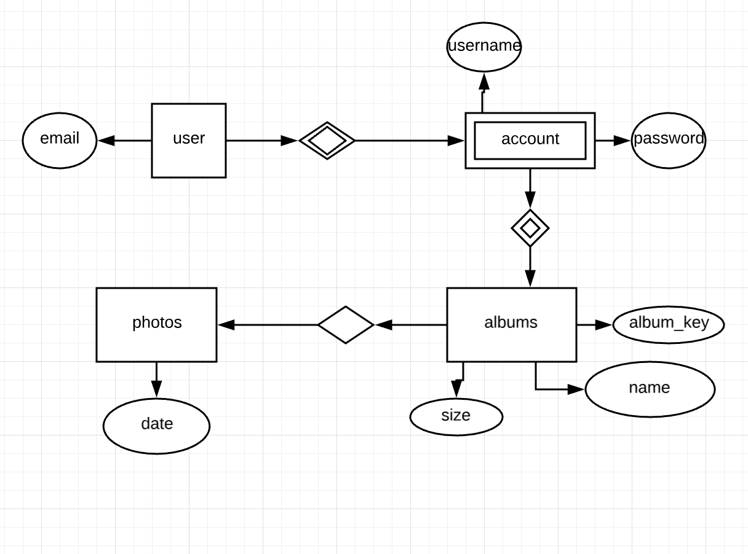

Link: <https://www.lucidchart.com/documents/edit/aff6d419-50c9-4bce-a60b-ec450e4f1620/0>

<?php

$user='root';

$pw='';

$db='account'

$connect = new mysqli('localhost',$user,$pw,$db) or die("Error");

echo"connected";

?>

To do: html for albums, letting user query the album.

