FRAM

CE

OE

A12

A11

AY38910

A8

A9

+5

BC2

BDIR

BC1

A10

A9

|  |  |  |  |  |
| --- | --- | --- | --- | --- |
| A12 | A11 | A10 | A9 |  |
| 1 | 1 | X | X | FRAM |
| 1 | 0 | 1 | 1 | Latch |
| 1 | 0 | 1 | 0 | Write |
| 1 | 0 | 0 | 1 | Read |
| 1 | 0 | 0 | 0 | --- |
| 0 | X | X | X | --- |

|  |  |
| --- | --- |
| F800 – FFFF | FRAM |
| F200 | Read |
| F400 | Write |
| F600 | Latch |

|  |  |  |  |
| --- | --- | --- | --- |
| BDIR (A10) | BC2 (+5) | BC1 (A9) |  |
| 0 | 1 | 1 | Read |
| 1 | 1 | 0 | Write |
| 1 | 1 | 1 | Latch |
| 0 | 1 | 0 | --- |

A12

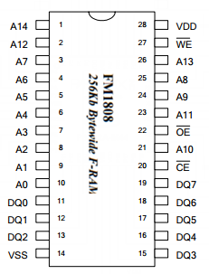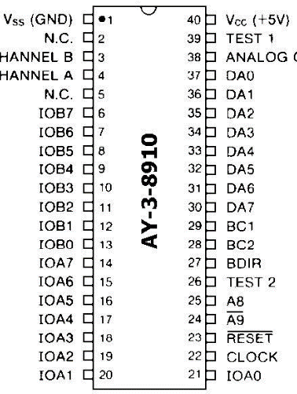

A11

A12

A11