

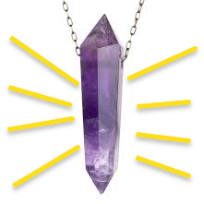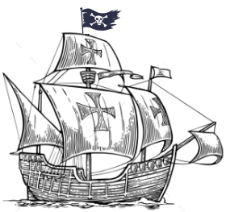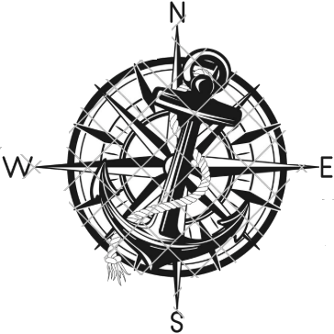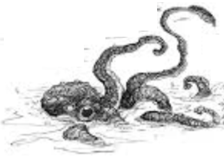

Hazel’s list of things they took with them. Whirled eas NF

* Violin
* Barel of Rum
* Dinghy of Rotten Apples
* Barel of Flour
* Painted Rock

Backer’s island clues

This is Backer’s font and his writing style.

Set sail at dawn on

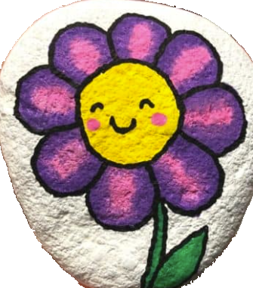

Music and rum tamed the monster.

Used the crystal to get the rest of the map.

I fell overboard. ?dropped food?

**Tortuga**

**St. John’s**

**Antilles**

**Ghost Isles**

**Chronos**

George Town

*Breeze Tavern*

*Ask for Brandy*



June 15, 1753.

Eighteen-eighths to wipe the slates,

and Lori joined the crew.

**Point Paul**

**Pelican Pub**

**Red Snapper**

**Kingston**

**Red Clam Inn**

**Smoked Oysters**

**San Fernando**

**Miranda’s Place**

**Salted Perch**

Used the flour to

best the pirates.

