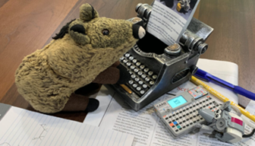

**https://piggie.blog**

**The Adventures of Piggie and Nibbles**



**https://piggie.blog**

**The Adventures of Piggie and Nibbles**



**https://piggie.blog**

**The Adventures of Piggie and Nibbles**



**https://piggie.blog**

**The Adventures of Piggie and Nibbles**



**https://piggie.blog**

**The Adventures of Piggie and Nibbles**



**https://piggie.blog**

**The Adventures of Piggie and Nibbles**



**https://piggie.blog**

**The Adventures of Piggie and Nibbles**



**https://piggie.blog**

**The Adventures of Piggie and Nibbles**



**https://piggie.blog**

**The Adventures of Piggie and Nibbles**



**https://piggie.blog**

**The Adventures of Piggie and Nibbles**