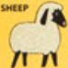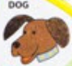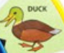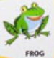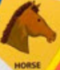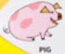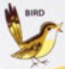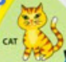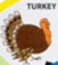

Barn



**USE EMPTY** and have pail to get MILK.

Coop

**USE BALLOON** to get EGGS.

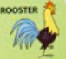

Pig Sty

Meadow

**USE WATERGUN** to pass.

Tree

BALLOON

WATERGUN

Stream

**ACTION** to fill water gun.

Pond

Yard

Garden

Pasture

Kitchen

Porch

To win:

**USE EGGS**,

**USE BREAD**,

**USE BUTTER**

Parlor

**USE MILK** to make BUTTER

**USE CORN** to get PAIL.

**START**

CORN

BREAD