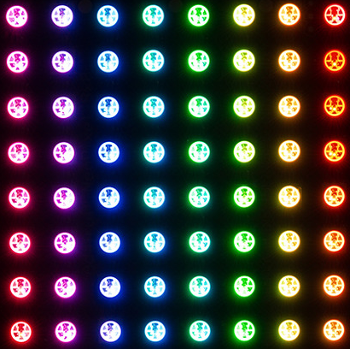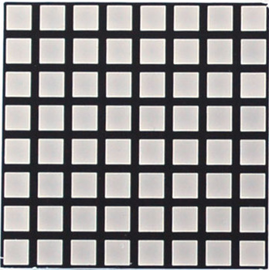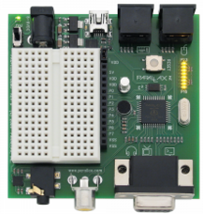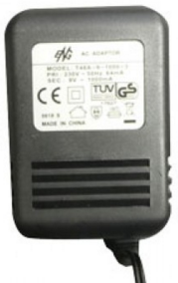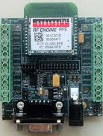

5V

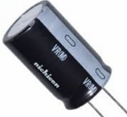

1000 uF

I2C Clock

I2C Data

Pixel Data

Pixel Data

Rx

Tx

P4

P5

P3

P2

P1

P0

Parallax Propeller Demo Board

Synapse SN171 Proto Board